**Test Word Document**

**Test Document**

This is a test document with a mermaid diagram.

**System Architecture Diagram**

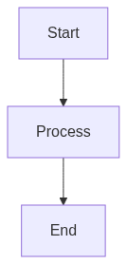

This diagram shows the system architecture and data flow for the DIA3 Strategic Intelligence Framework.

**Conclusion**

This is the end of the test document.