File Stalker

Collaborative Team Project

Stage III – Design

CSC260

Dr. Pulimood

27 March 2012

Team C.H.I.M.P

Alexa Cain

Danny DeChiara

Derek Duchesne

Tim Lee

Glen Oakley

Steve Schwarcz

Macintosh HD:Users:student:Desktop:cs3proj3:project:uml:log creation system sequence diagram.pdfMacintosh HD:Users:student:Desktop:cs3proj3:project:uml:user search system sequence diagram.pdf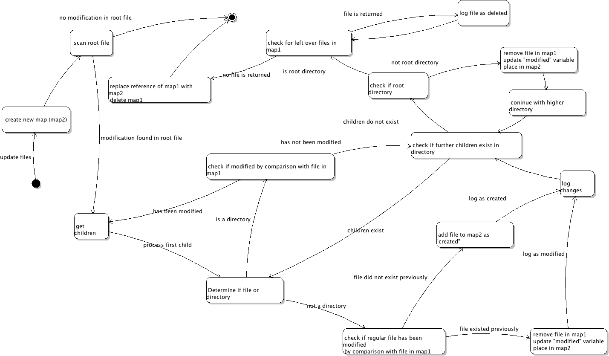

User Search System Sequence

Log Creation System Sequence

State Chart

Macintosh HD:Users:student:Desktop:SemiDetailedClassDiagram.pdf

Class Diagram