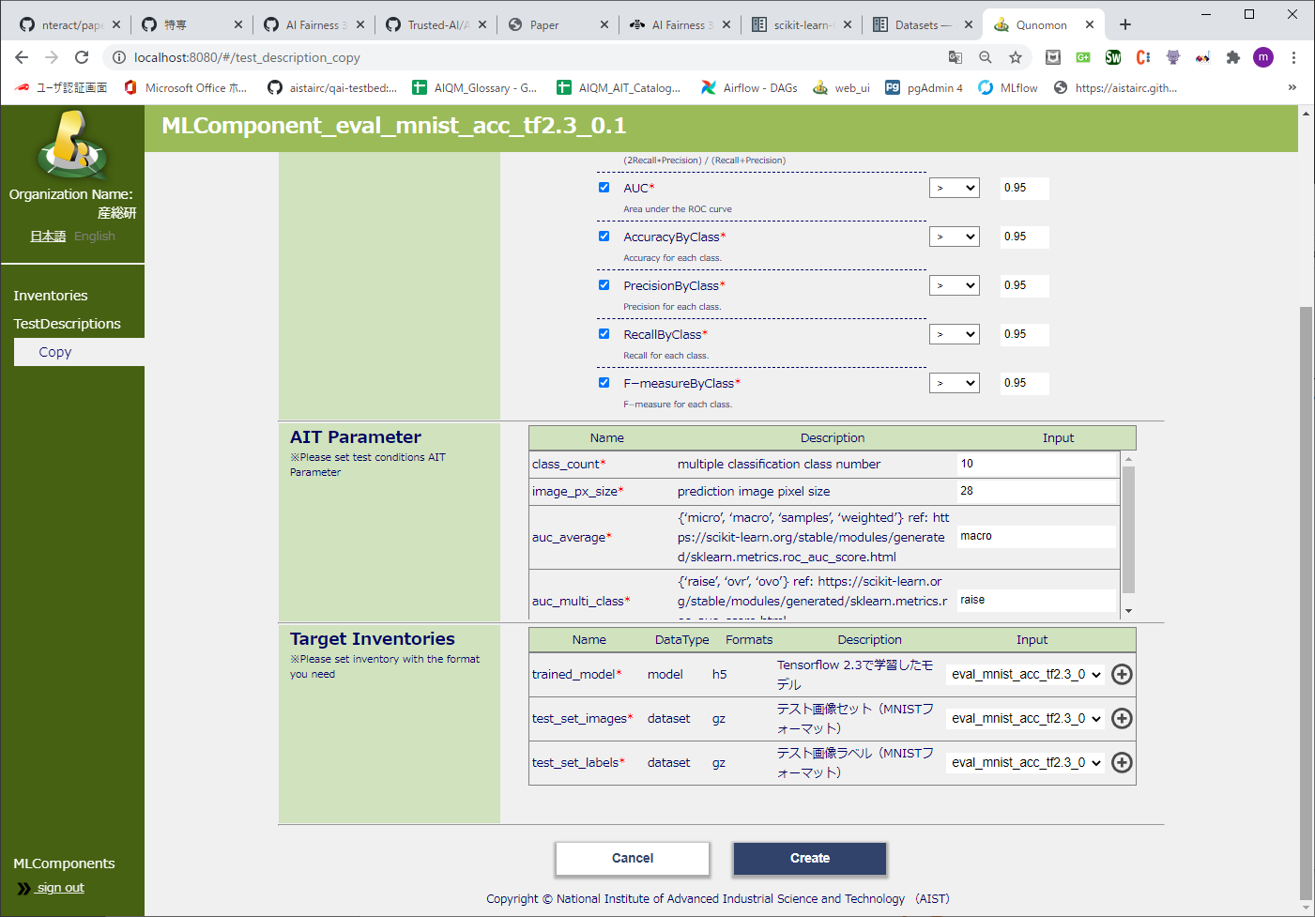
- Button area
- Target Inventories area

