**Step 1: Download and install XAMPP on your computer**

The first step on your way to install WordPress locally is to download and install the XAMPP software.

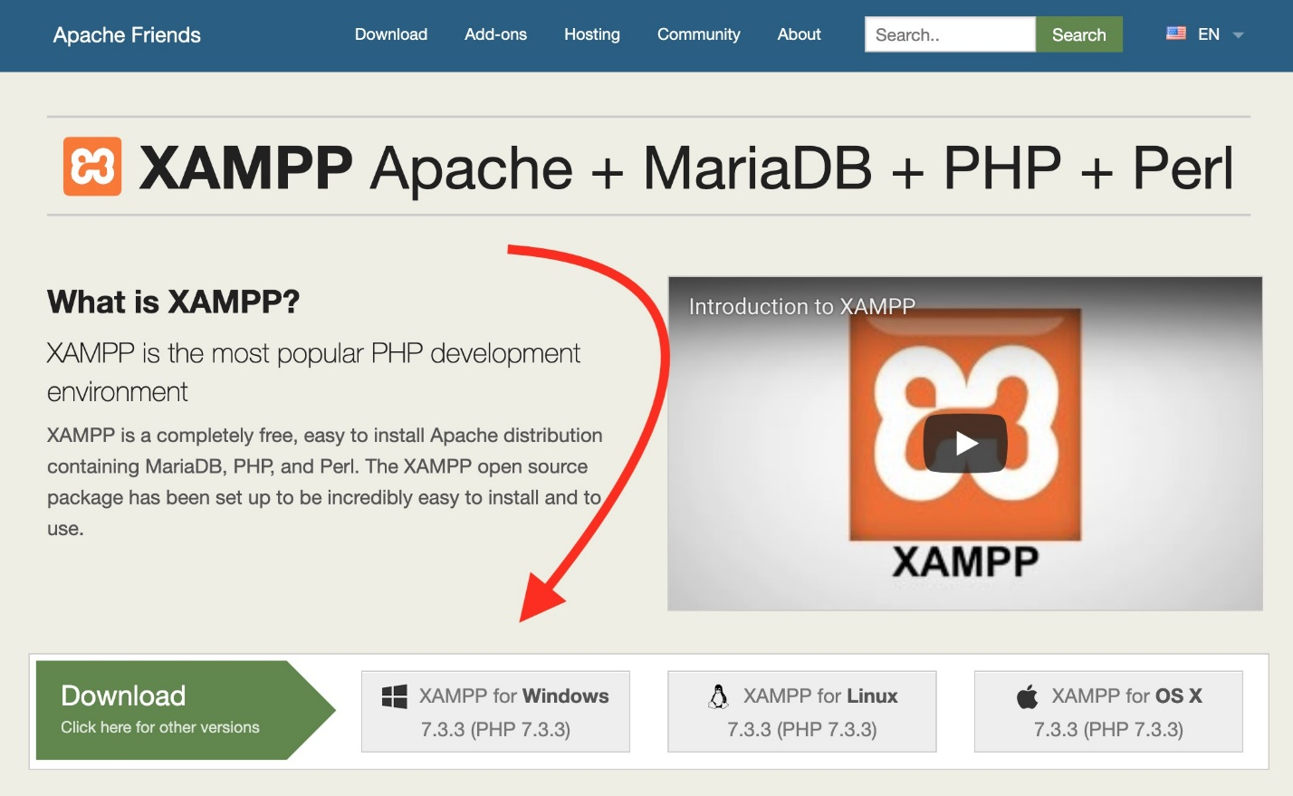

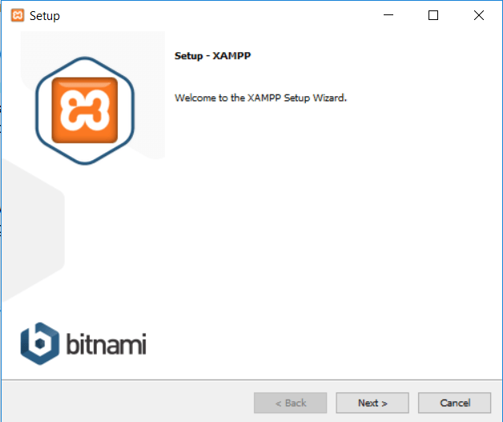

Just click **Next** to continue.

On the next screen, you can choose which components to install. To install XAMPP and WordPress, **you do not need all of the components. In addition to the required components, all you need are:**

* **MySQL**
* **PHPMyAdmin**

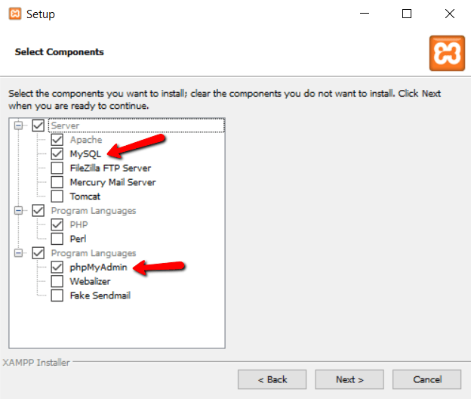

Again, this is all that’s needed to install WordPress locally. Uncheck everything else and click **Next.**

You can now select which folder to install XAMPP in. I always leave it as the default:

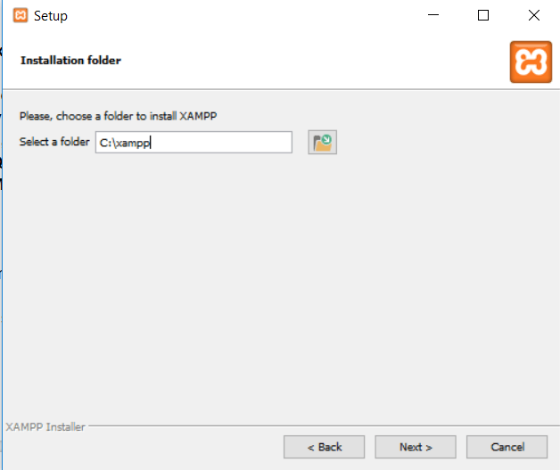

On the next screen, you’ll get a prompt asking you to install **Bitnami for XAMPP.** You do **not** need this to install XAMPP and WordPress, so just uncheck the box:

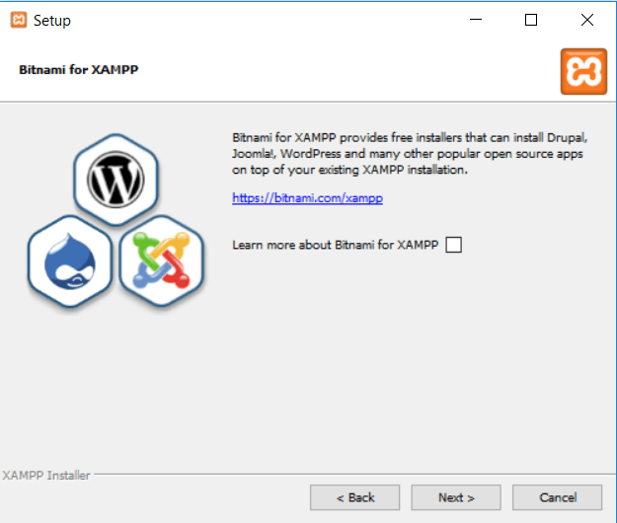

Once you click **Next**, you’re ready to run the install:

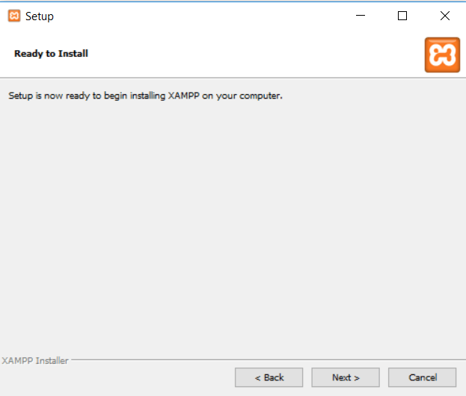

The install process might take a few minutes:

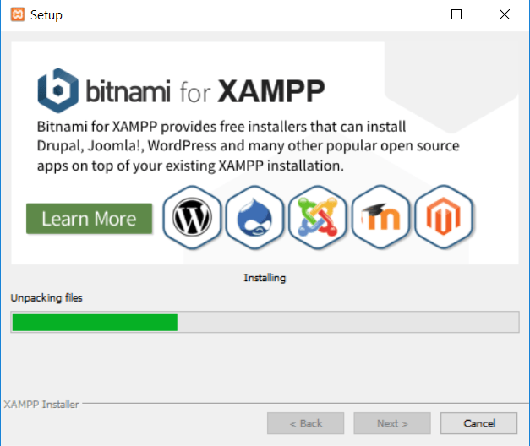

Once it finishes, you can launch the control panel to start working with XAMPP:

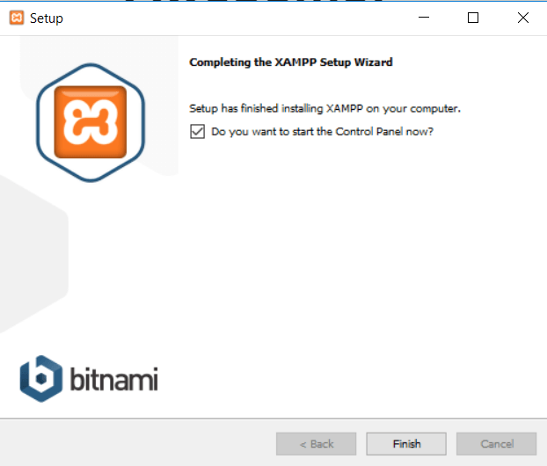

**Step 2: Start the modules and test your server**

To install XAMPP and WordPress properly, you’ll need to run two modules:

* Apache
* MySQL

You can start both modules from the XAMPP control panel:

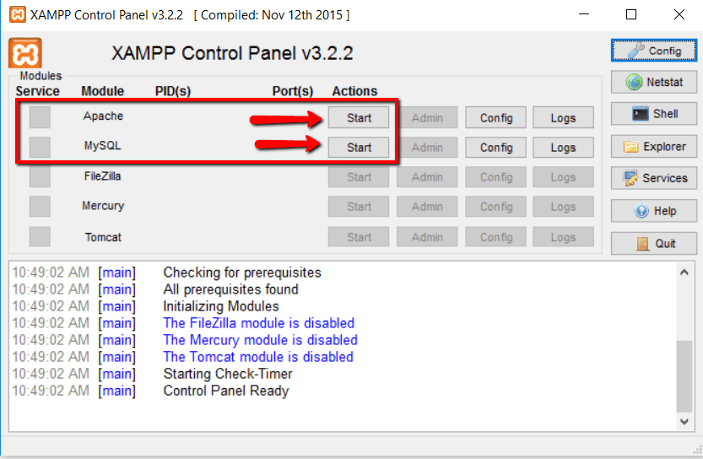

Once you launch them, you should see their status turn to green:

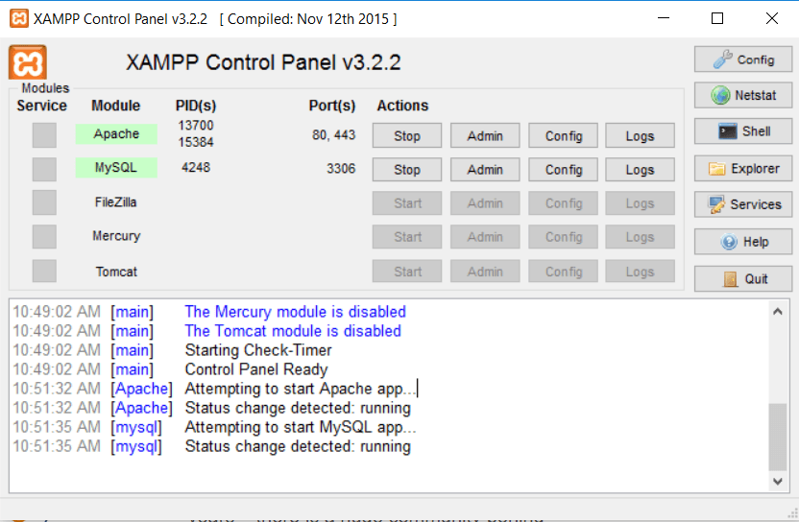

And now you should be able to test that your local server is working by going to http://localhost/ in your web browser of choice:

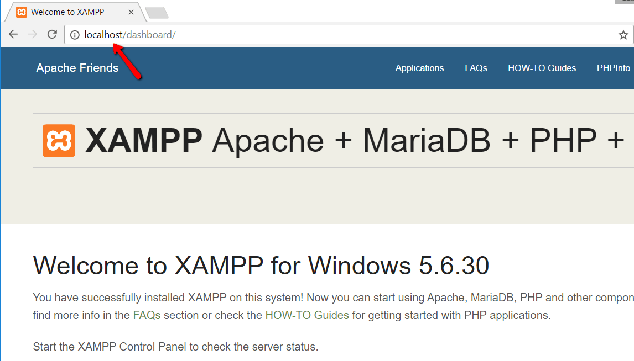

If all went well, you now have a functioning XAMPP server on your Windows PC! But now it’s time to install XAMPP **and** WordPress. So here’s how to get a WordPress site up and running on XAMPP.

**Step 3: Add the WordPress files**

In Windows, navigate to the folder where you installed XAMPP. For me, that’s C://xampp. It should be something similar for you. Then, in that folder, find the **htdocs** subfolder:

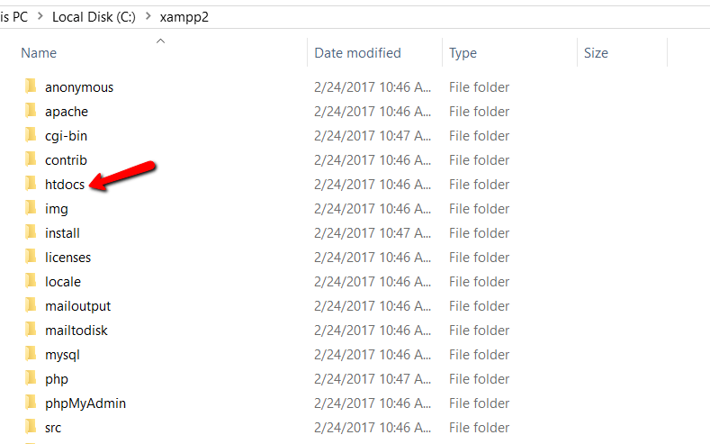

In **htdocs**, paste the zip file I emailed you that was called **“Nikey”**. This folder name will become the sub-name used to access your site. For example, if you make the folder testsite, you’ll access your site by going to http://localhost/testsite.

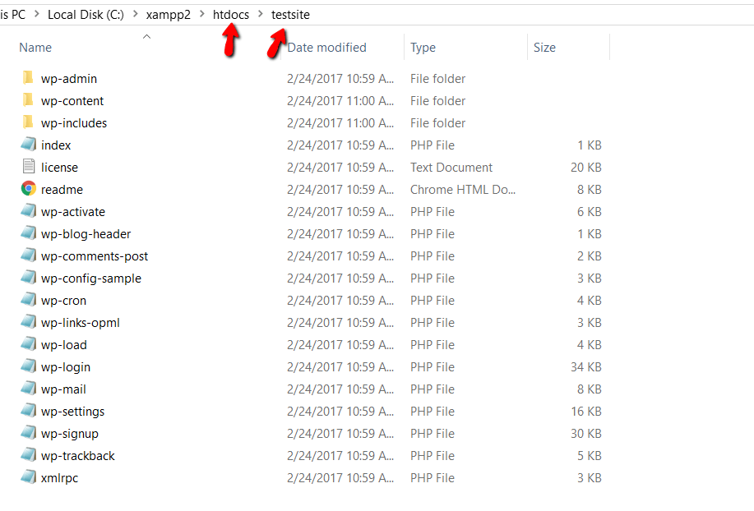

**Step 4: Create a database for WordPress**

Next, you need to create a MySQL database for your WordPress install. To do that, launch PHPMyAdmin from your XAMPP control panel:

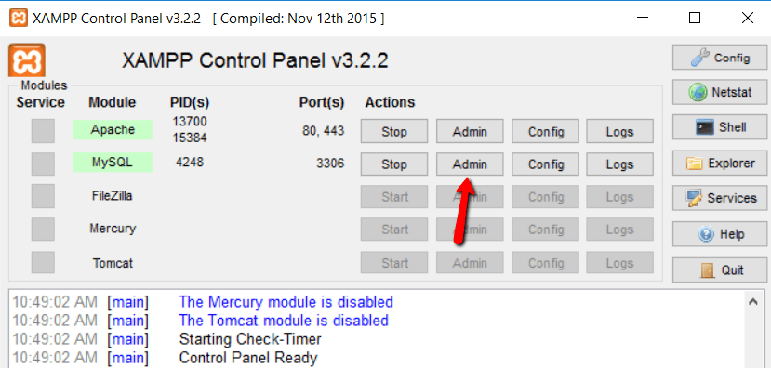

Then click on **Databases** at the top:

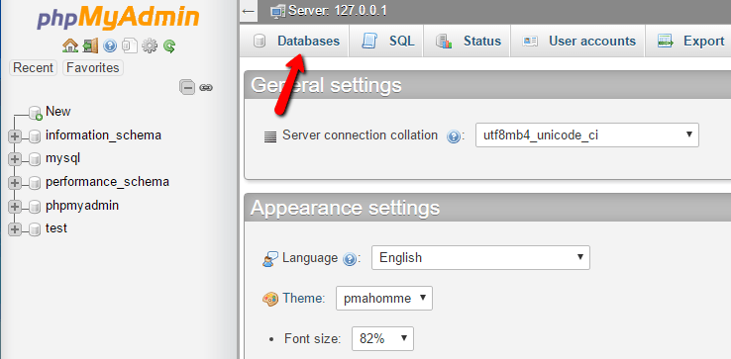

Click on “import” and import the “Nikey.sql” file included in the zipped archive of the site files. From there, you will now see a database on the left hand side of phpMyAdmin that is named: “Nikey”

**Step 5: Navigate to the local website**

When you visit your test site, you should see the homepage for Nikey.

The url is localhost/Nikey/



From here you are now hosting your own install of WordPress, and able to edit as if you were hosting the website online.