sudo apt update - install updates
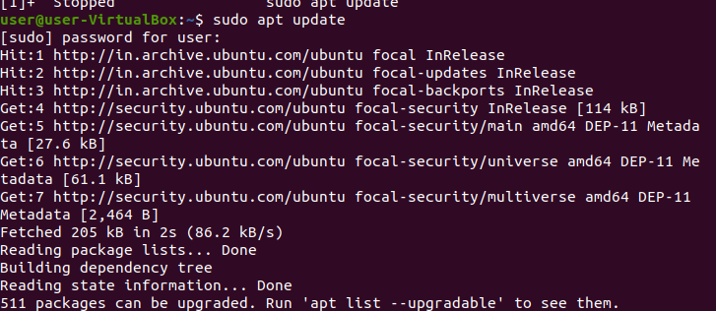
sudo apt install docker.io
this is used to install docker

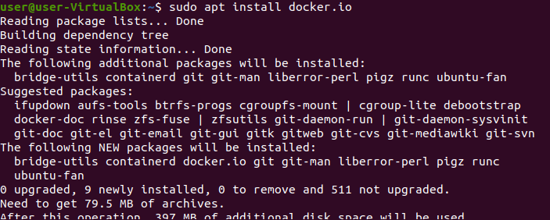

docker --version to know the docker version

sudo su
to switch to root user

sudo docker images to see images created

to create docker image
sudo docker pull ubuntu
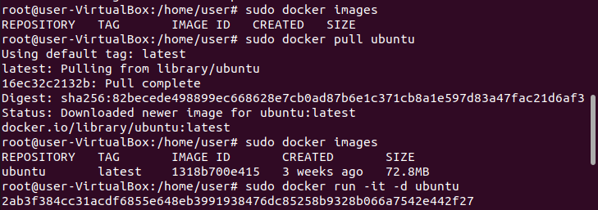
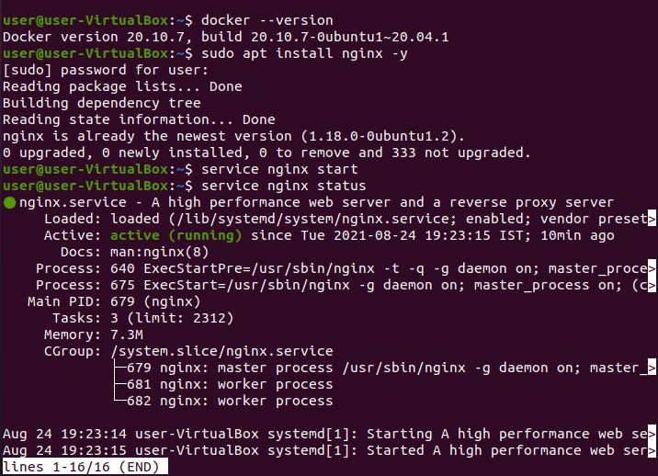
sudo docker run -it -d ubuntu
to see image number

sudo docker ps
to see detailed image information

