Subheading
This is the introduction to my thesis
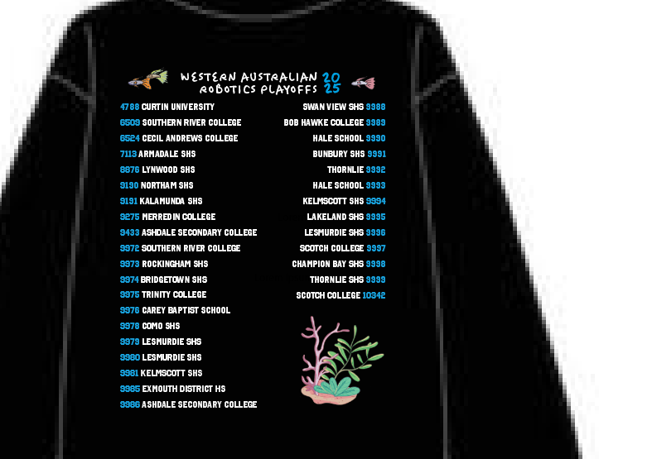
It should be able to recognise pictures with and without captions and parse them

This is a smaller heading
Thesis already kinda sucks low key

This is another big heading

That was a dramatic space that I want kept.

This | Is | a
Table | I | want

Im not quite sure what else, maybe citations would also be cool.

