LAB 1:

1. Setting up Python,
2. Jupyter as front-end,
3. Downloading Github codes.

**INSTALLING PYTHON VERSION 3.9.2**

STEP 1:

Google search install python ([www.python.org](http://www.python.org))

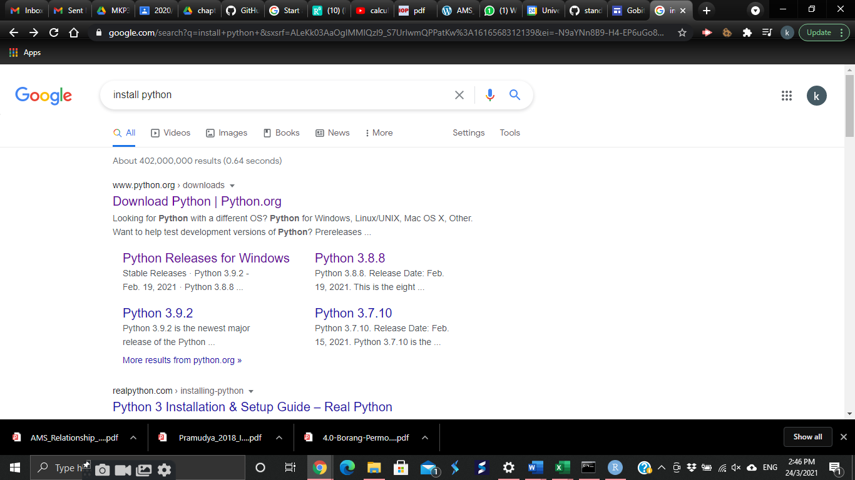

Step 2:

Install latest version of Python (3.9.2)

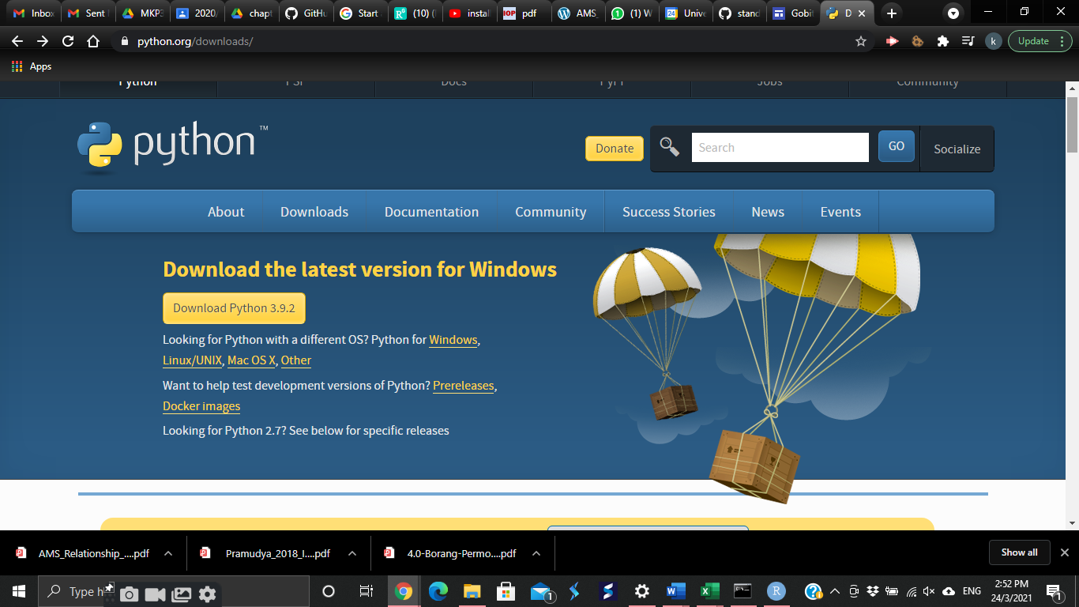

Optional: Any other version of Python is available. Scroll down the same page and you will see many versions is available.

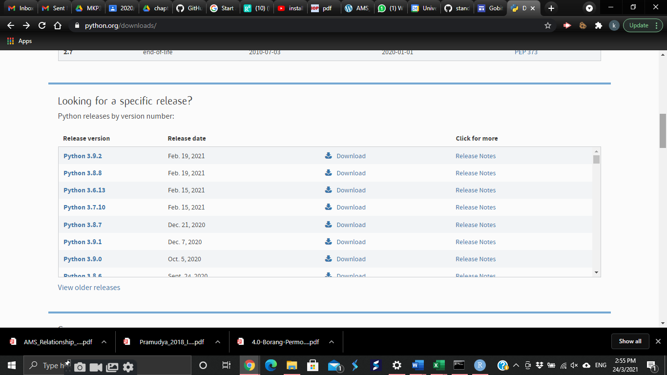

Step 3:

After downloading, check at the bottom of the page. Click the downloaded file.

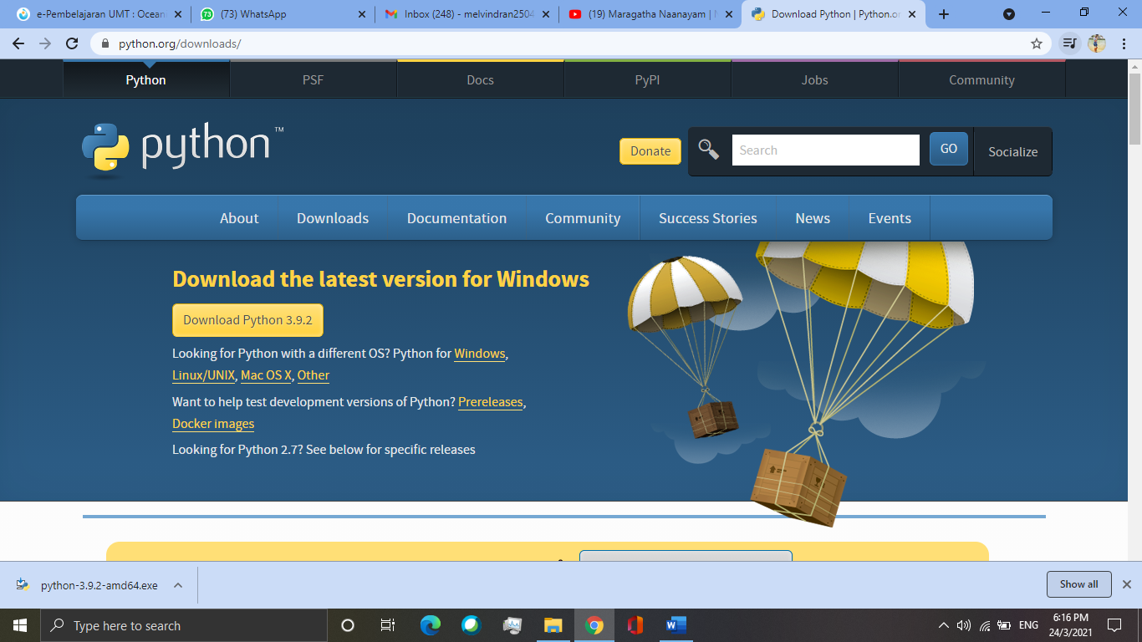

Step 4:

After opening the downloaded file, a pop-up notification just like in the picture will appear. Make sure to tick both boxes and click “customize installation”.

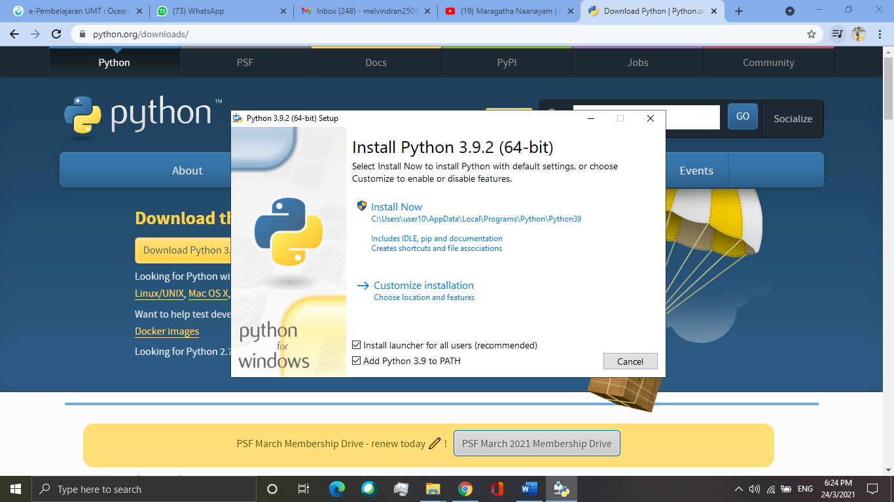

Step 5:

After clicking “customize installation”,

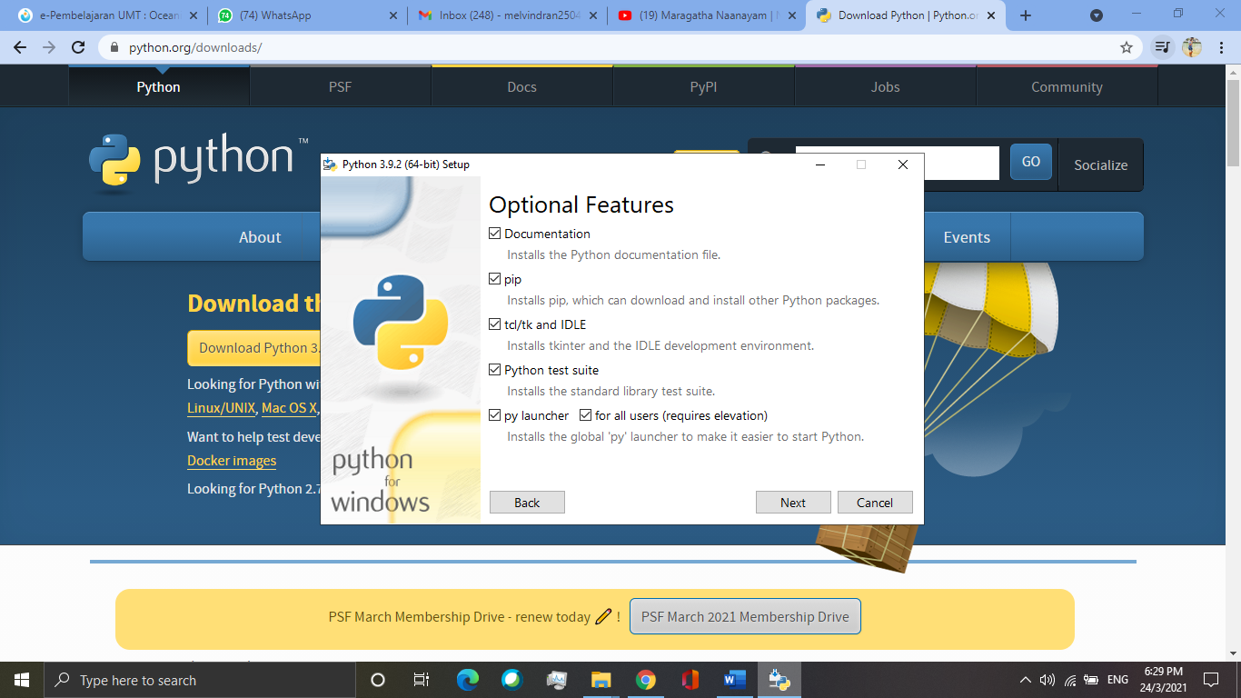

Step 6:

Choose a place where it is easy for you to find.

Step 7:

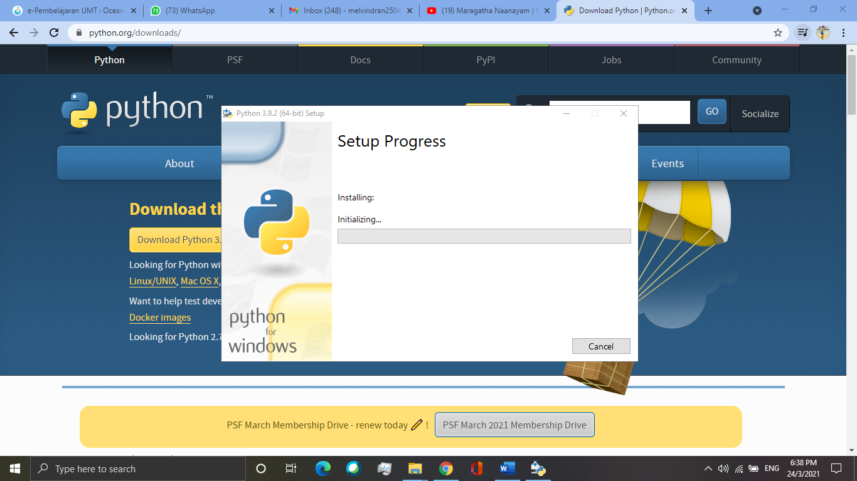

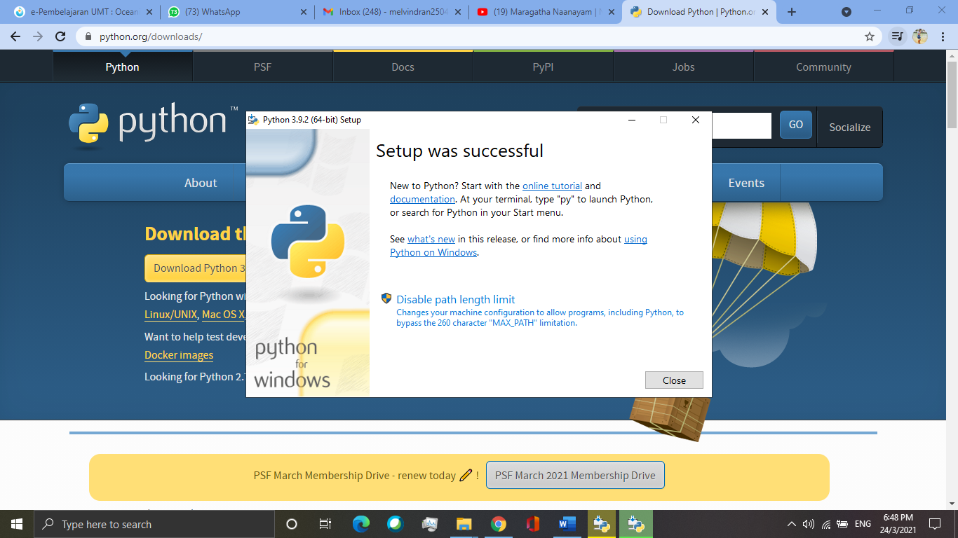

Step 8:

Identifying the Python 3.9 location.

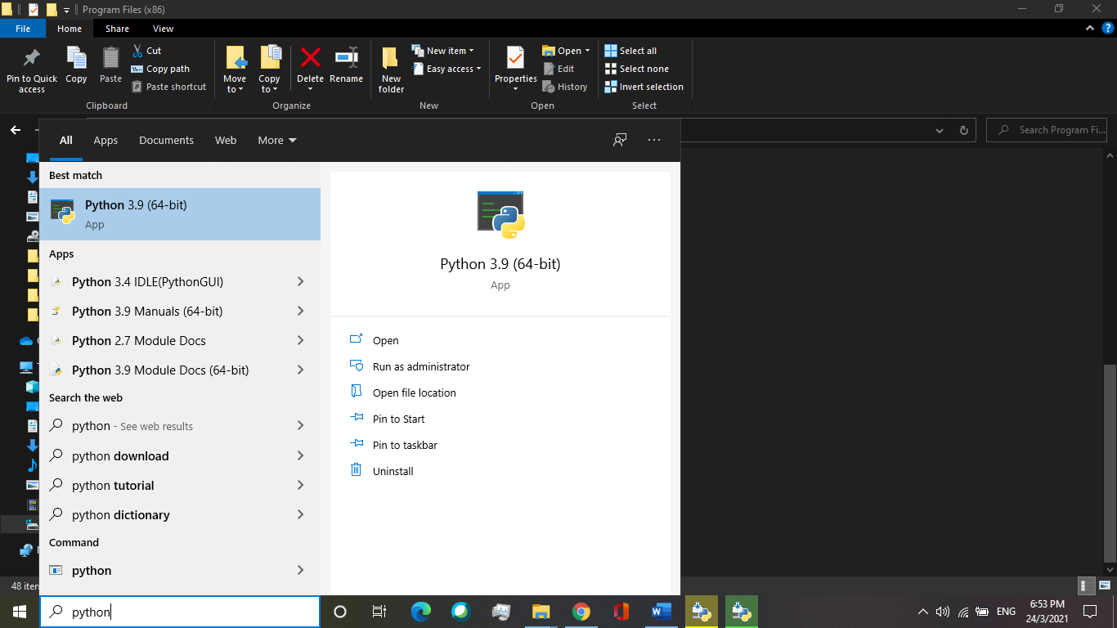

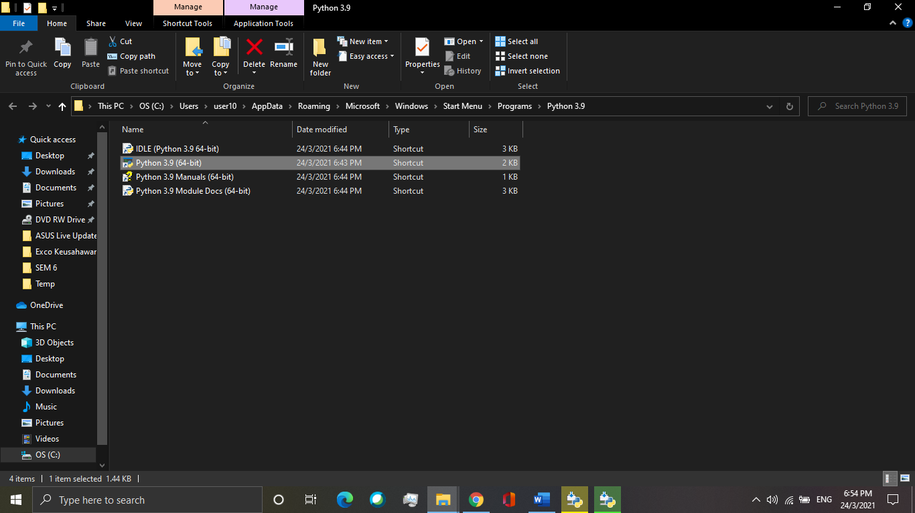

**INSTALLING JUPYTER NOTEBOOK**

Step 1:

Trace the AppData folder. Tick the hidden items

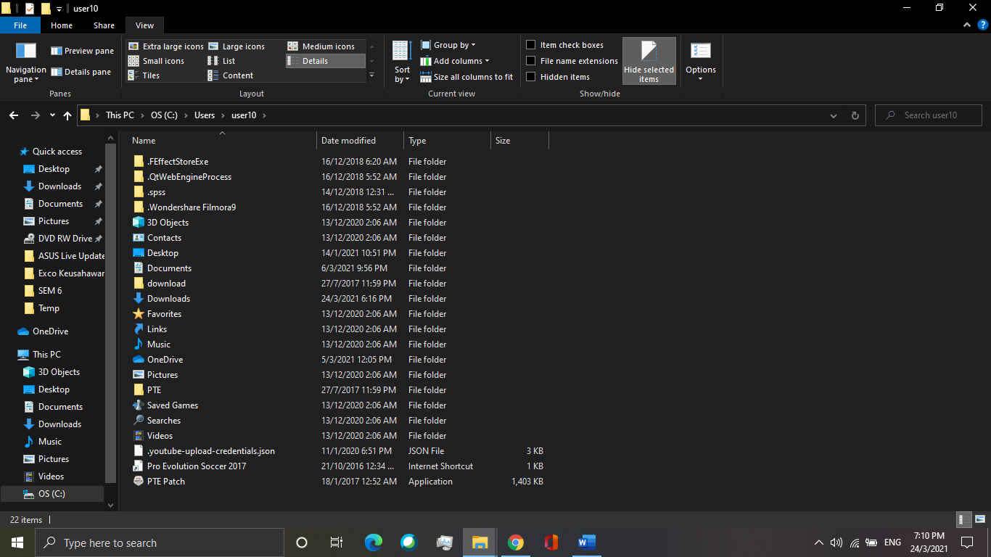

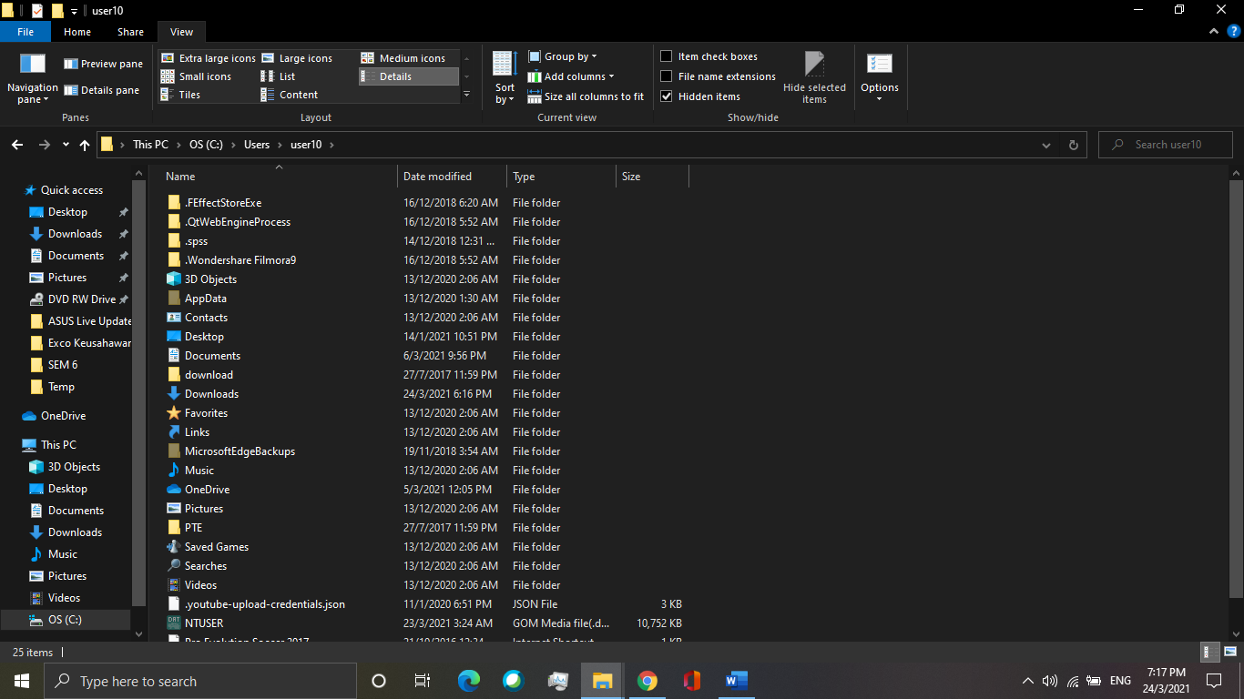

Step 2:

From AppData > Local > Programs > Python > Python 39 > Scripts

At the column with the red arrow place in the picture, type “cmd”.

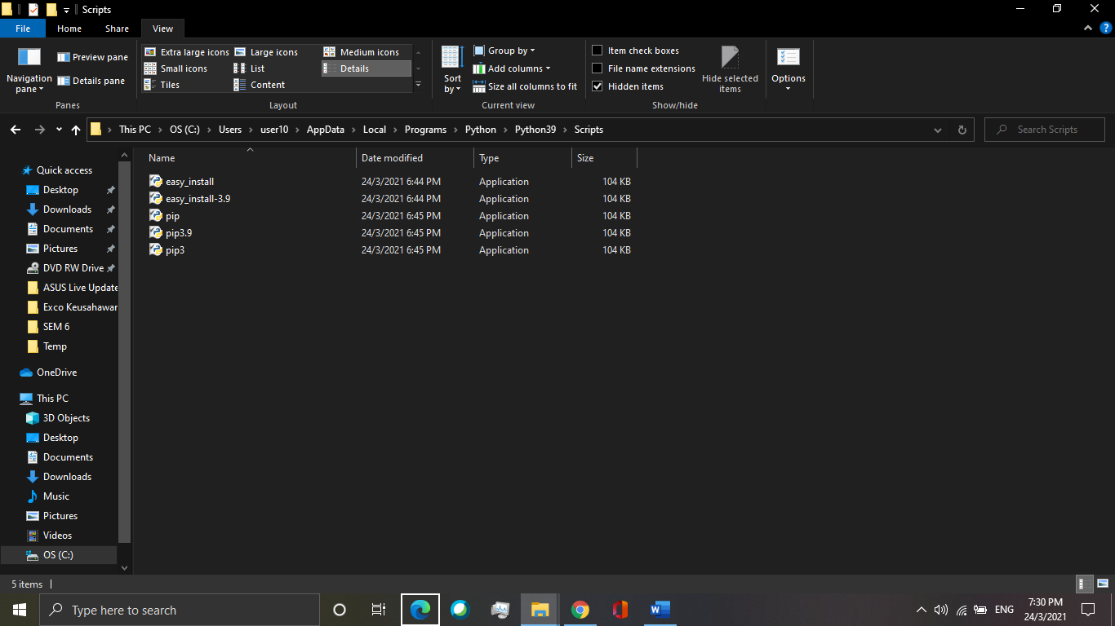

Step 3:

A black screen will pop out.

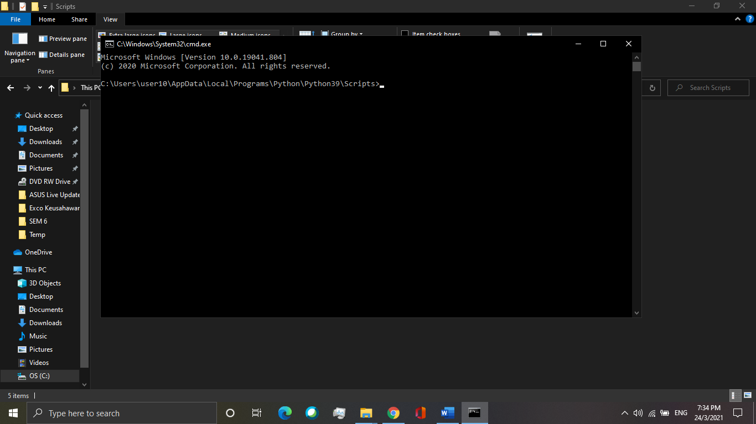

Type the command “**pip install jupyter**” and enter to run the command. You may also install jupyterlab by typing the command “**pip install jupyterlab**” and enter to run the command.

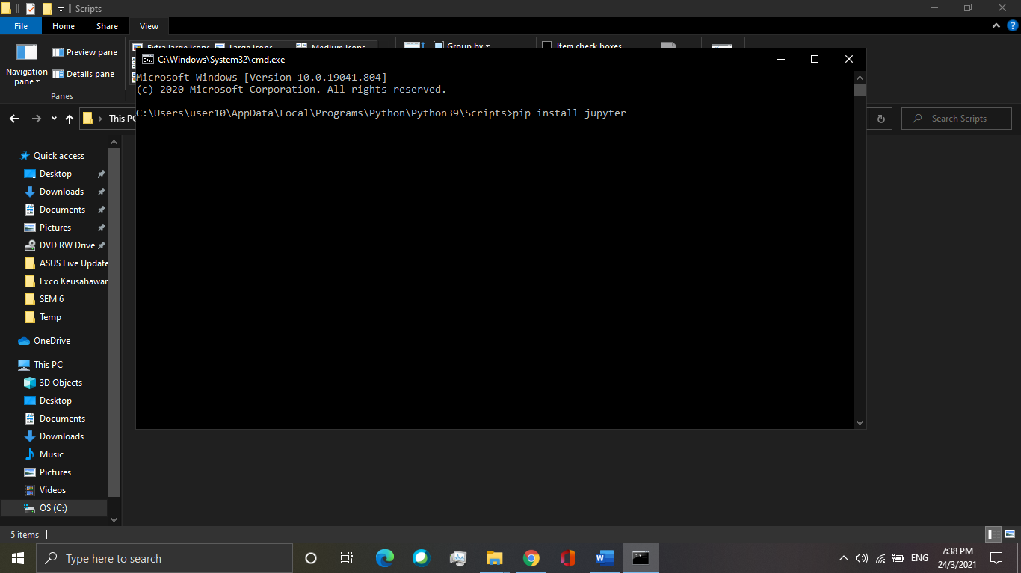

Step 4:

After downloading, open jupyter notebook by typing in command “**jupyter notebook**” or you may run jupyter lab by typing ““**jupyter-lab**”.

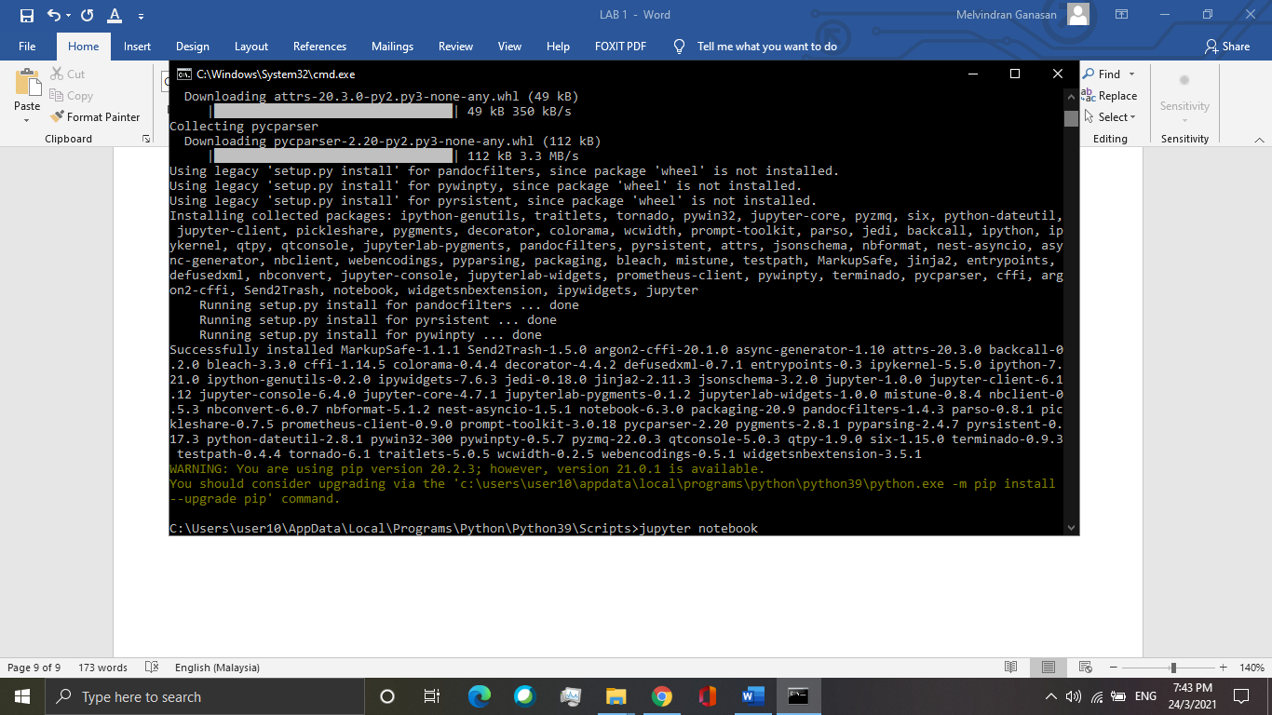

Below is the view of jupyter notebook.

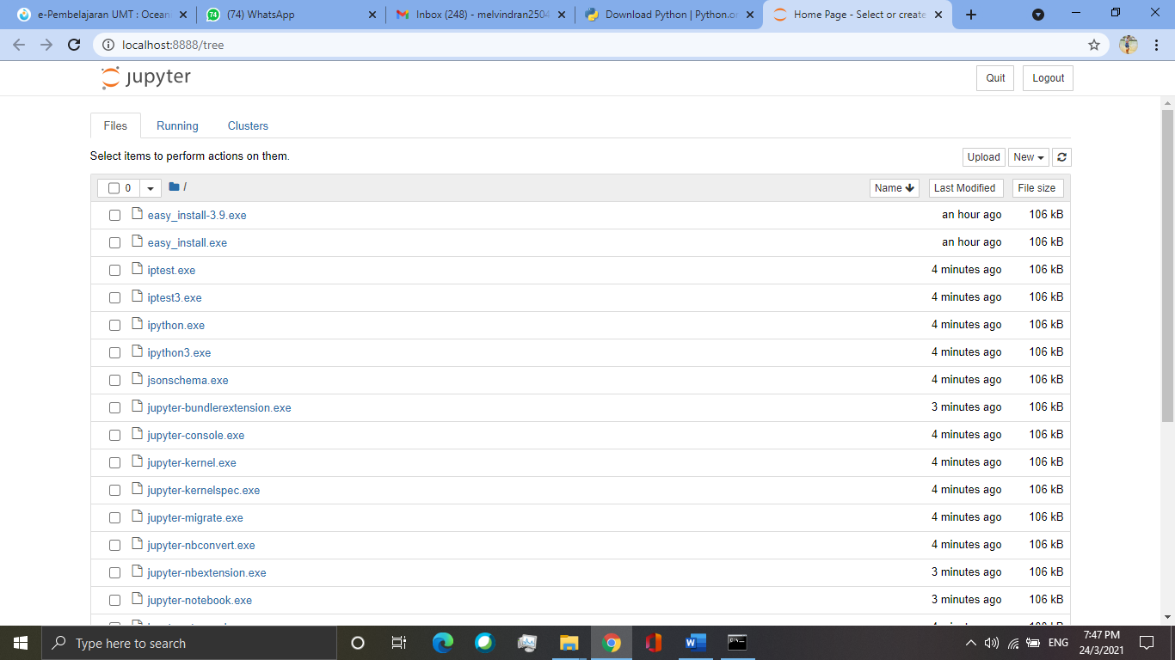

**DOWNLOAD AND RUN NOTEBOOK FROM GITHUB**

Step 1: Download notebook from:

<https://github.com/gob1thaasan/ScientificComputingWithPython>

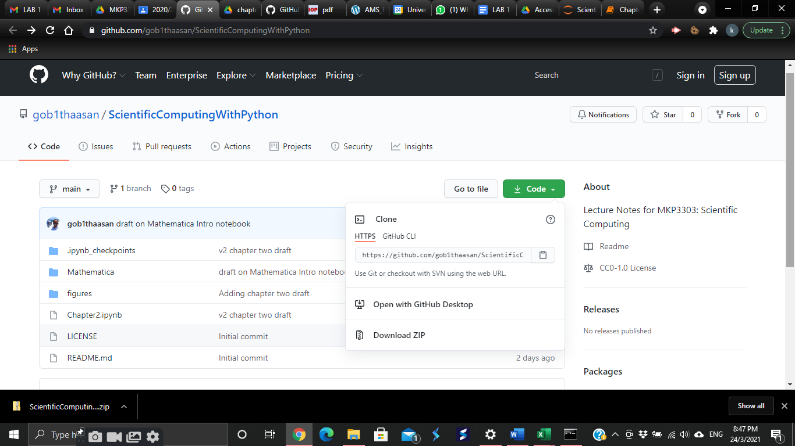

Step 2: Unzip the file from downloads and copy paste the file into Scripts in Python folder.

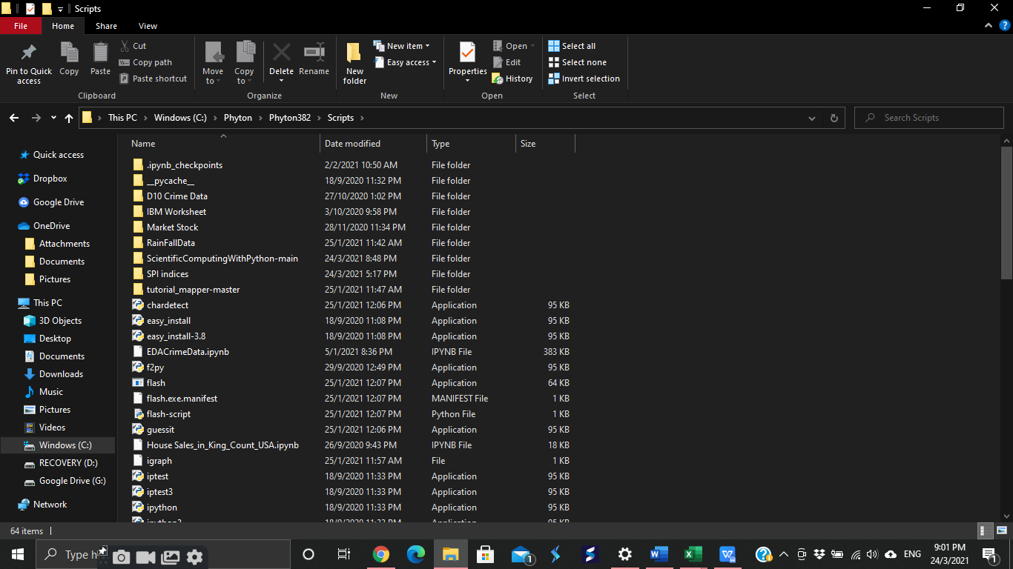

Step 3:

From AppData > Local > Programs > Python > Python 39 > Scripts

At the column with the red arrow place in the picture, type “cmd”.



Steps 4:

A black screen will pop out. Type the command “Jupyter Notebook” and enter to run the command.

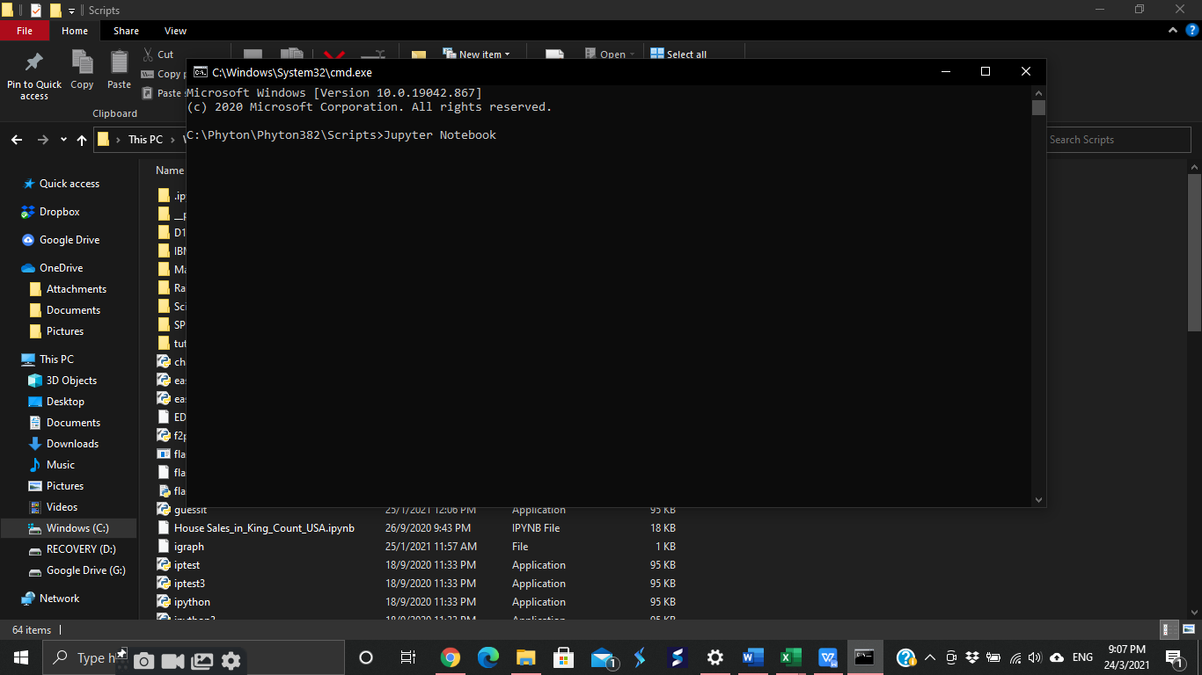

Steps 5:

After Jupyter Notebook open in Google Chrome, click on **ScientificComputingWithPython** file to look and run the code.

