Final project Report
Wenbo Sun 001994516

Topic: The Implementation of Particle swarm optimization on Three-body problem.

Problem statement:
Three-body problem is a very famous physics, classical mechanics, and astronomic problem.It is a problem of analysis on positions, masses, and velocities of three bodies and then predict the future movement of the three bodies.
Now, the consensus on three-body problem is there is no analytic solution, but only numerical solution. That means we can not use a formula to calculate the state of three bodies at a certain time.
So, I am going to use Particle swarm optimization to create a simulator for three-body system. Then we can use that to predict position and movement!

See more about three-body problem:
https://en.wikipedia.org/wiki/Three-body_problem
http://www.askamathematician.com/2011/10/q-what-is-the-three-body-problem

Solution:

structure :
This is the structure of my project


I first create Body.java to describe the feature of a body: position, velocity, and mass.
Then in motion.java I build the basic model for motion. I will use Newton's laws of motion to calculate approximate position and velocity.

In RedMotion, GreenMotion, and BlueMotion, I implement Particle swarm optimization to improve accuracy.

In DrawAnimation.java, I create a UI, and draw the motion animation by using Java 3D.

This is my UI: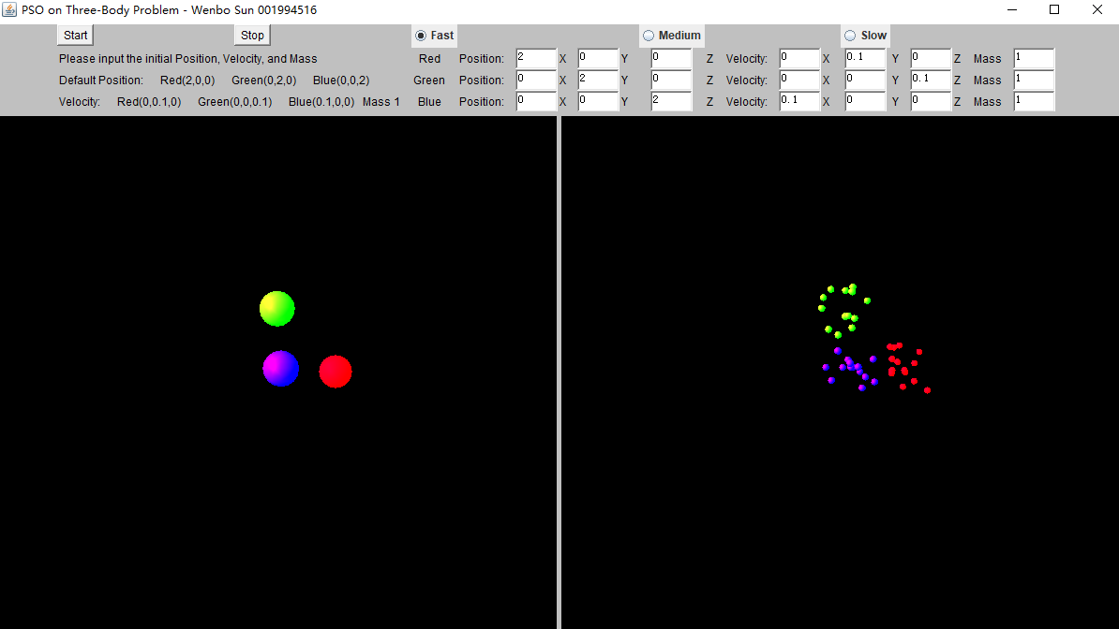

You can input the position, velocity, and mass you want.
The left screen show the over all motion of three body.
The right screen show the motion of all particles. Every times before the body move, I release 15 particles for each bodies(totally 45 particle running at the same time) to find the best position.

Algorithm&detail:
I use three-dimensional array to describe the position, velocity (x-axes ,y-axes,z-axes)

Then I use Newton's laws to calculate Acceleration, position, velocity
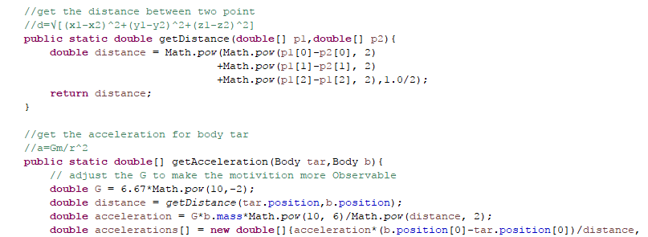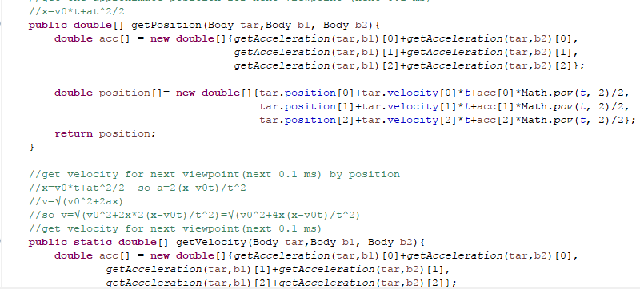

The position I got here is a approximate position. I use that to upgrade the pbest and gbest for PSO.

Main PSO Algorithm:

I have three classes to do PSO separately for three body.
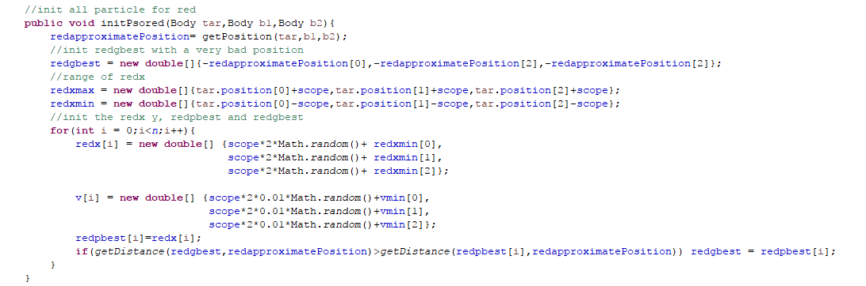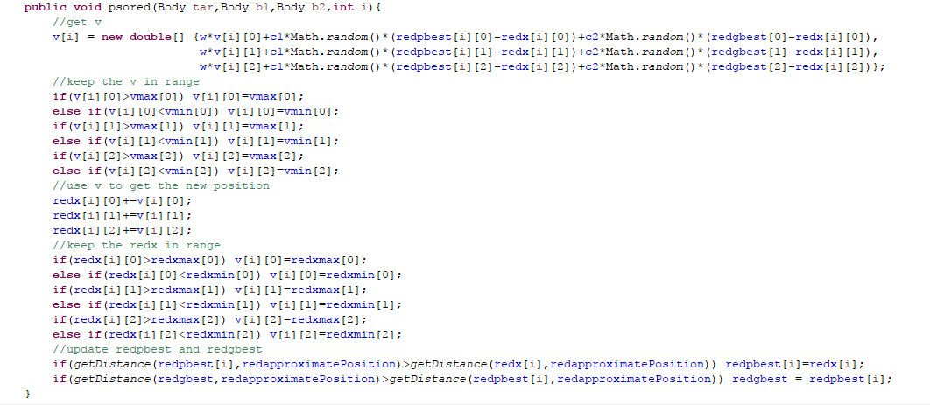

I use inertia weight 0.729 , cognitive/local weight 1.49445;, and social/global weight 1.49445 in my PSO Algorithm.
According to XiaoHui Hu and Russell Eberhart’s research,(Solving Constrained Nolinear Optimization Problems with Particle Swarm Optimization, 2002)
Those value is better in most of cases.

Every time I release 15 particle randomly, and let them find the best position.

Then I use the approximate position I got before to upgrade the pbest and gbest for PSO.

Now I can get all data for all bodies and particle:
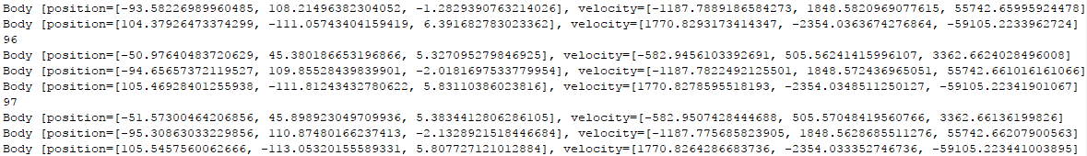
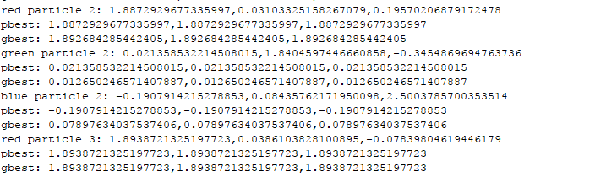

Here I create new thread for each particle by TimerTask:
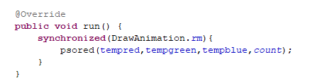

Then I use Java 3D to draw the animation:
Download Java 3d here:
http://www.oracle.com/technetwork/articles/javase/index-jsp-138252.html

I create two screen to display the motion:
Left screen shows the overall motion of three body. That is also a represent of the gbest.
Right screen show the motion of all particle.

I start one thread for one particle(totally 45 threads running on the same time)
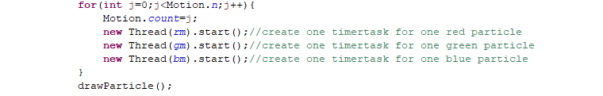

The I update the position information for each body and draw the Animation.

