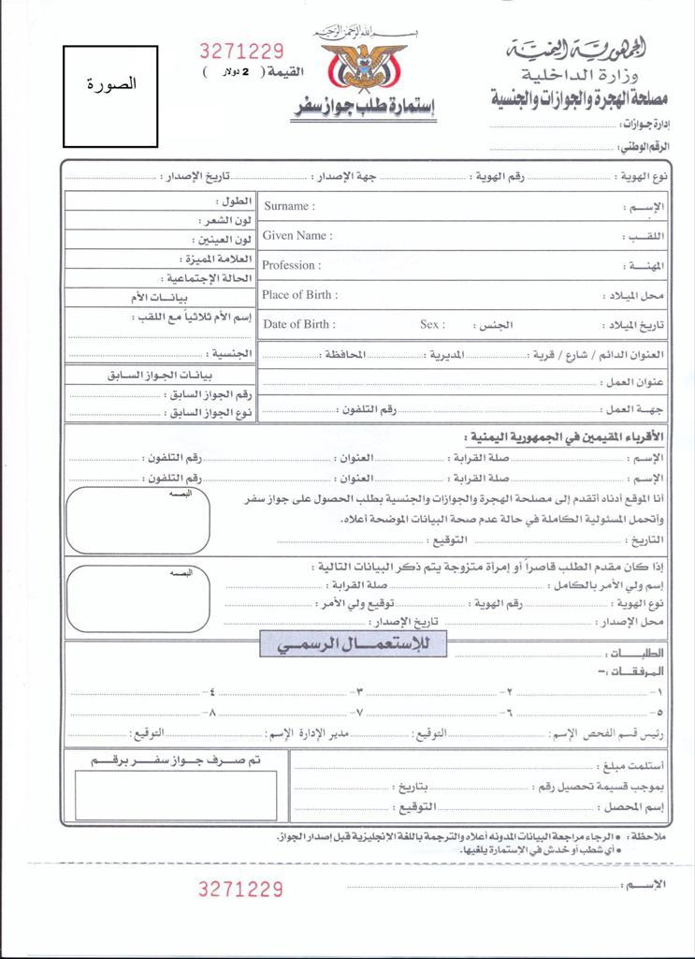

**${name}**

**${tel}**

${image}

${tel} ${city}