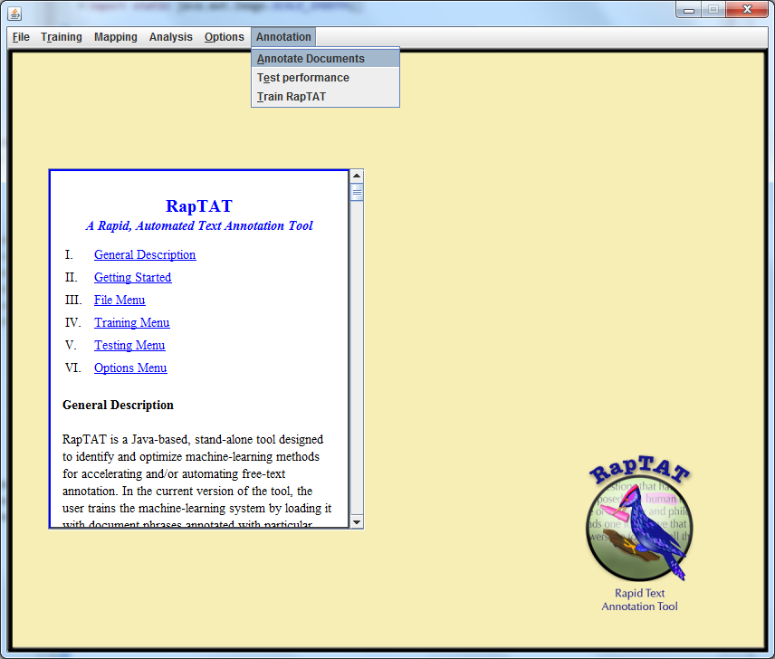

The Garvin Main Menu has the 3 options as shown. The various sub steps required to complete each process are displayed within separate windows.

|  |  |  |  |  |  |
| --- | --- | --- | --- | --- | --- |
| ANNOTATE DOCUMENTS **Upload corpus**   |  | | --- | | **LIST OF SELECTED DOCUMENTS**  Doc1.txt  Doc2.txt  -  -  ---(will have a list of selected text documents)  **ADD REMOVE CANCEL** |  * **Upload text documents for annotation** * **Upload project Schema and choose the required concepts** (will open file selection dialog to upload schema file. Concepts from the schema are displayed)   Raptat_schema123  Raptat_schema345  Knowtator_schema232  OR Choose existing from drop-down box  **Upload Schema**     |  | | --- | | **AVAILABLE CONCEPTS**  Avoidance  Agitated  Acute renal failure  Myocardial Infarction |  |  | | --- | | **SELECTED CONCEPTS**  **Agitated**  **Myocardial Infarction** |  * **Annotate**----logging / progress bar will indicate progress,   file dialog will ask user to specify location to save serialized results  **Annotate files**  **Export**   |  | | --- | | **OK REMOVE CANCEL** |  * **Export** (Opens a file dialog to specify export format and save location  |  | | --- | | **OK CANCEL** |   Click OK to finish and close window, Cancel to quit |
| TRAIN RAPTAT **Upload XML**   * **Upload Human corrected XML**  |  | | --- | | **LIST OF SELECTED XML**  Doc1.xml  -  -  ---(will have a list of selected XML documents)  **ADD REMOVE CANCEL** |  * **Upload text documents**   **Upload corpus**   |  | | --- | | **LIST OF SELECTED DOCUMENTS**  Doc1.txt  -  -  ---(will have a list of selected text documents)  **ADD REMOVE CANCEL** |  |  | | --- | |  |  * **Save Solution**   **Save solution**  (Opens a file dialog to specify location where the Solution would need to be saved.)  Click OK to finish and close window, Cancel to quit   |  | | --- | | **OK CANCEL** | |

|  |  |  |  |  |
| --- | --- | --- | --- | --- |
| TEST PERFORMANCE **Upload HU_XML**   |  | | --- | | **LIST OF SELECTED XML**  Doc1.xml  -  -  ---(will have a list of selected XML documents)  **ADD REMOVE CANCEL** |  * **Upload Human corrected XML** * **Upload Raptat exported XML**   **Upload Raptat_XML**   |  | | --- | | **LIST OF SELECTED XML**  Doc1.xml  -  -  ---(will have a list of selected XML documents)  **ADD REMOVE CANCEL** |  |  | | --- | |  |  * **Specify Location**   **Save report**  (Opens a file dialog to specify location for  Performance Report)   |  | | --- | | **OK CANCEL** |   Click OK to evaluate performance, Cancel to quit |