Kinetic Display

Figure . Front view

The display in the illustration above is a digital clock, date, indoor and outdoor temperature and humidity display. It has a white face and numbers that light when extended. The numbers are made up of segments that extend or retract to display time, date, temperature, and humidity. The display has four digits numbered 0 through 3 with a colon between digit 1 and 2. The colon is made up of two segments, an upper and a lower, which are retracted or extended for time, date, indoor or outdoor temperature and humidity. The elements of the kinetic display are:

* **Segments**: The segments are the basic units that form the numbers and the colon. They are lit hexagons that move in and out of the white face. Each segment has a letter assigned to it, from A to G. There are seven segments for each digit, and two segments for the colon.
* **Numbers**: The numbers are the digits that show the time, month and day, and temperature or humidity. They are made up of segments that are extended and lit depending on the value of the digit. For example, the time of 12:43 from left to right: number 1 is digit 0 with segments B and C extended, number 2 is digit 1 with segments A, B, G, E, and D extended, number 4 is digit 2 with segments B, C, F, and G, extended and number 3 with segments A, B, C, D, and G extended.
* **Colon**: Time is displayed when the upper and lower colons are EXTENDED. Month and day are displayed when the upper and lower colons are RETRACTED. Interior temperature and humidity have the upper colon is EXTENDED and the lower colon RETRACTED. Exterior temperature and humidity have the upper colon RETRACTED and the lower colon EXTENDED. The section on *Rotating Displays* details the meanings of the extended and retracted colon states.
* **Face**: The face is the white area that surrounds the segments. It is a rectangular shape that has hexagonally shaped holes for the segments to move in and out.
* **Feet**: The display is held up by a right and left foot that snaps into the lower corners of the display face.

# Rotating Displays

|  |  |
| --- | --- |
| Time Displays for 30 seconds each minute from 0 to 15 seconds and from 45 to 60 seconds.  Time displays when the upper and lower colons are EXTENDED. The example shows the time as 12:43 pm when in 24-hour mode, 12:43 AM or PM when in 12-hour mode. The switch for 12- or 24-hour time is located on the back behind digit 3. |  |
| Month and Day Displays for 10 seconds from 15 to 25 seconds.  Displays when the upper and lower colons are RETRACTED. The example shows the date as December 13, where the month is the left two digits (MM) and the day is the second two digits (DD). Note the clock face does not have enough digits to include the year along with the month and day. |  |
| Temperature Displays for 10 seconds from 25 to 35 seconds.  The INTERIOR temperature displays when the UPPER colon is extended and the lower retracted. The EXTERIOR temperature displays when the LOWER colon is extended and the upper retracted. This example shows the INTERIOR temperature as 72° Fahrenheit. Note you can change from Fahrenheit to Celsius using the Admin page. |  |
| Humidity Displays for 10 seconds from 35 to 45 seconds.  Like temperature, the INTERIOR humidity displays when the UPPER colon is extended and the lower retracted. The EXTERIOR humidity displays when the LOWER colon is extended and the upper retracted. This example shows the OUTDOOR humidity as 93%. |  |

Quick Start Guide

# Assemble and Start the Display

1. Lay the display face down on a smooth surface.
2. Snap the two feet onto the bottom of the display, one foot on the left and the other on the right. Make sure the display corners are set all the way inside each foot—there should be no gaps between the display face corner and foot insets.
3. Set the ON/OFF switch to the “OFF” position. Note the ON/OFF switch is found on the back of the display behind digit 3.
4. Remove the power supply from its package and plug the USB-C cable into the female receptacle found just above the right foot behind digit 3.
5. Plug the power supply into a ~120v wall outlet.
6. Turn on the power supply and verify the RED and GREEN LEDs are lit. The LEDs are located on the back of the face next to the ON/OFF switch.
7. Turn the ON/OFF switch to the “ON” position.
8. Set the display upright on its feet.

# Connect the Display to your WIFI Network

1. Open your default web browser from your phone, laptop, or desktop WIFI enabled device.
2. Open your device WIFI settings and locate the list of WIFI networks.
3. Connect to the “clock” SSID with “12oclock” as the password.
4. Return to your open web browser and type 192.168.4.1 into the address bar and hit enter.
5. The Admin page should appear in your browser.

# Kinetic Display Controls Settings Admin Page

This page connects the display to your WIFI network. Note that your display will not work until you successfully provide a valid SSID and Password to your WIFI network and select the “Submit” button.

Figure . Admin page

Following the diagram above:

1. Provide your WIFI network name and password in the text fields “WIFI SSID” and “WIFI Pwd”. Avoid using the built-in “clock” SSID as your home WIFI network.
2. Optionally set the “Daily Sleep” field with a new time for the clock to go to sleep.
3. Optionally change the default the “Sleep Duration” field with the number of minutes the display will sleep each day. For example, if you set the daily sleep time to 8:30 PM with 600 minutes of sleep (10 hour * 60 minutes), the display will show 8:29 PM then retract all its segments before reaching 8:30 PM. At 6:00 AM the following day the display will wake up and start its display with 6:00 AM.
4. Optionally set the “Temperature” dropdown to Fahrenheit or Celsius. The default is Fahrenheit.
5. Skip the “Display” settings for digits 0-3. See the instructions on *Segment Retract and Extend Adjustments* that detail how settings are used to fine tune the distance each segment extends or retracts.
6. Select the “submit” button to complete your settings as follows,

Figure . Web page indicating you've successfully saved your settings.

1. The LEDs in the back of the display will turn on and off in the following sequence:

Table . Start Up LED Sequence of Main Controller.

|  |  |  |  |
| --- | --- | --- | --- |
| Sequence | LED | Action | Duration |
| 1 | Red | Connecting to your WIFI network. | 5 seconds. If the LED continues to switch on for 5 seconds, turn off, then back on for 5 seconds then your WIFI password or SSID may be incorrect. Set the ON/OFF switch to “OFF” then turn off and on the power supply and try again. |
| 2 | Green | The display has successfully connected to your WIFI network and is attempting to obtain its regional location and sync to the local time from the internet. | 5 seconds. If the LED continues to remain green longer than 5 seconds, then your WIFI network may be slow or not have internet connectivity. Set the ON/OFF switch to “OFF” then turn off and on the power supply and try again. |
| 3 | Blue | The display is reading its DHT11 temperature and humidity sensor to obtain the interior temperature and humidity. | 1 second. If the LED turns on/off 5 times then the sensor may be disconnected or may be faulty. Check the connection under the controller PCB. Note it is rare for the DHT11 sensor to be disconnected or faulty. |
| 4 | Green | The display attempts to obtain its longitude and latitude then connect to a local weather station to internally store the outdoor temperature and humidity. | 5 seconds. If the LED continues to remain green longer than 5 seconds, then your WIFI network may be slow or not have internet connectivity. Set the ON/OFF switch to “OFF” then turn off and on the power supply and try again. |

User Guide

# Turning on and off the Display

There are three on and off states for the display: the power supply switch, the on/off switch on the back of the display, and a combination of the power supply switch and on/off switch. This section explains the need for each On/Off switch state and how to use them.

## Power Supply Switch

The power supply switch provides power to the display. The power supply rocker switch is located on the wire cord near the USB-C port.

TURNING ON the power supply powers the micro-controllers and servos on the back of the display. When the display is first powered up, and when the main controller (Raspberry Pi Pico-W) is configured to connect to your WIFI, the main controller starts the display startup sequence as displayed by its LEDs. See the table in the *Quick Start Guide* found in the section *Kinetic Display Controls Settings Admin Page.*

TURNING OFF the power supply while the display is showing time, date, temperature, or humidity, results in the display segments remaining extended. Do not try to physically push the segments back into the display while the display is powered off as it could damage the servo and components in the back of the display. Note when the power to the display is turned off or cut off, the display internally stores its last known state and will resume when the power supply switch is turned back on.

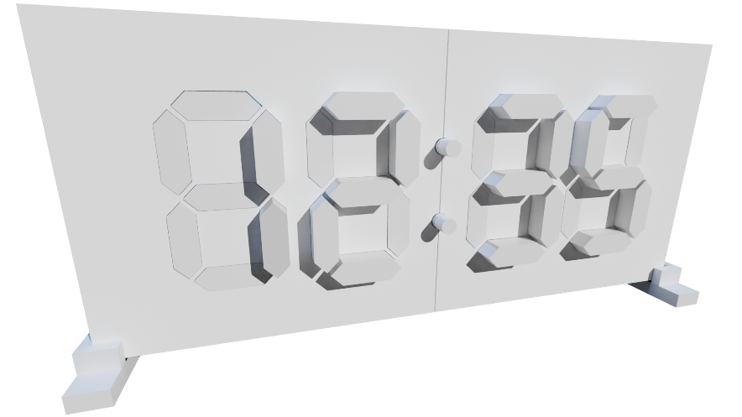

Figure . Display Ungracefully Switched Off While Showing the Time (12:35)

## Back-of-Display On/Off Switch

The on/off switch on the back of the display only works when the power supply switch is turned on.

TURNING OFF the back-of-display switch causes all extended segments to retract, then hibernates the micro-controllers in the display to a low power consumption mode.

TURNING ON the back-of-display switch resumes the rotating displays. Note there may be a delay of up to 15 seconds as the micro-controllers wake up every 15 seconds to check the status of the on/off back of the display switch.

## Back-of-Display On/Off Switch and Power Supply Switch

TURNING OFF the back-of-display switch then TURNING ON the power supply switch turns on the display’s WIFI hotspot and results in the RED and GREEN LEDs simultaneously turned on. See the *Display Controls Settings Admin Page* in the *Quick Start Guide* for details.

TURNING OFF the back-of-display switch causes all the extended segments to retract, then TURNING OFF the power supply gracefully shuts off your display. This sequence ensures there are no extended segments while the display is powered off.

Figure . Display in Hibernation or Gracefully Powered Off

# Segment Retract and Extend Adjustments

## Adjustment angles

Behind the display face is a sg90 mini servo motor that extends and retracts its segment. These inexpensive servos are used in remote controlled toys such as cars, airplanes, or robots. Over time the servo wears down causing the segment to not retract all the way into the display face or extend out as far as the other segments. Therefore, you’ll need to make slight adjustments to keep the segments aligned.

The illustration below is a top view of a few of the basic components in the rack and pinion segment assembly. The segment is a white hexagonal top and rack (flat gear). The servo is mounted on two screws onto the green servo mount. The yellow pinion gear is mounted on the servo.

Figure . Segment assembly

When first installed, the servo is set to 100° and the pinion gear is positioned to have the segment’s rack retracted into the display face, see the figure below. Note the position of the pinion gear tooth marked with a red dot.

Figure . Retracted segment

When the number is displayed, the servo extends the segment out by moving from its retracted position at around 100° to about 10°. The figure below shows the extended segment at 0°, which would likely be too far out.

Figure . Extended segment

## Steps to adjust the Digit Settings

1. Disconnect the UART Tx and Rx connections to the pair of digits that you will NOT be adjusting. For example, remove the UART Tx and Rx connections to Digit 2 and 3 when changing Digit 0 or 1 settings.
2. Click on a link to Digit 0 – 3 from the *Kinetic Display Control Settings Admin Page*, see figure below.

Figure . Accessing the segment adjustment page for each digit

1. Set one or more of the extend or retract angles for each segment A-G, see figure below.

1. Click the “update” button. Note that each segment will extend in order from A-G using your new setting. After all the segments have been extended, they retract in order from A-G.
2. Repeat the process until all the adjustments have been made.
3. Reconnect the UART Tx and Rx connections.