|  |  |
| --- | --- |
| **Mandatory Case** |  |
| PHPH1BP |
| **Periode Berlaku** Semester Ganjil 2019/2020  ***Valid on*** *Odd Year 2019/2020* | **Software Laboratory Center Assistant Recruitment 20-1** |

# Materi

*Material*

* Pagination and searching
* Infinite scrolling (lazy loading)
* AJAX using JQuery
* JSON

**Soal**

*Case*

# GoRum

**GoRum** is a simple blog that can share any idea from a person to everyone. but not just only blog, there’s public chatting feature that can be used when you confused. One day, Bluejack 18-2 gives you a challenge to create a web. To prove your worth, finish the challenge that has been set by Bluejack 18-2. Here’s the following requirements:

* Home Page

1. If user already logged in, show the user detail card that contain, **username**, **followers count**, **following** **count**, **status**.
2. If user want to create a **post**, user must already **logged in**.
3. If user click title of **post**, there will be **redicrect** to **comment page**.
4. User can **live** **searching** anything(**title**, **content**).
5. When user want to search something, user must wait **0.8s** to get the **result**.
6. If user want to **chat**, user must be **logged in**.
7. User can chat to others people.
8. User can be **follow a person** who **not yet** to follow.

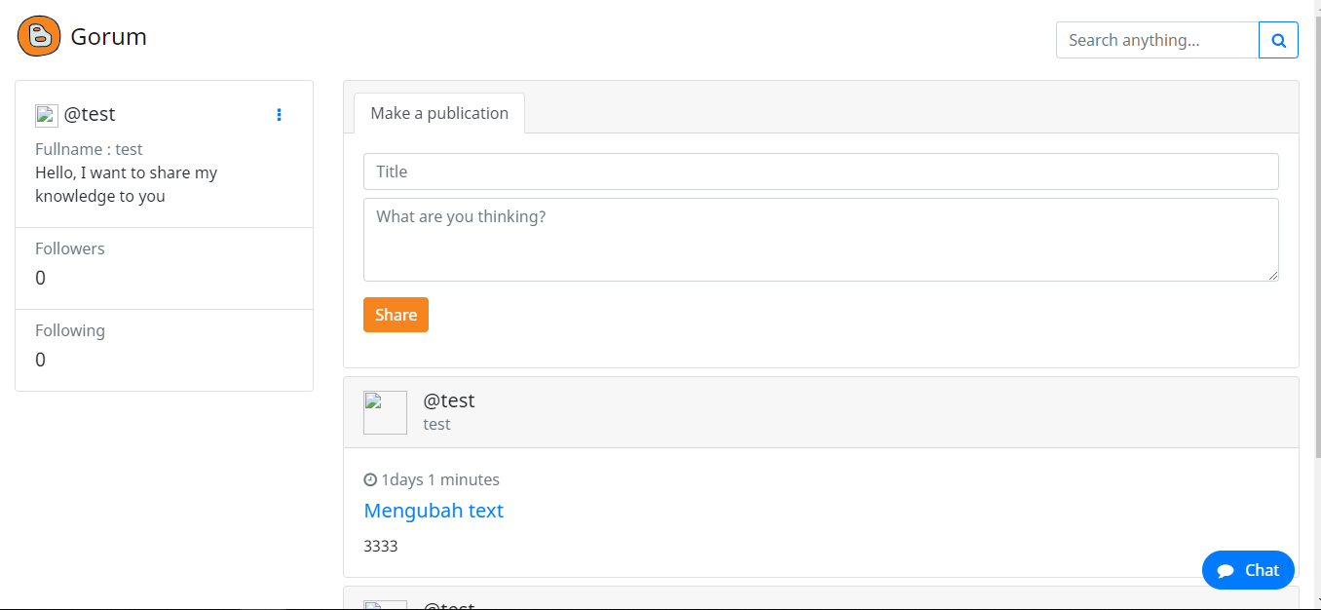

1. ***Home Page (Logged In)***

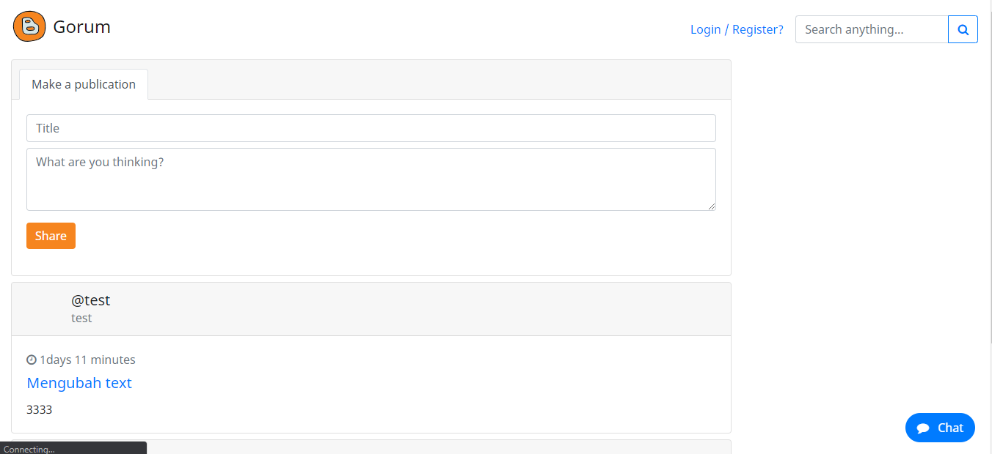

1. ***Home Page (Not Logged In)***

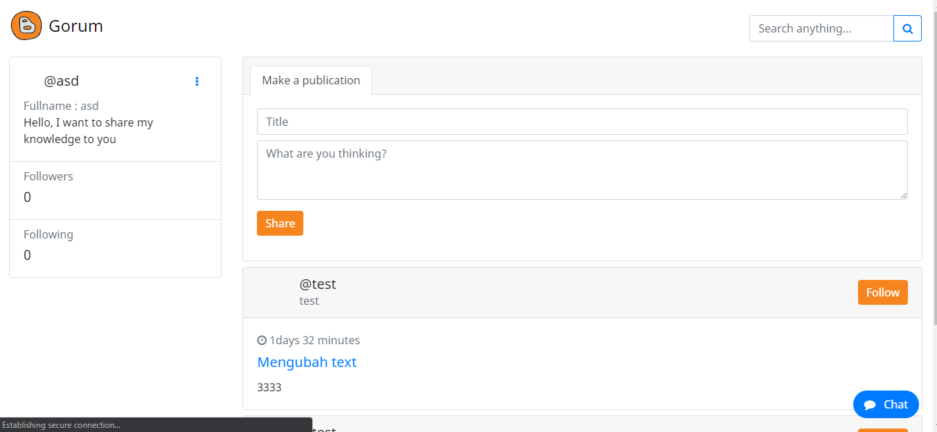

1. ***Post Section (If user not yet follow)***

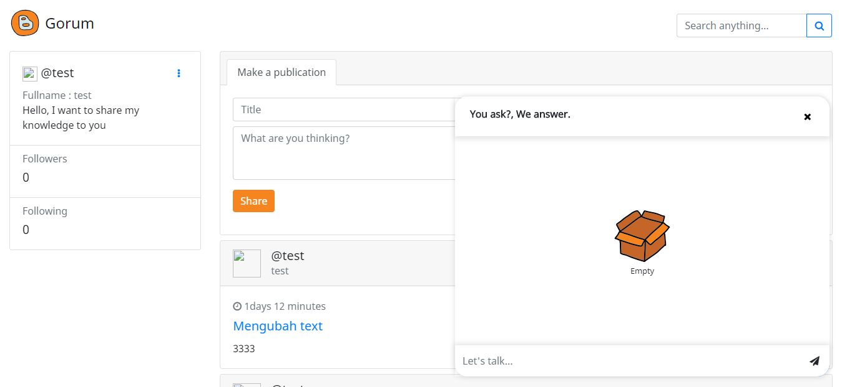

1. ***Chat Popup***

* Auth Page

1. *User can be* ***login.***
2. *System will check if* ***username*** *or* ***password******exists****.*
3. *If login* ***success****,* ***redirect*** *to* ***home page****.*
4. *User can be* ***register****.*
5. *System will* ***check*** *if* ***username exists*** *or* ***not****.*
6. *System will* ***save the user*** *that has been* ***registered****.*

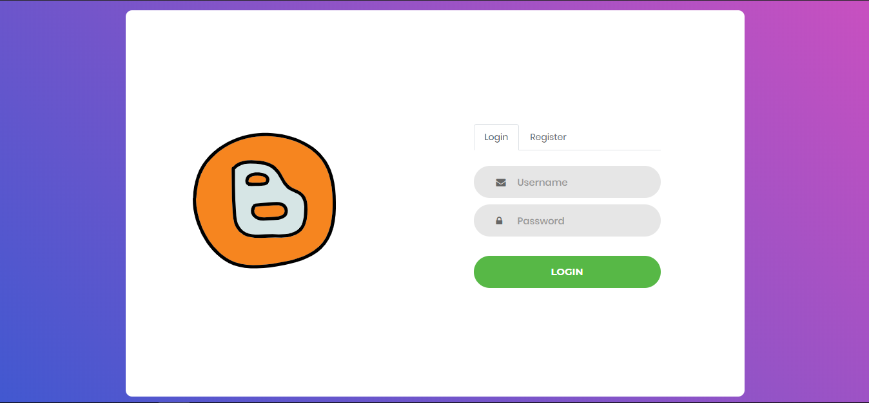

1. ***Login Page***

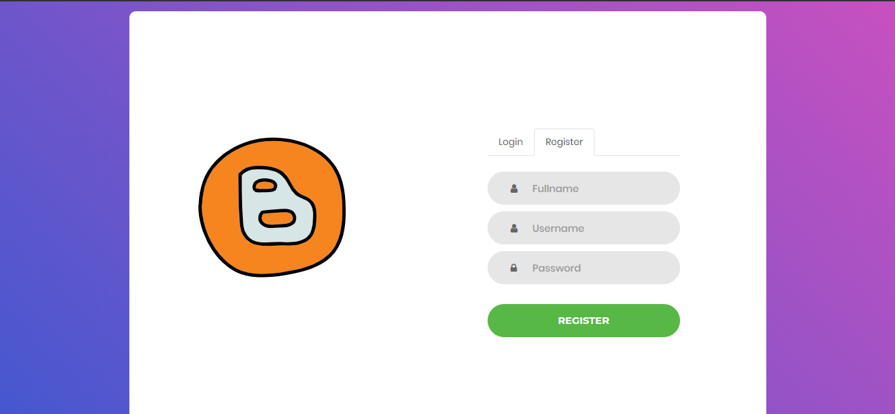

1. ***Register Page***

* Comment Page

1. User can **see** **selected post**.
2. User can **add comment** to that post.
3. User can **add comment** to **a comment**.
4. User can **see nested comment**.

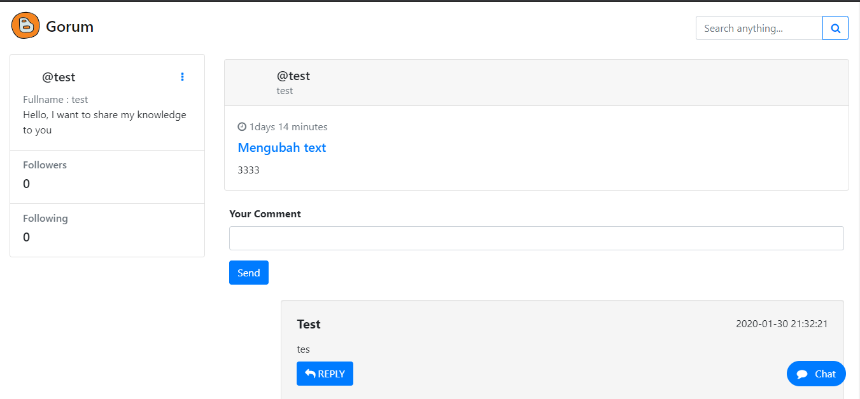

1. ***Comment Page***

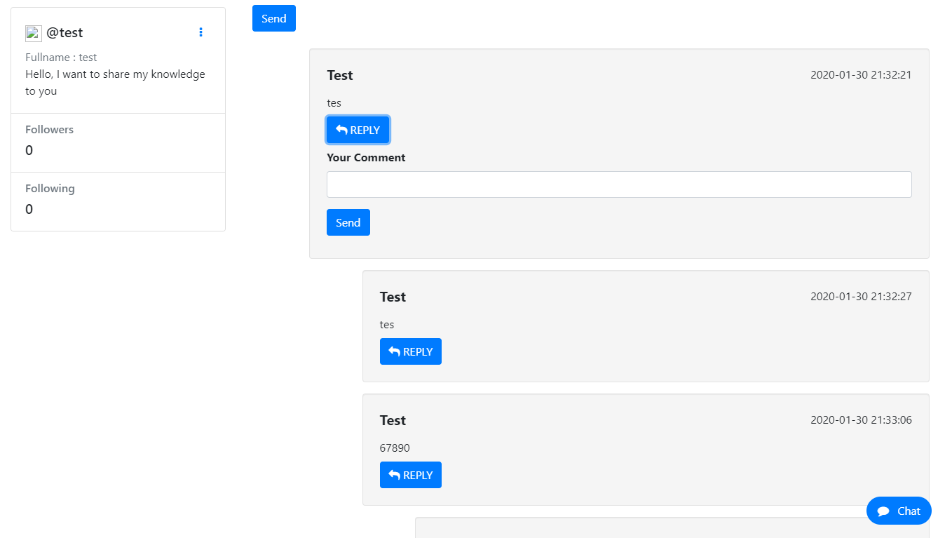

1. ***Comment Page (nested)***

## **Komponen**

*Component*

|  |  |  |
| --- | --- | --- |
| **No.** | **Criteria** | **Score** |
| 1. | Infinite Scrolling | 13 |
| 2. | Searching | 13 |
| 3. | Nested Comment | 30 |
| 4. | Realtime Chat | 30 |
| 5. | Validation Already Follow | 6 |
| 6. | Login | 4 |
| 7. | Register | 4 |