|  |  |
| --- | --- |
| **[Onsite] Case** |  |
| WDH3S2 |
| **Periode Berlaku** Semester Ganjil 2018/2019 ***Valid on*** *Odd Year 2018/2019* | **Software Laboratory Center Assistant Recruitment 19-2** |

# Materi

*Material*

• **jQuery 3 (selector, event, animation, dom manipulation)**

**Soal**

*Case*

# Songify

**Songify** is a music player based on a web application using HTML, CSS, and vanilla JS. It’s was created to make a person have fun. So, you as a **candidate assistant** should build an app to make the player have fun.

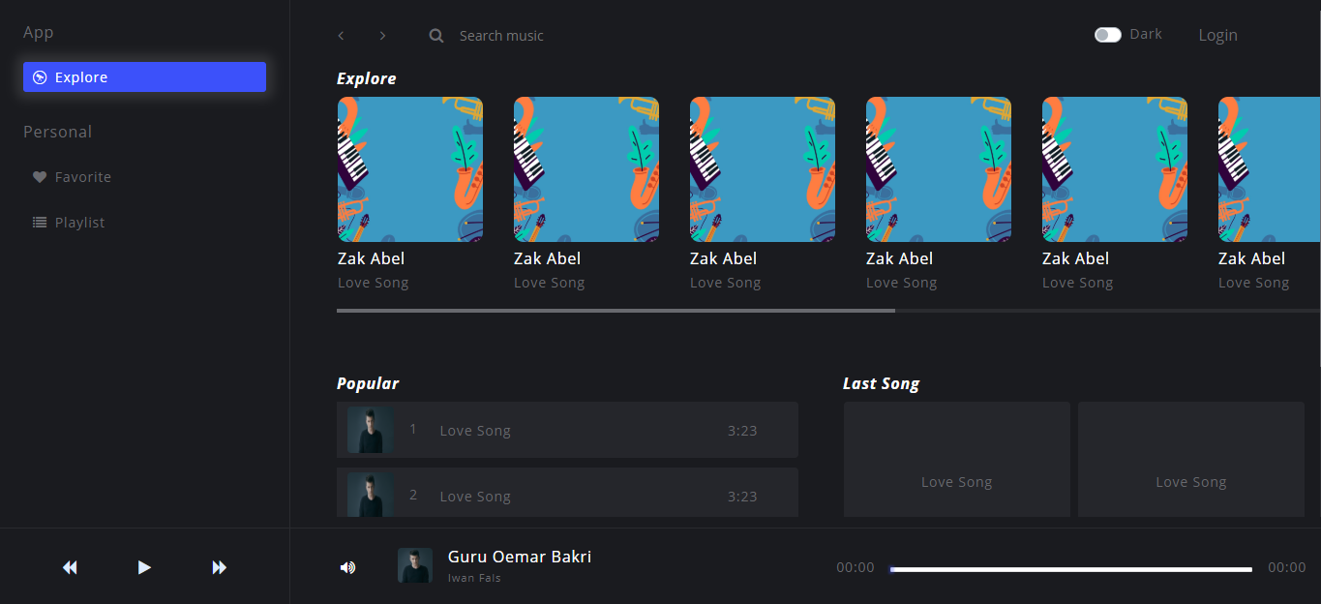

1.1 Dark Theme

There are **features** you should build.

* Dark / Light Theme.
* Music Player.
* Favorite List.
* Search.

When the app is run there a condition you should build

* You should notify the client, if something happened.
* When the client wants to change their theme application, it will be saved.
* When the client, click the heart button/symbol, it will add to favorite songs.

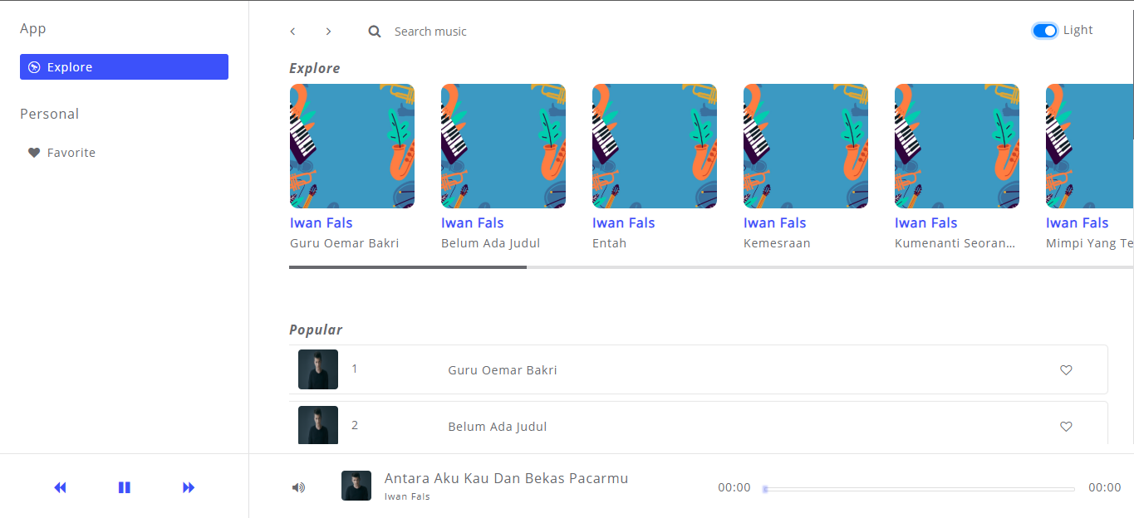

1.2 Light Theme

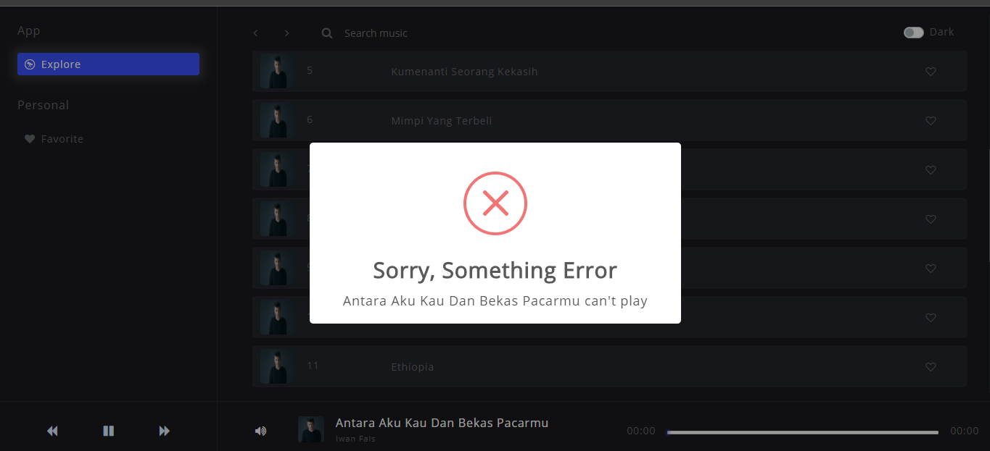

1.3 Notification

## ~ Work hard. Stay Humble. Dream Big ~ Steve Jobs

### Komponen

*Component*

|  |  |  |
| --- | --- | --- |
| **No.** | **Criteria** | **Percentage** |
| **1.** | **Toggle Theme** | **15** |
| **2.** | **Save Theme** | **5** |
| **3.** | **Music Player** | **25** |
| **4.** | **Notification** | **10** |
| **5.** | **Search** | **15** |
| **6.** | **Add to Favorite List** | **10** |
| **7.** | **Remove to Favorite List** | **10** |
| **8.** | **Get to Favorite List** | **10** |

**Please run the EXE file to see the sample program.**