GLOBAL ECONOMIC & DEMOGRAPHIC ANALYSIS
SUBMITTED BY | GOBIKA T M
COURSE | DA/DS, OFFLINE
BATCH | JUNE 2025

MILESTONE PROJECT - 2

Executive Summary
The Global Economic and Demographic Analysis project focuses on exploring key global indicators such as population, GDP, literacy, infant mortality, and industry distribution across countries and regions. Multiple datasets from SQL and Excel were integrated, cleaned, transformed, modeled, and visualized using Power BI. This report presents the entire workflow—from data preparation to final insights and dashboard design—offering a complete analytical and business intelligence narrative.

1. Overview
The Global Economic and Demographic Trends Analysis Dashboard provides a comprehensive visualization of global indicators across multiple countries. It combines demographic, economic, and social metrics to help users identify patterns, compare countries, and analyze development trends worldwide.
The dashboard includes summary metrics, interactive filters, and visual charts presenting data on population, GDP, mortality, literacy, income groups, and industrial output.

2. Purpose of the Dashboard
The main objectives of this dashboard are to:
- Present high-level global demographic and economic statistics
- Compare key indicators across countries and regions
- Identify development patterns using literacy, mortality, and income groups
- Support data-driven decision-making for researchers, educators, and policymakers
- Allow interactive exploration through country-level filtering

3. Key Performance Indicators (KPIs)
At the top of the dashboard, four major global metrics are highlighted:

3.1 Growth Rate (80.50bn)
Represents the aggregated growth rate across all countries.

3.2 Median Population (4.79M)
Shows the central population value when countries are ordered from smallest to largest.

3.3 Sum of Net Migration (1.64M)
Reflects the total net migration (immigration – emigration) across all countries.

3.4 Total GDP (2M)
Shows the combined Gross Domestic Product of all countries, representing overall global economic output.

4. Visualizations and Components

4.1 Infant Mortality Statistics by Country
A line chart showing:
- Minimum infant mortality
- Maximum infant mortality
- Standard deviation of infant mortality
This visualization highlights disparities in health outcomes and allows identification of countries with unusually high or variable infant mortality rates.

4.2 Donut Chart: Combined Global Indicators
This chart displays proportional contributions of:
- Sum of Infant Mortality
- Sum of Population Density
- Average Population
- Maximum GDP per Capita
It offers a quick overview of how demographic and economic factors compare globally.

4.3 Country Filter Panel
An interactive filter listing all countries.
Users can select one or multiple countries to dynamically update all visuals.
This enables targeted analysis and comparisons.

4.4 Average Population & Literacy by Country and Region
A bar chart that presents:
- Average population of each country
- Average literacy rate
- Grouped by geographic region (East Asia, Europe & Central Asia, Latin America, etc.)
This chart helps identify regional demographic characteristics and educational outcomes.

4.5 Count of Countries by Income Group
A bar chart that classifies countries according to income levels:
- Low income
- Lower middle income
- Upper middle income
- High income
This illustrates the global distribution of economic development.

4.6 Sum of Industry Output by Country
A bar chart ranking countries by total industrial production.
This metric gives insight into economic structure and industrial capacity across nations.

5. Definitions of Key Terms

5.1 GDP (Gross Domestic Product)
The total value of goods and services produced within a country.
Used as a measure of economic size and performance.

5.2 Literacy
The ability to read and write.
The dashboard typically uses the literacy rate:
Percentage of people (usually age 15+) who can read and write a simple statement.

5.3 Population Density
Number of people living per unit of land area (e.g., people per square km).

5.4 Infant Mortality
Number of infant deaths per 1,000 live births.
A key indicator of health and development.

6. Insights the Dashboard Can Provide
- Comparison of literacy and population across regions
- Identification of countries with high infant mortality
- Economic categorization by income group
- Industrial strength of individual nations
- Relationship between migration and population changes

7. Data Sources and Description
The project consolidated data from four different files.
1. SQL Dataset – CountriesWorld
Contains attributes such as population, area, literacy, GDP per capita, birthrate, deathrate, industry %, agriculture %, services %, phone usage, infant mortality, climate, and more.
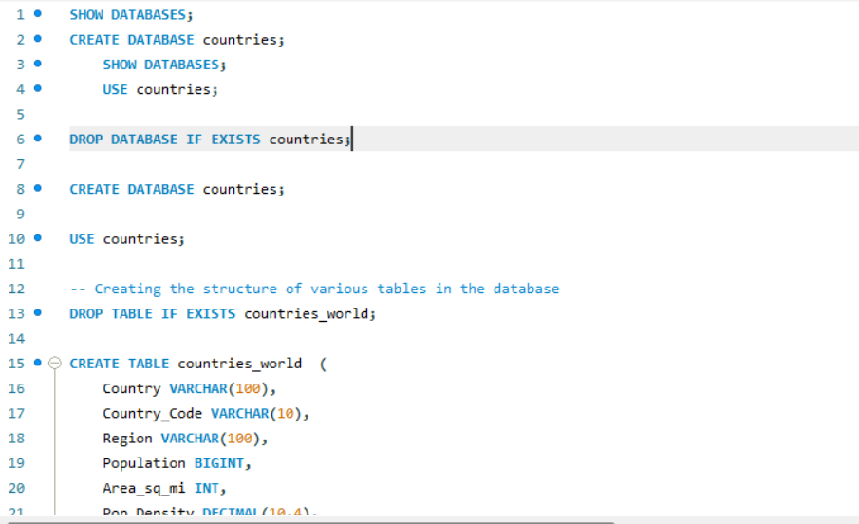
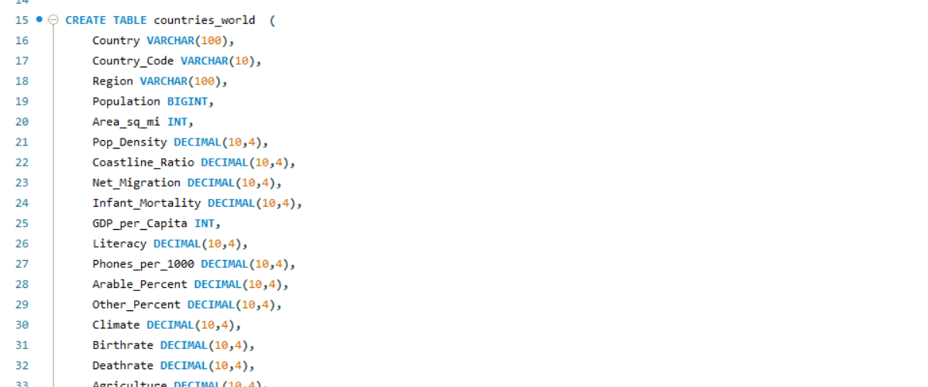
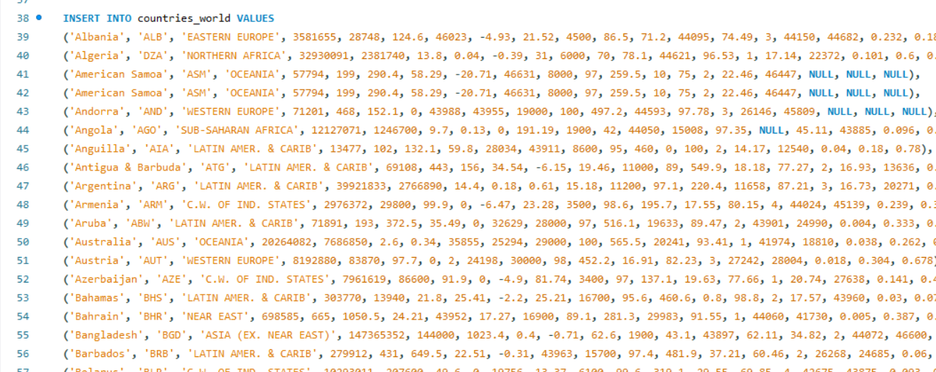

8. Data Cleaning & Preparation (Power Query)
Data cleaning included:
- Handling missing values
- Standardizing country names and country codes
- Converting data types (text → numeric)
- Removing duplicates
- Merging tables using Country Name and Country Code
- Unpivoting population year columns for time-series analysis
- Removing null/empty records for GDP and population
- Filtering out countries with incomplete data
- Creating clean dimension and fact tables

9. Data Model Design
The data model follows a star-schema structure:
Fact Table: Contains numeric measures such as population, GDP, birthrate, deathrate, literacy, industry %, agriculture %, services %, infant mortality.
Dimension Tables: Country dimension, region dimension, metadata dimension.
Relationships:
- Country Code → Primary linking field
- One-to-many relationships between metadata and fact tables

10. Descriptive Statistical Analysis
Key statistical measures were computed:
Population Statistics:
- Mean, median, mode
- Standard deviation across countries
- Year-wise global population growth
GDP Analysis:
- Average GDP per capita by country and region
- Highest & lowest GDP countries
Infant Mortality:
- Minimum, maximum and deviation
- Regional comparison
Literacy:
- Average literacy rate across countries
- Relation with GDP

11. DAX Calculations
Some of the important DAX measures used:
Total Population = SUM('Data'[Population])
Average GDP per Capita = AVERAGE('Data'[GDP_per_Capita])
Life Expectancy Avg = AVERAGE('Data'[Life_Expectancy])
Birthrate Total = SUM('Data'[Birthrate])
Deathrate Total = SUM('Data'[Deathrate])
Population Growth % =
VAR prev = CALCULATE(SUM('Data'[Population]), DATEADD('Date'[Date], -1, YEAR))
VAR curr = SUM('Data'[Population])
RETURN (curr - prev) / prev

12. Dashboard Visualizations & Documentation
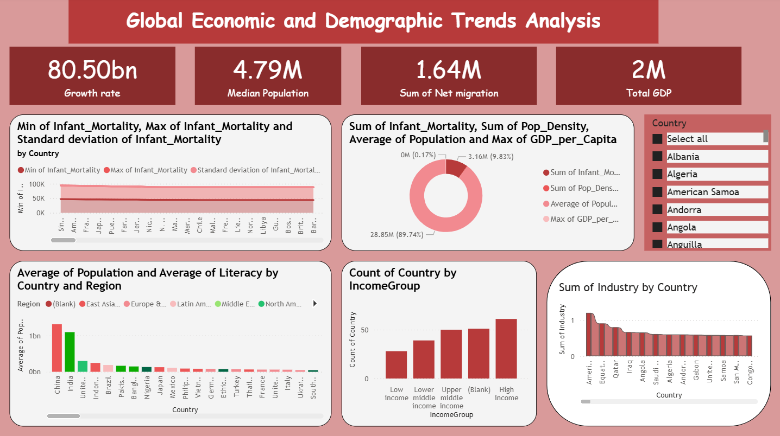

13. Conclusion
This dashboard delivers a clear and interactive way to explore global economic and demographic data. By combining multiple indicators, it helps users understand not only individual country trends but also global patterns related to development, education, population, and economic performance.

