GOBITSNBYTES FOUNDATION
bits&bytes™ Network
VOLUNTEER & ENGAGEMENT FORM
Form No. 1 | Version 2.0 | June 2026
────────────────────────────────────────────────────────────────────────
IMPORTANT — This form is used to onboard every person who participates in the bits&bytes™ Network in any capacity — Fork Leads, core team members, volunteers, mentors, and contributors. Everyone in bits&bytes is a volunteer.
If you are under 18 years of age, you must also complete and attach the Parental / Guardian Consent Form (Form No. 2). The minimum age to participate in the Network in any capacity is 13 years.
────────────────────────────────────────────────────────────────────────
SECTION A — PERSONAL INFORMATION
☐ I am 18 years of age or older
☐ I am under 18 years of age → Attach Parental / Guardian Consent Form (Form No. 2)
Full Name
Date of Birth
Age
Gender
Phone Number
WhatsApp Number
Email Address
Discord Username
Present Address

City / District
State
PIN Code
────────────────────────────────────────────────────────────────────────

SECTION B — EDUCATIONAL BACKGROUND
Current School / College / Institution
Class / Year / Degree
LinkedIn Profile (if any)
GitHub / Portfolio (if any)
────────────────────────────────────────────────────────────────────────
SECTION C — CONTRIBUTION TRACK
Select your primary track. You may tick a secondary track if applicable.
Primary Track (tick one):
☐ Ops (Operations) — event logistics, coordination, process, resource management
☐ Outreach — community growth, partnerships, ambassador, external comms
☐ Creative — graphic design, video editing, brand, visual content
☐ Tech — software, infrastructure, platforms, open-source, tooling
Secondary Track (optional, tick one):
☐ Ops (Operations)
☐ Outreach
☐ Creative
☐ Tech
────────────────────────────────────────────────────────────────────────
SECTION D — AVAILABILITY
Available From (Date)
Hours per Week Available
Preferred Days: ☐ Mon ☐ Tue ☐ Wed ☐ Thu ☐ Fri ☐ Sat ☐ Sun
────────────────────────────────────────────────────────────────────────
SECTION E — SKILLS & EXPERIENCE
Briefly describe your relevant skills and experience:

────────────────────────────────────────────────────────────────────────

SECTION F — DECLARATION
I, the undersigned, hereby declare that:
1. All information provided above is true and accurate to the best of my knowledge.
2. I understand that my engagement with GOBITSNBYTES FOUNDATION is a voluntary, non-paid community role and not a contract of employment, apprenticeship, consultancy, agency, partnership, or service. No salary, wages, stipend, bonus, overtime, leave, notice pay, PF, ESI, gratuity, or other employee benefit is promised or payable. I may decline tasks, may step back from the role, and any approved reimbursement is only for actual out-of-pocket expenses supported by receipts and is not payment for services. I shall not: (a) sign any contract, agreement, MoU, or binding document on behalf of the Foundation or any Fork; (b) accept, collect, hold, or route any money in the name of the Foundation or any Fork without express written authorisation from the Board; (c) make any representation of legal authority to any third party; (d) hire, appoint, or dismiss any person in the Foundation's name; or (e) take any action not expressly authorised to me in writing by the Foundation.
3. I agree to abide at all times by the Code of Conduct of GOBITSNBYTES FOUNDATION (published at gobitsnbytes.org/coc, adopted by the Board on 4 June 2026), the Foundation's Safeguarding & Participant Safety Policy, Fork Handbook, and all Network Policies as published from time to time.
4. I understand that my engagement may be suspended or terminated by the Foundation at any time in accordance with its governance framework.
5. I acknowledge that all intellectual property created by me in the course of or in connection with my participation in the bits&bytes™ Network — including code, designs, content, documentation, and event materials — vests in GOBITSNBYTES FOUNDATION to the fullest extent permitted by law, and that I will be credited for my contributions. If I am under 18, this operates together with the parental / guardian consent and IP assignment in Form No. 2. This clause does not affect IP created entirely outside the scope of my Network participation.
6. I consent to processing of my personal data only for the specific purposes stated in this form and the Foundation’s privacy notice. The Foundation will not use my data for targeted advertising, behavioural profiling, or child tracking, and will keep the data only as long as needed for those purposes or as required by law. I may withdraw consent and request deletion of my personal data at any time by writing to hello@gobitsnbytes.org.
7. If I am under 18 years of age, I understand that the Foundation will process my personal data only after receiving and verifying the Parental / Guardian Consent Form (Form No. 2) signed on my behalf.
8. I agree to set my Discord display name / server nickname in all official bits&bytes™ Discord servers to my legal full name as provided in Section A of this form, and to maintain it as such for the entire duration of my engagement with the Network. Use of aliases, handles, or pseudonyms in place of a legal name in official Network spaces is not permitted.
9. There is no minimum weekly time requirement or exclusivity. I am free to accept or decline tasks and to end my engagement at any time by giving reasonable notice, and the Foundation is not obliged to assign me any particular amount of work.
────────────────────────────────────────────────────────────────────────
Signature:
Full Name (Print):
Date:
Place:
────────────────────────────────────────────────────────────────────────

SECTION G — ROLE ASSIGNMENT
To be completed by GOBITSNBYTES FOUNDATION after review. Not filled by applicant.
Assigned Role / Domain
Attached Fork / Team
Reporting To
Effective From
────────────────────────────────────────────────────────────────────────
RECEIVED AND ACCEPTED BY GOBITSNBYTES FOUNDATION
Name:
Designation:
Signature:
Date of Receipt:
────────────────────────────────────────────────────────────────────────
bits&bytes™ by GOBITSNBYTES FOUNDATION
© 2026 GOBITSNBYTES FOUNDATION. All rights reserved. | gobitsnbytes.org
bits&bytes™ is a student-led builder network operated by GOBITSNBYTES FOUNDATION, a Section 8 non-profit company in India.
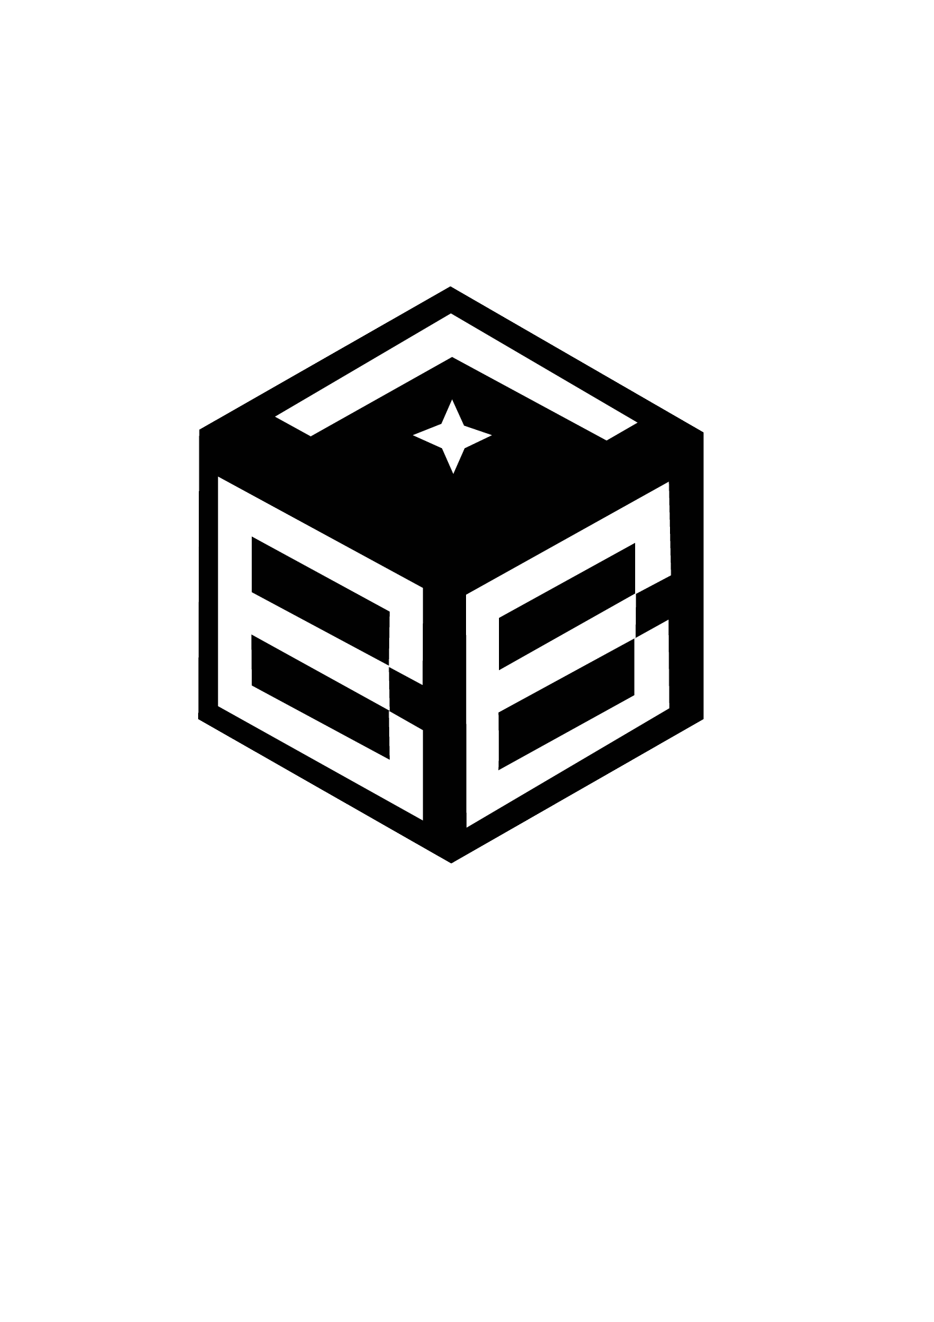
DIGITAL ONBOARDING RECORD
Full name: {{full_name}}
Date of birth: {{date_of_birth}}
Volunteer role: {{volunteer_role}}
Track: {{track}}
Volunteer consent: {{consent}}
Signature: [[signature_subject]]

