FRONT | page 1 of 3
TEAM CASE STUDY: RAY KESSLER  The whole class is ONE nursing team for one patient across 24 hours. We move through the time together, 4 hours at a time. | 5 East, Room 14 | Tue 0700 to Wed 0700

Write your team name in the header at the top of this page (it repeats on every page).
PAIR 1: MEDS & TREATMENTS | PAIR 2: ASSESSMENT & VITALS | PAIR 3: RESULTS & LABS
A name: ______________________ | C name: ______________________ | E name: ______________________
B name: ______________________ | D name: ______________________ | F name: ______________________
G FLOAT NURSE (helps wherever the charge nurse sends them): name: ____________________________

HOW THE TWO HOURS WORK
• The instructor moves the clock forward 4 hours at a time: 0700, 1100, 1500, 1900, 2300, 0300, and a final check at 0700.
• At each checkpoint, the instructor reads the situation. The team looks at Ray and the chart. The charge nurse runs the page: asks each pair what they found, and the pair reports. Only the charge nurse writes in the shared boxes while the pairs advise. The charge nurse makes one SBAR call.
• The packet is shared by the table; each student has their own reflection page (last page). You finish each page at the end of its time block. Do not turn the page until the instructor advances the clock.
• Use the EHR on your own device (vitals, meds, results). Your patient and the time are synced with the instructor. Write in dark pen.
ROLES
CHARGE NURSE  (one person; changes every stop) | Runs the section. Keeps time. Asks each pair what they found and what to do, then decides the priorities with the team. Makes the SBAR call and writes the team plan.
NURSE PAIRS  (the other students) | Meds & Treatments: MAR, orders, notes: what is running, due or should stop. Assessment & Vitals: the bedside monitor and the bedside exam (alertness, reflexes, breathing, urine). Results & Labs: new labs, ECG, trends, the Mg strip. Speak up when the charge nurse asks. If one of your pair is charge, your partner reports for the pair.

CHARGE NURSE ROTATION (each student is charge nurse exactly once)
Stop | 0700 | 1100 | 1500 | 1900 | 2300 | 0300 | Close 0700
Charge nurse (letter) | A | C | E | B | D | F | G
Partner reports for the pair | B | D | F | A | C | E | -
Name

TURN-IN
One shared packet for the team, fastened with a paperclip (no staples). The last page has an individual reflection and a peer check: write your own name on yours.

FRONT | page 2 of 3
PATIENT CARD: RAYMOND "RAY" KESSLER | Room 5E-14

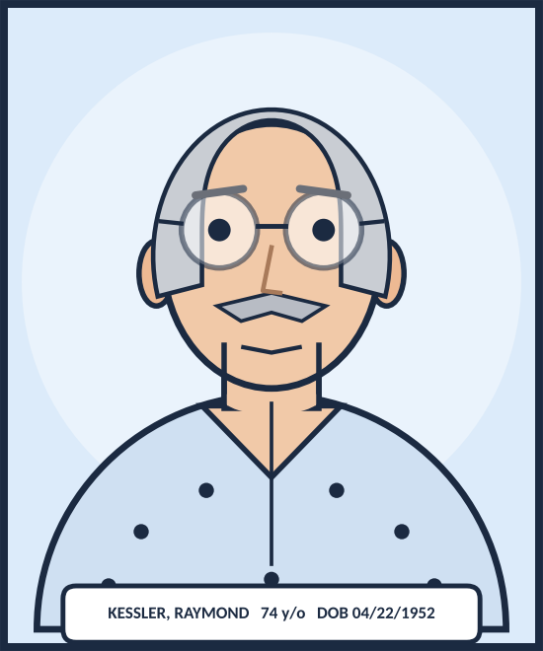 | Name: Raymond "Ray" Kessler, he/him, 74 years old, DOB 04/22/1952  MRN: SIM-40318  Height / weight: 175 cm | 88.0 kg on arrival (usual weight about 90 kg)  ALLERGY: Penicillin (childhood rash)  Code status: Full Code | Fall risk: HIGH  History: Kidney disease (stage 4), diabetes, weak heart (heart failure)  Family: Wife Eleanor Kessler (72, health care proxy); daughter Diane Ruiz (15 minutes away)  Care team: Hospitalist Dr. D. Okafor (0700-1900); night hospitalist Dr. J. Lindgren; nephrology Dr. P. Raman; ICU outreach Dr. H. Moreno; pharmacist L. Ferreira

MAGNESIUM IN ONE MINUTE
• Normal magnesium is 1.7 to 2.2 mg/dL. In this lab, anything over 5.0 is a critical value.
• Magnesium leaves the body through the kidneys. If the kidneys are failing, magnesium builds up.
• High magnesium slows the nerves, muscles, breathing and heart. The bands on the strip show what you might see. Trust your exam as much as the number.

TEAM TREND STRIP: MAGNESIUM | one mark per result

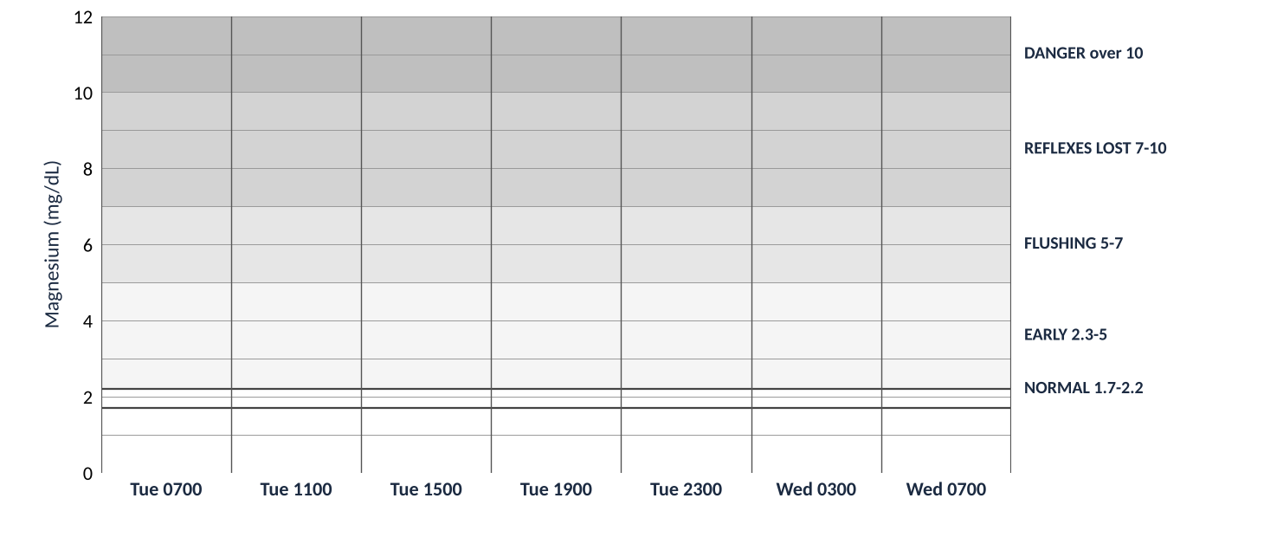
At each checkpoint, write the new magnesium level on your page, then mark an X in that checkpoint's column at the right height. Two new results? Mark both. Connect the dots as you go. The charge nurse of the round makes sure it is done.
Use this space for a quick team note (for example, what makes the line go up or down):
Team notes on the trend

FRONT | page 3 of 3
HOW YOU EARN YOUR 20 POINTS  This is a team grade. A complete, careful, team-minded effort earns full credit. Nothing here is a trick. | 4 categories | 3 levels each

Category and points | FULL credit | GOOD (partial) | GETTING THERE
Teamwork and charge-nurse rotation  5 points | 5. Every section has a charge nurse named, everyone was charge nurse once, and each pair reported its job at every checkpoint. | 3 to 4. The rotation was followed most of the time. Most teammates took part. | 1 to 2. The rotation was skipped, or one person did most of the work.
Clinical thinking at each checkpoint  6 points | 6. Every checkpoint has vitals, meds, results and changes filled in, with real numbers from the chart and a reason. | 4 to 5. Most checkpoints are filled in with numbers. One or two are thin. | 1 to 3. Many boxes are blank or have one-word answers.
Safety, priorities and SBAR  5 points | 5. At every checkpoint, 3 priorities in order, a complete SBAR (all four parts) and a next step that keeps Ray safe. | 3 to 4. Most checkpoints have priorities and an SBAR. A part is sometimes missing. | 1 to 2. Priorities or SBAR are missing at many checkpoints.
Completeness and reflection  4 points | 4. All boxes tried, the magnesium trend strip is marked, and each person handed in the reflection page. | 2 to 3. Most boxes tried. The strip or a reflection is missing. | 1. Many blanks. Little reflection.

WHAT WE LOOK FOR ON EVERY CHECKPOINT PAGE
• A charge nurse is named and each pair (Meds, Assessment, Results) reported in its own box.
• The boxes are filled in with real numbers from the chart (vitals, labs) and a short reason.
• Three priorities in order and a complete SBAR (Situation, Background, Assessment, Recommendation).
• The magnesium level is written and marked on the team strip.
• A prediction for the next 4 hours. A good guess with a reason earns credit, even if it turns out wrong.

AT THE END
• Each person hands in a short reflection (3 boxes) and a quick peer teamwork check on the last page.
• Answers that differ from the instructor's are fine if they are thoughtful and tied to Ray's chart.

Category | Points possible | Points earned (instructor)
Teamwork and charge-nurse rotation | 5
Clinical thinking at each checkpoint | 6
Safety, priorities and SBAR | 5
Completeness and reflection | 4
TOTAL | 20

CHECKPOINT 1 | page 1 of 1
0700 | Tuesday | Checkpoint 1 of 6
Charge nurse for this stop: __________ Partner reporting for their pair: __________ ☐ every pair heard ☐ SBAR done

SITUATION It is Tuesday 0700 on 5 East, room 5E-14. Ray Kessler, 74, came up from the ED about ten minutes ago after four days of vomiting, and he was hard to wake this morning.
The ED found a very high magnesium (7.8; normal is 1.7 to 2.2) and a creatinine of 4.9. They gave calcium gluconate and a saline bolus and placed a Foley. His wife Eleanor is holding a paper bag of medicines from home that nobody has looked at yet.

Time | Temp F | HR | BP (MAP) | RR | SpO2 / oxygen | Pain | Rhythm on the monitor | Glucose
0425 prev | 97.2 | 46 | 82/46 (58) | 14 | 95% RA | - | Sinus brady (ECG 0430) | 148
0700 NOW

MEDS & TREATMENTS pair reports Charge asks: "what is running, due, or dangerous? What should we give, hold or stop?"

ASSESSMENT & VITALS pair reports Charge asks: "what does the monitor show and what do you find at the bedside?"

RESULTS & LABS pair reports Charge asks: "what is new and what does it mean for his diagnosis?"

MAGNESIUM (mg/dL) new level(s): ______ and ______ | Compared with last time: ☐ up ☐ down ☐ same | Marked on the team strip ☐

What changed since the last stop? |  | What we will do next

Our top 3 priorities the charge nurse decides, in order
1.
2.
3.

What we will tell the provider (SBAR) The charge nurse makes the call.
S Situation
B Background
A Assessment
R Recommend

Prediction for the next 4 hours |  | Charge nurse notes ask each pair for one thing, then decide

CHECKPOINT 2 | page 1 of 1
1100 | Tuesday | Checkpoint 2 of 6
Charge nurse for this stop: __________ Partner reporting for their pair: __________ ☐ every pair heard ☐ SBAR done

SITUATION It is 1100. Since 0700 Ray has had another saline bolus, maintenance saline and IV furosemide (a water pill) at 0915. The pharmacist went through Eleanor's bag and the home products were stopped.
The 0900 labs are back: magnesium 8.7, up from 7.8. Eleanor stepped out to call their daughter. You walk in to check on Ray.

Time | Temp F | HR | BP (MAP) | RR | SpO2 / oxygen | Pain | Rhythm on the monitor | Glucose
0700 prev | 97.6 | 52 | 96/56 (69) | 14 | 94% RA | 2/10 | Sinus brady with first-degree AV block (PR 0.26 s) | 132
1100 NOW

MEDS & TREATMENTS pair reports Charge asks: "what is running, due, or dangerous? What should we give, hold or stop?"

ASSESSMENT & VITALS pair reports Charge asks: "what does the monitor show and what do you find at the bedside?"

RESULTS & LABS pair reports Charge asks: "what is new and what does it mean for his diagnosis?"

MAGNESIUM (mg/dL) new level(s): ______ and ______ | Compared with last time: ☐ up ☐ down ☐ same | Marked on the team strip ☐

What changed since the last stop? |  | What we will do next

Our top 3 priorities the charge nurse decides, in order
1.
2.
3.

What we will tell the provider (SBAR) The charge nurse makes the call.
S Situation
B Background
A Assessment
R Recommend

Prediction for the next 4 hours |  | Charge nurse notes ask each pair for one thing, then decide

CHECKPOINT 3 | page 1 of 2
1500 | Tuesday | Checkpoint 3 of 6
Charge nurse for this stop: __________ Partner reporting for their pair: __________ ☐ every pair heard ☐ SBAR done

SITUATION It is 1500. The rapid response team came at 1115 and Ray has had calcium gluconate (1 g at 1120, then 2 g doses ordered). He made only 70 mL of urine in four hours. The 1315 labs: magnesium 10.9, potassium 5.8, creatinine 5.3. The 1330 ECG shows HR 38 and a wider QRS (148 ms).
Dr. Raman decided on emergency dialysis. Eleanor gave phone consent at 1350, the neck catheter went in at 1440 and the x-ray is clear. Dialysis starts now. ICU outreach says Ray can stay on 5 East with a 1:1 nurse.

Time | Temp F | HR | BP (MAP) | RR | SpO2 / oxygen | Pain | Rhythm on the monitor | Glucose
1100 prev | 97.4 | 44 | 84/48 (60) | 10 | 91% RA | 0/10 | Sinus brady, long PR (0.30 s) | 104
1500 NOW

MEDS & TREATMENTS pair reports Charge asks: "what is running, due, or dangerous? What should we give, hold or stop?"

ASSESSMENT & VITALS pair reports Charge asks: "what does the monitor show and what do you find at the bedside?"

RESULTS & LABS pair reports Charge asks: "what is new and what does it mean for his diagnosis?"

MAGNESIUM (mg/dL) new level(s): ______ and ______ | Compared with last time: ☐ up ☐ down ☐ same | Marked on the team strip ☐

Keep going on the next page (the same time block).

CHECKPOINT 3 | page 2 of 2
1500 | Tuesday  Dialysis is starting. Same charge nurse. The charge nurse asks each pair for one more thing. | Checkpoint 3 of 6, page 2

Meds pair: before dialysis starts, what must be ready and checked?

Assessment pair: while dialysis runs, what do we watch, and how often?

Results pair: what numbers tell us to call for help, and who do we call?

What changed since the last stop? |  | What we will do next

Our top 3 priorities the charge nurse decides, in order
1.
2.
3.

What we will tell the provider (SBAR) The charge nurse makes the call.
S Situation
B Background
A Assessment
R Recommend

Prediction for the next 4 hours |  | Charge nurse notes ask each pair for one thing, then decide

CHECKPOINT 4 | page 1 of 1
1900 | Tuesday | Checkpoint 4 of 6
Charge nurse for this stop: __________ Partner reporting for their pair: __________ ☐ every pair heard ☐ SBAR done

SITUATION It is 1900. Dialysis ran from 1500 to 1800 and took off 500 mL of fluid. At 1630 his blood pressure dipped to 82/46 and the dialysis nurse gave 250 mL of saline. His magnesium was 7.2 at 1700 and 4.6 after dialysis (1800).
Ray is awake and breathing 16 times a minute. Your team rolls straight into the night shift as the day team gives report. Look him over.

Time | Temp F | HR | BP (MAP) | RR | SpO2 / oxygen | Pain | Rhythm on the monitor | Glucose
1500 prev | 97.2 | 46 | 88/50 (63) | 9 | 92% on 4 L NC | CPOT | Sinus brady, long PR (0.32 s), wide QRS (0.14 s), tall T waves | 88
1900 NOW

MEDS & TREATMENTS pair reports Charge asks: "what is running, due, or dangerous? What should we give, hold or stop?"

ASSESSMENT & VITALS pair reports Charge asks: "what does the monitor show and what do you find at the bedside?"

RESULTS & LABS pair reports Charge asks: "what is new and what does it mean for his diagnosis?"

MAGNESIUM (mg/dL) new level(s): ______ and ______ | Compared with last time: ☐ up ☐ down ☐ same | Marked on the team strip ☐

What changed since the last stop? |  | What we will do next

Our top 3 priorities the charge nurse decides, in order
1.
2.
3.

What we will tell the provider (SBAR) The charge nurse makes the call.
S Situation
B Background
A Assessment
R Recommend

Prediction for the next 4 hours |  | Charge nurse notes ask each pair for one thing, then decide

CHECKPOINT 5 | page 1 of 1
2300 | Tuesday night | Checkpoint 5 of 6
Charge nurse for this stop: __________ Partner reporting for their pair: __________ ☐ every pair heard ☐ SBAR done

SITUATION It is 2300. D10W (sugar water) has run since 1930 at 40 mL/h and Ray's sugars have been 98, 106 and 118. At 2100 his magnesium was 5.6, up from 4.6, and his calcium was 7.9.
Eleanor went home at 2100. Since 2230 Ray has been restless and is pulling at his lines. You go in.

Time | Temp F | HR | BP (MAP) | RR | SpO2 / oxygen | Pain | Rhythm on the monitor | Glucose
1900 prev | 97.6 | 66 | 104/60 (75) | 16 | 96% RA | 3/10 | Normal sinus rhythm 66, PR 0.20 s | 54 (at 1905)
2300 NOW

MEDS & TREATMENTS pair reports Charge asks: "what is running, due, or dangerous? What should we give, hold or stop?"

ASSESSMENT & VITALS pair reports Charge asks: "what does the monitor show and what do you find at the bedside?"

RESULTS & LABS pair reports Charge asks: "what is new and what does it mean for his diagnosis?"

MAGNESIUM (mg/dL) new level(s): ______ and ______ | Compared with last time: ☐ up ☐ down ☐ same | Marked on the team strip ☐

What changed since the last stop? |  | What we will do next

Our top 3 priorities the charge nurse decides, in order
1.
2.
3.

What we will tell the provider (SBAR) The charge nurse makes the call.
S Situation
B Background
A Assessment
R Recommend

Prediction for the next 4 hours |  | Charge nurse notes ask each pair for one thing, then decide

CHECKPOINT 6 | page 1 of 1
0300 | Wednesday | Checkpoint 6 of 6
Charge nurse for this stop: __________ Partner reporting for their pair: __________ ☐ every pair heard ☐ SBAR done

SITUATION It is 0300 Wednesday. Ray slept a little. The 0100 magnesium came back 6.4 (4.6 after dialysis, 5.6 at 2100) and calcium is 8.1. The D10W stopped at 0130 and his glucose is 126.
Ray has had no stool in four days and his belly looks full. He mumbles something about "the pink milk".

Time | Temp F | HR | BP (MAP) | RR | SpO2 / oxygen | Pain | Rhythm on the monitor | Glucose
2300 prev | 98.2 | 62 | 112/64 (80) | 16 | 96% RA | 3/10 | Sinus rhythm 62, PR 0.22 s | 118
0300 NOW

MEDS & TREATMENTS pair reports Charge asks: "what is running, due, or dangerous? What should we give, hold or stop?"

ASSESSMENT & VITALS pair reports Charge asks: "what does the monitor show and what do you find at the bedside?"

RESULTS & LABS pair reports Charge asks: "what is new and what does it mean for his diagnosis?"

MAGNESIUM (mg/dL) new level(s): ______ and ______ | Compared with last time: ☐ up ☐ down ☐ same | Marked on the team strip ☐

What changed since the last stop? |  | What we will do next

Our top 3 priorities the charge nurse decides, in order
1.
2.
3.

What we will tell the provider (SBAR) The charge nurse makes the call.
S Situation
B Background
A Assessment
R Recommend

Prediction for the next 4 hours |  | Charge nurse notes ask each pair for one thing, then decide

CASE CLOSED | page 1 of 2
0700 | Wednesday | Final check
Charge nurse for this stop: __________ Partner reporting for their pair: __________ ☐ every pair heard ☐ SBAR done

SITUATION It is Wednesday 0700. After the bisacodyl suppository Ray had a large stool at 0345 and slept. The 0500 magnesium is 5.3 (down from 6.4) and the creatinine is 3.3 (it peaked at 5.3). Urine has recovered to 85 mL/h. Weight is 90.0 kg (88.0 on arrival).
Dr. Raman says no more dialysis for now. The dialysis catheter stays 24 hours just in case. The Foley can come out, and furosemide is due at 0800 for the extra fluid. Eleanor is back at the bedside.

Time | Temp F | HR | BP (MAP) | RR | SpO2 / oxygen | Pain | Rhythm on the monitor | Glucose
0300 prev | 98.0 | 56 | 104/60 (75) | 12 | 95% RA | 4/10 | Sinus rhythm 56, PR 0.24 s (long again) | 126
0700 NOW

MEDS & TREATMENTS pair reports Charge asks: "what is running, due, or dangerous? What should we give, hold or stop?"

ASSESSMENT & VITALS pair reports Charge asks: "what does the monitor show and what do you find at the bedside?"

RESULTS & LABS pair reports Charge asks: "what is new and what does it mean for his diagnosis?"

MAGNESIUM (mg/dL) new level(s): ______ and ______ | Compared with last time: ☐ up ☐ down ☐ same | Marked on the team strip ☐

What changed since 0300 and since arrival? |  | What we will do next

Our top 3 priorities for the day team the charge nurse decides, in order
1.
2.
3.

What we will tell the provider (SBAR) The charge nurse makes the call.
S Situation
B Background
A Assessment
R Recommend

What we will teach Ray and Eleanor three plain tips |  | The story of Ray's stay in our words look at the team strip

Charge nurse notes (then turn to the individual reflection page)

CASE CLOSED | page 2 of 2
MY REFLECTION AND PEER CHECK  Hand this page in with your own name on it. | individual

Name: _______________________________ Team: _______________________________ Times I was charge nurse: ____________
1. Something I learned about Ray's case

2. Something our team did well (and who helped)

3. One thing I would do differently as a charge nurse or as a nurse

PEER TEAMWORK CHECK
Rate up to three teammates (not yourself). Mark one box for each.
Teammate | Did their share | Listened to teammates | Spoke up with good ideas | One kind, useful comment
 | ☐ yes ☐ mostly ☐ not yet | ☐ yes ☐ mostly ☐ not yet | ☐ yes ☐ mostly ☐ not yet
 | ☐ yes ☐ mostly ☐ not yet | ☐ yes ☐ mostly ☐ not yet | ☐ yes ☐ mostly ☐ not yet
 | ☐ yes ☐ mostly ☐ not yet | ☐ yes ☐ mostly ☐ not yet | ☐ yes ☐ mostly ☐ not yet

Hand in your reflection with the team packet. Thank you!

