FRONT | page 1 of 3
TEAM CASE STUDY: LAUREN MITCHELL  The whole class is ONE nursing team for one patient across 24 hours. We move through the time together, 4 hours at a time. | 4 West, Room 4W-22 | Mon 0700 to Tue 0700

Write your name in the header at the top of this page (it repeats on every page). Everyone fills in their own packet.
QUICK PATHOPHYSIOLOGY: ADDISON DISEASE AND ADRENAL CRISIS
The adrenal glands: The outer layer (cortex) makes cortisol and aldosterone. In Addison disease (primary adrenal insufficiency) the immune system destroys the cortex, so the person replaces both hormones with pills every day.
Cortisol: The stress hormone. It keeps blood pressure up (vessels respond to epinephrine), keeps blood glucose up between meals and helps the body get through illness. Too little: low BP, low glucose, weakness, nausea, vomiting, belly pain, confusion.
Aldosterone: Makes the kidneys keep sodium and water and get rid of potassium. Too little: sodium and water are lost in the urine (dehydration, low sodium) and potassium builds up (high potassium, peaked T waves, dysrhythmias).
ACTH: The pituitary keeps sending ACTH to glands that cannot answer. High ACTH darkens the skin (tan skin, dark skin creases and gums).
Adrenal crisis: Illness, injury, surgery or vomiting raises the need for cortisol, and the person cannot make more or keep the pills down. Result: shock that fluid alone does not fix, low glucose, low sodium, high potassium. It can kill within hours.
Treatment: IV hydrocortisone right away (never wait for tests; every dose is time-critical), IV saline with dextrose, treat the trigger, cardiac monitoring. High-dose hydrocortisone also acts like aldosterone, so fludrocortisone is held while the dose is high. Raise the sodium slowly (no more than 8 in 24 hours) to protect the brain.
Nursing focus: BP and orthostatic vitals, heart rate and rhythm, glucose, sodium and potassium, mental status, intake and output, fall safety, steroid doses on time, and sick-day teaching before going home.

HOW THE TWO HOURS WORK
• The instructor moves the clock forward 4 hours at a time: 0700, 1100, 1500, 1900, 2300, 0300, and a final check at 0700 Tuesday.
• At each checkpoint, the instructor sets the bedside monitor and reads the situation. Fill in the blanks in the situation box from the chart. Each pair does its job in the chart and at the bedside and writes its findings in its own box, with your names. You decide what to look for and what to ask.
• When a pair is finished, the charge nurse gets the findings from that pair. The Vitals & Assessment and Meds and Orders pairs work together on the actions to suggest. The charge nurse decides the top 3 priorities, then develops and gives the SBAR to the provider. Everyone writes them down.
• Every stop, the Vitals & Assessment pair fills one column of the response tracker (page 3): is the treatment working? At the end you use it to evaluate the whole treatment.
• Finish each page at the end of its time block. Do not turn the page until the instructor advances the clock. Use the EHR on your own device (vitals, MAR, results, notes); your patient and the time are synced with the instructor. Vitals row: read the bedside monitor, take your own set, do orthostatic vitals when ordered and safe, and ask the instructor for the bedside glucose. Write in dark pen.
ROLES
CHARGE NURSE  (one person; changes every stop) | Runs the section and keeps time. Gets the findings from each pair when the pair is finished. Decides the top 3 priorities with the team (writes their name in that box). Develops and gives the SBAR.
NURSE PAIRS  (switch jobs every stop) | The other students work in pairs. At every checkpoint each pair is assigned a new job and writes its names in that box. Meds and Orders: MAR, orders, notes: what is running, due, held or should change, and why. Vitals & Assessment: the bedside monitor, orthostatic vitals, the bedside exam (mental status, skin, mouth, belly), intake and output. Results & Labs: new labs, ECG, trends and what they mean. Report to the charge nurse when you are finished.

CHARGE NURSE ROTATION (each student is charge nurse exactly once)
Stop | 0700 | 1100 | 1500 | 1900 | 2300 | 0300 | Final 0700
Charge nurse name

TURN-IN
Each student turns in their own packet, fastened with a paperclip (no staples). The last page is your individual reflection and peer check.

FRONT | page 2 of 3
PATIENT CARD: LAUREN MITCHELL | Room 4W-22

Name: Lauren Mitchell, she/her, 46 years old, DOB 05/14/1980 | MRN SIM-40422 | 165 cm, 58.2 kg on arrival (usual 61.0 kg)
ALLERGY: Sulfamethoxazole-trimethoprim (hives) | Full Code | Fall risk: HIGH | Contact (enteric) precautions: soap and water
History: Addison disease (autoimmune primary adrenal insufficiency) since 2021; Hashimoto hypothyroidism (2016); appendectomy at 19. Middle school science teacher.
Home meds: Hydrocortisone 15 mg at 0700 + 5 mg at 1400 (20 mg/day); fludrocortisone 0.1 mg daily; levothyroxine 88 mcg at 0600; vitamin D3 2,000 units daily.
Family: Husband Daniel Mitchell (48, health care proxy); son Ethan (15, had a "stomach bug" on Friday).
Care team: Day hospitalist Dr. R. Delacroix (0700-1900); night hospitalist Dr. K. Osei; endocrinology Dr. M. Harrington; pharmacist T. Nakagawa; dietitian E. Lindqvist.
Normal values: Sodium 136-145 | potassium 3.5-5.1 | glucose 70-110 | creatinine 0.5-1.1 (her usual 0.8) | cortisol (morning) 5-23 | ACTH 7.2-63

HORMONE MAP: WHY DOES SHE LOOK LIKE THIS? | fill it in at 0700

The adrenal glands make cortisol and aldosterone. In Addison disease both are missing. Write what you find in Lauren's chart and at the bedside (with numbers) for each hormone.
Hormone | What it normally does | What Lauren shows (chart numbers and bedside findings)
CORTISOL (missing) | Keeps blood vessels tight and BP up; makes glucose in the liver between meals; needed for any stress or illness; helps the kidney get rid of water.
ALDOSTERONE (missing) | Makes the kidney keep sodium and water and get rid of potassium (and acid).
ACTH (very high) | The pituitary pushes harder on a gland that cannot answer. ACTH comes from the same parent molecule as the skin-darkening hormone.

FINDING IT IN THE EHR (this is what the chart shows at 0700)

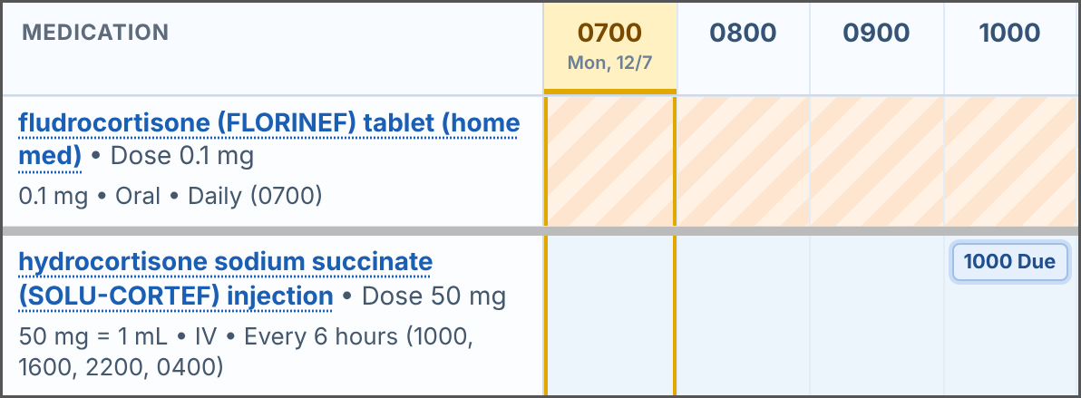 | MAR: the home fludrocortisone (and the home hydrocortisone, not shown) are held: the row is hatched. The IV hydrocortisone row shows its schedule and the next due time. Click a medicine name for the full order.
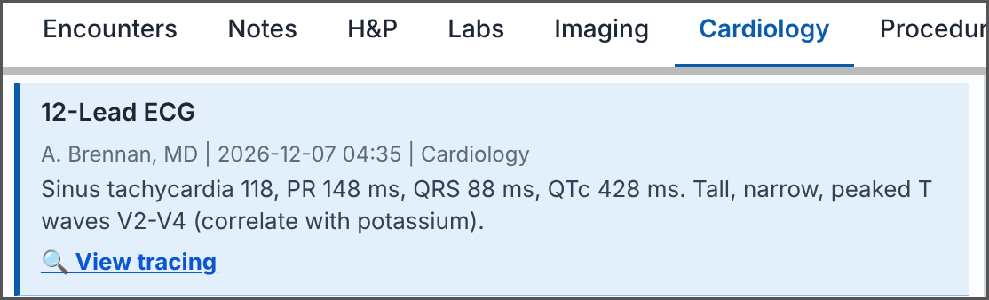 | Chart Review > Cardiology: the ED 12-lead ECG. Click View tracing to see the strip and look at the T waves. Later ECGs appear here too.

FRONT | page 3 of 3
HOW YOU EARN YOUR 20 POINTS  A complete, careful, team-minded effort earns full credit. Nothing here is a trick. | team grade

Category and points | FULL credit | GOOD (partial) | GETTING THERE
Teamwork and charge-nurse rotation  5 points | 5. A charge nurse is named at every stop, everyone was charge nurse once, and each pair reported its job when the charge nurse asked. | 3 to 4. The rotation was followed most of the time. Most teammates took part. | 1 to 2. The rotation was skipped, or one person did most of the work.
Clinical thinking at each checkpoint  6 points | 6. Every checkpoint has the pair boxes filled with real chart numbers and a reason (why it happens, and is the treatment working?). | 4 to 5. Most checkpoints are filled in with numbers. One or two are thin. | 1 to 3. Many boxes are blank or have one-word answers.
Safety, priorities and SBAR  5 points | 5. At 1100, 1500, 1900, 2300 and 0300: three priorities in order, a complete SBAR (all four parts) and a next step that keeps Lauren safe. | 3 to 4. Most stops have priorities and an SBAR. A part is sometimes missing. | 1 to 2. Priorities or SBAR are missing at many stops.
Completeness and reflection  4 points | 4. All boxes tried, the response tracker is filled at every stop, the final evaluation is done, and each person handed in a reflection. | 2 to 3. Most boxes tried. The tracker, the evaluation or a reflection is missing. | 1. Many blanks. Little reflection.

RESPONSE TRACKER: IS THE TREATMENT WORKING? | Vitals & Assessment pair fills this in

Vitals & Assessment pair: fill in this stop's column at every stop (ask the Results & Labs pair for the lab numbers). Add an arrow (up, down, same) when it helps. In the last row circle Better, Same or Worse.
Measure | Goal | Mon 0700 | Mon 1100 | Mon 1500 | Mon 1900 | Mon 2300 | Tue 0300 | Tue 0700
BP lying (MAP) | SBP 100 or more; MAP 65 or more
BP and HR standing | Negative: SBP drop under 20, HR rise under 30, no dizziness
Heart rate / T waves | Under 100; T waves normal
Glucose (bedside) | 70-180 without dextrose pushes
Sodium (latest) | Rising, but no more than 8 in 24 h (from 126 at 0406)
Potassium (latest) | 3.5-5.1
Mental status | Alert, oriented x4 (her baseline)
Urine output | 0.5 mL/kg/h or more (about 30 mL/h); tell if over 250 mL/h
Nausea / eating | No nausea; eating and drinking
OVERALL | Better, same or worse than the last stop? | B S W | B S W | B S W | B S W | B S W | B S W | B S W

CHECKPOINT 1 | page 1 of 1
0700 | Monday | Checkpoint 1 of 6
Charge nurse for this stop: ______________________ ☐ every pair reported to the charge nurse ☐ SBAR given

SITUATION It is Monday 0700, 4 West, room 4W-22. Lauren Mitchell, age ________, just came up from the ED. Her history: __________________________________. Since Saturday she has had __________________________________ and could not keep down her __________________________________ pills.
EMS found her confused on the bathroom floor at 0318: BP ________, glucose ________. EMS and the ED gave ________ L of saline, dextrose, and hydrocortisone ___________ at ________. Running now: ______________ mL/h. Her husband ________ is at the bedside.

Time | Temp F | HR | BP lying (MAP) | Standing BP, HR | RR | SpO2 | Pain | Rhythm on the monitor | Glucose
0700

MEDS AND ORDERS Names: ____________________ ____________________

VITALS & ASSESSMENT Names: ____________________ ____________________

RESULTS & LABS Names: ____________________ ____________________

RESPONSE TRACKER (page 3): Vitals & Assessment pair, fill in the Mon 0700 column ☐ Hormone map (p. 2) ☐ | Compared with the ED she is: ☐ better ☐ same ☐ worse

Actions to suggest (Vitals + Meds pairs)

Top 3 priorities Charge RN: ______________________
1.
2.
3.

SBAR to the provider
S Situation
B Background
A Assessment
R Recommend

Prediction for the next 4 hours |  | Charge nurse notes

CHECKPOINT 2 | page 1 of 1
1100 | Monday | Checkpoint 2 of 6
Charge nurse for this stop: ______________________ ☐ every pair reported to the charge nurse ☐ SBAR given

SITUATION It is 1100. The 0900 bedside glucose was ________; the 0900 serum sodium is ________ and potassium ________. Her hydrocortisone __________ was due at ________. She had a large liquid stool at 0945 and the sample went to the lab.
You walk in for the 1100 glucose check. Lauren is sweating and says, "Something's wrong." Her bedside glucose is ________ (ask the instructor). Her mental status compared with 0700: __________________________________.

Time | Temp F | HR | BP lying (MAP) | Standing BP, HR | RR | SpO2 | Pain | Rhythm on the monitor | Glucose
1100

MEDS AND ORDERS Names: ____________________ ____________________

VITALS & ASSESSMENT Names: ____________________ ____________________

RESULTS & LABS Names: ____________________ ____________________

RESPONSE TRACKER (page 3): Vitals & Assessment pair, fill in the Mon 1100 column ☐ | Since the last stop she is: ☐ better ☐ same ☐ worse

What changed since the last stop? |  | Actions to suggest (Vitals + Meds pairs)

Top 3 priorities Charge RN: ______________________
1.
2.
3.

SBAR to the provider
S Situation
B Background
A Assessment
R Recommend

Prediction for the next 4 hours |  | Charge nurse notes

CHECKPOINT 3 | page 1 of 1
1500 | Monday | Checkpoint 3 of 6
Charge nurse for this stop: ______________________ ☐ every pair reported to the charge nurse ☐ SBAR given

SITUATION It is 1500. Lauren has kept clear liquids down since ________, and endocrinology saw her. The ED cortisol (before the steroid) is ________ and the ACTH is ________. The 1300 sodium is ________: up ________ from 126 in ________ hours.
The urine hat keeps filling with pale urine: about ________ mL since 1100. Her lying BP is over 100 and she is alert, so orthostatic vital signs are due. The next hydrocortisone is due at ________.

Time | Temp F | HR | BP lying (MAP) | Standing BP, HR | RR | SpO2 | Pain | Rhythm on the monitor | Glucose
1500

MEDS AND ORDERS Names: ____________________ ____________________

VITALS & ASSESSMENT Names: ____________________ ____________________

RESULTS & LABS Names: ____________________ ____________________ |  | 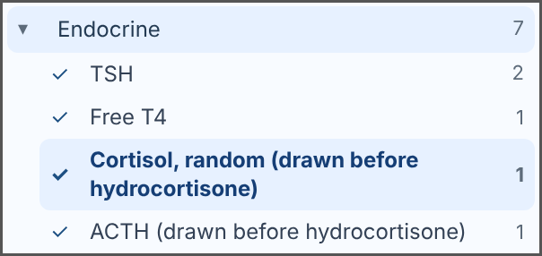  Lab Results > Endocrine (click a name to open it)

RESPONSE TRACKER (page 3): Vitals & Assessment pair, fill in the Mon 1500 column ☐ | Since the last stop she is: ☐ better ☐ same ☐ worse

What changed since the last stop? |  | Actions to suggest (Vitals + Meds pairs)

Top 3 priorities Charge RN: ______________________
1.
2.
3.

SBAR to the provider
S Situation
B Background
A Assessment
R Recommend

Prediction for the next 4 hours |  | Charge nurse notes

CHECKPOINT 4 | page 1 of 1
1900 | Monday | Checkpoint 4 of 6
Charge nurse for this stop: ______________________ ☐ every pair reported to the charge nurse ☐ SBAR given

SITUATION It is 1900, shift change: your team now becomes the night shift. At 1530 the provider changed the IV fluid from ________________ to ____________________________. Lauren has had ginger ale and juice, a _________ diet was ordered at 1830, and she had one loose stool at 1640.
The 1700 sodium is ________ and potassium ________. The stool GI panel found ___________, so she stays on ______________________ precautions; clean hands with __________________. Orthostatic vitals were ordered again for 1900. Tonight's hydrocortisone is due at ________ and ________.

Time | Temp F | HR | BP lying (MAP) | Standing BP, HR | RR | SpO2 | Pain | Rhythm on the monitor | Glucose
1900

MEDS AND ORDERS Names: ____________________ ____________________

VITALS & ASSESSMENT Names: ____________________ ____________________

RESULTS & LABS Names: ____________________ ____________________ |  | 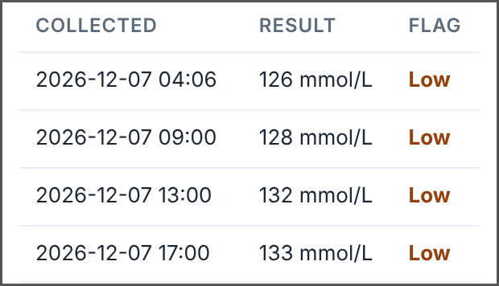  Lab Results > Sodium > History / Trend

RESPONSE TRACKER (page 3): Vitals & Assessment pair, fill in the Mon 1900 column ☐ | Since the last stop she is: ☐ better ☐ same ☐ worse

What changed since the last stop? |  | Actions to suggest (Vitals + Meds pairs)

Top 3 priorities Charge RN: ______________________
1.
2.
3.

SBAR to the provider
S Situation
B Background
A Assessment
R Recommend

Prediction for the next 4 hours |  | Charge nurse notes

CHECKPOINT 5 | page 1 of 1
2300 | Monday night | Checkpoint 5 of 6
Charge nurse for this stop: ______________________ ☐ every pair reported to the charge nurse ☐ SBAR given

SITUATION It is 2300. Lauren ate ________% of her dinner at 2000. The 2100 sodium is ________ and potassium ________; the sodium limit until 0400 is ________. The hydrocortisone was due at ________: given? _______________.
Her call light is on. "My mind won't stop. Who's going to take Ethan to school? Can I have something to knock me out?" Her bedside glucose is ________ (ask the instructor).

Time | Temp F | HR | BP lying (MAP) | Standing BP, HR | RR | SpO2 | Pain | Rhythm on the monitor | Glucose
2300

MEDS AND ORDERS Names: ____________________ ____________________

VITALS & ASSESSMENT Names: ____________________ ____________________

RESULTS & LABS Names: ____________________ ____________________

RESPONSE TRACKER (page 3): Vitals & Assessment pair, fill in the Mon 2300 column ☐ | Since the last stop she is: ☐ better ☐ same ☐ worse

What changed since the last stop? |  | Actions to suggest (Vitals + Meds pairs)

Top 3 priorities Charge RN: ______________________
1.
2.
3.

SBAR to the provider
S Situation
B Background
A Assessment
R Recommend

Prediction for the next 4 hours |  | Charge nurse notes

CHECKPOINT 6 | page 1 of 1
0300 | Tuesday | Checkpoint 6 of 6
Charge nurse for this stop: ______________________ ☐ every pair reported to the charge nurse ☐ SBAR given

SITUATION It is 0300 Tuesday. At ________ the bed alarm went off: Lauren had walked to the bathroom ________, had a soft loose stool, felt lightheaded and sat down on the toilet, then pulled the cord. You found her sitting there. She did not fall.
She is back in bed. The 0100 potassium is ________ (it was 6.0 at 0406) and sodium ________. Look at her and at both IV sites: the right forearm IV is _________________________________. The next hydrocortisone is due at ________.

Time | Temp F | HR | BP lying (MAP) | Standing BP, HR | RR | SpO2 | Pain | Rhythm on the monitor | Glucose
0300

MEDS AND ORDERS Names: ____________________ ____________________

VITALS & ASSESSMENT Names: ____________________ ____________________

RESULTS & LABS Names: ____________________ ____________________

RESPONSE TRACKER (page 3): Vitals & Assessment pair, fill in the Tue 0300 column ☐ | Since the last stop she is: ☐ better ☐ same ☐ worse

What changed since the last stop? |  | Actions to suggest (Vitals + Meds pairs)

Top 3 priorities Charge RN: ______________________
1.
2.
3.

SBAR to the provider
S Situation
B Background
A Assessment
R Recommend

Prediction for the next 4 hours |  | Charge nurse notes

CASE CLOSED | page 1 of 3
0700 | Tuesday | Final check, page 1 of 2
Charge nurse for this stop: ______________________ ☐ every pair reported to the charge nurse ☐ SBAR given

SITUATION It is Tuesday 0700. Lauren slept from about 0330. The 0500 sodium is ________ (it was 126 on arrival) and potassium ________. Endocrinology has written the plan to switch to ________________________ pills, and ___________________ restarts at ________. She wants to go home today: "What do I do next time Ethan gets sick?"
Daniel is back at the bedside: "Show me the shot. I'll be the one giving it if she can't." Her weight this morning is ________ kg (arrival 58.2 kg).

Time | Temp F | HR | BP lying (MAP) | Standing BP, HR | RR | SpO2 | Pain | Rhythm on the monitor | Glucose
0700

MEDS AND ORDERS Names: ____________________ ____________________

VITALS & ASSESSMENT Names: ____________________ ____________________

RESULTS & LABS Names: ____________________ ____________________

RESPONSE TRACKER (page 3): Vitals & Assessment pair, fill in the Tue 0700 column ☐ | Since the last stop she is: ☐ better ☐ same ☐ worse

EVALUATE: DID THE TREATMENT WORK?
Use the response tracker (page 3) and the chart. Write the number at arrival (Mon 0700) and now, then decide: goal met?
Criterion | Goal | At arrival (Mon 0700) | Now (Tue 0700) | Goal met?
Blood pressure / MAP | SBP 100 or more, MAP 65 or more |  |  | ☐ yes ☐ no
Orthostatic vitals | Negative |  |  | ☐ yes ☐ no
Heart rate and T waves | Under 100; T waves normal |  |  | ☐ yes ☐ no
Glucose | 70-180 without dextrose pushes |  |  | ☐ yes ☐ no
Sodium | Up, but no more than 8 in 24 h |  |  | ☐ yes ☐ no
Potassium | 3.5-5.1; normal T waves |  |  | ☐ yes ☐ no
Mental status | Oriented x4 (baseline) |  |  | ☐ yes ☐ no
Kidneys and urine | Creatinine back to baseline (0.8); urine 0.5 mL/kg/h or more |  |  | ☐ yes ☐ no
Nausea / eating | No nausea, eating and drinking |  |  | ☐ yes ☐ no

Our verdict on the treatment

CASE CLOSED | page 2 of 3
0700 | Tuesday  Going home safely. Same charge nurse. | Final check, page 2 of 2

What changed since 0300 and since arrival? |  | Actions to suggest (Vitals + Meds pairs)

Top 3 priorities for the day team Charge RN: ______________________
1.
2.
3.

Handoff to the day team (SBAR)
S Situation
B Background
A Assessment
R Recommend

MEDS AND ORDERS: the steroid plan at home Names: ____________________ ____________________

Sick-day rules we will teach |  | The emergency injection

Medical ID, card and who needs to know |  | Our teach-back question for Lauren and Daniel

Is she ready to go home? What must be true first?

Charge nurse notes

CASE CLOSED | page 3 of 3
MY REFLECTION AND PEER CHECK  Hand this page in with your own name on it. | individual

Name: _______________________________ Team: _______________________________ My charge stop: ________
1. Something I learned about adrenal crisis from Lauren's case (how the body, the treatment or the evaluation works)

2. Something our team did well (and who helped)

3. One thing I would do differently as a charge nurse or as a nurse

PEER TEAMWORK CHECK
Rate up to three teammates (not yourself). Mark one box for each.
Teammate | Did their share | Listened to teammates | Spoke up with good ideas | One kind, useful comment
 | ☐ yes ☐ mostly ☐ not yet | ☐ yes ☐ mostly ☐ not yet | ☐ yes ☐ mostly ☐ not yet
 | ☐ yes ☐ mostly ☐ not yet | ☐ yes ☐ mostly ☐ not yet | ☐ yes ☐ mostly ☐ not yet
 | ☐ yes ☐ mostly ☐ not yet | ☐ yes ☐ mostly ☐ not yet | ☐ yes ☐ mostly ☐ not yet

Hand in your reflection with the team packet. Thank you!

