Burn ICU Case Study: Marcus Delaney, a Three-Day ICU Stay, Shift by Shift
Critical Care / Advanced Med-Surg | Individual take-home clinical care-plan case study | Open book
Your patient
You are the Burn ICU nurse for Marcus Delaney, a 34-year-old man in room BICU-6 with burns from a house fire. Open the patient in the student EHR (Student View, or the patient file from your instructor). He arrived in the ICU at 0400 on Monday 11/02/26 and the night nurse has cared for him since. You take over at the 0700 shift change, and the chart runs until his transfer to a medical-surgical unit on Thursday 11/05/26 at 0700.
You will work through his stay one 12-hour shift at a time. At the start of each shift, set the simulation clock to the time written at the top of that shift and read the chart up to that moment. You may not need to look past the end of the shift you are working on. Each question tells you where to look in the EHR.
The six shifts
Shift 1: Monday 11/02, 0700 to 1900 (day). Shift 2: Monday 1900 to Tuesday 11/03 0700 (night). Shift 3: Tuesday 0700 to 1900 (day).
Shift 4: Tuesday 1900 to Wednesday 11/04 0700 (night). Shift 5: Wednesday 0700 to 1900 (day). Shift 6: Wednesday 1900 to Thursday 11/05 0700 (night, ends with transfer to Med-Surg).
How this case study works
Each numbered question is a real nursing decision or a piece of reasoning you would do on the unit: reading the flowsheets, labs, orders, MAR and notes, doing the math, and explaining what you would do and why. Write your answer in the large box under each question. Short, specific answers that use Marcus's own numbers earn more points than general textbook answers.
Expect to spend about one hour on each shift, six hours in all. It is a take-home, individual, open-book assignment: use your textbooks, drug guide, notes and the chart.
Scoring
- The whole case study is worth 100 points. A score of 78 or higher is passing.
- Each numbered question shows its point value. Points are given only for what is written in the box.
Writing and turning it in (your pages will be scanned)
- Write in dark pen or very dark pencil, print clearly, and stay inside the box. Write the answer in the box with the same number as the question.
- Write your name and date at the top of every page (the header prints a line for it).
- If you need more room, write "continued on the back" and put the question number on the back.
- Spell out drug names. Show your math: write the formula, the numbers and the units.
- Do not take photos of your work. Your instructor will scan it.
- TURN-IN: put ALL the pages in order and fasten them with a PAPERCLIP. Do NOT staple (the pages must come apart to be scanned). Leave the packet in the instructor's cubby at office G218i.
Honor statement: I completed this work myself, using only my textbooks, notes, drug references and the patient chart.
Signature: ______________________________ Date: ______________

PART 1: SHIFT 1: MONDAY 11/02, 0700 TO 1900 (DAY SHIFT)
Nursing process step: Day 1 of the stay | About 60 minutes | 20 points
Set the simulation clock to 0700 on Monday 11/02/26 and move it forward as you work. Marcus arrived in the ICU at 0400; you take report from the night nurse and care for him until you hand off at 1900. You can read everything charted before 0700, and the chart fills in as the clock moves forward.
1.1 Why Is He Here? Your Picture of Marcus at 0700 (2.5 pts)
Set the clock to 0700. You are taking report from the night nurse. Read the ED Provider Note, the Burn Surgery and Critical Care H&Ps, the nursing notes from 0425 to 0650 and the Patient Summary. In your own words, explain what happened to Marcus, what injuries he has and what has already been done, then name the THREE most urgent problems you must manage over the next 12 hours.
Where to look in the EHR: Patient Summary; Chart Review > Notes (ED Provider Note, Burn Surgery H&P, Critical Care H&P, Nursing Admission Note)

1.2 The Parkland Formula (2 pts)
Find the burn size and his weight in the chart. (a) Calculate his total 24-hour fluid need with the Parkland formula. (b) How much must he receive in the FIRST 8 hours, and by what clock time does that period end? (c) EMS gave 500 mL of lactated Ringer's before the ED. Explain how that changes the hourly rate for the first 8 hours, counting from his ED arrival at 0230. (d) What rate is the second half of the fluid given at? Show your work with the units. Why is the clock started at the time of the injury and not at his arrival?
Where to look in the EHR: Patient Summary (weight); Burn Surgery H&P (TBSA); Orders (lactated Ringer's); EMS Handoff Summary

1.3 Vital Sign Trend (1.5 pts)
Copy the vital signs at each time (he has an arterial line, so use the blood pressure shown). Circle every abnormal value. Then, in one or two sentences, describe the trend over the shift and say which value on the flowsheet you do NOT fully trust and why.
Where to look in the EHR: Flowsheets > Vital Signs
Vital sign | Mon 0700 | Mon 1100 | Mon 1500 | Mon 1900
Temperature
Heart rate
Blood pressure
Respiratory rate
SpO2 (%)
Pain (CPOT)

Trend in one sentence:

1.3b Trend (scored with 1.3) (0 pts)
Describe the trend over the shift and name the value you do NOT fully trust and why.

1.4 The Pulse Oximeter Says 100% (1.5 pts)
Marcus's SpO2 reads 99 to 100% all morning. (a) Explain why this number can be falsely reassuring in this patient. (b) Which lab results show how much carbon monoxide is on his hemoglobin, and what were the values at 0250, 0415 and 0800? (c) What treatment lowers it, and what did the night team change at 0600 (read their notes)? (d) He smokes a pack a day: what does that tell you about the value he is heading toward?
Where to look in the EHR: Lab Results > Blood Gas (Carboxyhemoglobin, PaO2); Orders (ventilator); Flowsheets > Respiratory

1.5 Titrating the Fluids (1.5 pts)
Open the lactated Ringer's order, the MAR and the hourly urine output. (a) What is the urine output goal in mL/h and in mL/kg/h? (b) At 0930 the rate was changed: from what to what, and why? (c) Using the graph, write the urine outputs for 1200-1300 and 1300-1400, say what the order tells you to do, and what the new rate becomes at 1400. (d) Name two things you check when you change the rate and one danger of giving too much fluid.
Where to look in the EHR: Orders > lactated Ringer's (burn resuscitation); MAR (rate changes); Flowsheets > Intake/Output
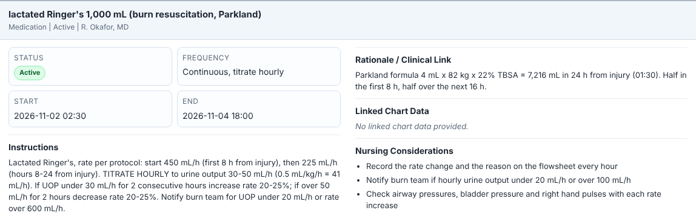
EHR screenshot: Orders, order detail for the lactated Ringer's (click the order to open this panel).
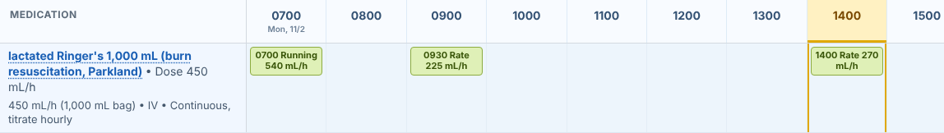
EHR screenshot: the MAR row for the lactated Ringer's on Monday (rate changes are shown in the hour they happened).
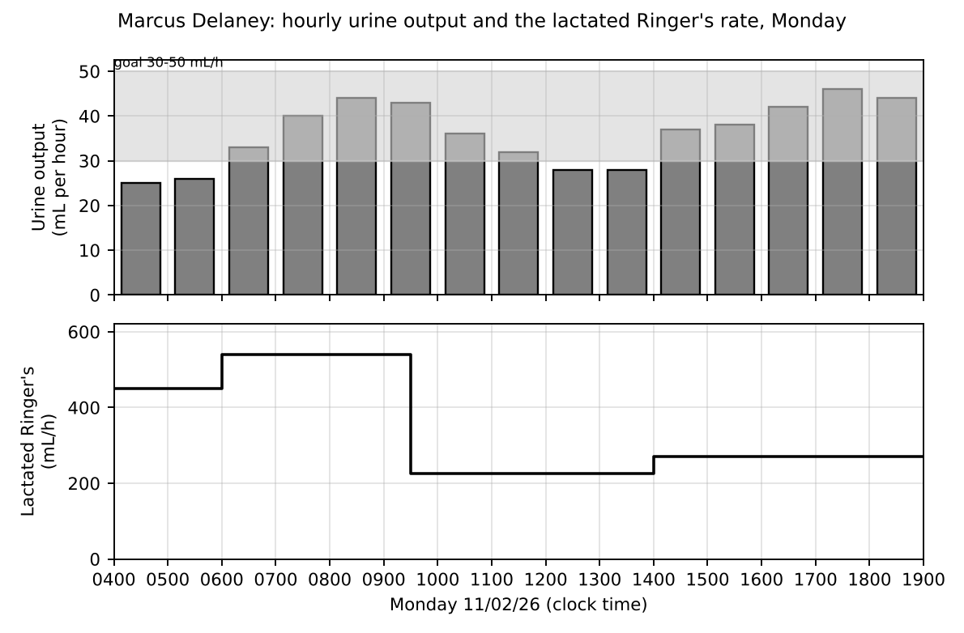
Graph from the chart: hourly urine output (bars, shaded band is the goal) and the lactated Ringer's rate (line), Monday 0400 to 1900.

1.6 Calling the Burn Surgeon (1.5 pts)
It is 1400 and you have just seen the second low urine output. Write the SBAR you give Dr. Okafor on the phone. Use real numbers from the chart. End with what you are asking him to do and how you will confirm the order.
Where to look in the EHR: Flowsheets (vital signs, I&O, neurovascular); Lab Results (lactate, potassium, CK); Orders

1.7 Lines, Tubes and Airway (1.5 pts)
List SIX lines, tubes or devices Marcus has at 0700 (not counting the ventilator). For each, write the site and what you check every shift, and one complication you are watching for.
Where to look in the EHR: Avatar (IVs, drains and tubes); Flowsheets > Lines / Drains / Airways; Nursing Admission Note
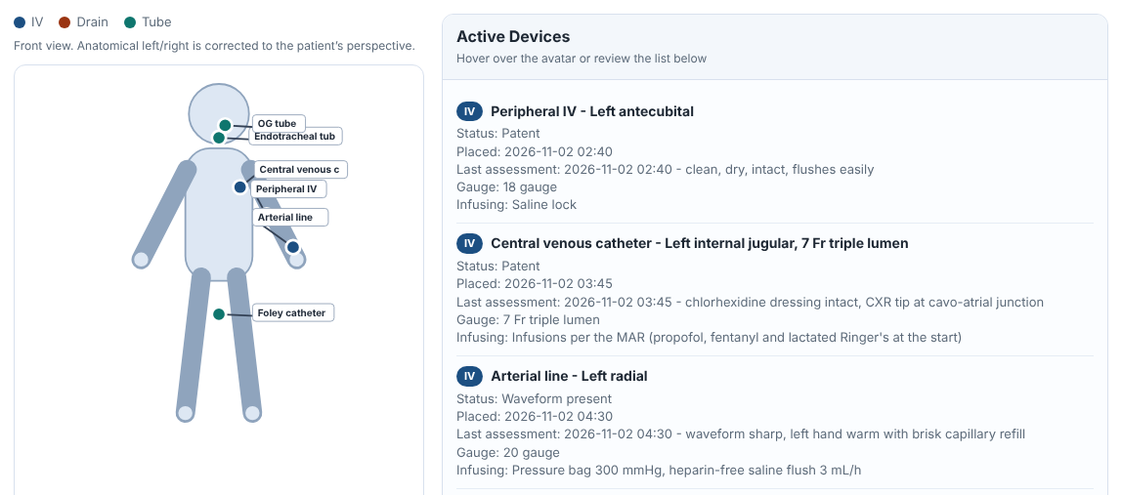
EHR screenshot: the Patient Summary page, Avatar and Active Devices list at 0700 (scroll the list to see every device).
Device and site | What you check or do every shift | A complication you watch for

1.8 The Ventilator and Sedation (1.5 pts)
Open Flowsheets > Respiratory at 0700. (a) Calculate his ideal body weight (male: 50 kg + 2.3 kg for every inch over 5 feet; 1 inch = 2.54 cm) and the tidal volume at 6 mL/kg. Does this match the set tidal volume? (b) List FOUR actions in the ventilator-associated pneumonia (VAP) bundle that you do this shift. (c) What is the RASS goal on Monday, and why is he sedated more deeply on the first day?
Where to look in the EHR: Flowsheets > Respiratory (vent settings, pressures); Orders (mechanical ventilation; sedation); Orders > Nursing

1.9 Reading the Labs (1.5 pts)
Open Lab Results and compare the first draws (about 0240-0250) with the 1200 and 1800 draws. Choose FOUR labs or lab groups that changed or matter. For each, write the values, why this happens in a burn patient, and what you do about it.
Where to look in the EHR: Lab Results (Chemistry, CBC, Blood Gas)
Lab and values (first draw to latest) | Why this happens in Marcus | What you do

1.10 Adding Up Your 12 Hours (1.5 pts)
Open Flowsheets > Intake/Output and find the Totals section at the bottom (the screenshot shows where). (a) For the DAY SHIFT 0700 to 1900, what are his total intake, total output and net balance? (b) What was his average urine output in mL/h and in mL/kg/h (82 kg)? (c) Using the Parkland rates, how much lactated Ringer's should he have received BY 1900 counting from the injury (the EMS 500 mL and the ED 675 mL before the ICU count), and how much did he actually receive in all (add up the rates and times on the MAR)? (d) What does that tell you?
Where to look in the EHR: Flowsheets > Intake/Output (Totals at the bottom); MAR (lactated Ringer's); EMS Handoff and ED notes
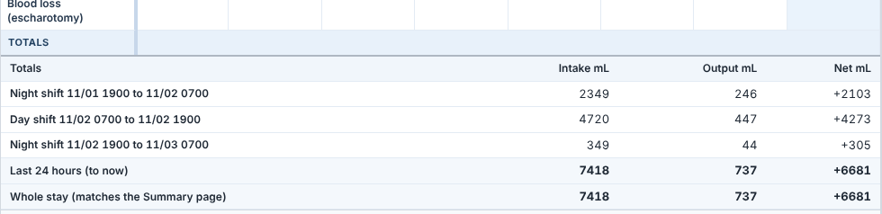
EHR screenshot: the Totals section at the bottom of the Intake/Output flowsheet, at 1900 on Monday.

1.11 The 1400 Dressing Change (1.5 pts)
Read the Burn Wound Assessment note and the 1520 nursing note. (a) Why was hydromorphone given at 1345 and what tool measures pain in an intubated, sedated patient (name its four parts)? (b) Which topical drugs were applied and where? (c) What do you assess at every dressing change? (d) Name two ways you protect him and yourself from infection.
Where to look in the EHR: Chart Review > Notes (Burn Wound Assessment; Nursing Note 1520); MAR (hydromorphone, silver sulfadiazine, bacitracin)

1.12 Handoff at 1900 (2 pts)
It is 1850. Write your SBAR handoff for E. Haddad, RN, the night nurse. Use real numbers and name what the night nurse must watch for and do in the first part of the night, including anything coming up in the next few hours.
Where to look in the EHR: Everything you have charted and read this shift; Orders; Lab Results; MAR; Flowsheets

PART 2: SHIFT 2: MONDAY 11/02 1900 TO TUESDAY 11/03 0700 (NIGHT SHIFT)
Nursing process step: Night of day 1 to day 2 | About 60 minutes | 16 points
Set the simulation clock to 1900 on Monday 11/02/26. You take report from the day nurse and care for Marcus until you hand off at 0700. Keep reading forward in the chart as the clock moves; do not look past 0700 for this shift.
2.1 Vital Sign Trend Through the Night (1.5 pts)
Set the clock to 1900 on Monday. You take report from the day nurse. Copy the vital signs at each time, circle every abnormal value, then write two sentences below: what the night looked like overall, and what the flowsheet does NOT show about the agitation event that happened around 0245.
Where to look in the EHR: Flowsheets > Vital Signs
Vital sign | Mon 1900 | Mon 2300 | Tue 0300 | Tue 0700
Temperature
Heart rate
Blood pressure
Respiratory rate
SpO2 (%)
Pain (CPOT)

Trend in one sentence:

2.1b Overall night, and what the vitals do not show (scored with 2.1) (0 pts)

2.2 Glucose and the Insulin Infusion (2 pts)
Open Lab Results (Glucose, point of care and serum), Orders, the MAR and the 0150-0320 nursing notes. (a) List his glucose values from 1800 through 0300 and explain why the insulin infusion was started at 0030 and at what rate. (b) Why does a burn patient have a high glucose even though he has no diabetes? (c) What is the glucose goal and how often do you check it on the infusion? (d) Give TWO safety actions for an insulin infusion, including what you must do if the tube feeding is stopped, and name one lab that you watch closely with insulin.
Where to look in the EHR: Lab Results (Chemistry, Bedside Testing); Orders; MAR (insulin infusion); Chart Review > Notes

2.3 The End of the First 24 Hours (1.5 pts)
The Parkland period ends at 0130 (24 hours after the injury). Using the lactated Ringer's rates and times on the MAR (EMS 500 mL, ED 450 mL/h from 0230 to 0400, then the ICU rates), (a) add up the total crystalloid he received from the injury to 0130 and compare it with the Parkland goal. (b) What did the order change to at 0130 and what new fluid starts at 0600? (c) Why do the fluids not simply stop at 24 hours? (d) His weight was 82 kg on arrival and is now 89.6 kg: what does that tell you and what else do you watch for?
Where to look in the EHR: MAR (lactated Ringer's rate changes); Orders; Flowsheets > Cardiac (daily weight) and Intake/Output; Nursing Note 0150

2.4 Alcohol and the Next Three Days (1 pt)
His ethanol level was 42 mg/dL at 0240 and he usually drinks 4 to 6 beers on weekends, more than that the night of the fire. (a) When could alcohol withdrawal begin, and when are seizures and delirium tremens most likely? (b) Why may you not see the signs yet? (c) Which two vitamins are ordered and why? (d) Name three signs you would watch for.
Where to look in the EHR: Lab Results (Toxicology); H&P (social history); MAR (thiamine and folic acid)

2.5 The Agitation Event at 0245 (2 pts)
Read the 0320 nursing note. Marcus (RASS -3 earlier) becomes restless, thrashes his head, bites the endotracheal tube and the ventilator pressure alarms sound. (a) In order, what do you check and do FIRST, before any medication, and why? (b) The provider orders lorazepam 1 mg IV. Name one concern about giving a benzodiazepine to this patient and one question you could ask the provider. (c) What are the rules for the soft wrist restraint you are using? (d) Besides the 0300 recheck, what do you document and who do you notify?
Where to look in the EHR: Chart Review > Notes (Nursing Note 0320); Orders (soft wrist restraint, lorazepam); Flowsheets (RASS, CPOT, ventilator); MAR

2.6 Checking the Right Hand and the Abdomen (1.5 pts)
Compartment syndrome is a risk after a circumferential burn and a large fluid resuscitation. For each of the six Ps, write what you can or cannot check in Marcus (he is sedated and intubated) and what the chart showed at 2300-0300. Then name the abdominal check ordered every six hours.
Where to look in the EHR: Flowsheets > Musculoskeletal / Mobility (Right Hand Neurovascular check); Nursing Notes; Orders (bladder pressure)
The 6 Ps | Can you check it in Marcus? How? | What the chart showed

2.7 Tube Feeding and Calories (1.5 pts)
Open the tube feeding order and the flowsheet. (a) Write the advancing schedule from 1000 Monday and the rate at 0600 on Tuesday. (b) The formula is Osmolite 1.5, which has 1.5 kcal per mL and 62.7 g of protein per liter: how many calories and grams of protein will he receive in 24 hours at 70 mL/h? (c) Give two reasons burn patients are fed early through the gut. (d) What do you check before advancing, and what do you do for a residual over 500 mL?
Where to look in the EHR: Orders (Osmolite 1.5); Flowsheets > GI (Diet / Feeding); Intake/Output; Chart Review (Nutrition Assessment)

2.8 The Midnight and 0600 Labs (1.5 pts)
Open Lab Results and compare the 0000 and 0600 draws (and the 0500 albumin and coagulation labs) with the day shift values. Choose FOUR results. Write the values, why they happen in a burn patient on propofol and tube feeding, and what you do or ask for.
Where to look in the EHR: Lab Results (Chemistry, CBC, Coagulation, Blood Gas)
Lab and values | Why this happens in Marcus | What you do or ask for

2.9 Propofol: Math and Safety (1.5 pts)
At 1900 on Monday the propofol is running at 35 mcg/kg/min. The bag is propofol 10 mg/mL and his weight is 82 kg. (a) Calculate the rate in mL/h. (b) Propofol gives 1.1 kcal per mL: how many calories does the sedation add in 24 hours? (c) Name two reasons you check the triglyceride level and two signs of propofol infusion syndrome. (d) Name two nursing actions for the bag and tubing.
Where to look in the EHR: MAR (propofol); Orders (propofol); Lab Results (Triglycerides); Flowsheets (RASS)

2.10 Handoff at 0650 (2 pts)
It is 0650 on Tuesday. Write your SBAR handoff for J. Morales, RN, the day nurse. Use real numbers, include the events of the night, what is happening in the next few hours (look at the orders and MAR), and anything you would like the day team to follow up.
Where to look in the EHR: Everything you read and charted this night; Orders; MAR; Lab Results; Flowsheets

