How to Use ​Flex​Patent
Welcome to FlexPatent. This software is designed to help you draft a better patent application by helping you find errors, inconsistencies, and help you while you work. The following will help you use our software.

NOTE: FlexPatent is a patent error checking platform and should NOT be relied on as a substitute for your own review, and legal expertise.

If you have any feedback or questions, please email us at: ​info@flexpatent.com​.

Table of Contents:
How to Use FlexPatent | 1
Adding FlexPatent to Microsoft Word | 2
Starting FlexPatent | 2
Logging In To FlexPatent | 3
Claims Section | 3
Analyze Once | 4
Analyze Live | 5
Remove All Highlights | 5
Specification Section | 6
Analyze the Specification | 6
Element Table | 7
Figures | 7

1

Adding ​Flex​Patent to Microsoft Word

FlexPatent can be installed as an add-in for Microsoft Word on almost any computer including PC and MAC. Navigate to “insert” in the Microsoft Word Ribbon, click “my add-ins” and then search for “FlexPatent”. In one click you can install the add-in and get started.

Starting FlexPatent

After you have installed FlexPatent, you can use the software anytime by clicking “Flex Patent” in the ribbon.
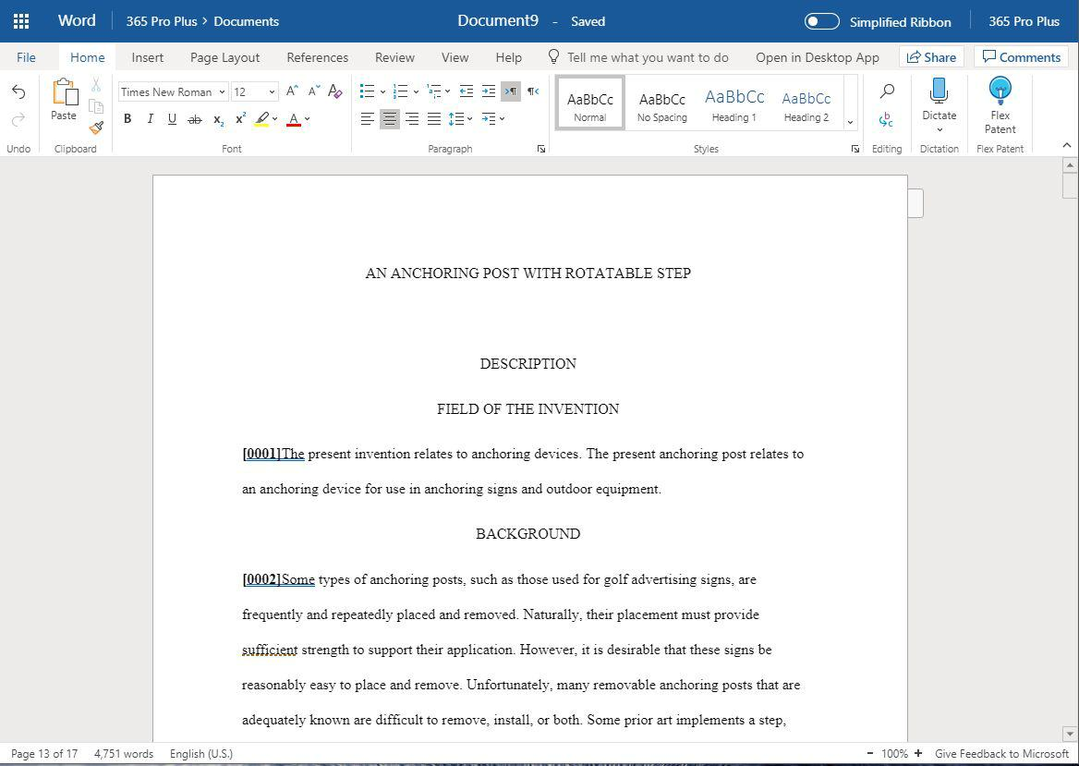

2

Logging In To ​Flex​Patent

Once you clicked the “Flex Patent” icon (it looks like a light bulb) you will be greeted with login information.
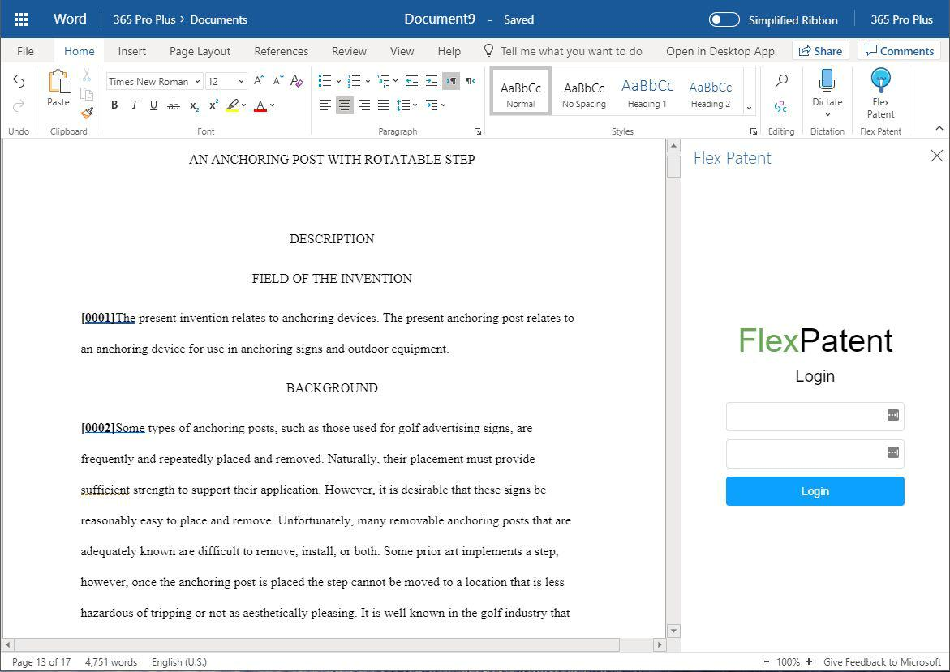

If you don’t have login information yet, head over to flexpatent.com and sign up!

Claims Section

After you login you will be greeted with various tools you can use. Such as the claims section.

3

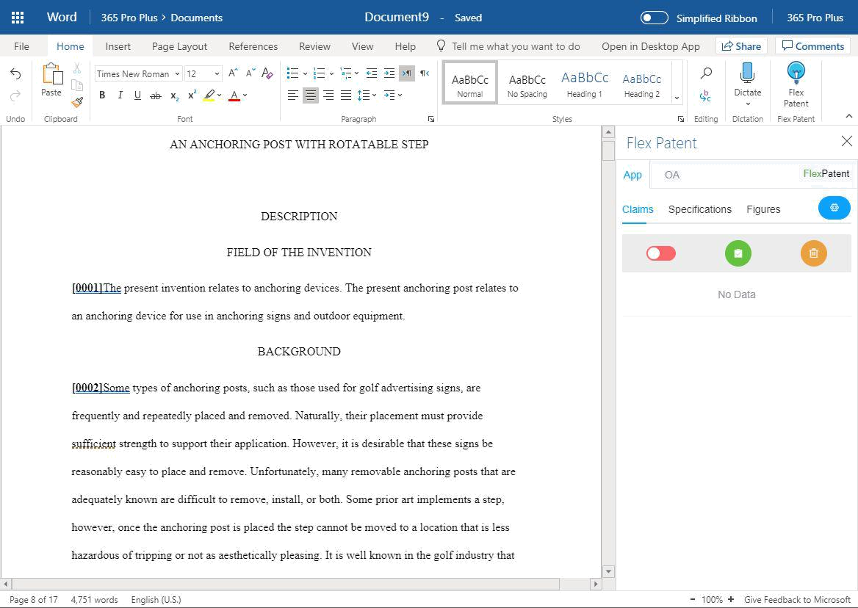

Here you are greeted with three options for the claims. You can analyze claims live using the red slider, you can analyze the claims once by clicking the green button, or you can remove all highlights by clicking the orange button.

Analyze Once

By clicking the green button “Analyze Once” (described above) the claims are analyzed, and errors are shown on screen. The errors are also shown as highlights to the patent application. This way, you can inspect and make changes to the claims easily.

4
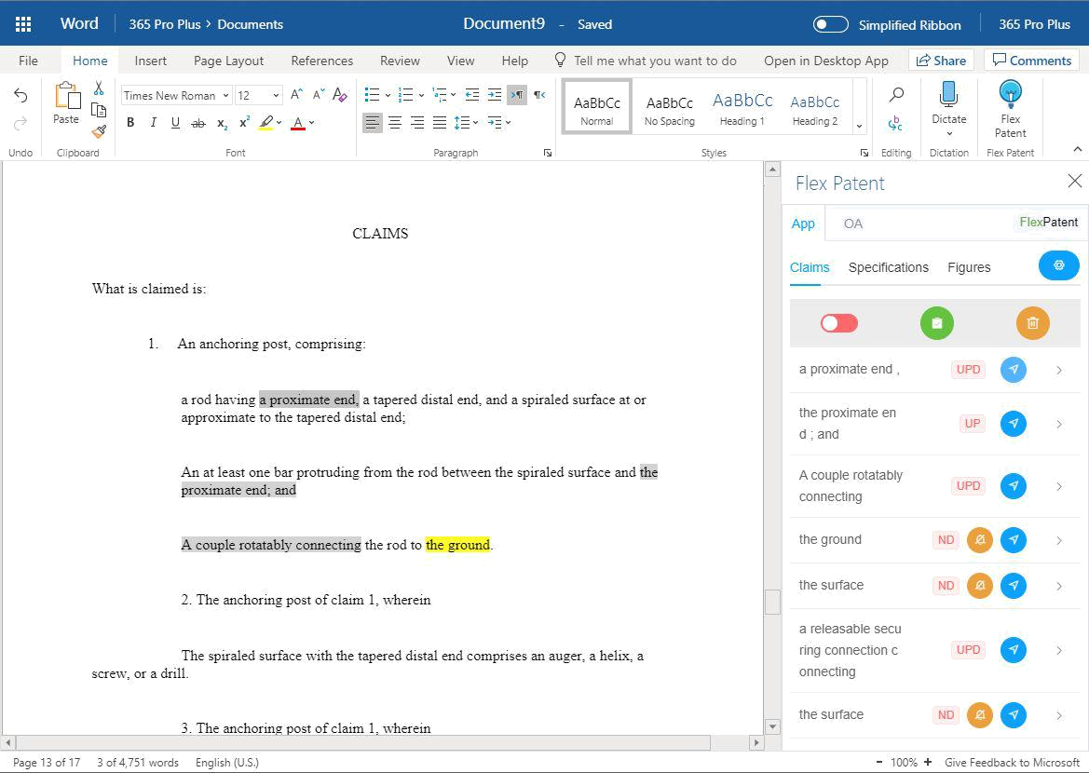

There are several colors of highlights corresponding to different error types. You can expand the panel on the right hand side to learn more about the error.

You can customize how errors are found using our software too. Just click the blue button to manually adjust any settings.

Analyze Live

Analyze live is similar to analyze once, where errors to the claims are analyzed, however, FlexPatent will analyze the claims over the course of every few seconds. You can change how frequently the live analysis occurs by clicking the blue button to adjust any settings.

Remove All Highlights

Remove all highlights removes from the document any highlights. We recommend clicking this button to remove all highlights after reviewing the errors found.

5

Specification Section

Click over to the “Specification” section and you can analyze the specification of your patent application. You have a green button to analyze the specification and a blue button to generate a popout of the element table.
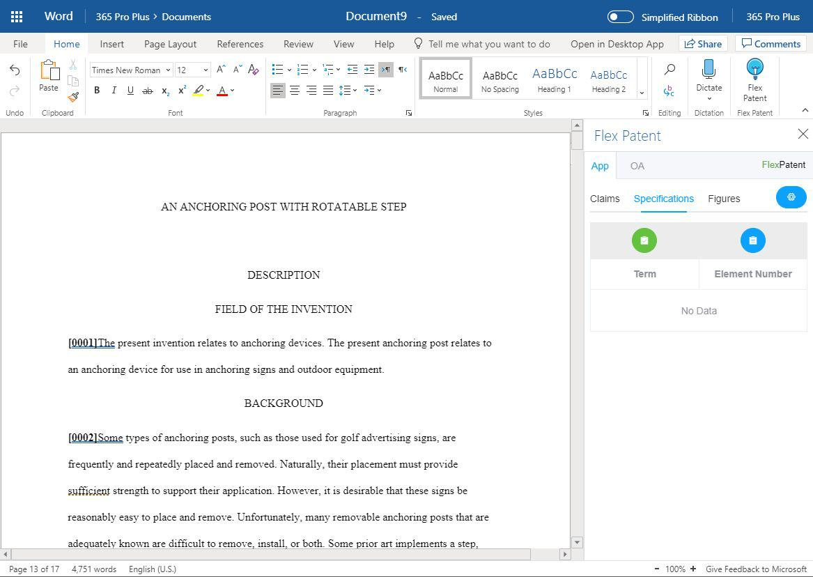

Analyze the Specification

At any time, you can click the green button to analyze the specification.

6

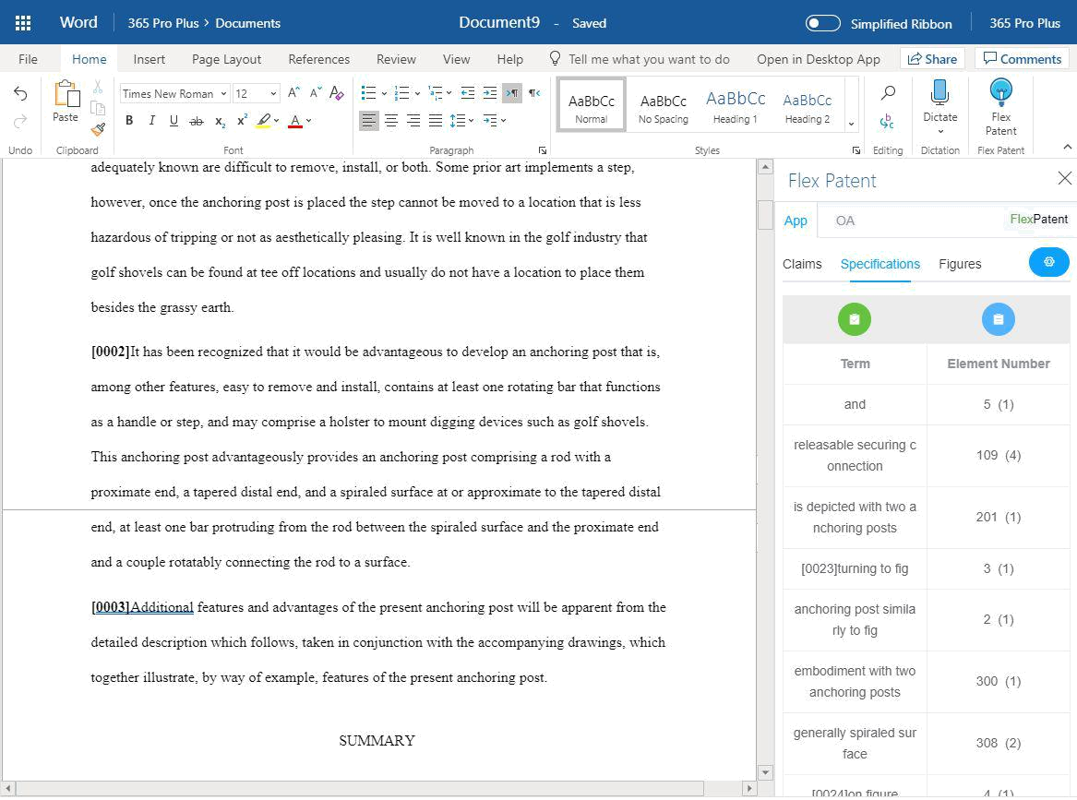

When you do, any errors from the specification will appear. Shown on the left are the elements found and the claim number is on the right such as “201” next to these element numbers is the number of times the element appears “(1)”.

Element Table

By clicking the blue button on the Specification tab, the elements found by FlexPatent will be updated.

Figures

7
If you click the “Figures” tab you will be greeted with the following screen. Drag and drop an OCR’ed PDF to check for any errors and receive an element table of the items in the figures.
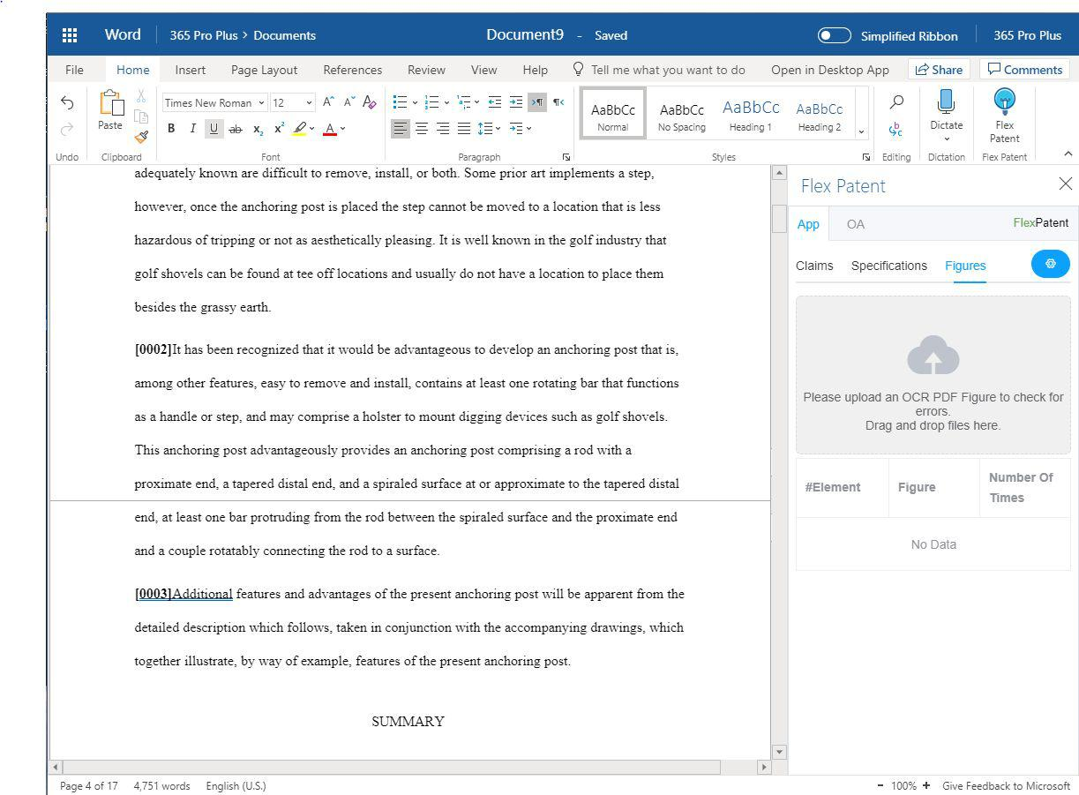

8

