Testing Feedback – 14/10/19

Comments: The system is starting to take shape and looks really good in most areas. I have outlined some amendments required.

I think the main observation is that the bar charts for the results don’t look as professional as the rest of the site does. Can this be reviewed first please? I have put some examples of other graphs below which may be easier to develop for you. They need to be clear and look clean and professional which I am sure you will be able to achieve with the time.

This article on some graph programs which are already out there may be useful for you: <https://alvinalexander.com/php/free-php-charts-graphs-pie-bar-line-charting-graphing>

Note, we are more than happy to continue with the current style of graph if the output is improved and will look more impressive and visually more appealing.



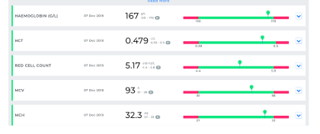

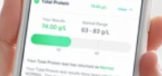

1. The order number in the order history does not match up with the test results tab.
2. When this results tab is open can the arrow please point the other way. Still to be corrected

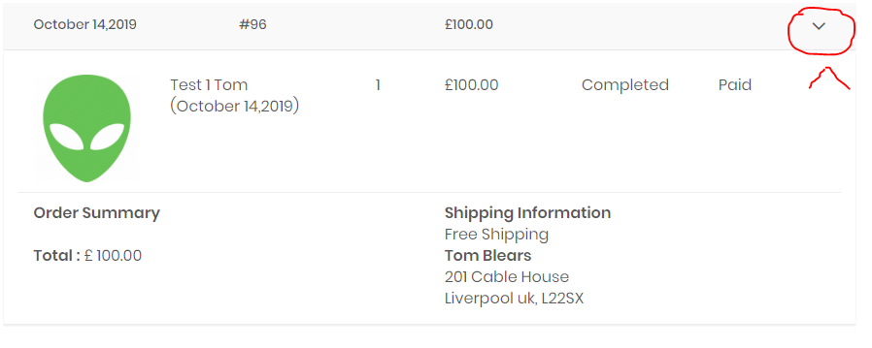

1. Can the following amendments be made to the upload results panel:

1 – What does this do? I’m not sure it is needed.

2 - What does this do? I’m not sure it is needed.

3 - What does this do? I’m not sure it is needed.

4 & 5 – Pre-populate with tomorrows date (this will error but will also make it easier to amend without making mistakes).

1. In the screen when reviewing the results tab the back button does not allow you to return to the screen where you input the results. It instead takes you out to the main orders hub. This doesn’t allow you to change the results – please see further testing 12.

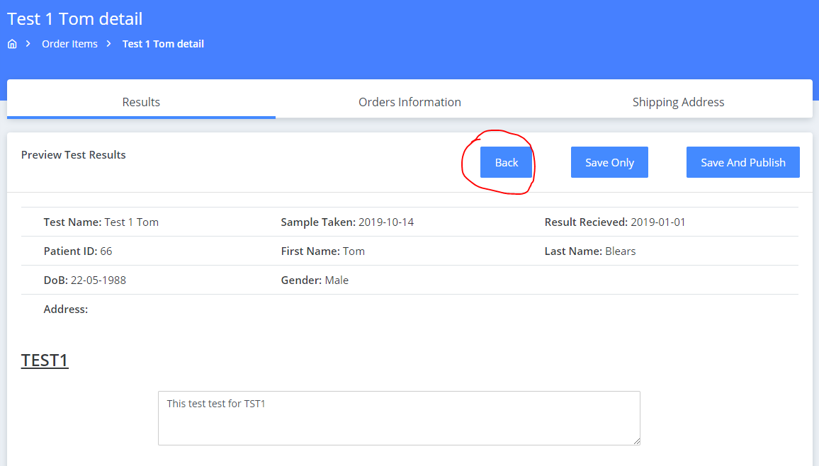

1. Discount price can’t be larger than the actual price. Still to be corrected

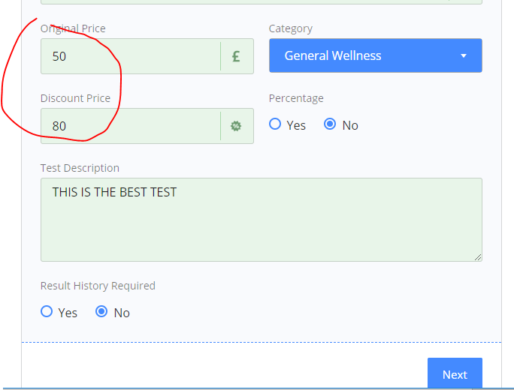

1. Uploading results: I created 4 markers:

Marker 1 – This should have a max and minimum of 0 and 100

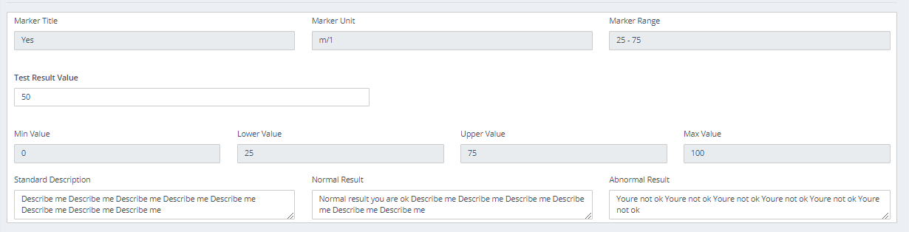

As you can see below, the graph goes beyond 0 and 100. It goes down to -12.5 and up past 100. This should not happen. Also the commentary that goes along with the result is not displayed for the customer. The icon is also not coming out as the icon for the test. This should be the tick icon. Also, the bar chart isn’t on the 50 mark.

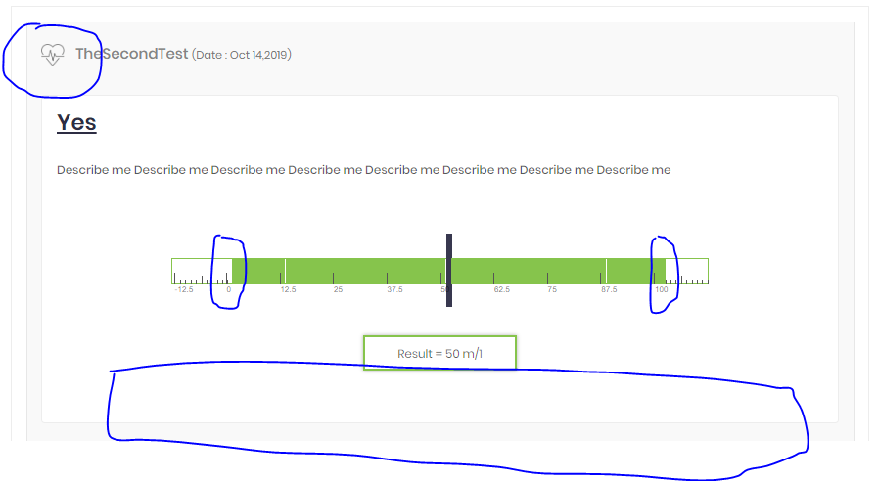

Also in the above between 0 and 25, and between 75 and 100 these should be red. In between 25 and 75 this should be the green section.

The next market should be limited to 50 as the minimum and 200 as the max.

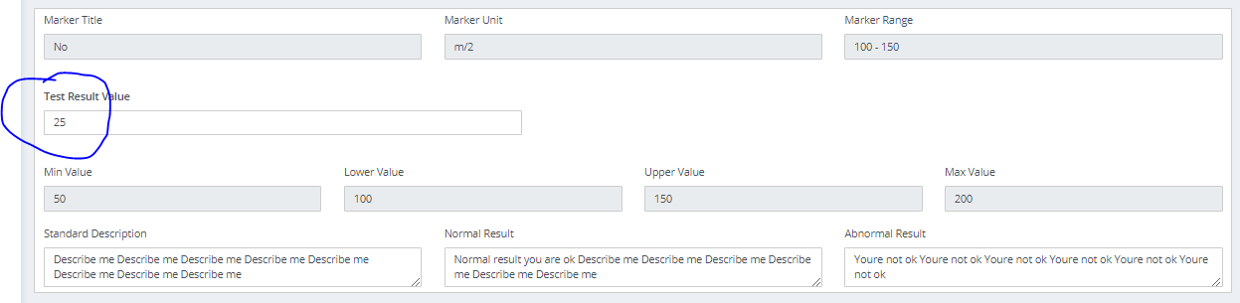

The actual result has come out as 25. This should not be possible as it is below the minimum value. Still to be corrected – please see further testing 12 for more detail

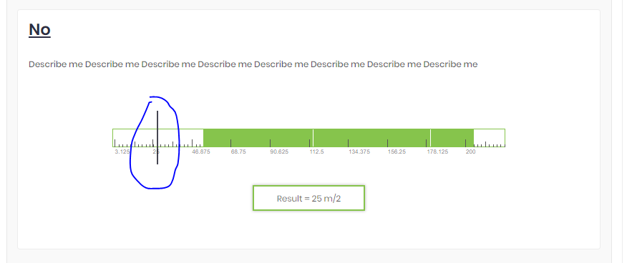

1. Please remove the scroll from the result value box’s also. I’m worried this may get scrolled and amended in error.

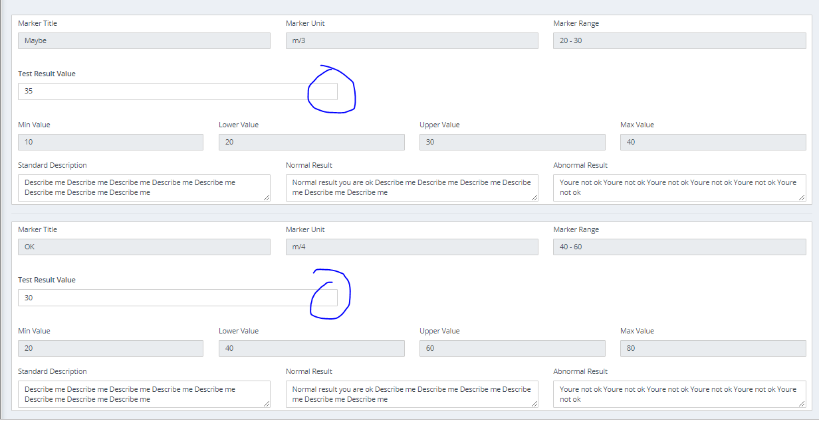

Also, the minimum, lower value, upper value, max value must be amendable. They are right to be blue but there can be occasions where these would need to be manually amended. Still to be corrected – See further testing 11 below for more detail.

1. In the “Your results tab” please add a reorder button to any tests with results. This button will add the test to the basket and then take the member to the basket.

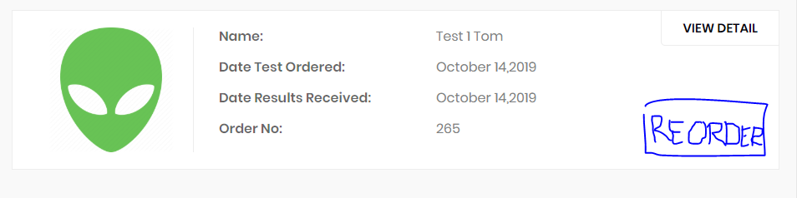

1. In the “Youre order history” please add a reorder button to any tests with a status of completed.

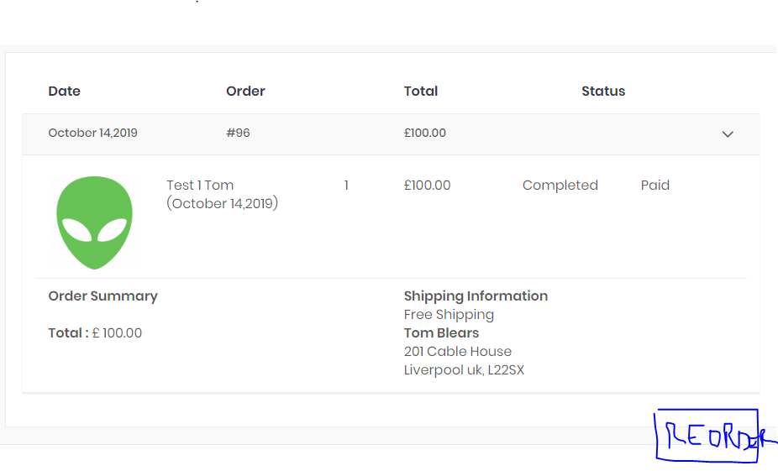

Out Of Scope Change – Hopefully Really Quick For You To Do Please

1. Please remove this box from the checkout. This is old functionality and is no longer needed.

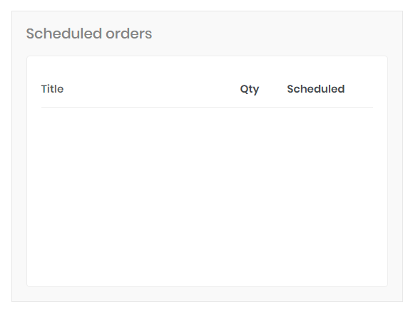

Further testing 04/11/2019

1. The input boxes below need to be amendable. They can change depending on the customers age/sex so we need to be able to amend them.

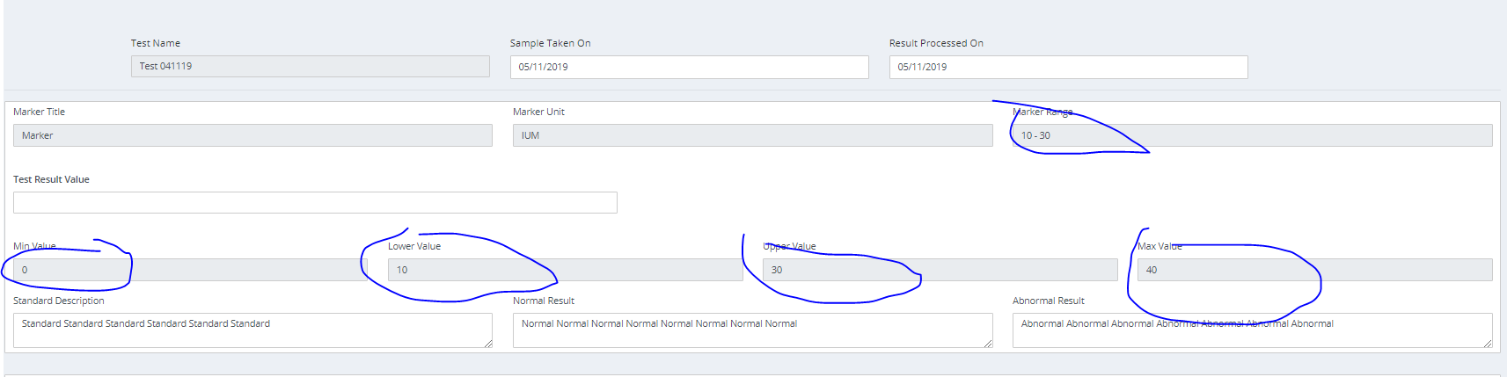

1. It should not be possible to enter in a result which is outside the maximum or minimum range. E.g. if the minimum value is 10 the result can’t be 5.

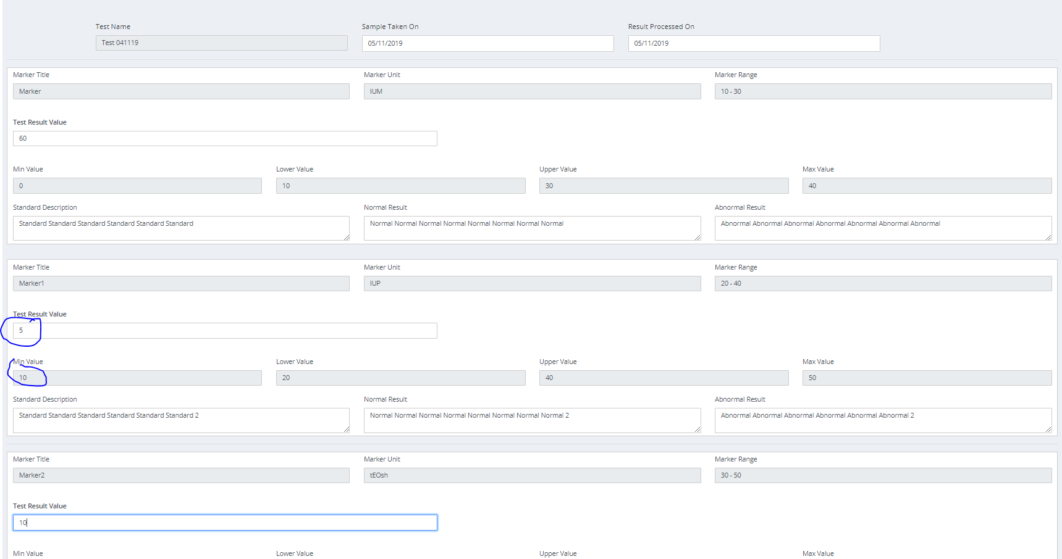

The graph doesn’t show these results which is correct, however I can’t go back to correct them

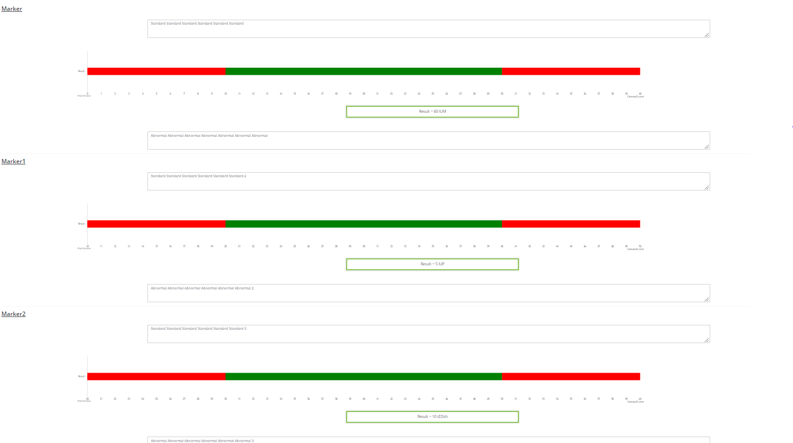

1. The new graph format does not print onto the download.

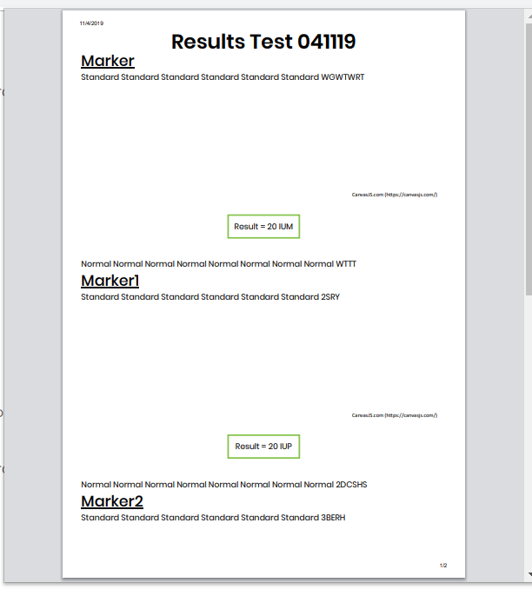

1. The new graph format has been improved however it looks like it is using a trial version of a library. What is the plan moving forward with this?