# Annexure3b- Complete filing

# INVENTION DISCLOSURE FORM

**Unilink: Decentralized AI Matchmaking & Career Growth Platform**

The invention exploits AI and blockchain for developing a secure, smart credential verification and resume optimizing system. It promotes hiring transparency, forestalls fraud, and enables individuals with privacy-governed data sharing. Through the provision of equal job opportunities and credible skill validation, this innovation facilitates UN Sustainable Development Goals (SDGs) like Quality Education (SDG 4), Decent Work & Economic Growth (SDG 8), and Industry, Innovation & Infrastructure (SDG 9) for a secure and inclusive digital workforce.

|  |  |
| --- | --- |
| A. Full name | Mohit Mankas |
| ­­­­­Mobile Number | 8168243170 |
| Email | Mohitgujjar@gmial.com |
| UID/Registration number | 12224231 |
| Address of Internal Inventors | Lovely Professional University, Punjab-144411, India |
| Signature |  |

|  |  |
| --- | --- |
| B. Full name | Sarthak Sharma |
| ­­­­­Mobile Number | 8534887052 |
| Email | Sarthaks264@gmail.com |
| UID/Registration number | 12326242 |
| Address of Internal Inventors | Lovely Professional University, Punjab-144411, India |
| Signature |  |

|  |  |
| --- | --- |
| C. Full name | Shubham |
| ­­­­­Mobile Number | 8770517056 |
| Email | shubhambargat143@gmail.com |
| UID/Registration number | 12300395 |
| Address of Internal Inventors | Lovely Professional University, Punjab-144411, India |
| Signature |  |

|  |  |
| --- | --- |
| D. Full name | Syed Mohammed Mohtashim |
| ­­­­­Mobile Number | 7889929416 |
| Email | Syedpeerzada80@gmail.comg |
| UID/Registration number | 12224093 |
| Address of Internal Inventors | Lovely Professional University, Punjab-144411, India |
| Signature |  |

|  |  |
| --- | --- |
| E. Full name | Gelson Samson |
| ­­­­­Mobile Number | 7439730554 |
| Email | gelsonsimpson64@gmail.com |
| UID/Registration number | 12210823 |
| Address of Internal Inventors | Lovely Professional University, Punjab-144411, India |
| Signature |  |

|  |  |
| --- | --- |
| F. Full name | Sir |
| ­­­­­Mobile Number |  |
| Email (personal) |  |
| UID/Registration number |  |
| Address of Internal Inventors | Lovely Professional University, Punjab-144411, India |
| Signature (Mandatory) |  |

**DESCRIPTION OF THE INVENTION:**

The invention unveils an artificial intelligence-enabled blockchain-based credential authentication system that brings improvements in storing, authenticating, and exchange of academic and professional documents. Contrary to slow and easily fraud-prone traditional methods, this system authenticates the secure storage of tamper-proof credentials, resume enhancement with intelligence optimization, sharing with data privacy management, and updated real-time. Through the use of blockchain for security and artificial intelligence for automation, it enables candidates to hold a dynamic, verified resume that facilitates employers and universities to make quicker, more accurate decisions. The system further has fraud-detection measures against identity theft and counterfeit credentials as well as automated credential expiration and renewal through smart contracts. Further, Zero-Knowledge Proofs (ZKP) enable the selective disclosure of only relevant data, ensuring privacy while promoting transparency. This method revolutionizes the recruitment and admissions process by rendering it more secure, efficient, and reliable for all parties involved.

**PROBLEM ADDRESSED BY THE INVENTION:**

The verification process of academic and professional qualifications is usually time-consuming, costly, and not reliable. Employers, institutions, and certification bodies depend on manual verification, which not only consumes time but also makes it easier for counterfeit or altered credentials to go undetected. Candidates, however, have a hard time storing and sending their credentials securely, resulting in lost documents, duplication, or unauthorized access.

Although blockchain-based credential verification systems do exist, they are primarily designed to securely store records. They do not assist in analyzing, ranking, or making more informed hiring and admission decisions. No method of authenticating true skills beyond paper is possible, keeping user privacy intact while sharing credentials, or detecting fraud in real-time.

This invention addresses these issues by marrying blockchain with AI and smart automation. It not only provides tamper-proof storage of credentials but also examines and ranks resumes, enables privacy-managed data exchange, identifies fraud, and automatically keeps records updated. This speeds up credential validation, makes it more reliable and future-proof, and is useful for both individuals and organizations.

**OBJECTIVE OF THE INVENTION:**

A. Building Trust and Transparency in Credential Verification

The innovation proposes a safe and fraud-proof environment where professional and academic credentials are placed on an tamper-evident blockchain. This will make all the qualifications authentic, verifiable, and readily accessible, eliminating the threat of fraudulent degrees and deceptive resumes.

B. Enhancing Hiring and Admissions with AI-Driven Resume Optimization

By combining AI-driven resume ranking and skill-matching, the platform assists candidates to receive improved job opportunities and empowers recruiters and universities to make quicker, better-informed choices. AI dynamically updates resumes with verified experiences, helping candidates showcase their most up-to-date and competitive resume.

C. Maintaining Privacy and Regulated Data Exchange

The system introduces selective sharing of credentials via Zero-Knowledge Proofs (ZKP) such that only required information is shared with recruiters or institutions without revealing their entire record. This preserves privacy while ensuring verification integrity.

D. Credential Management Automation for Lifelong Use

By utilizing smart contracts, the system automates the reminders for expiration and renewal of credentials so that expired certificates do not misinform employers and assist professionals in maintaining qualifications current and valid.

**STATE OF THE ART/ RESEARCH GAP/NOVELTY:**

|  |  |  |  |  |
| --- | --- | --- | --- | --- |
| Sr. No. | Patent I’d | Abstract | Research Gap | Novelty |
|  | US20220318757A1 | A system for verifying and issuing the credentials of a candidate using blockchain technology is disclosed. The system is configured to enable candidates to store blockchain credentials and verify the candidates' blockchain credentials and create a blockchain based credential wallet for the users and/or candidates to securely transfer/share the credentials. The system enables issuers to check, verify, and also transfer or share diplomas and certificates, test results, and professional accreditation to the user's blockchain based credential wallet via the network. The system enables receivers to verify the blockchain credentials of a candidate from the blockchain based credential wallet via the network. The system enables the users to share the blockchain credentials and apply universities and jobs using the blockchain credentials stored in the blockchain based credential wallet, and also enables the candidates to share the blockchain credentials to one or more third parties through a quick response (QR) code/URL link/HyperLink. |  No AI-Powered Resume Optimization   The system keeps and exchanges credentials but does not organize them into an intelligent resume.   AI can automatically create and update resumes based on verified credentials, and job applications become hassle-free.   AI can also match candidates with appropriate jobs or universities based on their verified abilities.   No Trust Score or Reputation System   Credentials are verified, but recruiters cannot determine a candidate's credibility beyond paperwork.   An AI-powered Trust Score from verified skills, endorsements, and previous work history can enhance hiring decisions.   No Selective Data Sharing (Privacy Issue)   Users are required to share complete credentials through QR codes/links, even if only certain information is needed.   Zero-Knowledge Proofs (ZKP) can enable selective sharing, enhancing privacy control.   No Fraud Detection Mechanism   Blockchain verifies credential authenticity but does not prevent fraud or identity theft.  Fraud detection using AI can identify similar, suspicious, or conflicting credentials prior to verification.   No Auto-Expiry & Renewal System for **Credentials**   * Stored credentials remain unchanged, with no mechanism to track expiry or renewal. * Smart contracts can automate expiry tracking and renewal reminders to keep records up to date. * validity over time. * Smart contracts can automate expiry tracking and send renewal reminders for certifications that expire after a set period. * This ensures credentials remain valid and up to date. |  AI-Based Smart Resume & Profile Analysis   AI can auto-create and revise resumes based on verified credentials.   It can also review job posts and recommend profile enhancements.   AI-based matching can link candidates to relevant jobs or universities based on verified skills.   AI-Based Trust Score for Candidates   A Trust Score system based on verified skills, prior experience, and recommendations can boost credibility.   Employers can evaluate candidates without long background checks.   This streamlines the hiring process and increases recruiter confidence.   Selective Data Sharing with Privacy Control   Users may share only limited credential information rather than the entire document.   Zero-Knowledge Proofs (ZKP) enable verification of qualifications without revealing sensitive information.   This enhances users' privacy and control over data.   AI-Powered Fraud Detection   AI can identify bogus, stolen, or duplicate credentials by cross-matching various sources.  The system can mark inconsistent job histories, fake |
|  | US20200007336A1 | Systems and methods for generating, presenting, and transmitting smart resumes that may have personally identifiable information hidden, but the remainder of the resume may be visible and include key elements (such as educational degrees, honors received, recommendations/references received, professional history) that may be verified by blockchain/distributed ledger technology. Partner companies may select a portion of the resume, such as a logo or icon, to verify that the user is credentialed on the platform and that select elements of the resume are verified. This verification allows companies to review blinded resumes with confidence knowing that the key underlying resume elements are factual even though they do not know the identity of the resume holder. |  Resume Optimization & Ranking Based on AI   Job descriptions can be analyzed and resumes ranked based on confirmed skills and experience using AI.   It can recommend resume enhancement based on current industry trends to make profiles recruiter-relevant.   This guarantees improved job-role alignment and reduces the hiring time.   Skill & Experience Verification Beyond Resumes   The platform can validate true skills and not merely degrees and previous employment.   Integration with coding tests, project-based assessments, and AI-skill analysis can yield tangible evidence of expertise.   AI also evaluates GitHub contributions, previous projects, and research papers for additional endorsement.   Selective Data Sharing & Privacy Control   Candidates may share only certain information rather than their entire resume.   Zero-Knowledge Proofs (ZKP) can verify qualifications without revealing sensitive information.   A dynamic access control system enables candidates to determine who may see what information.   Real-Time Resume Updates & Tracking   Integration of AI and blockchain can update resumes automatically when a new certification, job switch, or skill upgrade is confirmed.   A real-time tracking system can reveal when recruiters look at, shortlist, or engage with a resume.   This keeps resumes up to date and appropriate for hiring purposes.   Fraud Detection & Anomaly Detection System   AI can identify fake, duplicate, or inconsistent credentials prior to verification.  A fraud detection system can block identity theft, fraudulent references, and falsified work history.  Blockchain can keep a record of proof-of-work history to provide authenticity for employment records. |  AI-Based Resume Optimization & Ranking   AI-based resume ranking processes job postings and ranks job applicants on the basis of confirmed expertise and experience.   AI-powered individualized suggestions enhance resumes according to the latest job market trends.   AI-powered Applicant Tracking System (ATS) compatibility checker validates resumes go through automated screening barriers.   Skill & Experience Verification Beyond Documents  \tBlockchain-secured skill verification combines real-time tests, coding tests, and project reviews.   AI processes portfolios on GitHub, Kaggle, and research papers to ensure technical competence.   A peer-to-peer proof-of-work system logs actual project work experience attested to by previous employers.   Selective Data Sharing & Privacy Control   Zero-Knowledge Proofs (ZKP) facilitate selective disclosure of credentials (e.g., attestating a Master's degree without divulging university information).   Role-based access control permits applicants to authorize or withdraw the permissions for access to individual resume sections for various recruiters.   Secure sharing of credentials through QR codes or temporary access links maintains privacy.   Real-Time Resume Updates & Tracking   Automatic updates by AI account for new certifications, change of jobs, or upgraded skills.   A blockchain-based tracking system alerts the candidate when recruiters look at or shortlist the resume.   Analysis of job market trends prescribes skill upgrades based on recruiter demand.   Fraud Detection & Anomaly Detection System  Duplicate, conflicting, or suspicious credentials are detected by AI prior to verification.  Identity verification using deep learning prevents stolen credentials, impersonation attacks, and spoofed references.  Proof-of-employment stored in blockchain guarantees genuine work history and recommendations. |
|  |  |  |  |  |

**DETAILED DESCRIPTION:**

The verification of academic and professional credentials is usually time-consuming, inefficient, and prone to forgery. The conventional approach involves manual verification, resulting in delays and inconsistencies. This invention presents a blockchain-based credential verification system combined with AI-optimized resume, selective data exchange, real-time syncing, and fraud detection. Through these technologies combined, the system provides a secure, efficient, and intelligent credential management solution.

**Overcoming Current Limitations**

Existing blockchain-based credential verification systems, like those outlined in US20220318757A1 and US20200007336A1, are mainly concerned with storing and authenticating credentials but do not have intelligent resume ranking, privacy-managed data sharing, and sophisticated fraud detection. This invention addresses these shortcomings by integrating AI automation, smart contracts, and improved security features, thus making it a complete solution for academic and professional verification.

**System Features and Functionality**

1.Blockchain-Based Credential Wallet

o Stores academic degrees, certifications, and professional records securely.

o Ensures credentials are tamper-proof, obviating the necessity for third-party verification.

2. AI-Powered Resume Optimization and Ranking

o Automatically organizes and ranks resumes according to confirmed credentials.

o Matches candidates with appropriate job opportunities or academic institutions according to skill relevance.

3. Privacy-Controlled Credential Sharing

o Employs Zero-Knowledge Proofs (ZKP) to enable users to share only particular verified information without disclosing full documents.

o Offers encrypted access links, guaranteeing controlled and secure data sharing.

4. AI-Driven Fraud Detection and Prevention

o Identifies identity theft, duplicate records, and fraudulent references.

o Utilizes AI pattern recognition to identify suspicious credentials prior to verification.

5. Smart Contracts for Credential Expiry and Renewal

o Automates certification and professional accreditation expirations reminders.

o Guarantees that old credentials are updated or renewed to ensure data integrity.

6. Real-Time Resume Updates and Tracking

o AI automatically refreshes resumes upon new certification or job role verification.

o Allows tracking of recruiter interactions with the resume for enhanced transparency.

**Implementation and Workflow**

• Blockchain-verified credentials are issued by universities, employers, and certifying agencies to candidates.

• AI processes the credentials to create structured resumes and enable smart job matching.

• Users selectively share verified credentials with recruiters with control over their data.

• AI keeps the blockchain under continuous observation to identify any fraudulent activities and maintain data integrity.

• Smart contracts automate credential renewal and expiration with minimal manual intervention.

Advantages and Novelty Over Existing Systems

• Enhances efficiency through the combination of blockchain security with AI-powered automation.

• Enhances hiring accuracy by validating real-life skills beyond the confines of conventional documents.

• Improves privacy through selective data exposure mechanisms.

• Maintains data accuracy through automatic expiration and renewal of credentials.

• Offers a seamless user experience to job applicants, recruiters, and educational institutions through an intelligent, verifiable, and fraud-immune credential management system.

This invention reinvents credential verification by merging blockchain, AI and privacy controls, delivering a safe and future-proof solution for professional and academic record validation.

**RESULTS AND BENEFITS:**

• Quicker and Safe Credential Verification

• Leverages blockchain for ensuring tamper-proof storage and authenticity of professional and academic records.

• Eliminates third-party verification, saving processing time.

• AI-Driven Resume Optimization and Ranking

• Automatically ranks and structures resumes based on verified credentials and job relevance.

• Enables recruiters to efficiently discover the best candidates.

• Privacy-Controlled Data Sharing

• Zero-Knowledge Proofs (ZKP) enable selective sharing of certain credentials without revealing complete details.

• Users can create encrypted QR codes or secure links for controlled access.

• Fraud Prevention and Detection

• AI identifies false credentials, duplicate profiles, and fraudulent behavior.

• Guarantees that admissions and hiring are conducted on authentic, validated information.

• Smart Contract-Based Expiry and Renewal of Credentials

• Semi-automates reminders for expiring and renewing time-sensitive certifications.

• Forbids the use of expired credentials.

• Real-Time Resume Updates and Monitoring

• AI dynamically updates resumes as additional certifications or positions are entered.

• Job applicants are able to monitor when recruiters view or engage with their resumes.

• Enhanced Hiring and Admission Trust

• Universities and employers can use blockchain-validated credentials, lowering recruitment risks.

• Simplifies recruitment and admissions by offering real-time, verifiable records.

• Scalable and Easy to Use

• Built for professionals, employers, educational institutions, and students.

• Can easily be incorporated in current HR and university systems to facilitate easy use.

A.

**EXPANSION:** In order to make sure the invention is complete and highly flexible, multiple important variables are taken into consideration:

1. Blockchain Integration – The network should be compatible with multiple blockchain networks (for example, Ethereum, Hyperledger) to be able to make it secure, transparent, as well as harmonious with currently existing credentialing systems.

2. AI Algorithms – Machine learning algorithms are needed for resume optimization, ranking, fraud prevention, and verification of skills. The algorithms need to learn and update themselves regularly based on industry trends and hiring scenarios.

3. Data Privacy & Security – Utilization of Zero-Knowledge Proofs (ZKP) and encrypted sharing protocols guarantees selective sharing of credentials along with data privacy.

4. Smart Contracts – Automating the expiration of credentials, renewals, and verification requests via smart contracts allows for smooth functionality without human interference.

5. Integration with External Platforms – The system should be able to integrate with job sites, universities, certification authorities, and recruitment platforms to facilitate smooth data exchange verification.

6. User Accessibility & Control – An easy-to-use interface should enable users to manage their credentials, govern data sharing, and get in-real-time updates on verification status.

These factors render the system scalable, flexible, and future-proof, guaranteeing that it can be applied across sectors for secure and effective credential management.

**WORKING PROTOTYPE/ FORMULATION/ DESIGN/COMPOSITION:**

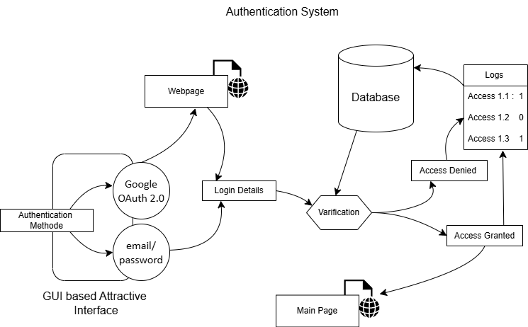

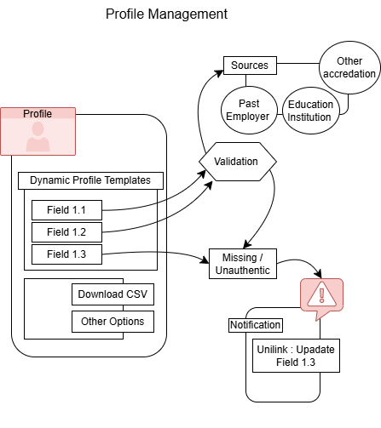

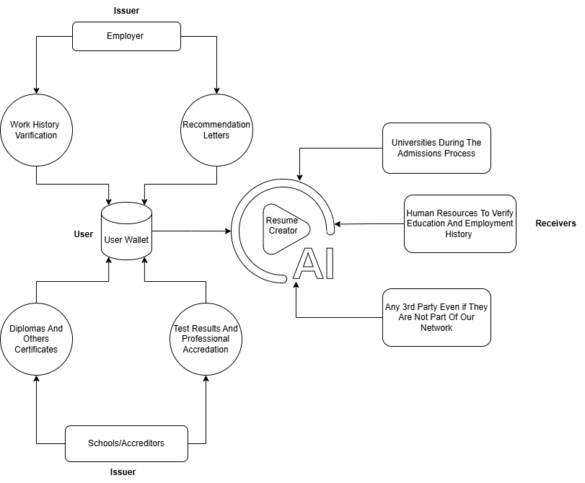

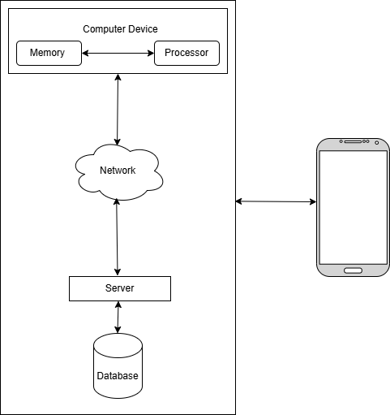

**Existing Data: Comparative Analysis**

**To validate this invention, we compared existing blockchain-based credential verification systems and determined the main differences. Current systems offer simple verification but do not include intelligent elements that enhance efficiency, security, and convenience. Let's consider how our invention differs:**

**1. Smarter Credential Verification – The old systems store and verify records on the blockchain but do not verify fraudulent claims. Our solution adds an AI-based fraud detection to flag fake or duplicate credentials.**

**2. AI-Powered Resume Optimization – The current systems restrict users to storing documents, but our innovation takes it a step ahead by automatically structuring, ranking, and updating resumes with verified skills and industry trends.**

**3. Selective Data Sharing & Privacy Control – Existing solutions compel users to either share their whole document or conceal it entirely. We bring in Zero-Knowledge Proofs (ZKP), where users can share only certain authenticated information, such as demonstrating they possess a degree without sharing the complete certificate.**

**4. Real-Time Updates & Tracking – The majority of credential systems maintain static records that do not change over time. Our innovation allows real-time updates whenever new certifications, job titles, or endorsements are entered, making records up-to-date and current.**

**5. Credential Expiry & Renewal Management – In contrast to current systems that do not track expiration, our smart contract technology provides automatic reminders and renewals for time-sensitive credentials such as professional licenses or certifications.**

**USE AND DISCLOSURE :**

|  |  |
| --- | --- |
| 1. Have you described or shown your invention/ design to anyone or in any conference? | NO |
| 1. Have you made any attempts to commercialize your invention (for example, have you approached any companies about purchasing or manufacturing your invention)? | NO |
| 1. Has your invention been described in any printed publication, or any other form of media, such as the Internet? | NO |
| 1. Do you have any collaboration with any other institute or organization on the same? Provide name and other details. | NO |
| 1. Name of Regulatory body or any other approvals if required. | NO |

**Commercialization Potential**

**The invention has good commercialization potential based on its capacity to automate credential validation, resume optimization, and fraud detection in various industries. Educational institutions, businesses, job markets, and government agencies can be helped by a trustworthy verification system that is AI-based, minimize recruitment fraud, and guarantee data authenticity.**

**The combination of blockchain and AI is extremely appealing for job portals, background verification agencies, and EdTech platforms who wish to provide secure, automated, and privacy-oriented solutions. Further, opportunities for licensing lie with HR tech firms and online learning platforms to embed this technology into their existing platforms.**

**Keywords**

**(i). Blockchain credential authentication, (ii). AI-driven resume ranking, (iii). decentralized identity management, (iv). smart contract-based credential verification, (v). selective data sharing,(vi). zero-knowledge proofs (ZKP), (vii). fraud detection in recruitment, (viii). secure digital credentials,(ix). automated skill authentication, (x). AI-driven job matching,(xi). blockchain-based academic records,(xii). privacy-preserving credential sharing,(xiii). real-time resume updates,(xiv). tamper-proof certification,(xv). blockchain for education and employment.**