**Credit Card Default Prediction**

**PW SILLS: FULL STACK DATA SCIENCE PRO**

**SUBMITTED BY: POONAM SAINI**

**WireFrame**



The first page of the application displays a form where users need to fill in the following details:

* **Age:** Integer input for the user's age.
* **Marital Status:** Selection input with the following options:
  + 1: Married
  + 2: Single
  + 3: Other
* **Payment status:** Integer input representing payment status:
  + 0: Pay Duly
  + 1: Duly for 1 month
  + (And so on, indicating the number of months the payment was overdue)
* **Payment Amount:** Float input for the payment amount.
* **Credit Limit:** Float input for the credit limit balance.

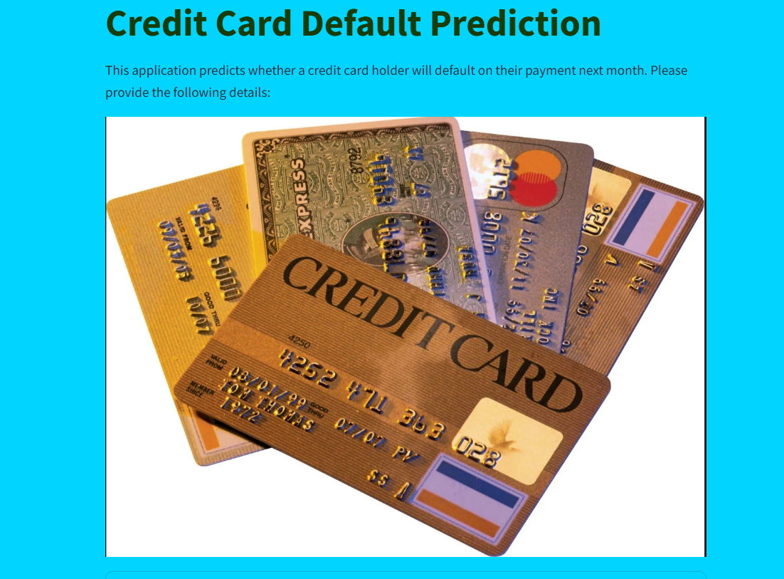

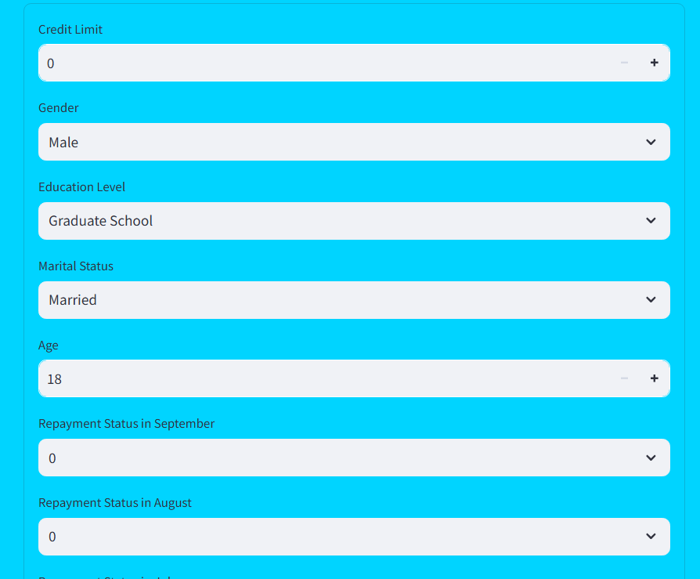



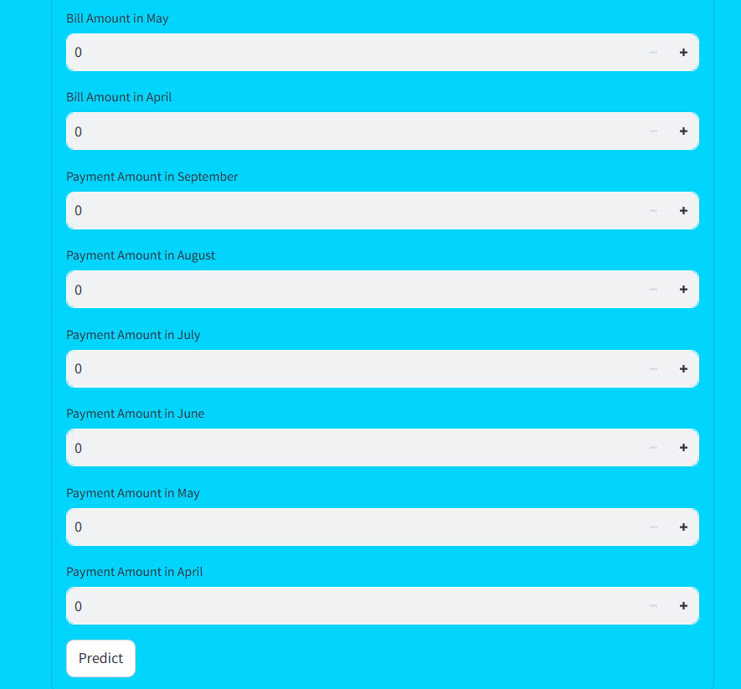

Once all details are filled, the application displays a result indicating whether the user is likely to “Default” or “Not Default.” If any field is left blank, the application assigns default values for those categories and provides a result based on the available information.

After filling up all the fields when you click the Predict button show the message:



**.In case the user is defaulter:**