Experiment -4
Aim: Write a program to solve the 3- SAT Problem using Stochastic Hill
Climbing Algorithm.
Code:
package AiLab;
import java.util.*;
public class ThreeSATHillClimbing {
static boolean toBool(int x) {
return x != 0;
}
static int heuristicValue(ArrayList<Integer> data) {
boolean a = toBool(data.get(0));
boolean b = toBool(data.get(1));
boolean c = toBool(data.get(2));
boolean d = toBool(data.get(3));
boolean e = toBool(data.get(4));
int val = 0;
if (a || b || !c) val++;
if (!a || d) val++;
if (!b) val++;
if (a || !e) val++;
if (!c) val++;
if (!c || d) val++;
return val;
}
static double probability(int h, int hp) {
double diff = hp - h;
return 1.0 / (1.0 + Math.exp(-diff / 10.0));
}
static ArrayList<Integer> neighbourFunction(ArrayList<Integer> data, int index) {
ArrayList<Integer> temp = new ArrayList<>(data);
temp.set(index, data.get(index) == 0 ? 1 : 0);
return temp;
}
static ArrayList<Integer> findSolution(ArrayList<Integer> arr) {
Random rnd = new Random();
ArrayList<Integer> current = new ArrayList<>(arr);
int currentHeuristic = heuristicValue(current);
for (int iter = 0; iter < 1000; iter++) {
if (currentHeuristic == 6) {
System.out.println("Goal State Reached in iteration " + iter);
return current;
}
int index = rnd.nextInt(current.size());
ArrayList<Integer> neighbour = neighbourFunction(current, index);
int neighbourHeuristic = heuristicValue(neighbour);
double prob = probability(neighbourHeuristic, currentHeuristic);
if (neighbourHeuristic >= currentHeuristic || rnd.nextDouble() < prob) {
current = neighbour;
currentHeuristic = neighbourHeuristic;
}
}
System.out.println("Goal not reached. Returning best found state.");
return current;
}
public static void main(String[] args) {
Scanner sc = new Scanner(System.in);
System.out.println("Enter 5 binary values (0/1) for a, b, c, d, e:");
ArrayList<Integer> init_data = new ArrayList<>();
for (int i = 0; i < 5; i++) init_data.add(sc.nextInt());
System.out.println("Initial State: " + init_data);
System.out.println("Heuristic Value (Initial): " + heuristicValue(init_data));
ArrayList<Integer> soln = findSolution(init_data);
System.out.println("Final Solution: " + soln);
System.out.println("Heuristic Value (Solution): " + heuristicValue(soln));
}
}

output:

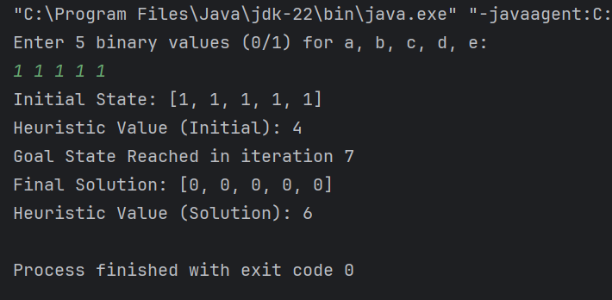

Experiment – 5
Aim: Write a program to solve the 8-Puzzle problem using A* algorithm.
Code:
package AiLab;
import java.util.*;
class Node {
List<List<Integer>> data;
Node n1, n2, n3, n4;
int depth;
Node(List<List<Integer>> data, int depth) {
this.data = data;
this.depth = depth;
n1 = n2 = n3 = n4 = null;
}
}
public class PuzzleSolver {
private static Node createNode(List<List<Integer>> data, int depth) {
return new Node(data, depth);
}
private static List<List<Integer>> moveUp(List<List<Integer>> data) {
List<List<Integer>> result = copy(data);
for (int i = 0; i < 3; i++)
for (int j = 0; j < 3; j++)
if (result.get(i).get(j) == 0 && i != 0) {
result.get(i).set(j, result.get(i - 1).get(j));
result.get(i - 1).set(j, 0);
return result;
}
return result;
}
private static List<List<Integer>> moveDown(List<List<Integer>> data) {
List<List<Integer>> result = copy(data);
for (int i = 0; i < 3; i++)
for (int j = 0; j < 3; j++)
if (result.get(i).get(j) == 0 && i != 2) {
result.get(i).set(j, result.get(i + 1).get(j));
result.get(i + 1).set(j, 0);
return result;
}
return result;
}
private static List<List<Integer>> moveLeft(List<List<Integer>> data) {
List<List<Integer>> result = copy(data);
for (int i = 0; i < 3; i++)
for (int j = 0; j < 3; j++)
if (result.get(i).get(j) == 0 && j != 0) {
result.get(i).set(j, result.get(i).get(j - 1));
result.get(i).set(j - 1, 0);
return result;
}
return result;
}
private static List<List<Integer>> moveRight(List<List<Integer>> data) {
List<List<Integer>> result = copy(data);
for (int i = 0; i < 3; i++)
for (int j = 0; j < 3; j++)
if (result.get(i).get(j) == 0 && j != 2) {
result.get(i).set(j, result.get(i).get(j + 1));
result.get(i).set(j + 1, 0);
return result;
}
return result;
}
private static List<List<Integer>> copy(List<List<Integer>> data) {
List<List<Integer>> newData = new ArrayList<>();
for (List<Integer> row : data)
newData.add(new ArrayList<>(row));
return newData;
}
private static int h(List<List<Integer>> data, List<List<Integer>> goal) {
int count = 0;
for (int i = 0; i < 3; i++)
for (int j = 0; j < 3; j++)
if (!data.get(i).get(j).equals(goal.get(i).get(j)))
count++;
return count;
}
private static int fval(int gval, int hval) {
return gval + hval;
}
private static void printMat(Node node) {
for (int i = 0; i < 3; i++) {
for (int j = 0; j < 3; j++) {
System.out.print(node.data.get(i).get(j) + " ");
}
System.out.println();
}
System.out.println("f(): " + fval(node.depth, h(node.data, node.data)) + ", h(): " + h(node.data, node.data) + ", g(): " + node.depth);
}
private static List<List<Integer>> findSol(List<List<Integer>> start, List<List<Integer>> goal) {
Comparator<Node> cmp = (a, b) -> (fval(a.depth, h(a.data, goal)) - fval(b.depth, h(b.data, goal)));
PriorityQueue<Node> q = new PriorityQueue<>(cmp);
Node root = createNode(start, 0);
q.add(root);
int min = 0;
int moves = 0;
while (!q.isEmpty()) {
Node temp = q.poll();
moves++;
printMat(temp);
min = fval(temp.depth, h(temp.data, goal));
if (temp.data.equals(goal)) {
System.out.println("Number of nodes expanded: " + moves);
System.out.println("Solution found after " + temp.depth + " moves.");
System.out.println("Goal State Reached.");
return temp.data;
}
int deep = temp.depth;
List<List<Integer>> up = moveUp(temp.data);
List<List<Integer>> down = moveDown(temp.data);
List<List<Integer>> left = moveLeft(temp.data);
List<List<Integer>> right = moveRight(temp.data);
if (!up.equals(temp.data)) {
Node node = createNode(up, deep + 1);
temp.n1 = node;
q.add(node);
}
if (!down.equals(temp.data)) {
Node node = createNode(down, deep + 1);
temp.n2 = node;
q.add(node);
}
if (!left.equals(temp.data)) {
Node node = createNode(left, deep + 1);
temp.n3 = node;
q.add(node);
}
if (!right.equals(temp.data)) {
Node node = createNode(right, deep + 1);
temp.n4 = node;
q.add(node);
}
}
return null;
}
public static void main(String[] args) {
List<List<Integer>> start = Arrays.asList(
Arrays.asList(2,8,3),
Arrays.asList(1,6,4),
Arrays.asList(7,0,5)
);
List<List<Integer>> goal = Arrays.asList(
Arrays.asList(1,2,3),
Arrays.asList(8,0,4),
Arrays.asList(7,6,5)
);
List<List<Integer>> sol = findSol(start, goal);
for (int i = 0; i < 3; i++) {
for (int j = 0; j < 3; j++)
System.out.print(sol.get(i).get(j) + " ");
System.out.println();
}
}
}
output:
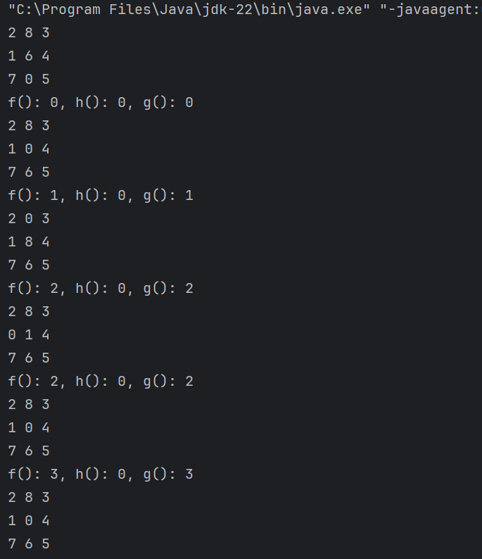
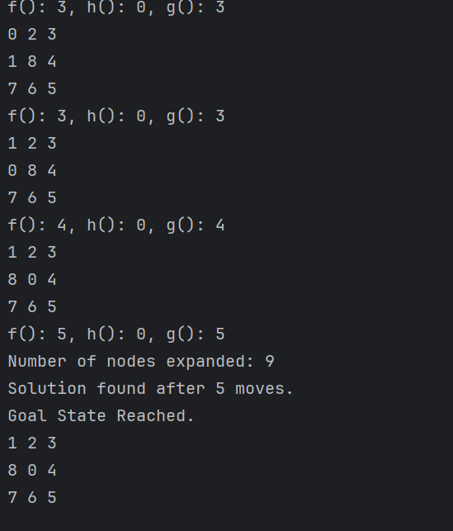

Experiment-6
Aim: Write a program to implement AO* search algorithm on any AND
OR graph.
Code:
package AiLab;
import java.util.*;
public class HeuristicShortestPath {
static Map<String, Integer> costCalc(Map<Character, Integer> H, List<String> Condition, int weight) {
Map<String, Integer> Updated_cost = new HashMap<>();
for (String i : Condition) {
Updated_cost.put(i, 0);
for (char k : i.toCharArray()) {
Integer hValue = H.get(k);
if (hValue == null) {
throw new RuntimeException("Missing heuristic value for character: " + k);
}
Updated_cost.put(i, Updated_cost.get(i) + hValue + weight);
}
}
return Updated_cost;
}
static Map<Character, Map<String, Integer>> Updated_costs(
Map<Character, Integer> H,
Map<Character, List<String>> Conditions,
int weight
) {
List<Character> Nodes = new ArrayList<>(H.keySet());
Collections.reverse(Nodes);
Map<Character, Map<String, Integer>> UpdatedG = new HashMap<>();
for (Character node : Nodes) {
if (!Conditions.containsKey(node)) continue;
Map<String, Integer> UpdatedC = costCalc(H, Conditions.get(node), weight);
int minC = Integer.MAX_VALUE;
for (Map.Entry<String, Integer> entry : UpdatedC.entrySet()) {
minC = Math.min(minC, entry.getValue());
}
H.put(node, minC);
UpdatedG.put(node, UpdatedC);
}
return UpdatedG;
}
static void printUpdatedC(Map<Character, Map<String, Integer>> Updated_cost) {
for (Map.Entry<Character, Map<String, Integer>> i : Updated_cost.entrySet()) {
System.out.print(i.getKey() + " -> ");
for (Map.Entry<String, Integer> p : i.getValue().entrySet()) {
System.out.print(p.getKey() + ": " + p.getValue() + " ");
}
System.out.println();
}
}
static void printShortestP(Map<Character, Map<String, Integer>> Updated_costs, char start) {
Queue<Character> Path = new LinkedList<>();
Path.add(start);
while (!Path.isEmpty()) {
char curr = Path.peek();
int v = Integer.MAX_VALUE;
String next = "";
Path.poll();
if (Updated_costs.containsKey(curr)) {
for (Map.Entry<String, Integer> i : Updated_costs.get(curr).entrySet()) {
if (i.getValue() < v) {
v = i.getValue();
next = i.getKey();
}
}
}
if (v == Integer.MAX_VALUE) {
System.out.print(curr + " \n");
} else {
for (char c : next.toCharArray()) {
Path.add(c);
}
System.out.print(curr + " < " + next + "\n");
}
}
}
public static void main(String[] args) {
Map<Character, Integer> HeuristicV = new HashMap<>();
HeuristicV.put('A', 0);
HeuristicV.put('B', 6);
HeuristicV.put('C', 4);
HeuristicV.put('D', 5);
HeuristicV.put('E', 5);
HeuristicV.put('F', 6);
HeuristicV.put('G', 8);
HeuristicV.put('H', 0);
HeuristicV.put('I', 3);
HeuristicV.put('J', 4);
HeuristicV.put('K', 7);
HeuristicV.put('M', 10);
HeuristicV.put('N', 10);
HeuristicV.put('O', 9);
HeuristicV.put('P', 9);
HeuristicV.put('Q', 10);
HeuristicV.put('R', 10);
HeuristicV.put('S', 7);
HeuristicV.put('T', 7);
HeuristicV.put('U', 8);
HeuristicV.put('V', 7);
HeuristicV.put('W', 9); // Added for correctness
Map<Character, List<String>> Conditions = new HashMap<>();
Conditions.put('A', Arrays.asList("BC", "DE"));
Conditions.put('B', Arrays.asList("FG", "HJ"));
Conditions.put('C', Arrays.asList("FI"));
Conditions.put('D', Arrays.asList("TJ"));
Conditions.put('E', Arrays.asList("MN"));
Conditions.put('F', Arrays.asList("OP", "PQ"));
Conditions.put('G', Arrays.asList("UV", "VW"));
Conditions.put('H', Arrays.asList("PR", "RS"));
Conditions.put('I', Arrays.asList("TS"));
Map<Character, Map<String, Integer>> UpdatedC = Updated_costs(HeuristicV, Conditions, 1);
printUpdatedC(UpdatedC);
System.out.println("\nShortest Path:");
printShortestP(UpdatedC, 'A');
}
}
output:
