8.Project report with code and screenshot
Table doctors
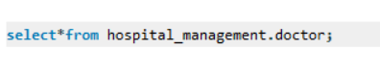
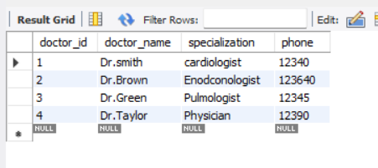

Table Patients

Table tests
