DBMS Project File

P-4 LAB


MC209
DELHI TECHNOLOGICAL UNIVERSITY DEPARTMENT OF APPLIED MATHEMATICS

SUBMITTED TO:- Ms.Himani Pokhriyal

SUBMITTED BY:- Lokesh Godara 23/MC/82
Krrishnav Gupta 23/MC/78

Practical -1
Synopsis of the Project, along with its E-R Diagram

Synopsis of Hospital Management System
Project Title: Hospital Management System (HMS)
Objective: The primary objective of this Hospital Management System (HMS) is to create a comprehensive database solution that manages the daily operations and administrative tasks of a hospital. This system aims to improve the efficiency and accuracy of various processes, including patient registration, appointment scheduling, medical records
management, billing, and staff management.
Introduction: In the modern healthcare environment, hospitals face challenges such as managing patient data, scheduling appointments, and ensuring seamless communication among healthcare providers. The Hospital Management System seeks to address these challenges by
providing a centralized platform that streamlines operations, enhances patient care, and optimizes resource management.

Key Features:
- Patient Registration:
  - Collect and store patient information, including personal details, medical history, and contact information.
  - Assign a unique patient ID for easy identification.

Appointment Scheduling:
  - Allow patients to book appointments with doctors online.
  - Manage appointment availability and send reminders to patients.

Medical Records Management:
  - Maintain electronic medical records (EMRs) for each patient.
  - Facilitate easy access to patient history, diagnoses, treatments, and prescriptions.

Billing and Invoicing:
  - Automate the billing process for medical services rendered.
  - Generate invoices and manage payment records.

Staff Management:
  - Manage doctor, nurse, and administrative staff information.

  - Track staff schedules, availability, and performance.

Reporting:
  - Generate reports on patient statistics, financials, and operational efficiency.
  - Provide insights to aid decision-making and improve services.

Technologies Used:

- Database Management System: MySQL

Conclusion: The Hospital Management System will significantly enhance the efficiency of hospital operations, improve patient experience, and ensure accurate management of medical records. By implementing a robust database solution, the system will facilitate better healthcare delivery, ultimately leading to improved patient outcomes.

Practical -2
Implement the following DDL statements: a. Create
  - Create table with constraints (NOT NULL, UNIQUE, DEFAULT, CHECK, PRIMARY KEY, FOREIGN KEY)
  - Alter Table:
- Add column
- Drop column
- Add/drop constraint iv. Rename column
  - Drop Table

- Create

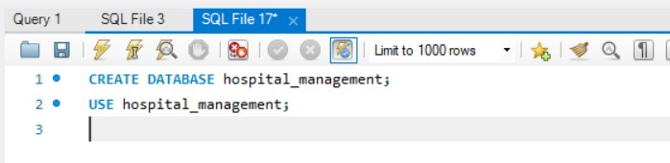

- Create table with constraints (NOT NULL, UNIQUE, DEFAULT, CHECK, PRIMARY KEY, FOREIGN KEY)

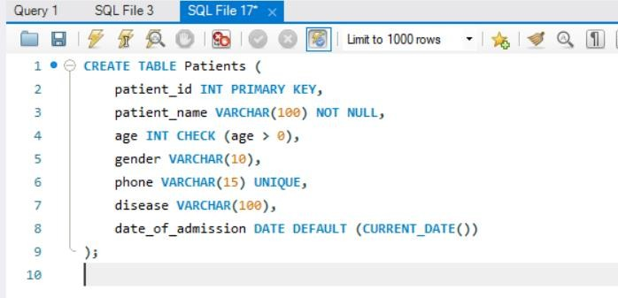

- Alter Table:
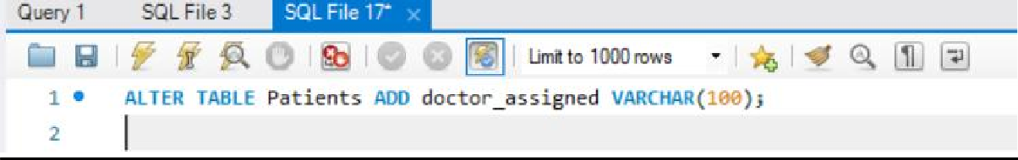
- Add column

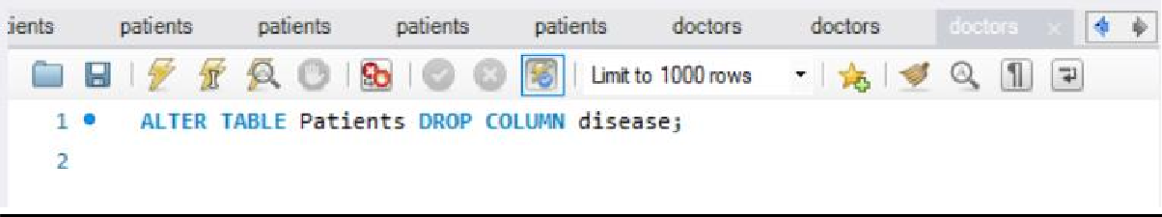
- Drop column

- Add/drop constraint
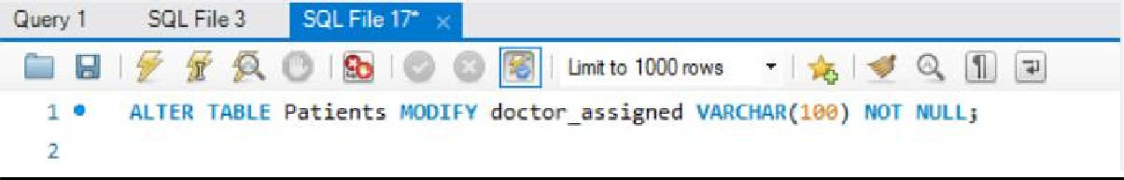
Add a NOT NULL constraint on doctor_assigned

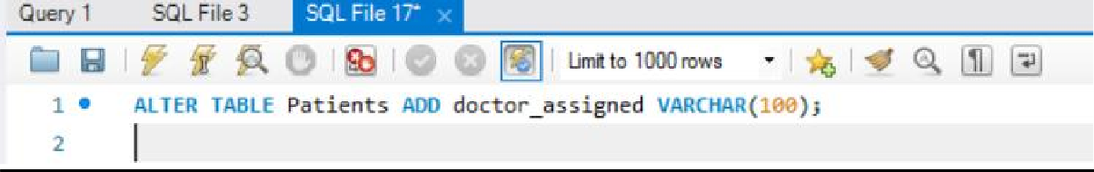
Drop the NOT NULL constraint

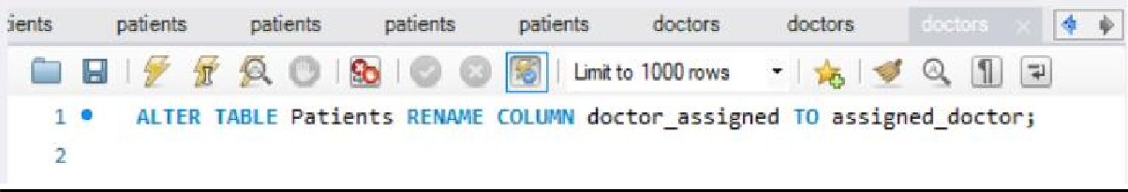
- Rename column

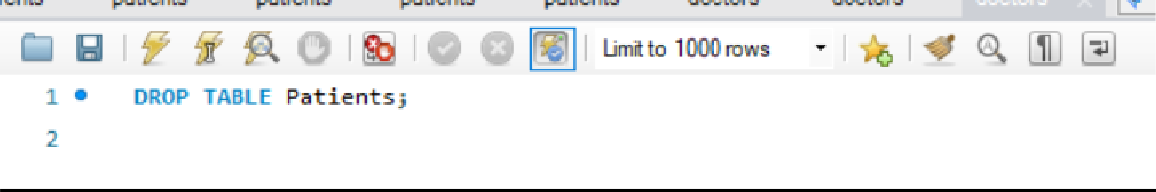
- Drop Table

Practical -3
Implement the following DML statements: a. Insert
b. Update c. Delete
d. Truncate

- 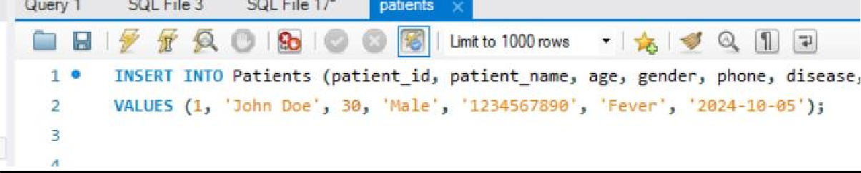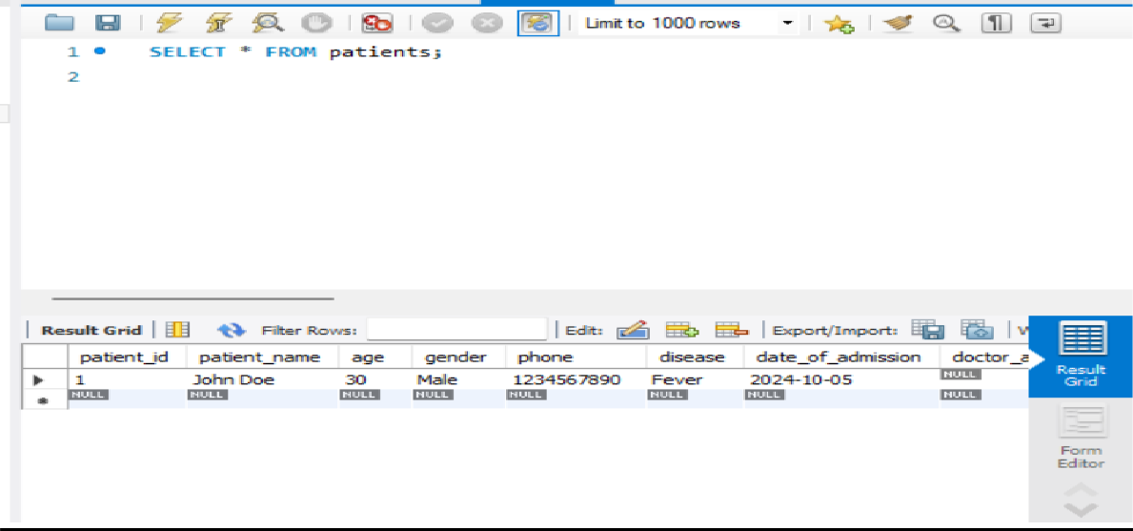Insert

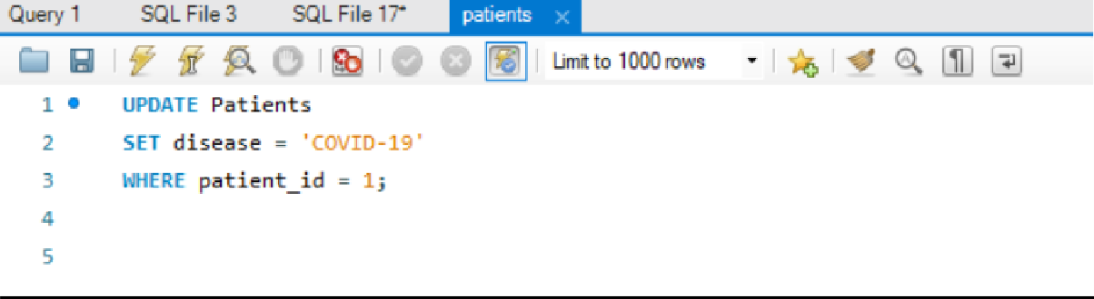
- Update

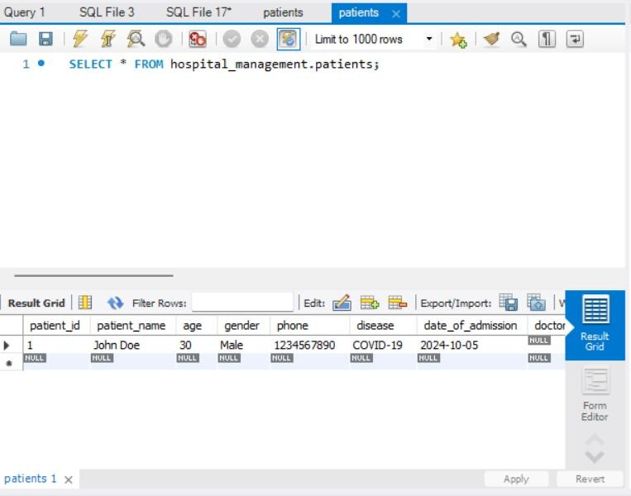

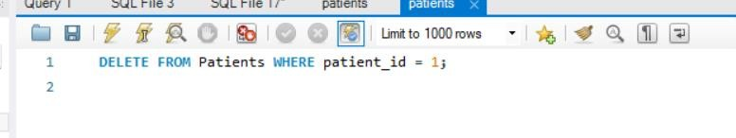
- Delete

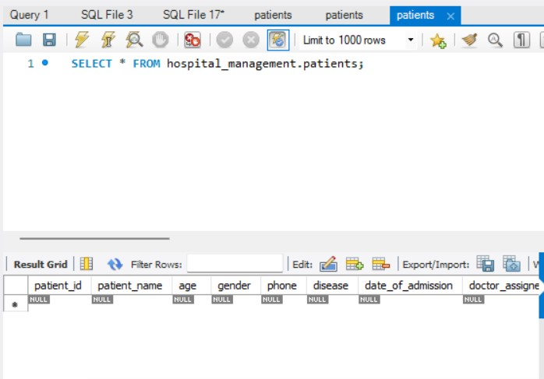

- Truncate

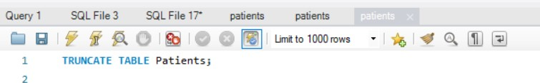

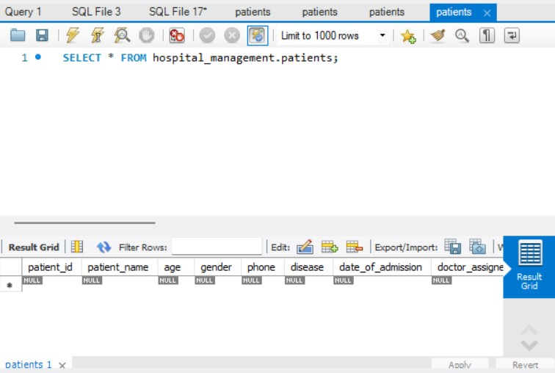

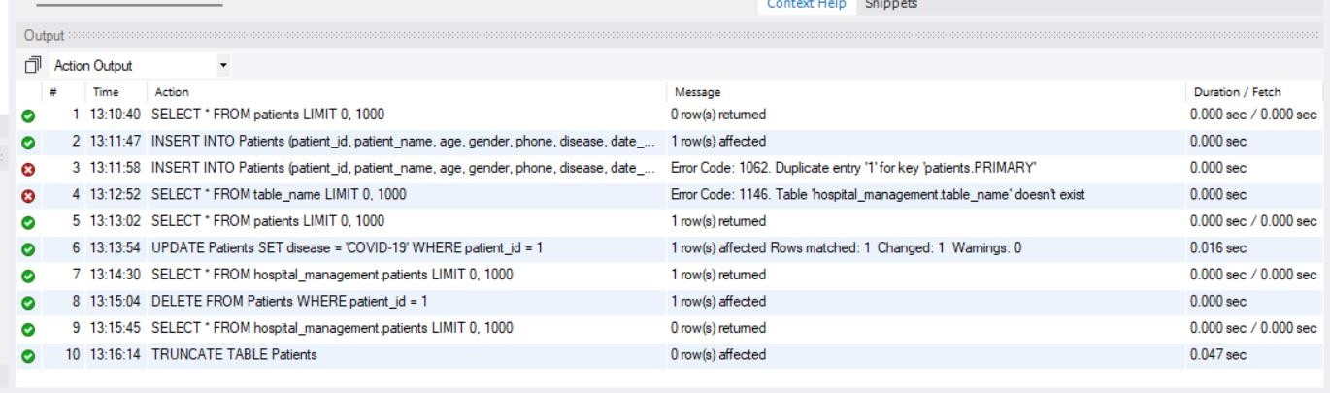

Practical -4
Implement the following SELECT statements: a. Simple SELECT statement
b. Where clause+ IN/NOT IN c. Aggregate functions
d. Group by + Having e. Order by
f. Views
g. Inbuilt Functions (e.g., Date)

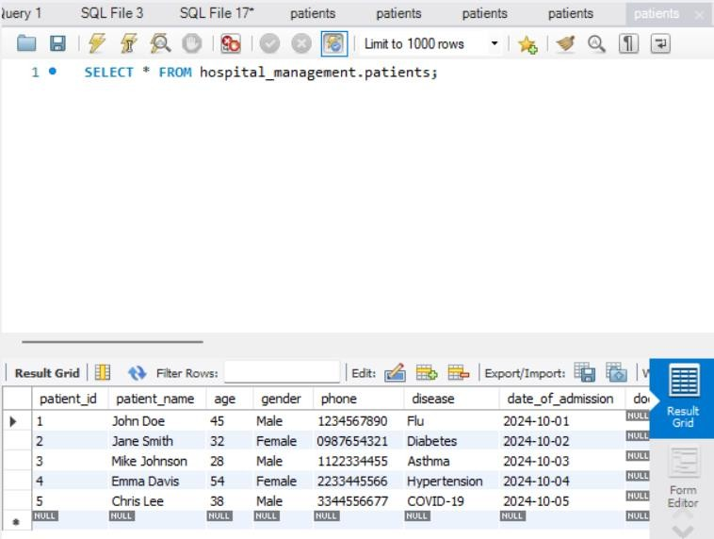
- Simple SELECT statement

- Where clause + IN/NOT IN:

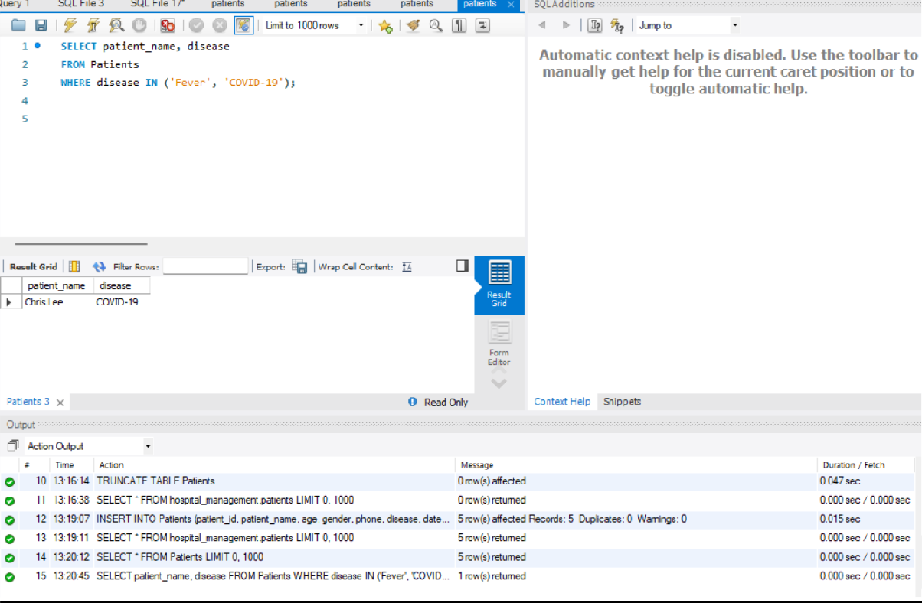

- Aggregate Functions (e.g., COUNT, AVG): sql
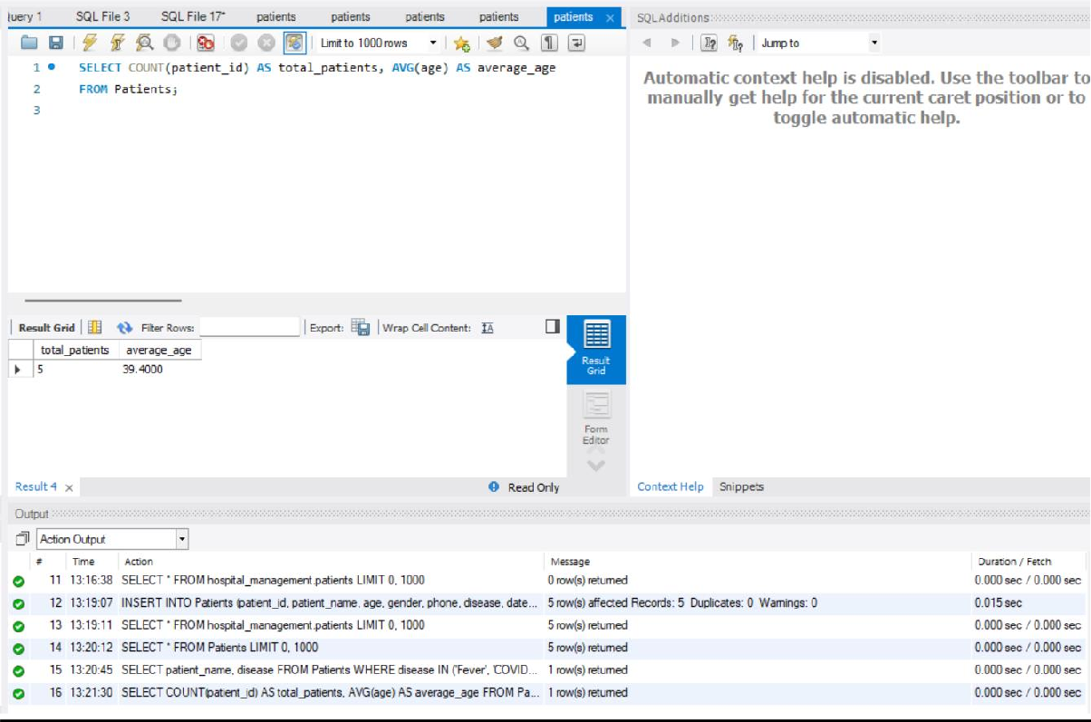

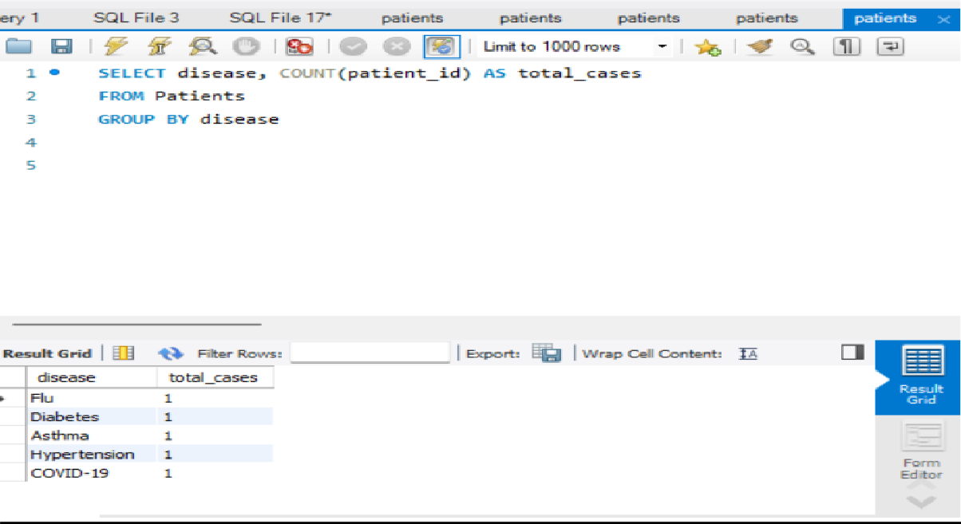
- Group By + Having

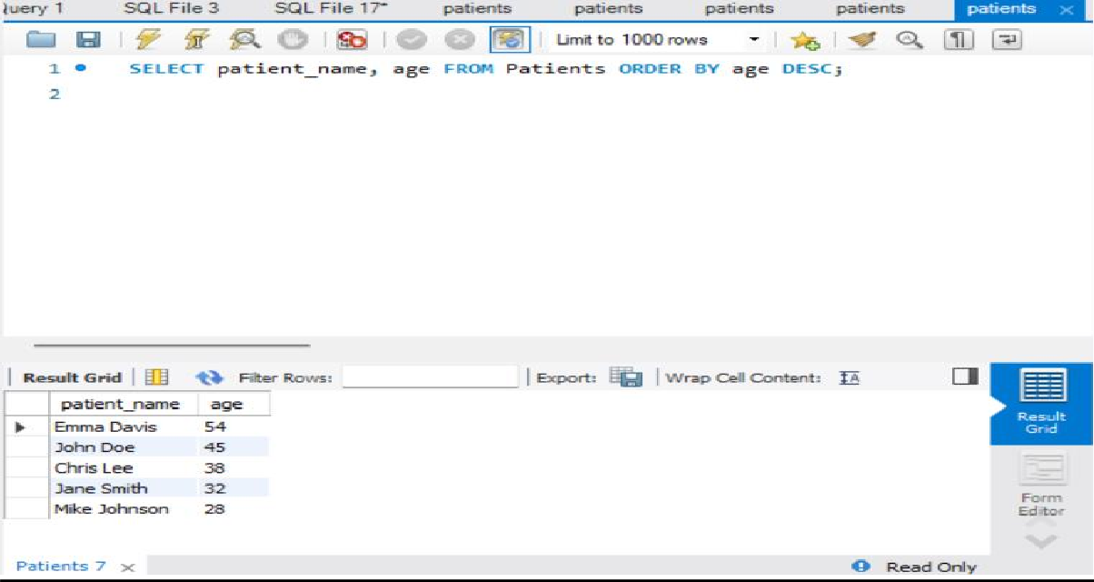
- Order By

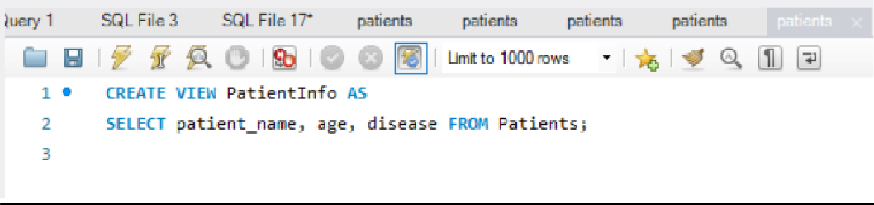
- Views

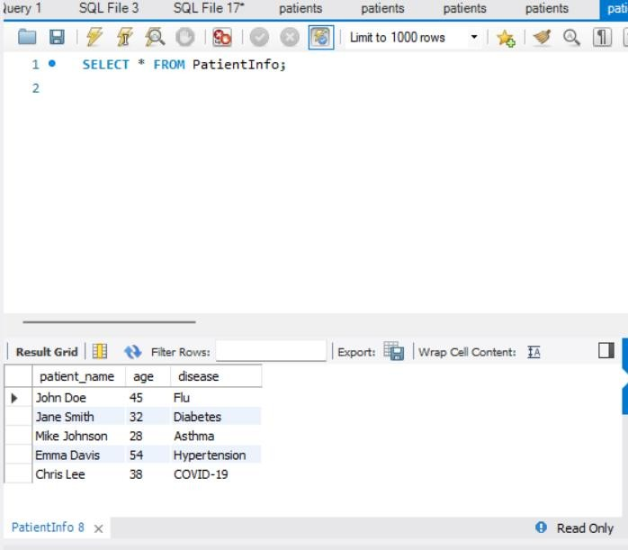

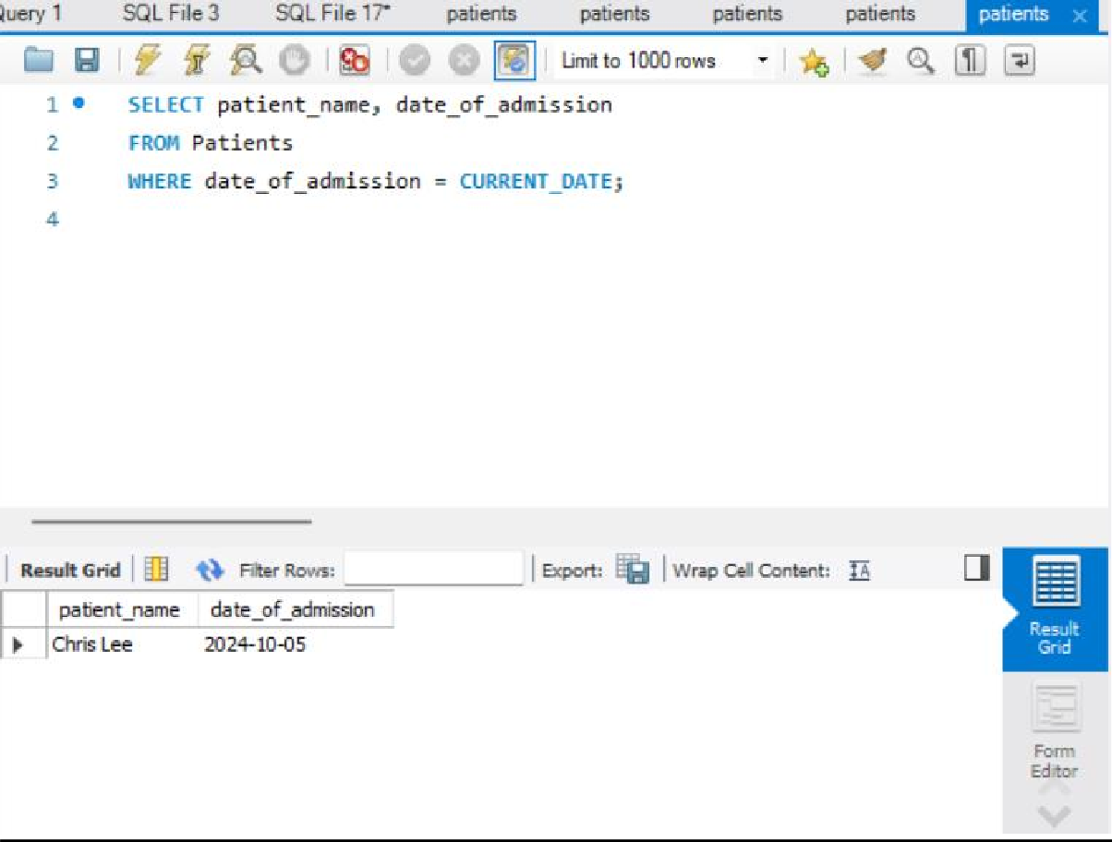
- Inbuilt Functions (e.g., Date)

Practical -5

Implement and perform Nested Queries along with Joins (Inner join, Outer join, Left join, Right join)

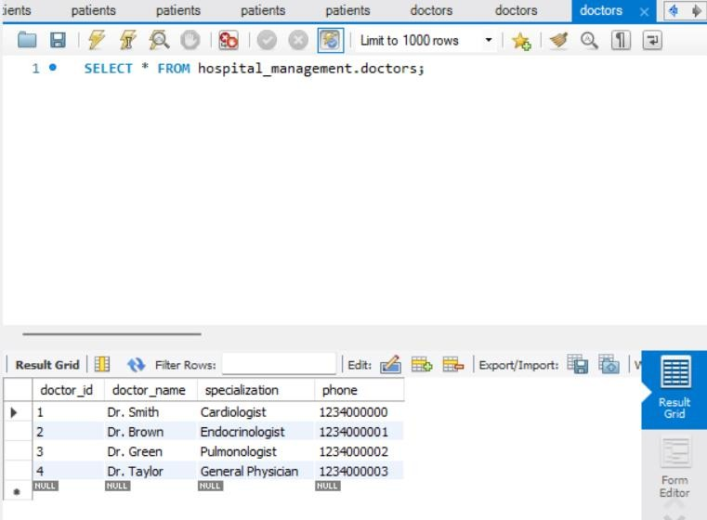
We have 2 tables named Patients and doctors

Add a doctor_id to the Patients Table (for relational queries)
We need to update the Patients table to include a reference to the Doctors table, linking patients to doctors using a

foreign key.
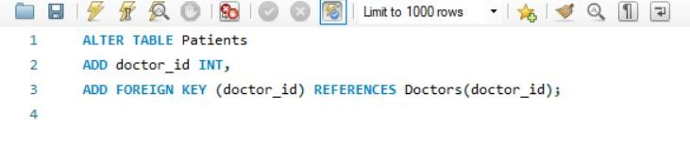
Update Patient Records to Assign Doctors
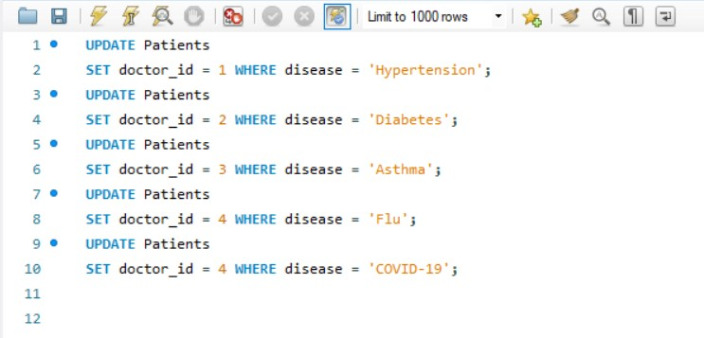
Nested Queries
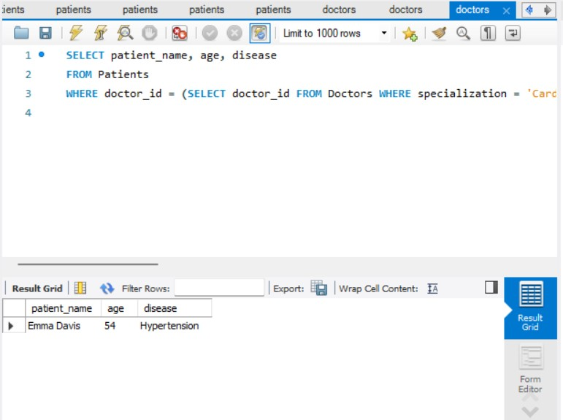

Inner join
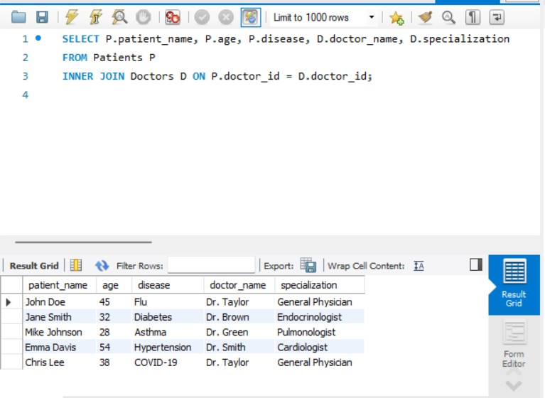

Left join
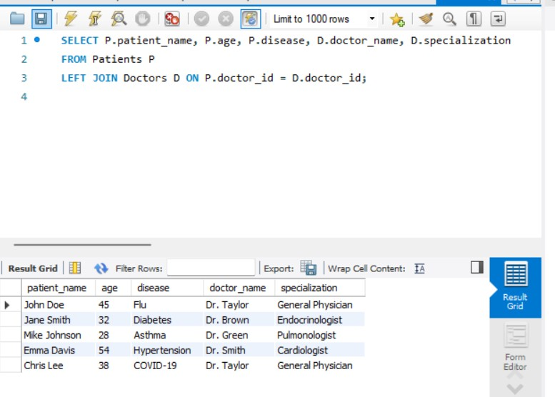

Right join
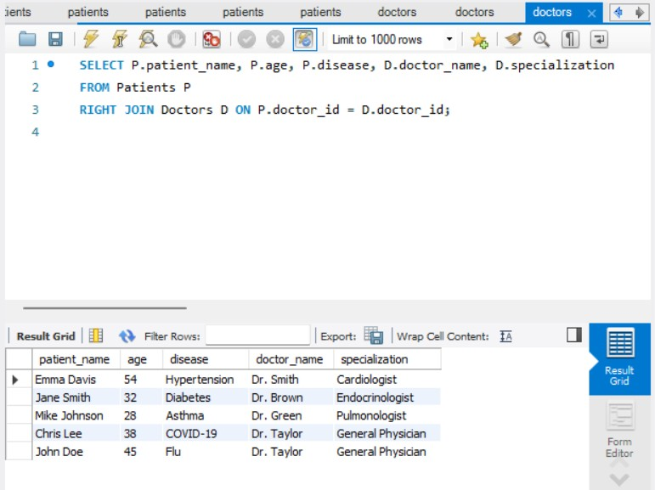
Outer join
