Ques1) Retrieve the department name and the number of employees for each department with an average salary greater than $30,000:
SELECT dname, COUNT(*) AS Num_Employees
FROM EMPLOYEE
JOIN DEPARTMENT ON EMPLOYEE.Dno = DEPARTMENT.Dnumber
GROUP BY Dname
HAVING AVG(Salary) > 30000;
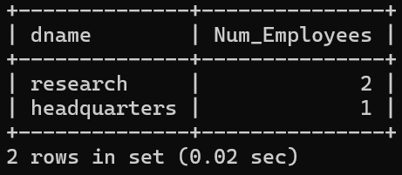
2. Retrieve the department name and the number of employees for each department with an average salary greater than $30,000:
SELECT E.Fname, E.Lname
FROM EMPLOYEE E
WHERE E.Dno = (
SELECT Dno FROM EMPLOYEE ORDER BY Salary DESC
LIMIT 1;
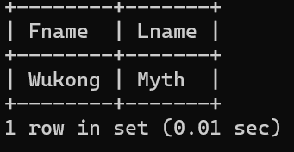
3. Retrieve the names of employees whose supervisor's supervisor has an SSN of '888665555':
SELECT E.Fname, E.Lname
FROM EMPLOYEE E
JOIN EMPLOYEE M ON E.Super_ssn = M.Ssn JOIN EMPLOYEE S ON M.Super_ssn = S.Ssn
WHERE S.Ssn = '888665555';

4. Display names of employees who don't have a manager:
SELECT Fname, Lname FROM EMPLOYEE
WHERE Super_ssn IS NULL;
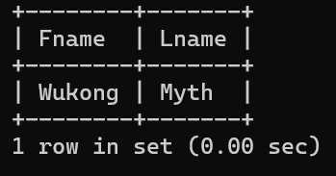
5. Display the full name, age, department name, and department number for all employees:
SELECT CONCAT(E.Fname, ' ', E.Lname) AS Full_Name,
YEAR(CURDATE()) - YEAR(E.Bdate) AS Age,
D.dname AS Department_Name,
D.dnumber AS Department_Number
FROM EMPLOYEE E JOIN DEPARTMENT D ON E.dno = D.dnumber;
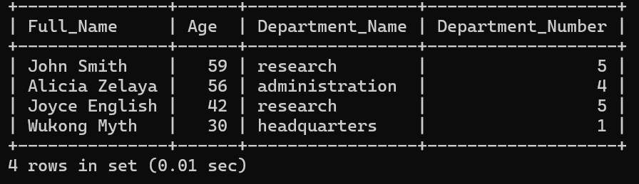
6. Display name, employee number, manager's name, manager's employee number, and names of employees without a manager:
SELECT E.Fname AS EmployeeName, E.ssn AS EmployeeNum, M.Fname AS ManagerName, M.ssn AS ManagerNum
FROM EMPLOYEE E
LEFT JOIN EMPLOYEE M ON E.super_ssn = M.ssn
WHERE E.super_ssn IS NULL;
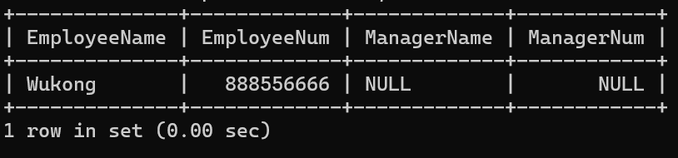
7. Display each employee's current and dream salary with the column labeled as "Dream Salary":
SELECT CONCAT(Fname, ' ', Lname) AS EmployeeName, Salary,
(3 * Salary) AS DreamSalary FROM EMPLOYEE;
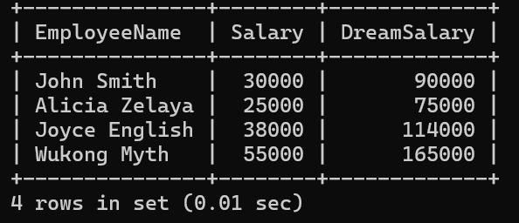
PRACTICAL 10
Ques1)

