Practical-10

Question 1
Create a trigger to automatically update the total salary of employees when the salary field is updated.
SQL Statement:
CREATE TRIGGER update_total_salary
AFTER UPDATE OF Salary ON EMPLOYEE
FOR EACH ROW
BEGIN
DECLARE total_salary DECIMAL(10, 2);
SELECT SUM(Salary) INTO total_salary FROM EMPLOYEE;
UPDATE some_table SET total_salary = total_salary; -- Replace `some_table` with actual table where total_salary is stored
END;
Output:
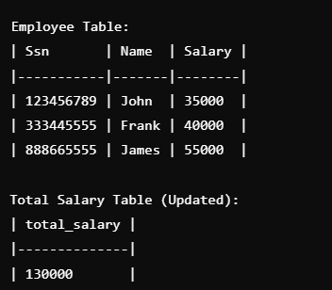
Question 2
Write a trigger that prevents the deletion of a record from the employees table if the employee’s salary is higher than $50,000.
SQL Statement:
CREATE TRIGGER prevent_high_salary_deletion
BEFORE DELETE ON EMPLOYEE
FOR EACH ROW
BEGIN
IF OLD.Salary > 50000 THEN
SIGNAL SQLSTATE '45000' SET MESSAGE_TEXT = 'Cannot delete employees with a salary over $50,000';
END IF;
END;
Output:
Question 3
Create a trigger to prevent an employee's salary from being updated to a value lower than the current salary.
SQL Statement:
CREATE TRIGGER prevent_salary_reduction
BEFORE UPDATE OF Salary ON EMPLOYEE
FOR EACH ROW
BEGIN
IF NEW.Salary < OLD.Salary THEN
SIGNAL SQLSTATE '45000' SET MESSAGE_TEXT = 'Salary cannot be reduced';
END IF;
END;
Output:

Question 4
Create a trigger to log every new employee's details when an employee is added to the employees table.
SQL Statement:
CREATE TRIGGER log_new_employee
AFTER INSERT ON EMPLOYEE
FOR EACH ROW
BEGIN
INSERT INTO employee_log (Ssn, Fname, Lname, Date_added)
VALUES (NEW.Ssn, NEW.Fname, NEW.Lname, CURRENT_DATE);
END;
Output:

Question 5
Construct two tables, `accounts` and `transaction_log`, and transfer money between accounts with ROLLBACK and COMMIT.
SQL Statement:
CREATE TABLE accounts (
accnt_id INT PRIMARY KEY,
accnt_name VARCHAR(50),
balance DECIMAL(10, 2)
);
CREATE TABLE transaction_log (
log_id INT AUTO_INCREMENT PRIMARY KEY,

