Lab 7– Some more Update/Delete-based, View-based and Alter-based queries

Create the virtual tables(views) for the schemas given below.
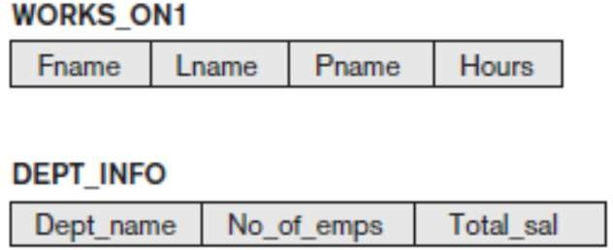

CREATE VIEW WORKS_ON1 AS
SELECT E.FNAME AS FNAME, E.LNAME AS LNAME, P.PNAME AS PNAME, W.HOURS AS HOURS FROM EMPLOYEE E, PROJECT P, WORKS_ON W
WHERE E.SSN = W.ESSN AND P.PNUMBER = W.PNO;
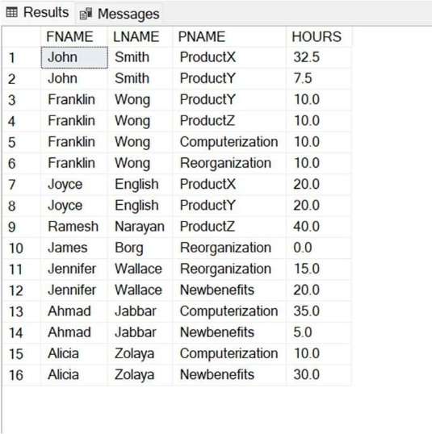

CREATE VIEW DEPT_INFO AS
SELECT DNAME, COUNT(*) EMP_COUNT, SUM(SALARY) AS SALARY
FROM DEPARTMENT, EMPLOYEE WHERE DNO = DNUMBER GROUP BY DNAME;
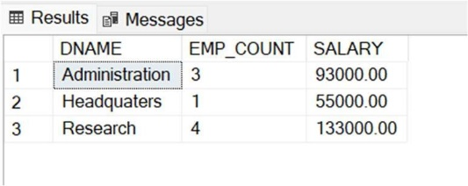

Consider the WORKS_ON1 view, and issue the command to update the PNAME attribute of ‘John Smith’ from ‘ProductX’ to ‘ProductY’.
UPDATE WORKS_ON1 SET PNAME = 'ProductY' WHERE FNAME = 'John' AND PNAME = 'ProductX';
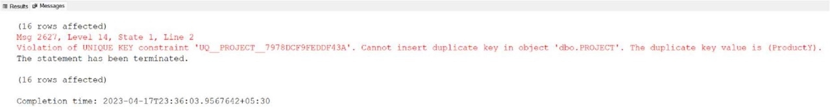

Get rid of the view WORKS_ON1.
DROP VIEW WORKS_ON1;
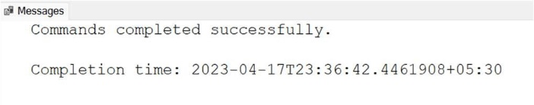

Create a view that has the department name, manager name, and manager salary for every department.
CREATE VIEW DEPT AS
SELECT D.DNAME AS DNAME, E.FNAME AS FNAME, E.LNAME AS LNAME, E.SALARY AS SALARY FROM EMPLOYEE E, DEPARTMENT D
WHERE E.SSN = D.MGR_SSN;
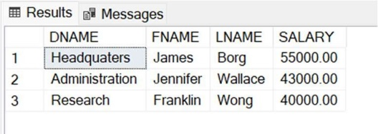

Create a view that has the employee name, supervisor name, and employee salary for each employee who works in the ‘Research’ department.
CREATE VIEW RESEARCH AS
SELECT E1.FNAME AS FNAME, E2.FNAME AS SFNAME, E1.SALARY AS SALARY FROM EMPLOYEE E1,EMPLOYEE E2, DEPARTMENT D
WHERE E1.SUPER_SSN = E2.SSN AND E1.DNO = (SELECT D.DNUMBER WHERE DNAME = 'Research');
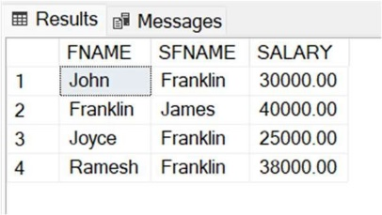

Create a view that has the project name, controlling department name, number of employees, and total hours worked per week on the project for each project.
CREATE VIEW PROJ AS
SELECT PNAME AS PROJECT, DNAME AS DEPT,
(SELECT COUNT(*) FROM WORKS_ON W WHERE W.PNO = P.PNUMBER) AS EMPLOYEES,
(SELECT SUM(W.Hours) FROM WORKS_ON W WHERE W.PNO = P.PNUMBER GROUP BY PNO) AS HOURS FROM PROJECT P, DEPARTMENT D WHERE P.DNUM = D.DNUMBER;
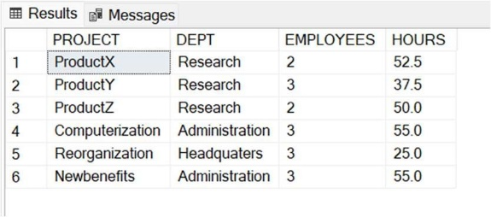

Create a view that has the project name, controlling department name, number of employees, and total hours worked per week on the project for each project with more than one employee working on it.
CREATE VIEW NEW_PROJ AS
SELECT PNAME AS PROJECT, DNAME AS DEPT,
(SELECT COUNT(*) FROM WORKS_ON W WHERE W.PNO = P.PNUMBER) AS EMPLOYEES,
(SELECT SUM(W.Hours) FROM WORKS_ON W WHERE W.PNO = P.PNUMBER GROUP BY PNO) AS HOURS FROM PROJECT P, DEPARTMENT D
WHERE P.DNUM = D.DNUMBER AND (SELECT COUNT(*) FROM WORKS_ON W WHERE W.PNO = P.PNUMBER GROUP BY W.PNO)>1;
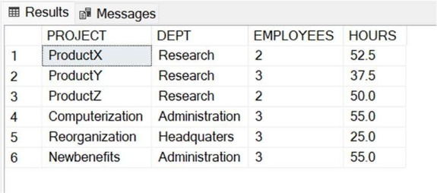

Create a view for a certain user who is only allowed to see employee information for employees who work for department 5.
CREATE VIEW DEPT5 AS
SELECT * FROM EMPLOYEE WHERE DNO = 5;
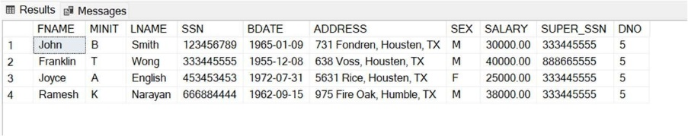

Remove the attribute Address from the EMPLOYEE base table.
SELECT * FROM EMPLOYEE; ALTER TABLE EMPLOYEE DROP COLUMN ADDRESS;
SELECT * FROM EMPLOYEE;
