Lab 8– Some more Nested Queries and complex subqueries

Retrieve the names of employees who have no dependents.
SELECT * FROM EMPLOYEE WHERE SSN NOT IN (SELECT ESSN FROM DEPENDENT);
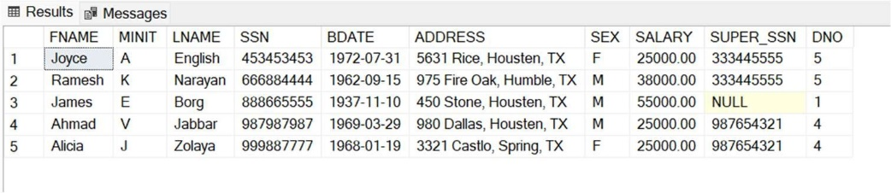

Retrieve all supervisees of a supervisory employee e at all levels—that is, all employees e′ directly supervised by e, all employees e′’ directly supervised by each employee e′, all employees e″′ directly supervised by each employee e″, and so on.
WITH RECURSIVE SUP_EMP(SUPER_SSN, SSN) AS( SELECT SUPER_SSN, SSN FROM EMPLOYEE
UNION
SELECT E.SSN, S.SUPER_SSN
FROM EMPLOYEE AS E , SUP_EMP AS S WHERE E.SUPER_SSN = S.SSN)
SELECT * FROM SUP_EMP;
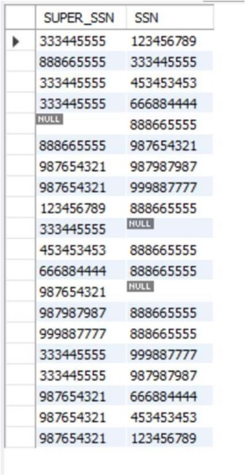

For every project located in ‘Stafford’, list the project number, the controlling department number, and the department manager’s last name, address, and birth date.
SELECT P.PNUMBER, P.DNUM, E.LNAME, E.ADDRESS, E.BDATE FROM PROJECT AS P, DEPARTMENT AS D, EMPLOYEE AS E
WHERE P.PLOCATION = 'Stafford' AND P.DNUM = D.DNUMBER AND D.MGR_SSN = E.SSN;

Make a list of all project numbers for projects that involve an employee whose last name is ‘Smith’, either as a worker or as a manager of the department that controls the project.
(SELECT W.PNO FROM WORKS_ON AS W, EMPLOYEE AS E WHERE E.LNAME = 'Smith' AND E.SSN = W.ESSN)
UNION
(SELECT W.PNO FROM WORKS_ON AS W, PROJECT AS P, EMPLOYEE AS E, DEPARTMENT AS D
WHERE E.LNAME = 'Smith' AND W.PNO = P.PNUMBER AND P.DNUM = D.DNUMBER AND D.MGR_SSN = E.SSN);

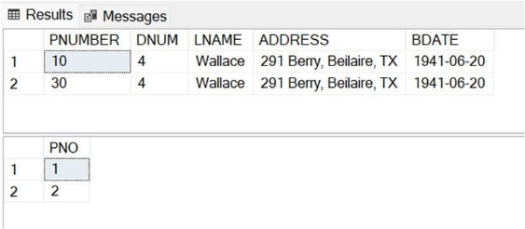

Retrieve the names of all employees in department 5 who work more than 10 hours per week on the ProductX project.
SELECT DISTINCT(E.FNAME) FROM EMPLOYEE AS E, WORKS_ON AS W, PROJECT AS P
WHERE P.PNAME = 'ProductX' AND P.PNUMBER = W.PNO AND W.HOURS > 10 AND W.ESSN = E.SSN AND E.DNO = 5;

- List the names of all employees who have a dependent with the same first name as themselves. SELECT E.FNAME FROM EMPLOYEE AS E, DEPENDENT AS D WHERE E.FNAME = D.DEPENDENT_NAME AND E.SSN = D.ESSN;

Retrieve a list of employees and the projects they are working on, ordered by department and, within each department, ordered alphabetically by last name, then first name.
SELECT E.FNAME, E.LNAME, P.PNAME FROM EMPLOYEE AS E, DEPARTMENT AS D, WORKS_ON AS W, PROJECT AS P
WHERE W.ESSN = E.SSN AND W.PNO = P.PNUMBER AND P.DNUM = D.DNUMBER ORDER BY D.DNAME, E.LNAME, E.FNAME;

Show the resulting salaries if every employee working on the ‘ProductX’ project is given a 15 percent raise.
SELECT E.SALARY*1.15 AS SALARY_15 FROM PROJECT AS P, WORKS_ON AS W, EMPLOYEE AS E WHERE P.PNAME = 'ProductX' AND P.PNUMBER = W.PNO and W.ESSN = E.SSN;
