LAB FILE

COURSE : DATA STRUCTURE
COURSE CODE:MC-201
MATHEMATICS AND COMPUTING
B.TECH 3rd SEMESTER


DEPARTMENT OF APPLIED MATHEMATICS
DELHI TECHNOLOGICAL UNIVERSITY
(FORMERLY DELHI COLLEGE OF ENGINEERING )

BAWANA ROAD ,DELHI -110042

SUBMITTED BY : LOKESH GODARA
23/MC/082

SUBMITTED TO:Ms.POOJA YADAV

EXP-1 (a)Linear search and binary search in an array:
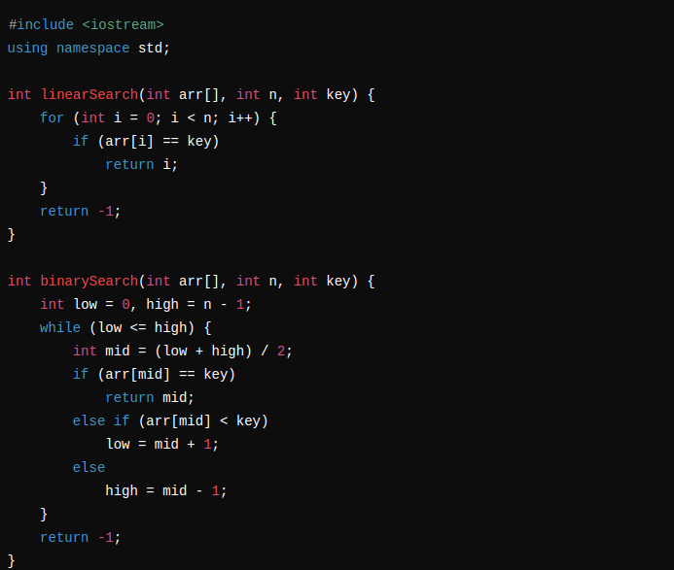

(b)Insertion and deletion in an array:
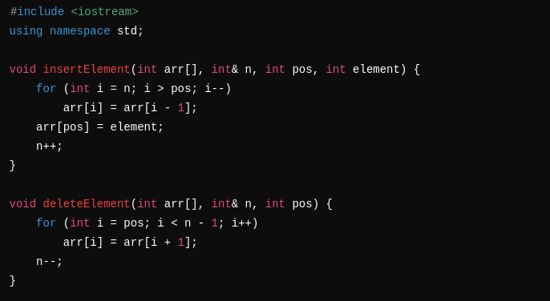

EXP-2 (a) Fetch a substring from a string, find its position and length:
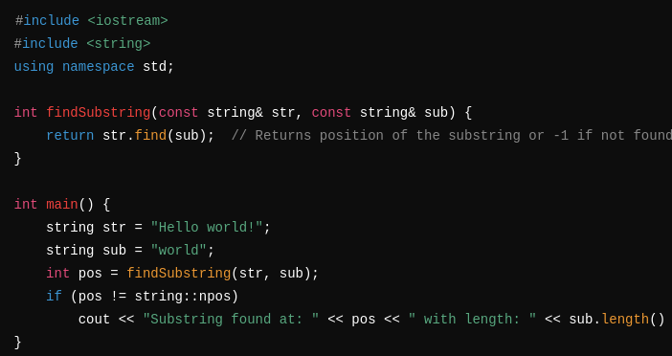
Replace a substring in a string with another
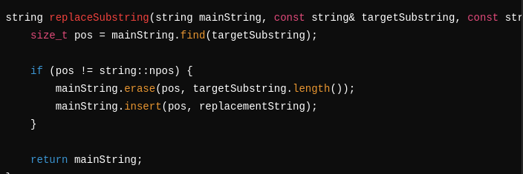
Concatenate 2 strings
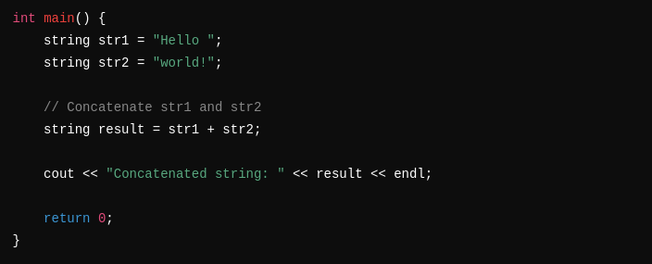

EXP5 -(Implement Singly LL, Doubly LL, Circular LL: Searching, Insertion, Deletion)
