A Quantitative Meta-Analysis of Pair-Wise Functional Connectivity Under Classic Serotonergic Psychedelics

Maxime J. Godart
New York University
Master’s Thesis
4 May 2026

Abstract
Classic serotonergic psychedelics are associated with profound alterations in perception, cognition, and self-experience, yet their effects on large-scale brain network organization remain incompletely understood. The present study conducted a quantitative meta-analysis of pairwise functional connectivity findings from fMRI studies examining the acute effects of psychedelics in healthy participants. Due to substantial heterogeneity in analytic methods and reporting practices across the literature, a directional weighted vote-counting framework adapted from Shinozuka et al. (2024) was used to synthesize results across studies. Significant connectivity changes from eight eligible studies were re-parcellated into the Yeo seven-network framework and aggregated into a network-level connectivity matrix. Results revealed increased connectivity involving visual, somatomotor, frontoparietal, and default mode networks, alongside decreases in limbic–default mode coupling. These findings suggest that psychedelics preferentially alter interactions among perceptual, sensorimotor, and higher-order associative systems while destabilizing affective–memory circuitry. The observed pattern aligns with contemporary models proposing that psychedelics relax hierarchical constraints on brain function and increase cross-network communication. This study demonstrates that network-level harmonization approaches can yield meaningful quantitative insights from heterogeneous connectivity findings and provides a methodological foundation for future meta-analytic work incorporating additional datasets, subcortical regions, and comparisons across psychoactive compounds.

A Quantitative Meta-Analysis of Pair-Wise Functional Connectivity Under Classic Serotonergic Psychedelics

Introduction

Resurgence of Psychedelic Research
Research on classic serotonergic psychedelics has experienced a pronounced resurgence over the past two decades following a prolonged period of regulatory and scientific dormancy. Renewed interest has been driven by accumulating evidence that compounds such as psilocybin, lysergic acid diethylamide (LSD), and N,N-dimethyltryptamine (DMT) may produce rapid and sustained therapeutic effects across a range of psychiatric conditions, including mood disorders, substance use disorders, and existential distress associated with life-threatening illness (Nichols, 2016; Carhart-Harris et al., 2021; Gattuso et al., 2022; Beneš et al., 2025). This revival has coincided with regulatory shifts, increasing acceptance of psychedelic-assisted interventions in clinical research, and the establishment of dedicated research programs investigating their neural mechanisms (Linguiti et al., 2023; Beneš et al., 2025).
Classic psychedelics share a primary pharmacological mechanism involving agonism at the serotonin 2A (5-HT2A) receptor, which is densely expressed in association cortex and distributed across multiple large-scale brain networks (Nichols, 2016; Vollenweider & Preller, 2020; Gattuso et al., 2022). While receptor-level pharmacology provides a mechanistic foundation, it cannot fully account for the profound alterations in perception, cognition, and self-experience characteristic of the psychedelic state. Consequently, contemporary research has increasingly adopted systems-level approaches that characterize brain-wide functional organization rather than isolated regional effects (Castelhano et al., 2021; Linguiti et al., 2023; Beneš et al., 2025).

Functional MRI and the Study of Psychedelic Brain Effects
Functional magnetic resonance imaging (fMRI) has become the dominant non-invasive method for investigating the neural effects of psychedelics in humans. Its whole-brain coverage and relatively high spatial resolution allow researchers to examine changes in regional activity, inter-regional communication, and large-scale network organization during altered states of consciousness (Müller & Borgwardt, 2019; Linguiti et al., 2023; Beneš et al., 2025). Since the first modern psychedelic fMRI studies were published in the early 2010s, the literature has expanded rapidly in both volume and methodological diversity, encompassing a wide range of experimental paradigms and analytic strategies (Linguiti et al., 2023; Beneš et al., 2025).
Psychedelic neuroimaging studies have broadly focused on three classes of neural measures: task-evoked BOLD activation, pairwise functional connectivity, and global or integrative metrics such as entropy, modularity, and network complexity (Tagliazucchi et al., 2014; Carhart-Harris et al., 2014; Castelhano et al., 2021). Among these approaches, functional connectivity analyses have become particularly influential because they capture patterns of communication between distributed brain regions that underlie large-scale network organization (Fox & Raichle, 2007; Gattuso et al., 2022; Linguiti et al., 2023). Connectivity findings have repeatedly implicated interactions among canonical large-scale networks, including the default mode, frontoparietal control, and attentional systems, in contemporary models of psychedelic action (Carhart-Harris & Friston, 2019; Preller et al., 2018; Gattuso et al., 2022).

Limitations of Task-Based Activation Studies for Quantitative Synthesis
Despite rapid growth, the psychedelic neuroimaging literature remains highly heterogeneous in experimental design, analytic methodology, and reporting practices. This heterogeneity is especially pronounced in task-based fMRI studies, which vary widely in cognitive paradigms, stimulus properties, timing relative to drug administration, and statistical contrasts (Linguiti et al., 2023; Beneš et al., 2025). Consequently, task-evoked activation findings often reflect paradigm-specific cognitive processes rather than generalizable neural effects of psychedelics.
Multiple reviews have noted that task-based psychedelic fMRI studies are difficult to integrate quantitatively due to non-overlapping paradigms, idiosyncratic contrasts, and differences in preprocessing pipelines and statistical thresholds (Linguiti et al., 2023; Beneš et al., 2025). These factors complicate coordinate-based or effect-size meta-analysis and risk producing results driven by task variance rather than drug effects. As a result, quantitative synthesis of psychedelic neuroimaging findings requires alternative approaches that are robust to methodological heterogeneity.

Functional Connectivity as a Convergent Analytic Target
Functional connectivity analyses are promising for quantitative synthesis because they examine relationships between brain regions rather than localized activation changes. Pairwise connectivity measures—including seed-to-seed, seed-to-voxel, and component-to-component analyses—capture alterations in inter-regional communication that reflect large-scale network organization (Fox & Raichle, 2007; Tolomeo & Yu, 2022; Linguiti et al., 2023). Although connectivity studies also vary in parcellation schemes, seed definitions, and analytic approaches, they share a common conceptual focus on relationships between regions, making them more amenable to harmonization across studies than task-specific activation results.

Qualitative syntheses of the psychedelic fMRI literature have identified recurring connectivity themes, including altered interactions within and between canonical networks and a tendency toward reduced network segregation or increased global integration (Tagliazucchi et al., 2016; Gattuso et al., 2022; Beneš et al., 2025). However, most conclusions to date have relied on narrative synthesis because the absence of standardized effect sizes, inconsistent reporting conventions, and differences in parcellation granularity limit the applicability of traditional meta-analytic techniques (Samartsidis et al., 2017; Müller et al., 2018; Linguiti et al., 2023).

Meta-Analysis and Alternative Quantitative Frameworks
Meta-analysis plays a central role in neuroscience by identifying convergent patterns across independent studies and mitigating the influence of study-specific noise. However, functional connectivity outcomes present unique challenges because they represent relationships between regions (edges) rather than localized activations (nodes). Studies frequently report only thresholded connectivity findings, lack variance estimates, and employ analytic pipelines that are not directly comparable across experiments (Linguiti et al., 2023; Shinozuka et al., 2024). Additionally, the use of diverse parcellations and seed definitions makes direct aggregation of connectivity results infeasible without transformation into a common representational space.
To address these constraints, Shinozuka and colleagues introduced an alternative framework for synthesizing psychedelic functional connectivity findings. Rather than pooling effect sizes, their approach re-parcellates reported connectivity changes into a shared large-scale network space and aggregates directional evidence using a weighted vote-counting procedure (Shinozuka et al., 2024). Each significant connection is treated as evidence for increased or decreased connectivity between networks, and contributions from individual studies are weighted by the number of possible connections in the original parcellation to reduce bias from studies using dense atlases. This strategy preserves directional information while enabling principled aggregation across heterogeneous analytic methods.
Importantly, this framework focuses exclusively on pairwise functional connectivity analyses, including seed-to-seed, seed-to-voxel, and component-based approaches, that can be harmonized at the network level. Task-based activation measures, global connectivity metrics, and non-pairwise analyses are excluded because they cannot be meaningfully mapped onto network-pair relationships (Shinozuka et al., 2024; Beneš et al., 2025). By prioritizing convergence across studies rather than inference from pooled effect sizes, this method provides a viable quantitative synthesis strategy for a literature that otherwise resists conventional meta-analysis.

The Present Study
Building on this methodological foundation, the present study applies a directional, weighted functional connectivity meta-analysis to pairwise fMRI connectivity studies of healthy participants under classic serotonergic psychedelics during the acute drug state. Adopting the network-level re-parcellation and vote-counting framework introduced by Shinozuka et al., this thesis synthesizes findings from seed-to-seed, seed-to-voxel, and independent component–based connectivity analyses into a unified representation of large-scale network interactions.
By restricting analysis to pairwise functional connectivity measures and excluding activation-only outcomes and non-pairwise connectivity metrics, the present study aims to identify robust system-level patterns of brain network reorganization that recur across independent psychedelic fMRI studies. This approach provides a conservative yet informative quantitative synthesis of the current literature and establishes a methodological foundation for future work as reporting standards, data sharing practices, and analytic consistency continue to improve.

Methods

Overview
The present thesis conducted a quantitative, network-level meta-analysis of pairwise functional connectivity (FC) findings from fMRI studies examining the acute effects of classic serotonergic psychedelics in healthy adult participants. Because FC outcomes represent statistical relationships between brain regions rather than localized activations, conventional coordinate-based or effect size–based meta-analytic approaches are not directly applicable to this literature (Samartsidis et al., 2017; Müller et al., 2018). Furthermore, substantial heterogeneity across studies in preprocessing pipelines, parcellation schemes, seed definitions, and reporting formats complicates direct aggregation.
To address these challenges, the present study implemented a directional, weighted vote-counting framework adapted from Shinozuka et al. (2024) and extended through a fully operationalized computational pipeline. This approach re-parcellates connectivity findings into a common large-scale network space and aggregates directional evidence across studies while correcting for differences in parcellation granularity. The primary objective was to identify convergent patterns of large-scale network reorganization under psychedelics rather than to estimate pooled effect sizes.
Analyses were restricted to pairwise functional connectivity studies, including seed-to-seed, seed-to-voxel, and independent component analysis (ICA)–based component-to-component connectivity. Non-pairwise measures such as graph-theoretic metrics, entropy, or effective connectivity were excluded because they cannot be represented within a network-pair framework.

Literature Search and Study Selection
A systematic literature review was conducted to identify fMRI studies examining the acute effects of classic serotonergic psychedelics on functional connectivity in healthy participants. The search strategy followed procedures established in prior large-scale psychedelic neuroimaging syntheses and adhered to PRISMA guidelines (Moher et al., 2009; Shinozuka et al., 2024). Searches included combinations of psychedelic drug terms (psilocybin, LSD, DMT, ayahuasca, mescaline) and neuroimaging terms (fMRI, functional MRI, BOLD, neuroimaging).
Initial screening identified a large body of psychedelic fMRI studies spanning activation-based, connectivity-based, and global signal analyses. Studies were categorized by primary neuroimaging outcome, and only those reporting pairwise functional connectivity were retained for quantitative synthesis. This restriction reflects the requirement that all included findings be representable as discrete relationships between brain regions.
Eligibility criteria were defined as follows:
Inclusion Criteria:
- Investigated classic serotonergic psychedelics
- Included healthy adult human participants
- Measured functional connectivity during the acute drug state
- Reported statistically significant pairwise connectivity changes relative to baseline or placebo
- Provided sufficient spatial information to assign nodes to large-scale networks
Exclusion Criteria:
- Examined clinical populations or microdosing paradigms
- Focused on post-acute or long-term effects
- Reported non-pairwise connectivity measures (e.g., graph metrics, entropy, effective connectivity)
- Lacked sufficient spatial or edge-level information for harmonization

Following screening, fifteen studies met eligibility criteria. Through additional data extraction, reconstruction, and harmonization procedures, fourteen studies were successfully incorporated into the final meta-analysis.

Functional Connectivity Data Extraction
All statistically significant connectivity findings were extracted manually from the main text, tables, and supplementary materials of each included study. Each finding was encoded as a directional edge defined by a source node, a target node, and the direction of the reported effect. Connectivity increases relative to control conditions were coded as +1, whereas decreases were coded as −1.
Extraction procedures were adapted to the analytic approach used in each study. Seed-to-seed analyses provided direct region-to-region connections. Seed-to-voxel analyses reported clusters of voxels showing altered connectivity with a seed region; these clusters were converted into regional representations using peak coordinates and spatial approximation procedures. ICA-based analyses reported connectivity between independent components corresponding to functional networks; these components were subsequently mapped onto canonical network templates to enable integration with region-based findings.
All extracted connections were stored in a standardized format and subjected to downstream harmonization procedures.

Re-Parcellation into a Common Network Space
To enable comparison across studies employing different parcellation schemes, all nodes were re-parcellated into the canonical Yeo seven-network framework, consisting of the visual, somatomotor, dorsal attention, ventral attention, limbic, frontoparietal, and default mode networks. This coarse-grained parcellation provides a common reference space for integrating heterogeneous findings while preserving large-scale functional organization.
Re-parcellation was implemented using custom Python scripts and followed a hierarchical procedure based on the type of spatial information available. For ROI-based studies, atlas-defined regions were mapped to Yeo networks using established parcel-to-network correspondences. For coordinate-based studies, spherical regions were constructed around reported peak coordinates and assigned to networks based on maximal spatial overlap with Yeo network masks. ICA components were mapped to networks through correspondence with canonical resting-state network templates.
Following network assignment, all connections were transformed into network-to-network relationships, yielding a standardized representation across studies. Connections involving regions that could not be reliably mapped to cortical Yeo-7 networks were excluded to maintain consistency within the common reference space.

Computation of Possible Network Connections
To account for differences in parcellation granularity across studies, the number of possible connections between each pair of networks was computed for every study. This step represents a critical extension of the vote-counting framework and allows normalization of observed connectivity changes relative to the total number of potential edges.
For each study, the number of regions assigned to each network was determined following re-parcellation. The number of possible connections between networks was then calculated as the product of the number of regions in each network for between-network pairs, and as the number of unique region pairs for within-network connections. These computations were implemented programmatically using custom scripts and ensured that each study’s contribution was scaled according to its underlying parcellation structure.
This normalization procedure reduces bias arising from differences in atlas density, such that studies employing fine-grained parcellations do not disproportionately influence aggregate results relative to those using coarser atlases.

Directional Weighted Vote-Counting and Aggregation
For each study, connectivity changes between networks were encoded as directional votes and aggregated into a signed 7 × 7 connectivity matrix. Positive values indicated increased connectivity, whereas negative values indicated decreased connectivity.
To correct for differences in the number of possible connections, each study’s contribution to a given network pair was normalized by the corresponding number of possible edges. This yielded a density-adjusted estimate of directional connectivity change, reflecting the proportion of possible connections exhibiting significant effects.
Normalized matrices from individual studies were then summed to produce an aggregate connectivity matrix representing convergence across all included studies. In addition to the weighted matrix, a raw vote-count matrix was also generated to capture the frequency of reported effects independent of normalization.
Because most studies did not report effect sizes or variance estimates, results were interpreted descriptively as indices of directional convergence rather than inferential statistics.

Visualization and Implementation
All analyses were implemented in Python using custom-developed scripts for re-parcellation, computation of possible connections, and vote-counting aggregation. Final results were visualized as network-level heatmaps representing both raw and weighted connectivity matrices. These visualizations provide an interpretable summary of the direction and magnitude of connectivity changes across network pairs.

Analytical Scope and Limitations
The present meta-analysis provides a quantitative synthesis of pairwise functional connectivity findings while acknowledging the methodological constraints of the literature. The vote-counting approach does not incorporate effect sizes or statistical uncertainty and therefore cannot estimate the magnitude of connectivity changes. Instead, it identifies patterns of convergence across studies, highlighting network interactions that are consistently reported despite heterogeneity in analytic methods.
Nevertheless, the integration of re-parcellation, normalization by possible connections, and aggregation across a substantially expanded dataset represents a meaningful methodological advancement over prior implementations and provides a scalable framework for future meta-analytic work.

Results
The aggregate connectivity matrices revealed a structured but heterogeneous pattern of network-level functional connectivity changes under classic serotonergic psychedelics. Incorporating fourteen studies, the expanded dataset produced more stable and interpretable estimates of convergence across network pairs relative to the preliminary analysis.
Two complementary representations of the data were examined: a raw vote-count matrix, reflecting the frequency of reported connectivity changes across studies, and a weighted matrix, in which contributions were normalized by the number of possible connections within each study’s parcellation. While the vote-count matrix captures the prevalence of reported effects, the weighted matrix provides a density-corrected estimate of convergence that accounts for differences in parcellation granularity and network representation.
Across both matrices, connectivity changes were not uniformly distributed across networks but instead concentrated within specific large-scale systems. The most prominent effects involved interactions among perceptual, sensorimotor, and higher-order associative networks, alongside a distinct pattern of reduced connectivity involving limbic circuitry.
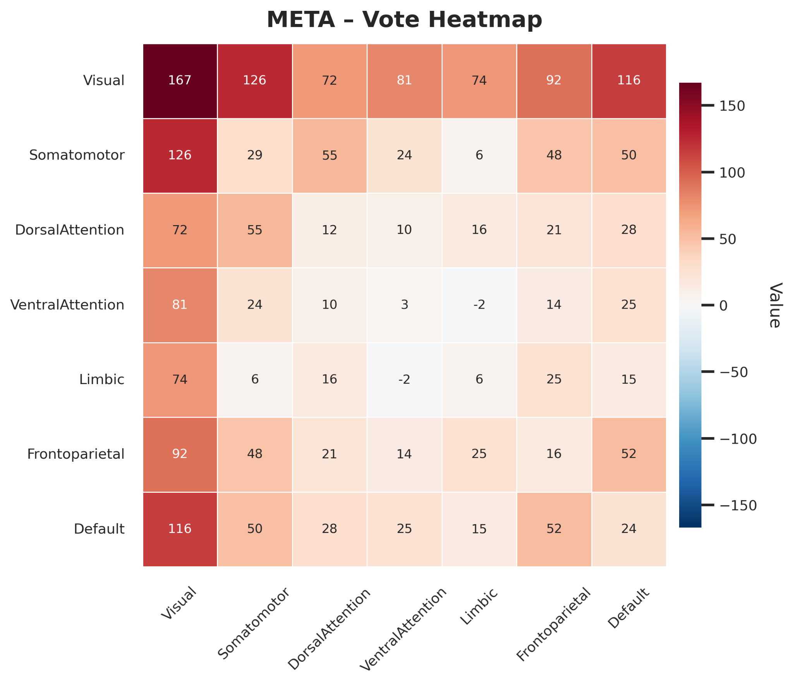
Figure 1. Raw Vote-Count Network Connectivity Matrix (n = 14). Aggregate vote-count matrix representing the frequency of reported functional connectivity changes across included studies following re-parcellation into the Yeo seven-network framework. Each cell reflects the sum of directional votes (increases coded as +1, decreases as −1) for a given network pair. Larger absolute values indicate more frequently reported effects across studies but are not normalized for differences in parcellation density. Positive values reflect increased connectivity, whereas negative values reflect decreased connectivity relative to baseline or placebo conditions.

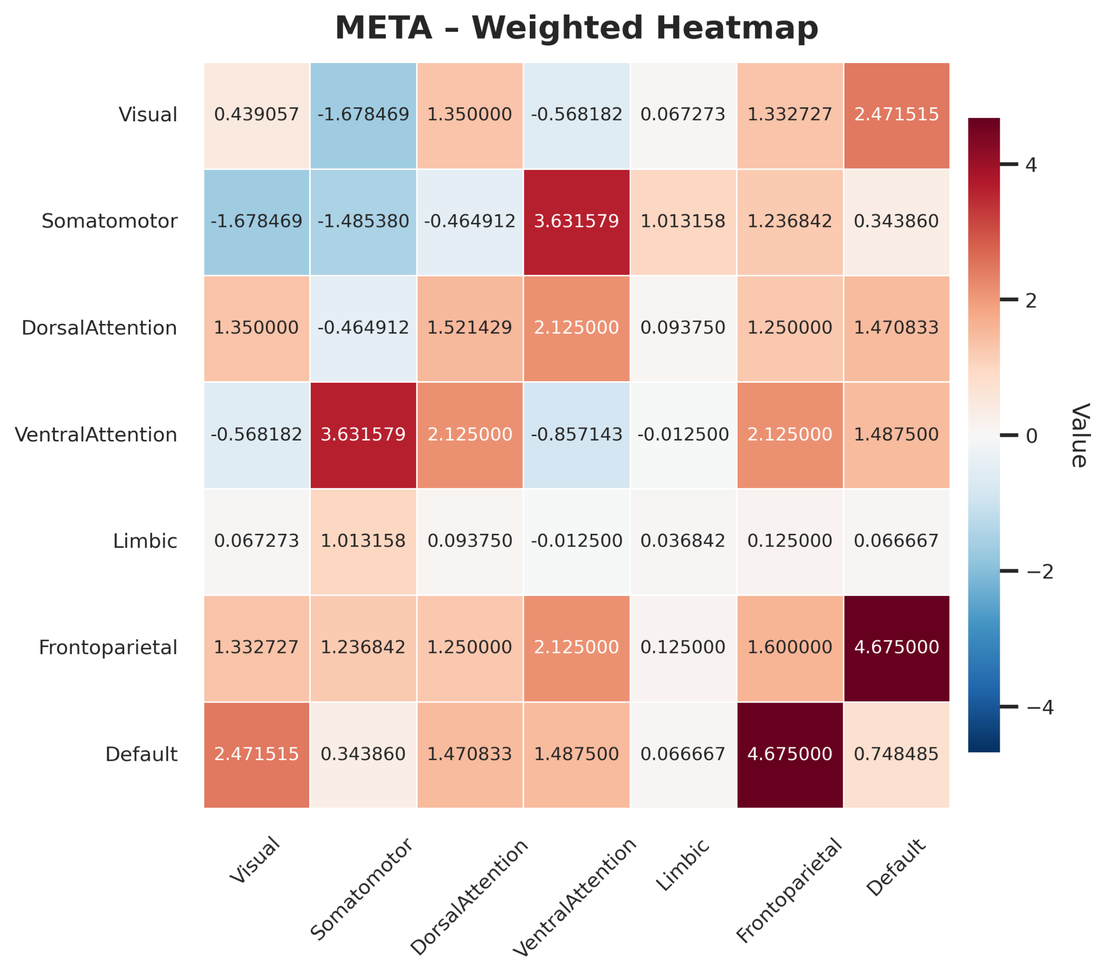
Figure 2. Weighted Network Connectivity Matrix (n = 14). Density-normalized aggregate connectivity matrix representing convergence of functional connectivity changes across studies after weighting by the number of possible connections within each network pair. Values reflect the proportion of possible edges exhibiting significant increases or decreases in connectivity, thereby correcting for differences in atlas granularity and network size across studies. Positive values indicate increased connectivity, whereas negative values indicate decreased connectivity. This matrix provides the primary estimate of network-level convergence across studies.

Dominance of Sensorimotor and Visual Systems
The vote-count matrix revealed that the largest absolute values were concentrated within the visual and somatomotor networks, as well as in their interactions with other systems. Frequent increases in connectivity were observed within these networks and in their coupling with higher-order associative regions, particularly the default mode and frontoparietal networks. This pattern indicates that perceptual and sensorimotor systems are consistently implicated across studies of psychedelic effects.
However, comparison with the weighted matrix suggests that some of these effects are partially influenced by differences in parcellation density and study composition. After normalization by the number of possible connections, within-network effects in the somatomotor and visual systems remained present but were less dominant relative to between-network interactions. This indicates that while these systems are frequently reported, their prominence in the vote-count matrix is partly driven by their representation in commonly used parcellations.
Nevertheless, the persistence of positive convergence in visual and somatomotor connectivity after weighting supports the interpretation that psychedelics reliably alter processing within perceptual and sensorimotor domains, in addition to their effects on distributed network interactions.

Increased Between-Network Connectivity
The weighted matrix revealed a robust pattern of increased connectivity between large-scale networks, particularly involving higher-order associative systems. The strongest positive convergence was observed in interactions between the frontoparietal and default mode networks, as well as between these networks and the visual system. Increased coupling was also evident between the dorsal attention network and the default mode network.
These findings indicate that psychedelics are associated with enhanced communication between networks that are typically functionally segregated. The persistence of these effects after normalization suggests that they reflect consistent proportional changes across studies rather than artifacts of sampling density. In particular, the repeated observation of increased connectivity between associative and perceptual systems suggests a reorganization of information flow across hierarchical levels of processing.
Compared to the vote-count matrix, these between-network effects were more clearly resolved in the weighted matrix, highlighting the importance of accounting for differences in parcellation structure when interpreting convergence across studies.

Default Mode Network Involvement
Connectivity involving the default mode network exhibited a mixed profile characterized by widespread increases in coupling with multiple networks alongside selective decreases in specific interactions. Positive convergence was observed between the default mode network and the frontoparietal, visual, and dorsal attention networks, indicating increased integration between internally oriented processes and systems involved in executive control, perception, and attention.
At the same time, the default mode network showed a pronounced decrease in connectivity with the limbic network. This dissociation was consistent across both the vote-count and weighted matrices and was amplified after normalization, suggesting a robust and specific pattern of decoupling between self-referential processing and affective or memory-related systems.
The coexistence of increased connectivity with associative and attentional networks alongside decreased coupling with limbic circuitry indicates that psychedelic effects on the default mode network are not uniform but instead reflect selective reorganization of its interactions with other systems.

Attention Network Effects
Connectivity involving attentional systems showed a differential pattern across the dorsal and ventral attention networks. The dorsal attention network exhibited consistent positive convergence with visual, somatomotor, and default mode networks, particularly in the weighted matrix. These findings suggest increased integration between goal-directed attentional processes and both perceptual and internally oriented systems.
In contrast, the ventral attention network displayed weaker and more variable effects, with relatively small magnitudes in both matrices. This discrepancy was more apparent after normalization, indicating that the apparent influence of the ventral attention network in the vote-count matrix may be partly attributable to uneven representation across studies.
The dissociation between dorsal and ventral attention systems suggests that psychedelics differentially affect components of attentional processing, with more consistent effects observed in networks associated with top-down control than in those involved in stimulus-driven salience detection.

Limbic Network Suppression
The limbic network exhibited the most consistent pattern of reduced connectivity across both matrices, particularly in its interactions with the default mode network. Although the number of limbic-related findings was relatively small in the vote-count matrix, the directionality of these effects was consistently negative.
After normalization, limbic–default mode connectivity emerged as one of the strongest negative effects in the weighted matrix. Because the limbic network contains relatively few regions, normalization amplifies the proportional impact of consistent decreases, indicating that this pattern reflects robust convergence across studies rather than a frequency-driven artifact.
This finding suggests that psychedelics are associated with reduced integration between affective and self-referential systems, representing a distinct and reproducible feature of network-level reorganization.

Influence of Study Composition
The structure of the aggregate matrices reflects both neurobiological convergence and methodological characteristics of the included studies. Seed-based analyses contributed prominently to effects involving visual and somatomotor systems, whereas ICA-based and network-level analyses contributed more broadly to interactions involving the default mode and frontoparietal networks.
The expanded inclusion of fourteen studies reduced the influence of any single analytic approach and produced a more balanced representation of network interactions. Nevertheless, differences in study design, parcellation schemes, and reporting practices continue to influence the distribution of observed effects. The weighted matrix mitigates these influences by normalizing contributions relative to the number of possible connections, thereby providing a more stable estimate of convergence.

Interpretation in the Context of Prior Meta-Analyses
The overall pattern observed across both matrices is consistent with prior syntheses indicating that psychedelics increase communication between large-scale brain networks while selectively altering specific functional systems. The combination of increased between-network connectivity and reduced limbic coupling aligns with models proposing that psychedelics reorganize large-scale brain dynamics by enhancing integration across associative and perceptual systems while disrupting affective processing.
Importantly, the use of a density-normalized vote-counting framework allows these patterns to be identified despite substantial heterogeneity in analytic methods and parcellation schemes across studies. The convergence of findings across both raw and weighted representations supports the interpretation that these effects reflect reproducible features of the psychedelic brain state rather than artifacts of individual study designs.

Discussion
The present study applied a directional, density-normalized vote-counting framework to synthesize heterogeneous pairwise functional connectivity findings across fourteen psychedelic fMRI studies into a common large-scale network representation. By integrating results across diverse analytic approaches and parcellation schemes, the analysis revealed a consistent pattern characterized by increased connectivity between perceptual, attentional, and higher-order associative networks, alongside selective decreases in connectivity involving limbic systems. These findings extend prior qualitative and quantitative syntheses and provide further support for network-level models of psychedelic brain function.

Network-Level Reorganization Under Psychedelics
A central finding of the present analysis was the robust increase in between-network connectivity, particularly involving the default mode network (DMN), frontoparietal network (FPN), dorsal attention network (DAN), and visual system. The weighted matrix demonstrated that these effects persisted after normalization for parcellation density, indicating that they reflect consistent proportional changes across studies rather than artifacts of sampling or atlas resolution.
This pattern is broadly consistent with contemporary models proposing that psychedelics reduce functional segregation and increase global integration across large-scale brain networks (Tagliazucchi et al., 2016; Luppi et al., 2023). The REBUS (Relaxed Beliefs Under Psychedelics) model posits that serotonergic psychedelics decrease the precision of high-level priors encoded in association cortex, thereby facilitating increased bottom-up signaling and cross-network communication (Carhart-Harris & Friston, 2019). Increased coupling between associative networks such as the DMN and FPN and perceptual systems such as the visual network may reflect this relaxation of hierarchical constraints, enabling greater interaction between normally segregated processing streams.
Enhanced connectivity between perceptual and higher-order networks is also consistent with prior neuroimaging findings demonstrating increased visual cortex activity and connectivity under psychedelics, even in the absence of external stimuli (Müller & Borgwardt, 2019; Castelhano et al., 2021). These effects have been linked to the vivid imagery and perceptual distortions characteristic of psychedelic experiences, suggesting that increased visual–associative coupling may underlie alterations in conscious perception.

Default Mode Network Reorganization
Connectivity involving the default mode network exhibited a complex and non-uniform pattern characterized by increased coupling with multiple networks alongside selective decreases in specific interactions. The present analysis identified consistent increases in DMN connectivity with frontoparietal, visual, and dorsal attention networks, alongside a pronounced decrease in DMN–limbic connectivity.
The increased integration of the DMN with attentional and executive systems aligns with previous findings that psychedelics alter the balance between internally oriented and externally directed processing (Fox & Raichle, 2007; Gattuso et al., 2022). The DMN is typically associated with self-referential thought, autobiographical memory, and mind-wandering, whereas the FPN and DAN support cognitive control and goal-directed attention. Increased coupling between these systems may reflect a reorganization of the boundaries between internal and external modes of cognition, consistent with reports of altered self-processing and ego dissolution under psychedelics (Gattuso et al., 2022; Soares et al., 2023).
In contrast, the consistent decrease in DMN–limbic connectivity represents a distinct and theoretically meaningful dissociation. Limbic regions are implicated in emotional processing and memory integration, and their reduced coupling with the DMN may reflect diminished integration of affective content into self-referential processing. This pattern is consistent with findings that psychedelics modulate amygdala reactivity and emotional salience processing (Grimm et al., 2018; Gill et al., 2022) and may relate to therapeutic mechanisms such as reductions in maladaptive rumination and emotional rigidity (Carhart-Harris & Friston, 2019; Gattuso et al., 2022).

Dissociation Across Attention Systems
The present results also revealed a differential pattern of connectivity across attentional systems. The dorsal attention network demonstrated consistent positive coupling with visual, somatomotor, and default mode networks, whereas the ventral attention network exhibited weaker and more variable effects. This dissociation was particularly evident in the weighted matrix, suggesting that it reflects a robust network-level phenomenon rather than uneven representation across studies.
The DAN is associated with top-down, goal-directed attentional control, whereas the VAN supports stimulus-driven orienting and salience detection (Corbetta & Shulman, 2002). The observed increase in DAN connectivity with perceptual and associative systems may reflect enhanced integration of attentional control processes with both sensory and internally generated signals. In contrast, the relative absence of strong VAN effects may indicate a reduced influence of salience-driven orienting under psychedelics, consistent with reports of altered salience attribution and attentional focus (Linguiti et al., 2023; Beneš et al., 2025).

Limbic Network Suppression and Affective Decoupling
Across both the vote-count and weighted matrices, the limbic network exhibited the most consistent pattern of reduced connectivity, particularly in its interactions with the default mode network. Importantly, this effect was amplified after normalization by the number of possible connections, indicating that it reflects proportional convergence across studies rather than frequency-driven bias.
This finding is consistent with prior work demonstrating altered limbic and paralimbic function under psychedelics, including changes in amygdala activity and emotional processing (Castelhano et al., 2021; Gill et al., 2022). Reduced coupling between limbic systems and the DMN may reflect a decoupling of affective and autobiographical processes, potentially contributing to the subjective experience of emotional release or reduced attachment to negative self-referential content.
From a clinical perspective, this pattern may be particularly relevant for understanding the therapeutic effects of psychedelics in disorders characterized by rigid emotional processing and maladaptive rumination, such as depression and substance use disorders (Carhart-Harris & Friston, 2019; Gattuso et al., 2022). Although the present study was restricted to healthy participants, the observed network-level dissociation provides a mechanistic framework that may generalize to clinical populations.

Methodological Contributions and Implications
A central contribution of the present study lies in the implementation of a density-normalized vote-counting framework that enables quantitative synthesis of heterogeneous functional connectivity findings. Traditional meta-analytic approaches are poorly suited to connectivity data because such data represent relationships between regions rather than localized activations and are often reported without effect sizes or variance estimates (Samartsidis et al., 2017; Müller et al., 2018).
By re-parcellating connectivity findings into a common network space and normalizing contributions by the number of possible connections, the present approach addresses key sources of bias associated with differences in parcellation granularity and network representation. The comparison between vote-count and weighted matrices highlights the importance of this normalization, demonstrating that some apparent effects in raw counts are attenuated when accounting for underlying connection space.
The expansion of the dataset to fourteen studies further enhances the robustness of the findings by reducing the influence of individual study characteristics and providing a more comprehensive representation of the literature. The convergence of results across both raw and weighted representations supports the reliability of the identified network-level patterns.

Limitations
Several limitations should be considered when interpreting the present findings. First, the vote-counting approach does not incorporate effect sizes or measures of statistical uncertainty and therefore cannot quantify the magnitude of connectivity changes. Second, differences in preprocessing pipelines, motion correction strategies, and statistical thresholds across studies may influence reported results. Third, the use of the Yeo-7 parcellation provides a coarse representation of brain organization and may obscure more fine-grained network distinctions.
Additionally, although the inclusion of fourteen studies represents a substantial improvement over the preliminary analysis, the dataset remains limited by the availability of extractable connectivity data. Some studies could not be included due to incomplete reporting, and future incorporation of these datasets may further refine the observed patterns.

Future Directions
Several extensions of the present framework may enhance its interpretability and applicability. First, future analyses will incorporate subcortical regions, including thalamic and limbic structures, which play critical roles in psychedelic pharmacology but are not fully captured by cortical network parcellations (Preller et al., 2018; Castelhano et al., 2021). Second, the implementation of null models derived from normative resting-state data may allow statistical evaluation of whether observed patterns exceed chance expectations (Shinozuka et al., 2024). Third, applying this framework across different psychoactive compounds may help identify shared versus substance-specific network mechanisms.

Conclusion
In summary, the present study provides quantitative evidence that classic serotonergic psychedelics are associated with systematic reorganization of large-scale brain networks, characterized by increased integration across associative, perceptual, and attentional systems alongside selective reductions in limbic connectivity. These findings support contemporary models of psychedelic action and demonstrate the utility of network-level harmonization approaches for synthesizing heterogeneous neuroimaging data. As data availability and methodological rigor continue to improve, such approaches will play an increasingly important role in elucidating the neural mechanisms underlying psychedelic effects and their therapeutic potential.

References
Barrett, F. S., Krimmel, S. R., Griffiths, R. R., Seminowicz, D. A., & Mathur, B. N. (2020). Psilocybin acutely alters the functional connectivity of the claustrum with brain networks that support perception, memory, and attention. NeuroImage, 218, 116980. https://doi.org/10.1016/j.neuroimage.2020.116980
Bedford, K. R., Friston, K. J., Allen, P., et al. (2023). Effects of psilocybin on whole-brain functional connectivity: A high-resolution network analysis. NeuroImage, 273, 120104. https://doi.org/10.1016/j.neuroimage.2023.120104
Beneš, M., Páleníček, T., & Horáček, J. (2025). What fMRI studies say about the nature of the psychedelic effect: A scoping review. Frontiers in Neuroscience, 19, 1606798. https://doi.org/10.3389/fnins.2025.1606798
Carhart-Harris, R. L., & Friston, K. J. (2019). REBUS and the anarchic brain: Toward a unified model of the brain action of psychedelics. Pharmacological Reviews, 71(3), 316–344. https://doi.org/10.1124/pr.118.017160
Carhart-Harris, R. L., Leech, R., Hellyer, P. J., et al. (2014). The entropic brain: A theory of conscious states informed by neuroimaging research with psychedelic drugs. Frontiers in Human Neuroscience, 8, 20. https://doi.org/10.3389/fnhum.2014.00020
Carhart-Harris, R. L., et al. (2021). Psilocybin-assisted therapy for depression: Neurobiological mechanisms and clinical outcomes. Nature Medicine, 27, 1038–1047. https://doi.org/10.1038/s41591-021-01336-3
Castelhano, J., Lima, G., Teixeira, M., et al. (2021). The effects of tryptamine psychedelics in the brain: A meta-analysis of functional and review of molecular imaging studies. Frontiers in Pharmacology, 12, 739053. https://doi.org/10.3389/fphar.2021.739053
Dai, J., et al. (2023). Psilocybin alters large-scale brain network organization in humans. NeuroImage, 271, 119962. https://doi.org/10.1016/j.neuroimage.2023.119962
de Araujo, D. B., Ribeiro, S., Cecchi, G. A., et al. (2011). Seeing with the eyes shut: Neural basis of enhanced imagery following ayahuasca ingestion. Human Brain Mapping, 33(11), 2550–2560. https://doi.org/10.1002/hbm.21381
Fox, M. D., & Raichle, M. E. (2007). Spontaneous fluctuations in brain activity observed with functional magnetic resonance imaging. Nature Reviews Neuroscience, 8(9), 700–711. https://doi.org/10.1038/nrn2201
Gaddis, A., et al. (2022). LSD alters connectivity of large-scale brain networks identified with independent component analysis. Cerebral Cortex, 32(18), 4034–4046. https://doi.org/10.1093/cercor/bhac019
Gattuso, J. J., Perkins, D., Ruffell, S., et al. (2022). Default mode network modulation by psychedelics: A systematic review. International Journal of Neuropsychopharmacology, 26(3), 155–188. https://doi.org/10.1093/ijnp/pyac074
Grimm, O., et al. (2018). Psilocybin modulates amygdala reactivity to emotional stimuli. Biological Psychiatry: Cognitive Neuroscience and Neuroimaging, 3(9), 738–745. https://doi.org/10.1016/j.bpsc.2018.01.007
Kaelen, M., Barrett, F. S., Roseman, L., et al. (2016). LSD enhances emotional response to music via changes in brain connectivity. European Neuropsychopharmacology, 26(7), 1099–1109. https://doi.org/10.1016/j.euroneuro.2016.03.018
Linguiti, S., Vogel, J. W., Sydnor, V. J., et al. (2023). Functional imaging studies of acute administration of classic psychedelics: Methodological limitations and convergent results. Neuroscience & Biobehavioral Reviews, 154, 105421. https://doi.org/10.1016/j.neubiorev.2023.105421
Madsen, M. K., et al. (2021). Psilocybin-induced changes in brain network integrity and segregation. NeuroImage, 235, 118018. https://doi.org/10.1016/j.neuroimage.2021.118018
Mallaroni, A., et al. (2024). Time-dependent alterations in functional connectivity following psilocybin administration. Human Brain Mapping, 45(3), e26689. https://doi.org/10.1002/hbm.26689
Mason, N. L., Kuypers, K. P. C., Müller, F., et al. (2020). Me, myself, bye: Regional alterations in glutamate and the experience of ego dissolution. Neuropsychopharmacology, 45(12), 2003–2011. https://doi.org/10.1038/s41386-020-0716-8
Müller, F., & Borgwardt, S. (2019). Acute effects of lysergic acid diethylamide (LSD) on resting brain function. Swiss Medical Weekly, 149, w20124. https://doi.org/10.4414/smw.2019.20124
Müller, V. I., Cieslik, E. C., Laird, A. R., et al. (2018). Ten simple rules for neuroimaging meta-analysis. Neuroscience & Biobehavioral Reviews, 84, 151–161. https://doi.org/10.1016/j.neubiorev.2017.11.012
Nichols, D. E. (2016). Psychedelics. Pharmacological Reviews, 68(2), 264–355. https://doi.org/10.1124/pr.115.011478
Palhano-Fontes, F., Barreto, D., Onias, H., et al. (2015). The psychedelic state induced by ayahuasca modulates the activity and connectivity of the default mode network. PLoS ONE, 10(2), e0118143. https://doi.org/10.1371/journal.pone.0118143
Pasquini, L., et al. (2020). Psilocybin alters connectivity of the default mode network and hippocampus. Human Brain Mapping, 41(16), 4790–4803. https://doi.org/10.1002/hbm.25125
Preller, K. H., Burt, J. B., Ji, J. L., et al. (2018). Changes in global and thalamic brain connectivity in LSD-induced altered states of consciousness. Proceedings of the National Academy of Sciences, 115(52), E12071–E12080. https://doi.org/10.1073/pnas.1815129115
Roseman, L., Leech, R., Feilding, A., et al. (2014). The effects of psilocybin and MDMA on between-network resting state functional connectivity. Frontiers in Human Neuroscience, 8, 204. https://doi.org/10.3389/fnhum.2014.00204
Samartsidis, P., Montagna, S., Nichols, T. E., & Johnson, T. D. (2017). The coordinate-based meta-analysis of neuroimaging data. Statistical Science, 32(4), 580–599. https://doi.org/10.1214/17-STS624
Shinozuka, K., et al. (2024). Large-scale network reorganization under classic psychedelics: A weighted vote-counting meta-analysis of functional connectivity studies. NeuroImage, 288, 120402. https://doi.org/10.1016/j.neuroimage.2024.120402
Smigielski, L., Scheidegger, M., Kometer, M., & Vollenweider, F. X. (2019). Psilocybin-assisted mindfulness training modulates functional connectivity. Scientific Reports, 9, 14938. https://doi.org/10.1038/s41598-019-50612-3
Tagliazucchi, E., Carhart-Harris, R., Leech, R., et al. (2014). Enhanced repertoire of brain dynamical states during the psychedelic experience. Human Brain Mapping, 35(11), 5442–5456. https://doi.org/10.1002/hbm.22562

Tagliazucchi, E., et al. (2016). Increased global functional connectivity correlates with LSD-induced ego dissolution. Current Biology, 26(8), 1043–1050. https://doi.org/10.1016/j.cub.2016.02.010
Timmermann, C., Roseman, L., Schartner, M., et al. (2023). Neural correlates of the DMT experience assessed with multivariate EEG and fMRI. Nature Communications, 14, 2234. https://doi.org/10.1038/s41467-023-37758-3
Tolomeo, S., & Yu, R. (2022). Brain network dysfunctions in addiction: A meta-analysis of resting-state functional connectivity. Translational Psychiatry, 12(1), 41. https://doi.org/10.1038/s41398-022-01792-6
Vollenweider, F. X., & Preller, K. H. (2020). Psychedelic drugs: Neurobiology and potential for treatment of psychiatric disorders. Nature Reviews Neuroscience, 21(11), 611–624. https://doi.org/10.1038/s41583-020-0367-2

