Day_01_Data_Analytics_Fundamentals

Topics Covered
- What is Data
- What is Data Analytics
- What is Data Science
- Data Analyst vs Data Scientist
- Data Engineer vs ML Engineer
- Structured vs Unstructured Data
- Descriptive, Diagnostic, Predictive and Prescriptive Analytics
- Complete Data Project Lifecycle
- Real-world examples
- Technologies used by Analysts and Data Scientists

- What is Data?
Data is a collection of facts, values, observations, or information that can be processed to generate useful information and insights.
Examples: customer names, ages, order values, transaction dates, ratings, salaries, locations, images, videos, audio, and text.

- What is Data Analytics?
Definition: Data Analytics is the process of collecting, cleaning, transforming, exploring, analyzing, and interpreting data to discover useful insights and support business decision-making.
Example: A food-delivery company analyzes 100,000 orders and discovers that cancellations are highest during weekends. This finding is an insight that can lead to further investigation and business action.

- What is Data Science?
Definition: Data Science is an interdisciplinary field that combines programming, statistics, mathematics, data analysis, machine learning, and domain knowledge to extract knowledge and build predictive or intelligent systems from data.
Example: Historical customer information can be used to build a model that predicts whether a customer is likely to leave a company.

Data Analyst vs Data Scientist
Aspect | Data Analyst | Data Scientist
Main focus | Analyze existing data and provide insights | Build predictive/intelligent solutions
Typical output | Reports, dashboards, insights | Models, predictions, experiments
Common skills | SQL, Excel, Python, visualization, statistics | Python, statistics,  mathematics, ML, SQL

Data Engineer vs ML Engineer
Role | Main Responsibility | Examples of Work
Data Engineer | Builds and maintains data infrastructure and pipelines | Data pipelines, data storage, ETL/ELT, cloud data  platforms
ML Engineer | Deploys, scales, and maintains machine-learning models | Machine-learning models and production systems

Structured vs Unstructured Data
Structured data: Data organized in a predefined format, commonly rows and columns. Examples include SQL tables, CSV files, and spreadsheets.
Unstructured data: Data without a fixed tabular structure. Examples include images, videos, audio, PDFs, emails, social-media text, and free-form documents.
Semi-structured data: Data that does not follow a traditional table structure but contains organizational elements such as keys and values. JSON and XML are common examples.

Four Types of Analytics
- Descriptive Analytics — What happened? Summarizes historical data using counts, totals, averages, dashboards, reports, and charts.
Example: Sales increased from n10 lakh in January to n15 lakh in March.
- Diagnostic Analytics — Why did it happen? Investigates causes and relationships using filtering, comparison, drill-down, segmentation, correlation, and root-cause analysis.
Example: Sales decreased because of stock shortages, higher prices, or increased competition.
- Predictive Analytics — What might happen? Uses historical patterns, statistics, and often machine learning to estimate future outcomes.
Example: Predicting next month's sales or whether a customer may churn.
- Prescriptive Analytics — What should we do? Recommends possible actions based on analysis and predictions.
Example: Increase inventory when a model predicts a large increase in demand.

Complete Data Project Lifecycle
Business Problem
↓
Data Collection
↓
Data Cleaning
↓
Data Exploration
↓
Statistical Analysis
↓
Visualization
↓
Machine Learning
↓
Model Evaluation
↓
Business Decision
↓
Deployment / Reporting

Step | Stage | What happens?
1 | Business Problem | Define the problem, objective, stakeholders, and expected outcome.
2 | Data Collection | Collect relevant data from databases, files, APIs, applications, surveys, or other sources.
3 | Data Cleaning | Handle missing values, duplicates, incorrect formats, inconsistent values, and other quality issues.
4 | Data Exploration | Understand rows, columns, data types, distributions, missingness, patterns, and relationships.
5 | Statistical Analysis | Use descriptive statistics and statistical techniques to understand the data.
6 | Data Visualization | Communicate trends, comparisons, distributions, and relationships using charts/dashboards.
7 | Machine Learning | Build a predictive model when the project requires prediction or automation.
8 | Model Evaluation | Measure model performance with appropriate evaluation metrics.
9 | Business Decision | Translate findings or predictions into useful business actions.
10 | Deployment/Reporting | Deliver dashboards/reports or deploy a model/system for use.

Real-World Example — Food Delivery Analytics
Business Problem: A food-delivery company wants to understand why order cancellations are increasing.
Data Collection: Collect order, customer, delivery, rating, city, date/time, and cancellation information.
Data Cleaning: Check missing ratings/cancellation reasons, duplicate orders, incorrect data types, and invalid values.
Data Exploration: Calculate total orders, delivered orders, cancelled orders, average order value, average delivery time, and average rating.
Statistical Analysis: Study relationships such as delivery time vs cancellation and city vs cancellation.
Visualization: Create charts for cancellation by city, cancellation by time, delivery-time distribution, and order-value distribution.
Machine Learning : Build a model to predict whether an order may be cancelled.
Business Decision: If high delivery time is strongly associated with cancellations, the company may improve delivery capacity in high-delay periods or locations.
Reporting: Present findings in a dashboard or management report.

Technologies Used by Data Analysts
Technology | Common Use
Excel | Quick analysis, formulas, Pivot Tables, charts, reporting
SQL | Querying, filtering, joining, aggregating, and analyzing database data
Python | Data cleaning, analysis, automation, and visualization
Pandas | DataFrames, filtering, transformation, aggregation, cleaning
NumPy | Numerical operations and arrays
Malplotlib | Data Visualization
Seaborn | Statistical/data visualizations
PowerBI/Tableau | Interactive dashboards and business reporting

Technologies Used by Data Scientists
Technology | Common Use
Python | Programming, analysis, modeling, automation
SQL | Working with structured data in databases
Pandas/NumPy | Data manipulation and numerical computation
SciPy | Scientific and statistical computing
Matplotlib/Seaborn | Visualization and exploratory analysis
Scikit-learn | Machine-learning algorithms and model evaluation
TensorFlow/PyTorch | Deep learning and neural-network application
Jupyter | Interactive development, analysis, and experimentation
Cloud platforms | Scalable storage, compute, data and ML services

DAY 2 — Python Fundamentals
Topics Covered:
- Variables
- Data Types
- Strings
- Integers
- Float
- Boolean
- Lists
- Tuples
- Sets
- Dictionaries
- Operators
- Conditions
- Loops

Variable
Variables are names used to store values in a program. Python automatically determines the data type of the assigned value.
name = "Yash" age = 22 salary = 25000

Data Types
Python provides different data types for representing different kinds of values. The basic types used in this task include int, float, str, bool, list, tuple, set, and dictionary.

Strings
A string is a sequence of characters enclosed in single or double quotation marks. Strings support indexing and operations such as upper(), lower(), and slicing.
name = "Python" print(name[0]) print(name.upper())

Integers
An integer represents a whole number without a decimal point, such as 10, 25, or -5.
age = 22

Float
A float represents a decimal number, such as 10.5, 99.50, or 85.75. price = 99.50

Boolean
Boolean values represent logical states and can be either True or False. They are commonly used in conditions.
age = 22 print(age >= 18)

Lists
A list is an ordered and mutable collection. Its elements can be changed after creation.
numbers = [10, 20, 30, 40] numbers[0] = 100

Tuples
A tuple is an ordered and immutable collection. Its values cannot normally be changed after creation.
numbers = (10, 20, 30, 40)

Sets
A set stores unique values. Duplicate elements are automatically removed.
numbers = {10, 20, 30, 20} print(numbers)

Dictionaries
A dictionary stores data as key-value pairs and is useful for representing structured information.
student = {"name": "Yash", "age": 22, "marks": 85} print(student["name"])

Operators
Operators are symbols used to perform calculations and comparisons. Arithmetic operators include +, -, *, /, //, %, and **. Comparison operators include >, <, >=, <=, ==, and !=. Logical operators include and, or, and not.

Conditions
Conditional statements allow a program to make decisions using if, elif, and else.
age = 20 if age >= 18: print("Adult") else: print("Minor")

Loops
Loops execute a block of code repeatedly. The main loops studied were for and while loops.
for i in range(1, 6): print(i) Screenshots:
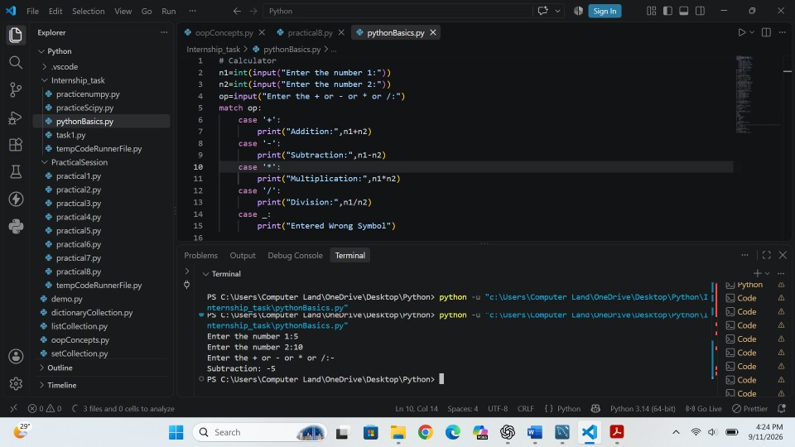

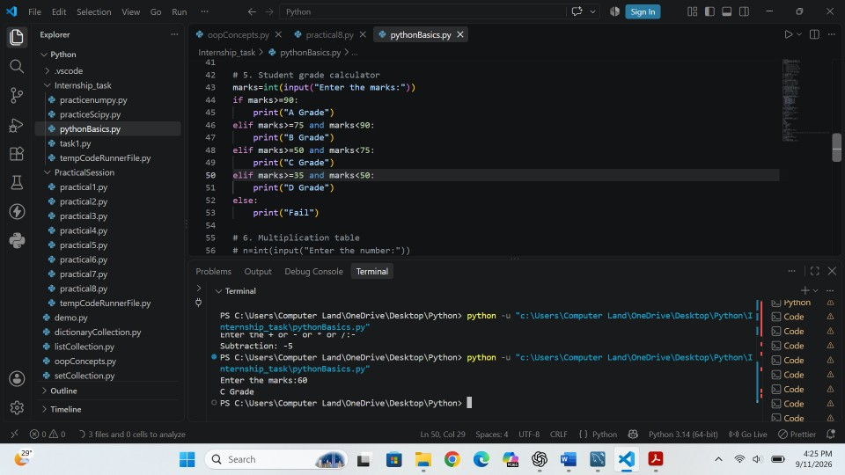

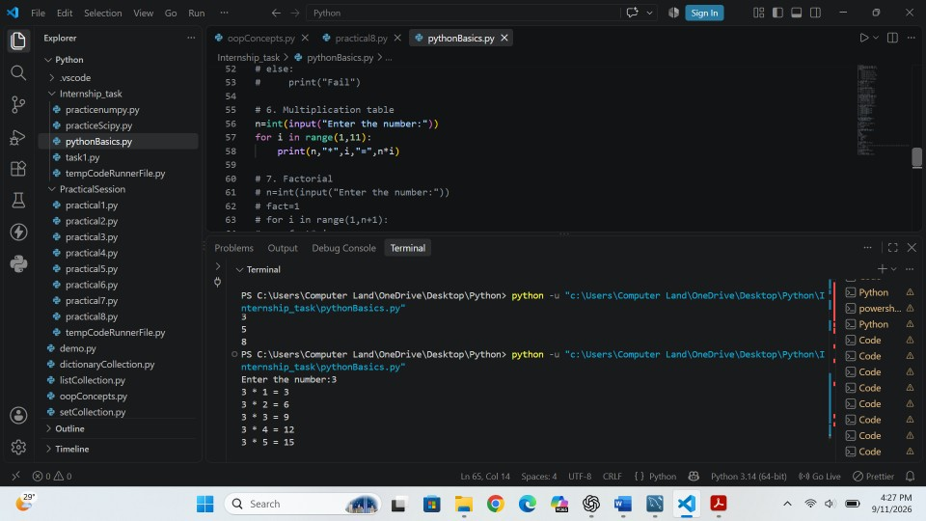

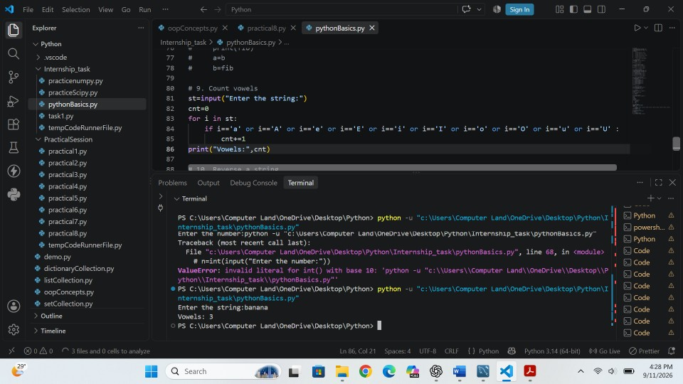

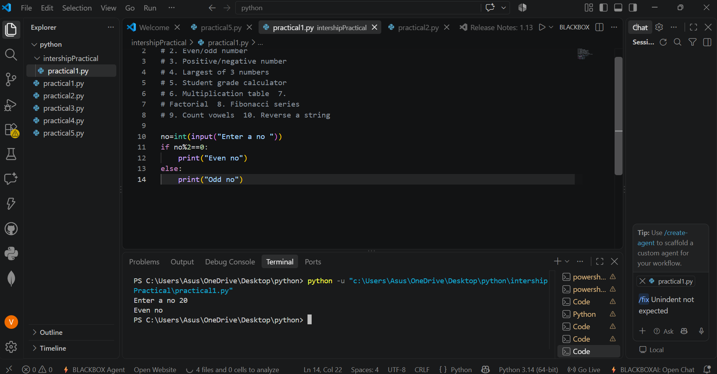

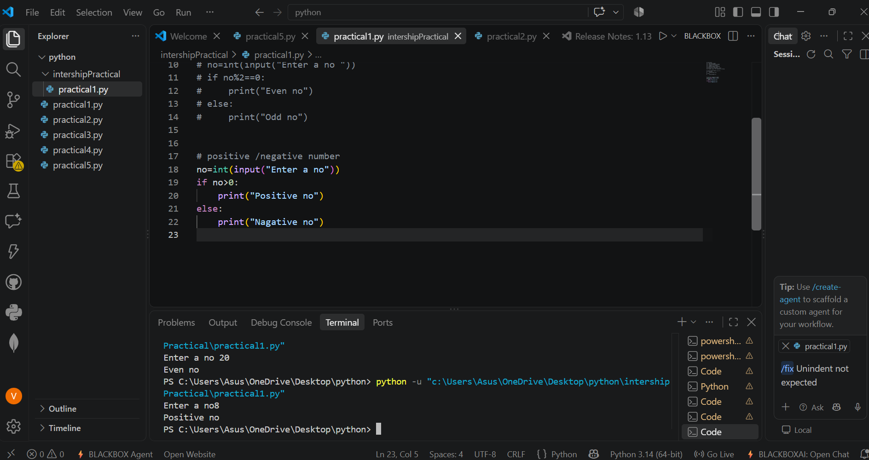

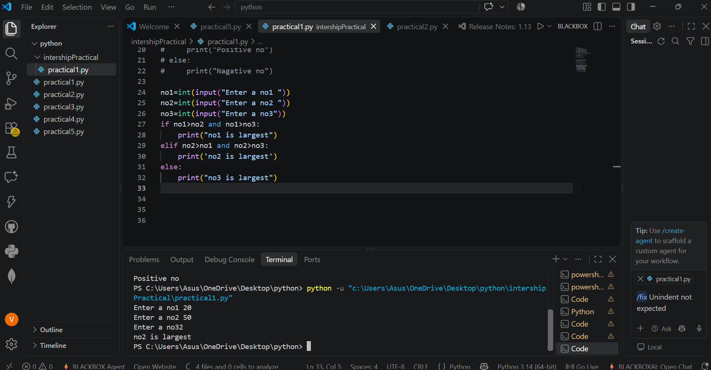

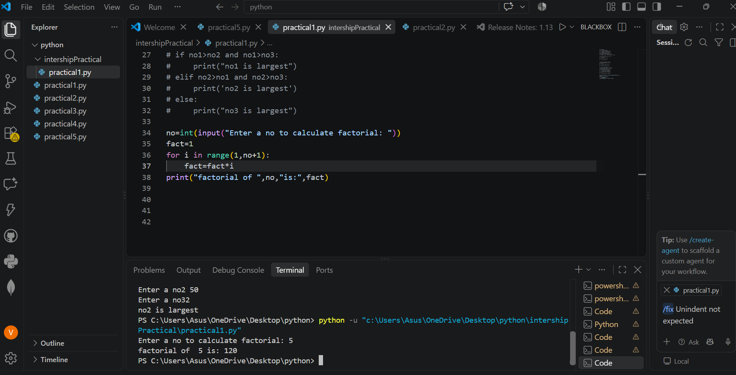

DAY 3 — Function + Advanced Python basics

Topics Covered:
- Function
- Parameters
- Return Values
- Lambda
- Map ()
- Filter ()
- List Comprehension
- Dictionary Comprehension
- Exception Handling
- Modules

Function
A function in Python is a block of reusable code that performs a specific task.
Instead of writing the same code again and again, we create a function once and call it whenever we need it.
def function_name():
# code
26 . Parameters
A parameter is a variable that is written inside the parentheses () when we define a function. It is used to receive a value from the function call.
def add(a, b):
print(a + b)

add(10, 20)

Return values
A return value is the value that a function sends back to the place where the function was called.
We use the return keyword to send a value back.
def add(a, b):
return a + b
result = add(10, 20)
print(result)

Lambda
A lambda function is a small, anonymous function that is written in a single line.
It is mainly used when we need a simple function for a short operation.
square = lambda x: x * x:
print(square(5))

Map ( )
The map() function is used to apply a function to every element of an iterable, such as a list or tuple.
numbers = [1, 2, 3, 4, 5]
result = map(lambda x: x * 2, numbers)
print(list(result))

Filter ( )
The filter() function is used to select/filter elements from a sequence based on a condition.
filter() keeps only the elements for which the given condition is True.
numbers = [1, 2, 3, 4, 5, 6]
result = filter(lambda x: x % 2 == 0, numbers)
print(list(result))

List Comprehension
List comprehension is a short and powerful way to create a new list from an existing iterable such as a list, tuple, range, or string.
Instead of writing multiple lines using a for loop, we can often write the same logic in one line.
numbers = [i for i in range(1, 6)]
print(numbers)

Dictionary Comprehension
Dictionary comprehension is a short and simple way to create a new dictionary from an iterable.
It is similar to list comprehension, but instead of creating a list, it creates a dictionary with key-value pairs.
numbers = [1, 2, 3, 4, 5]
result = {x: x*x for x in numbers}
print(result)

Exception handling
Exception handling is a mechanism in Python used to handle runtime errors without stopping the entire program suddenly.
try
↓
Does an error occur?
↓
┌───────────────┐
│ │
NO YES
│ │
↓ ↓
else except
│ │
└───────┬───────┘
↓
finally
try:
# code that may cause an error
except:
# code to handle the error

Modules
A module in Python is a Python file (.py) that contains code such as functions, classes, variables, or statements, which can be reused in another Python program.

Simple definition
A module is a Python file containing reusable code that can be imported and used in another program

Day 4_NumPy.ipynb
Topics covered:
- Array
- Dimension
- Shape
- Indexing
- Slicing
- Reshape
- Arithmetic operations
- Aggregation
- Mean
- Median
- Standard deviation

Array
A NumPy array is a data structure provided by the NumPy library in Python. It is used to store and perform operations on a collection of values efficiently.
NumPy arrays are especially useful for Data Analysis, Data Science, Machine Learning, and numerical calculations.
An array is a collection of elements stored in an organized structure.

Dimension
A dimension represents the number of axes in an array.
Dimension tells us how many levels are required to access the data in an array
a = np.array([
[10, 20, 30],
[40, 50, 60]
])

Shape
In NumPy, shape tells us how many elements are present along each dimension (axis) of an array.
shape tells us the size/structure of an array.

Indexing
Indexing means accessing a particular element from a sequence such as a list, tuple, or string using its position.
Python indexing starts from 0, not 1.

Slicing
Slicing is a technique in Python used to extract a specific portion or range of elements from a sequence without changing the original sequence
sequence[start : stop : step]
numbers = [10, 20, 30, 40, 50, 60]
print(numbers[0:6:2])

Reshape
Reshape is a NumPy function used to change the shape or dimensions of an array without changing the actual data (values) inside the array.
For example, you can convert a 1-D array into a 2-D array, or change a 2 × 3 array into a 3 × 2 array.
reshape() changes the structure of an array, not its values.
numbers = np.array([1, 2, 3, 4, 5, 6, 7, 8])
new_array = numbers.reshape(2, 2, 2)
print(new_array)

Arithmetic operations
Arithmetic operations are mathematical operations used to perform calculations on numbers.
Python provides arithmetic operators such as addition, subtraction, multiplication, division, modulus, floor division, and exponentiation.
a = 10
b = 5

result = a + b
print(result)

Aggregation
Aggregation means combining multiple values or data points and performing a calculation on them to get a summarized result.
Aggregation = Taking many values and producing one meaningful summary value.
Aggregation is the process of combining multiple data values and calculating a summary such as sum, average, minimum, maximum, or count.

Mean
Mean is the average value of a set of numbers.
In simple words:
Mean = Sum of all values ÷ Total number of values
Formula:
$Mean=​\frac{Sum of all values}{Number of values}$
numbers = [10, 20, 30, 40, 50]
mean = sum(numbers) / len(numbers)
print("Mean:", mean)

Median
Median is the middle value in a dataset when all the values are arranged in ascending or descending order.

Median=Middle value

Standard Deviation

Standard deviation (SD) is a statistical measure that tells us how much the values in a dataset are spread out from the mean (average).
- Low standard deviation → values are close to the mean.
- High standard deviation → values are more spread out from the mean.

DAY 5 — Pandas Basics

Topics Covered:
- Series
- DataFrame
- Read_csv ( )
- Head ( )
- Tail ( )
- Info ( )
- Describe ( )
- Shape
- Columns
- Dtypes

Series
A Series is a one-dimensional labeled data structure in Pandas. It can be considered similar to a single column of a table.
marks=pd.Series([80,75,90,65])
print(marks)
A Series contains values along with an index. By default, Pandas assigns integer indexes starting from 0.
marks=pd.Series([80,75,90],index=["Rahul","Priya","Amit"])
print(marks)
A value can be accessed using its label:
print(marks["Rahul"])

DataFrame
A DataFrame is a two-dimensional labeled data structure consisting of rows and columns. It is the main Pandas structure used for working with tabular datasets.
data={
"Name":["Rahul","Priya","Amit"],
"Age":[22,25,23],
"Salary":[30000,45000,35000]
}
df=pd.DataFrame(data)
print(df)
A DataFrame can be viewed as a table similar to an Excel worksheet. Each column can have a different data type.

read_csv ( )
The read_csv() function is used to load a CSV (Comma-Separated Values) file into a Pandas DataFrame.
Import pandas as pd
df = pd.read_csv("dataset.csv")
print(df)
If the CSV file is not in the current working directory, its file path can be provided.
df = pd.read_csv(r"C:\Users\YourName\Desktop\dataset.csv")
After loading the file, the variable df represents the DataFrame containing the dataset.

head ( )
The head() function displays the first rows of a DataFrame. By default, it displays the first five rows.
df.head()
To display the first 10 rows, as required in this task:
df.head(10)

tail ( )
The tail() function displays the last rows of a DataFrame. By default, it displays the last five rows.
df.tail()
To display the last 10 rows:
df.tail(10)

info ( )
The info() method provides an overview of the DataFrame. It shows information such as the number of rows, columns, column names, non-null counts, data types, and memory usage.
df.info()
This is useful during initial dataset inspection because it helps identify column types and possible missing values.

Describe ( )
The describe() method generates descriptive statistics for numerical columns by default.
df.describe()
Important statistics include:
- count — number of non-missing values.
- mean — arithmetic average.
- std — standard deviation, indicating data spread.
- min — minimum value.
- 25% — first quartile (Q1).
- 50% — median (Q2).
- 75% — third quartile (Q3).
- max — maximum value.

Shape
The shape attribute returns the dimensions of a DataFrame in the form (rows, columns).
df.shape
For example, if the output is (100, 5), the dataset contains 100 rows and 5 columns.
print("Number of rows:" ,df.shape[0])
print("Number of columns:", df.shape[1])

Columns
The columns attribute returns the names of all columns in the DataFrame.
print(df.columns)
Column names can also be converted into a normal Python list:
print(df.columns.tolist())

dtypes
The dtypes attribute displays the data type of each column.
print(df.dtypes)
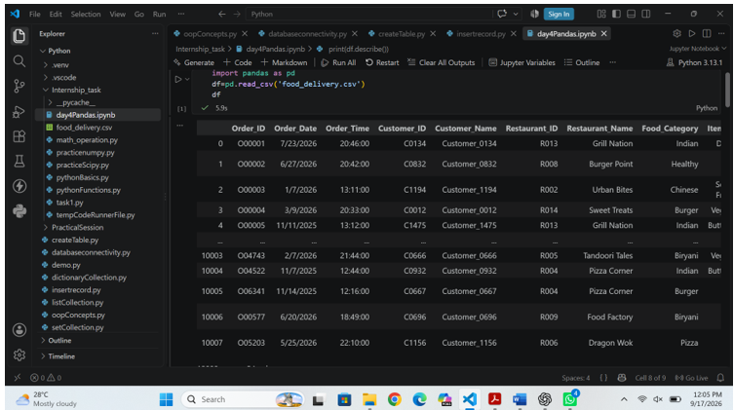
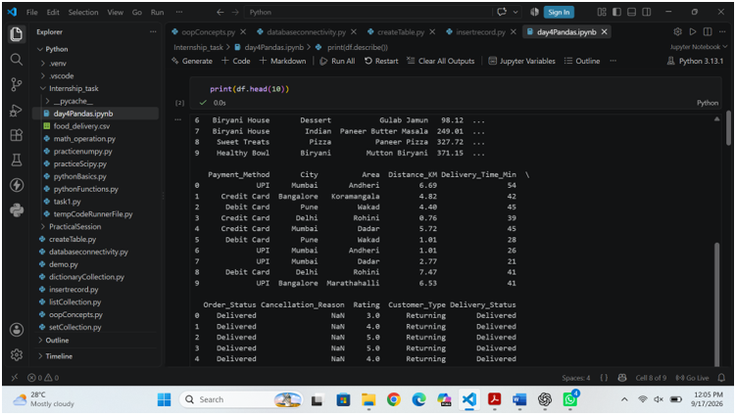
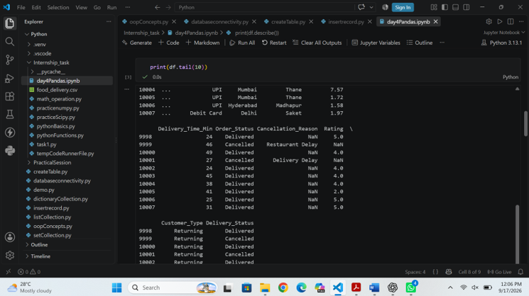
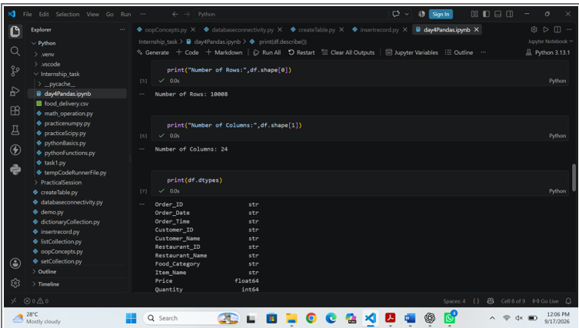

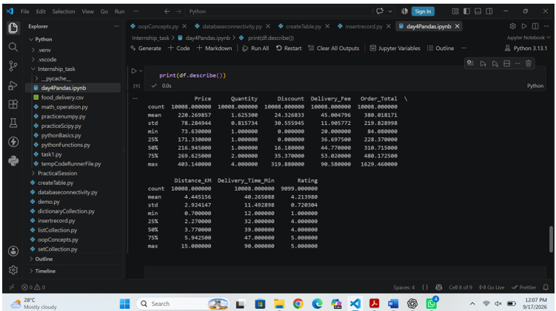

DAY 6 — Data Cleaning

Topics covered:
- Missing Values
- Duplicates
- Wrong Datatypes
- Incorrect Values
- Inconsistent Texts
- Outliers

- Missing Values
isnull()` identifies missing values and `sum()` counts them column-wise.
print(df.isnull().sum())
- Duplicates
`duplicated()` identifies repeated complete rows.
print(df.duplicated().sum())
print(df[df.duplicated()])
- Wrong Datatypes
dtypes give the datatypes of column.
print(df.dtypes)
astype() use to convert datatype of column
df["Age"] = df["Age"].astype(int)
- Incorrect Values
Converted different representations of gender into consistent values.
df["Gender"]=df["Gender"].replace({
"M":"Male","male":"Male","m":"Male",
"F":"Female","f":"Female"
})
Converted the text value 'twenty' into a numeric value and ensured the Age column is numeric.
df["Age"]=df["Age"].replace("twenty”,20)
df["Age"] = pd.to_numeric(df["Age"], errors="coerce")
- Inconsistent Texts
str.strip()` removes extra spaces and `str.title()` standardizes capitalization.
df["City”]df["City"].str.strip()
df["City"] = df["City"].str.title()
- Outliers
Used the IQR method to identify potential salary outliers. A potential outlier was investigated rather than automatically deleted.
Q1df["Salary"].quantile(0.25)
Q3=df["Salary"].quantile(0.75)
IQR = Q3 - Q1
lower = Q1 - 1.5 * IQR
upper = Q3 + 1.5 * IQR
outliers = df[(df["Salary"] < lower) | (df["Salary"] > upper)]
print(outliers)

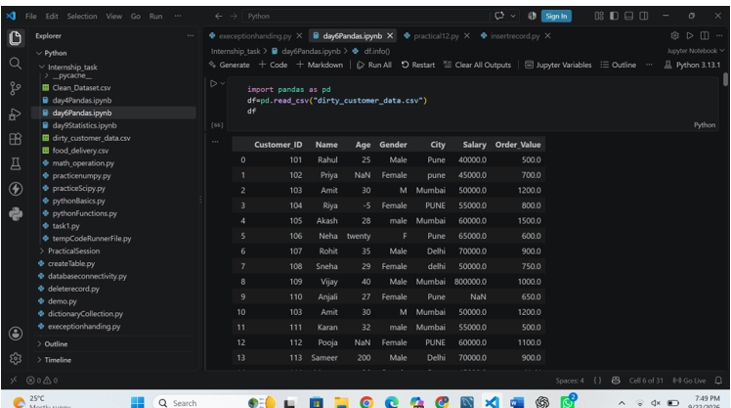

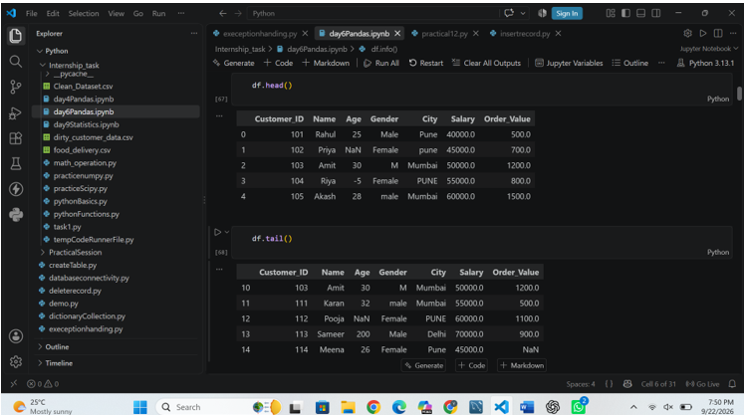

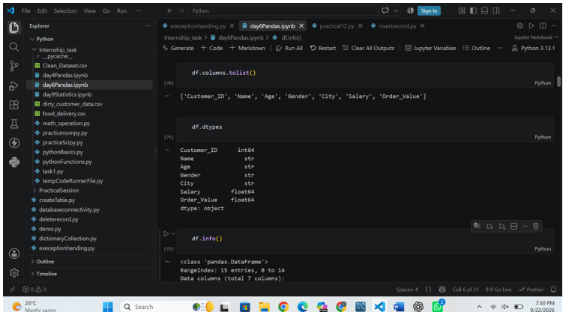

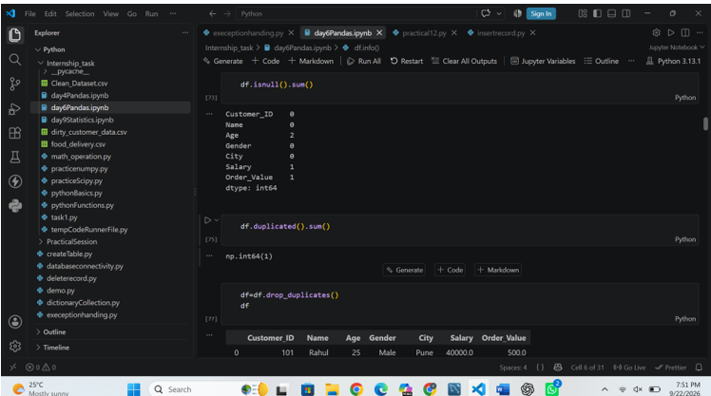

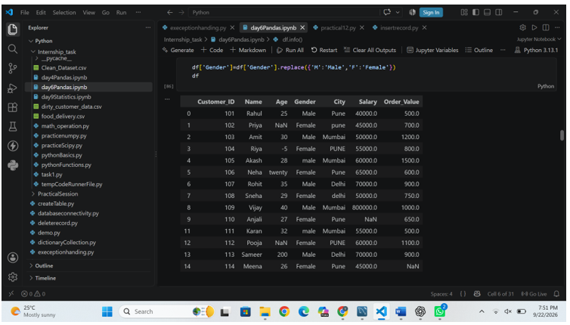

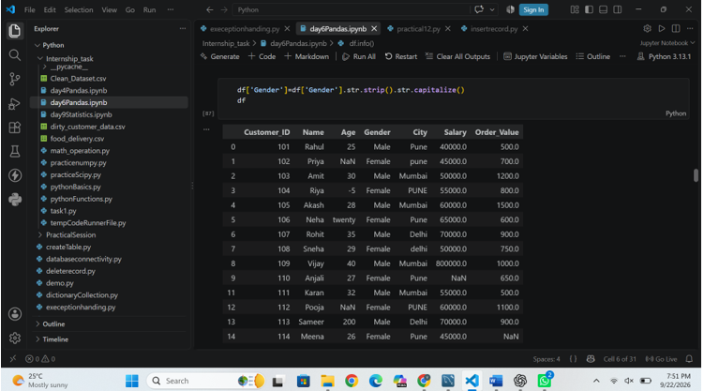

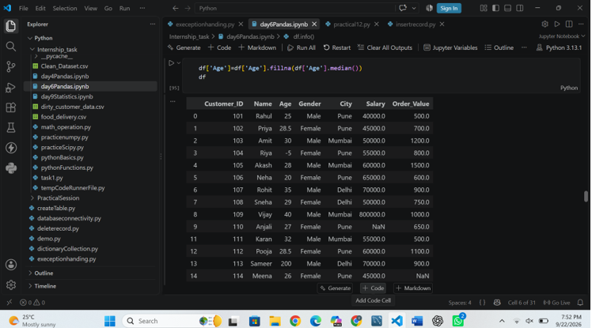

DAY 7 — SQL Fundamentals

- Database
- Table
- Row
- Column
- Primary Key
- Foreign Key
- SELECT
- WHERE
- ORDER BY
- GRIUP BY
- HAVING
- DISTINCT
- CASE
- Database
A database is a structured collection of data.
CREATE DATABASE ecommerce_db;

- Table
A table stores data in rows and columns.
CREATE TABLE customers (
customer_id INT PRIMARY KEY,
customer_name VARCHAR(100),
city VARCHAR(50),
email VARCHAR(100));
- Row
A row represents one complete record.
Example:
| Rahul | Pune | rahul@gmail.com
- Column
A column represents one attribute/property of the data.
Example:
customer_id
customer_name
city
email
- Primary Key
A Primary Key uniquely identifies every row in a table.
Example:
CREATE TABLE customers (
customer_id INT PRIMARY KEY,
customer_name VARCHAR(100),
city VARCHAR(50),
email VARCHAR(100)
);
- Foreing Key
A Foreign Key creates a relationship between tables.
CREATE TABLE orders ( order_id INT PRIMARY KEY, customer_id INT, product_id INT, quantity INT, order_date DATE, FOREIGN KEY (customer_id) REFERENCES customers(customer_id), FOREIGN KEY (product_id) REFERENCES products(product_id) );

- Select
SELECT is used to retrieve data.
Example:
SELECT * FROM customers;

- Where
WHERE filters records.
Example:
SELECT *
FROM customers
WHERE city = 'Pune';

- Order by
ORDER BY sorts the result.
Example:
SELECT *
FROM products
ORDER BY price ASC;

- Group by
GROUP BY groups similar values together.
Example:
SELECT city, COUNT(*) AS customer_count
FROM customers
GROUP BY city;

- Having
Filters rows before grouping.
Example:
SELECT city, COUNT(*) AS total_customers
FROM customers
GROUP BY city
HAVING COUNT(*) > 1;

- Distinct
DISTINCT removes duplicate values.
Example:
SELECT DISTINCT city FROM customers;

- Case
CASE is basically SQL's version of an if-else condition.
Example:
SELECT product_name, price, CASE WHEN price >= 10000 THEN 'Expensive' WHEN price >= 5000 THEN 'Medium' ELSE 'Affordable' END AS price_category FROM products;

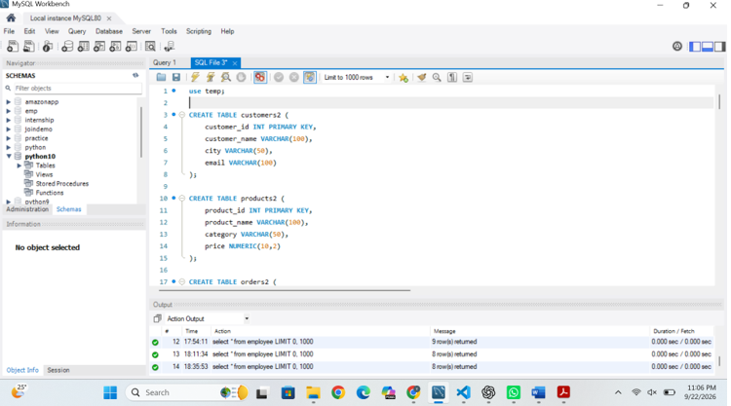

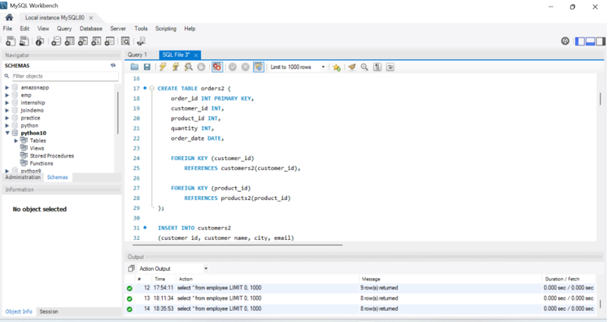

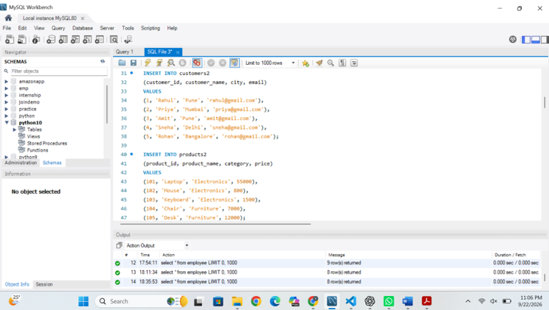

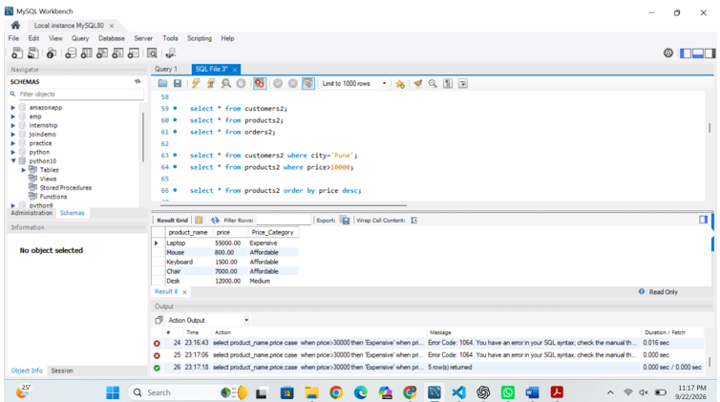

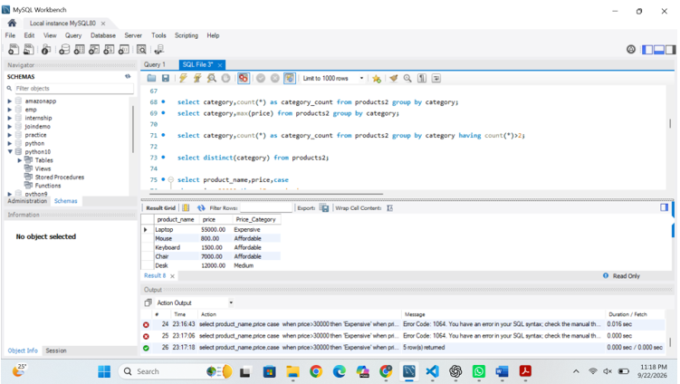

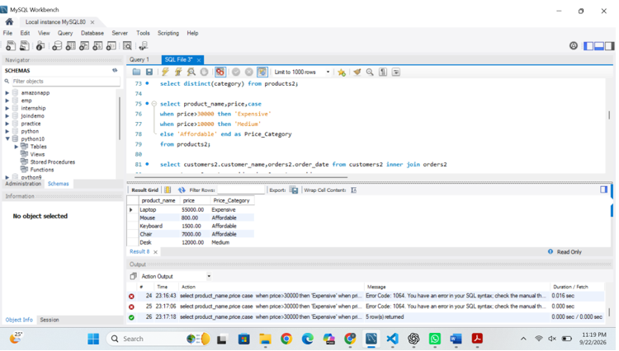

DAY 8 — Advanced SQL

Topics covered:
- Join
- Inner join
- Left join
- Subquery
- CTE
- Windows Function
- Join
A JOIN is used to combine data from two or more tables using a related column.
Example:
SELECT c.customer_name, o.order_id, o.amount FROM customers c JOIN orders o ON c.customer_id = o.customer_id;

- Inner join
An INNER JOIN returns only matching records from both tables.
Example:

SELECT c.customer_name, o.amount FROM customers c INNER JOIN orders o ON c.customer_id = o.customer_id;

- Left join
LEFT JOIN returns:All records from the left table + matching records from the righttable.

SELECT c.customer_id, c.name, o.order_id FROM customers c LEFT JOIN orders o ON c.customer_id = o.customer_id;

- Subquery
A subquery is a query inside another query.
Example:
SELECT *
FROM employees
WHERE salary > (
SELECT AVG(salary)
FROM employees
);

- CTE
CTE means:Common Table Expression
A CTE allows you to create a temporary named result and then use it in another query.
Example:
WITH avg_salary AS (
SELECT AVG(salary) AS average_salary
FROM employees
)
SELECT *
FROM employees
WHERE salary > (
SELECT average_salary
FROM avg_salary
);

- Windows function
A window function calculates information across related rows without collapsing the individual rows into one result.
Example:
SELECTemployee_name, salary,
AVG(salary) OVER() AS average_salary
FROM employees;

- Row_Number ( )
ROW_NUMBER() assigns a unique sequential number to each row according to the specified order.
Example:
SELECT employee_namesalary,
ROW_NUMBER() OVER(ORDER BY salary DESC) AS row_num
FROM employees;

- RANK ( )
RANK() gives tied values the same rank and leaves a gap after the tie.
Example:
SELECT employee_name, salary,
RANK() OVER(ORDER BY salary DESC) AS salary_rank
FROM employees;

- DENSE_RANK ( )
DENSE_RANK() gives tied values the same rank but does not leave gaps.
Example:
SELECT employee_name, salary,
DENSE_RANK() OVER(ORDER BY salary DESC) AS salary_rank
FROM employees

- LAG
LAG() retrieves a value from a previous row. It is useful for previous-month revenue and comparisons.
Example:
SELECT month, revenue,
LAG(revenue) OVER(ORDER BY month) AS previous_revenue
FROM monthly_sales;

- LEAD ( )
LEAD() retrieves a value from a following row.
Example:
SELECT month, revenue,
LEAD(revenue) OVER(ORDER BY month) AS next_revenue
FROM monthly_sales;

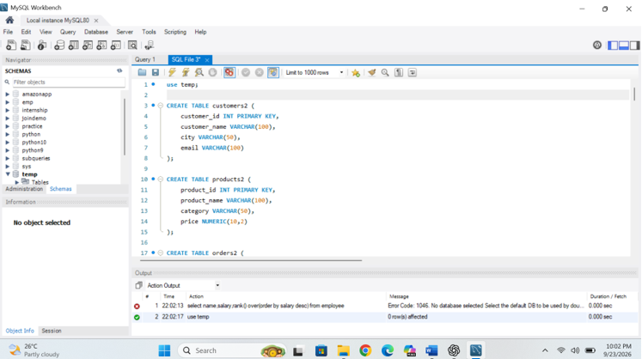

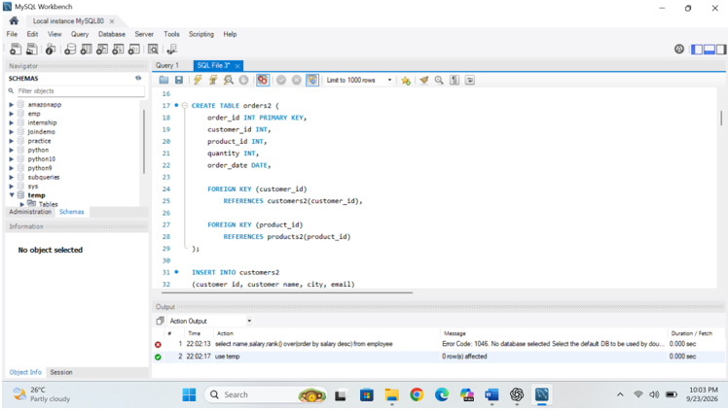

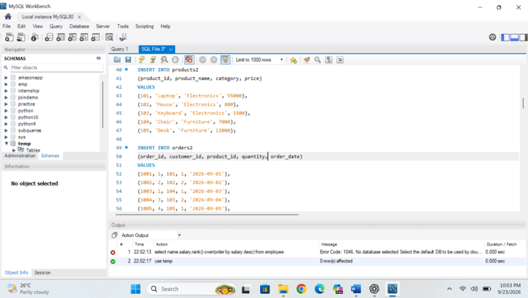

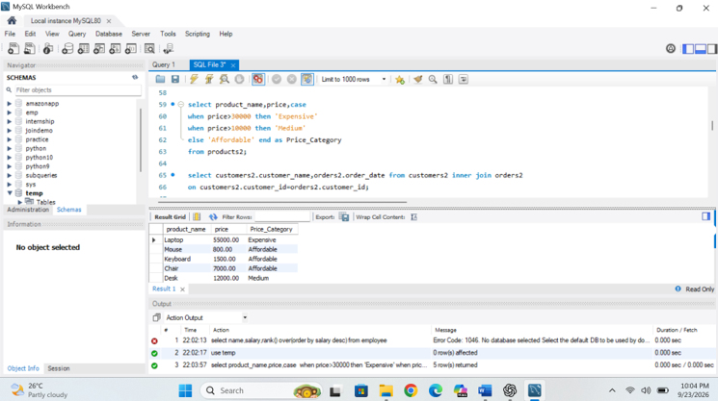

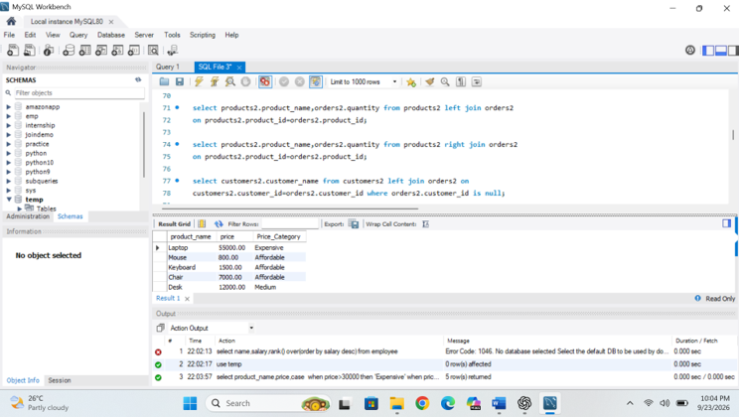

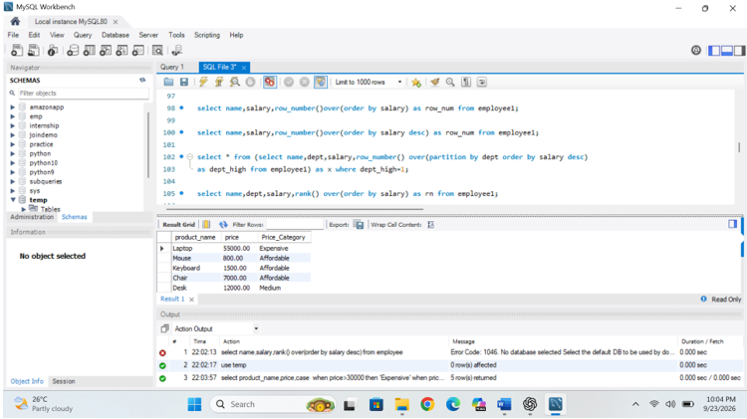

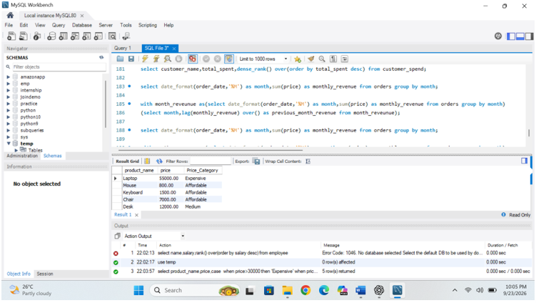

DAY 9 — Statistics

Topics covered

- Mean
- Median
- Mode
- Range
- Variance
- Standard Deviation
- Percentile
- Quartile
- IQR
- Correlation
- Covariance

- Mean
Mean is the arithmetic average of all observations. It is calculated by adding all values and dividing the total by the number of observations.
Formula:
Mean = Sum of all values / Number of values
Calculation: Mean = 214 / 10 = 21.40

- Median
Median is the middle value after the observations are arranged in ascending or descending order. When there is an even number of observations, the median is the average of the two middle values.
Ordered data: 10, 12, 12, 15, 18, 20, 22, 25, 30, 50
The two middle values are 18 and 20.
Calculation: Median = (18 + 20) / 2 = 19

- Mode
Mode is the value that occurs most frequently in a dataset.
In the dataset, the value 12 occurs twice, while the other values occur once.
Result: 12

- Range
Range measures the total distance between the largest and smallest observations.
Formula: Range = Maximum − Minimum
Calculation: Range = 50 − 10 = 40

- Variance
Variance measures how far observations are spread around the mean by using squared deviations from the mean. For this report, population variance is used, meaning the denominator is the total number of observations (N).
Formula: Population Variance = Σ(x − μ)² / N
Mean (μ) = 21.40
Value | Deviation from Mean | Squared Deviation
10 | -11.40 | 129.96
12 | -9.40 | 88.36
12 | -9.40 | 88.36
15 | -6.40 | 40.96
18 | -3.40 | 11.56
20 | -1.40 | 1.96
22 | 0.60 | 0.36
25 | 3.60 | 12.96
30 | 8.60 | 73.96
50 | 28.60 | 817.96

Sum of squared deviations = 1266.40
Population Variance = 1266.40 / 10 = 126.64

- Standard Deviation
Standard deviation is the square root of variance. It expresses dispersion in the same units as the original data, which generally makes it easier to interpret than variance.
Formula: Standard Deviation = √Variance
Calculation: √126.64 = 11.25

- Percentile
A percentile describes the relative position of a value within an ordered distribution. For example, the 90th percentile is a point below which approximately 90% of the observations fall, depending on the percentile calculation convention.

Percentile | Value | Meaning
25th percentile | 12.75 | A point representing the lower quarter of the ordered distribution.
50th percentile | 19.00 | The median / central position.
75th percentile | 24.25 | A point representing the upper quarter boundary.
90th percentile | 32.00 | A high-position point in the ordered distribution.

- Quartiles
Quartiles divide an ordered dataset into four sections. Q1 is the 25th percentile, Q2 is the 50th percentile (median), and Q3 is the 75th percentile.

Quartile | Percentile | Value | Interpretation
Q1 | 25th | 12.75 | Approximately the lower 25% position.
Q2 | 50th | 19.00 | Median / central position.
Q3 | 75th | 24.25 | Approximately the upper 75% position.

- Interquartile Range (IQR)
Interquartile Range measures the spread of the middle 50% of the observations.
Formula: IQR = Q3 − Q1
Calculation: IQR = 24.25 − 12.75 = 11.50
Result: 11.50

- Correlation
Correlation measures the direction and strength of a linear relationship between two numerical variables. The correlation coefficient is generally between −1 and +1.
For demonstration, the following advertising-spend values are paired with the sales observations. This second variable is an illustrative example created for demonstrating correlation and covariance.
Observation | Advertising Spend | Sales
1 | 5 | 10
2 | 7 | 12
3 | 8 | 12
4 | 10 | 15
5 | 12 | 18
6 | 13 | 20
7 | 15 | 22

Population covariance = 47.6000
Population standard deviation of advertising = 4.7592
Population standard deviation of sales = 11.2534
Correlation = Covariance / (SD of X × SD of Y) = 0.8888
Correlation result: 0.8888

- Covariance
Covariance indicates whether two variables tend to move together. Positive covariance means the variables tend to increase together, while negative covariance means that when one increases, the other tends to decrease.
Formula for population covariance: Cov(X,Y) = Σ[(x − μx)(y − μy)] / N
Population covariance: 47.6000

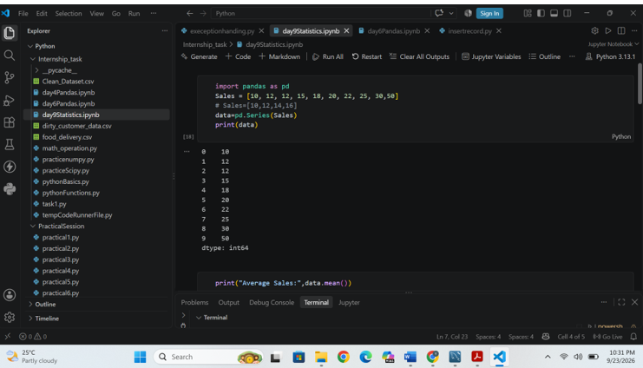

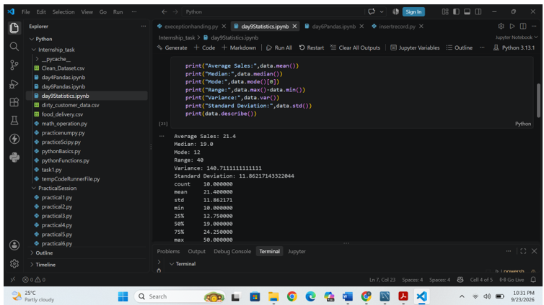

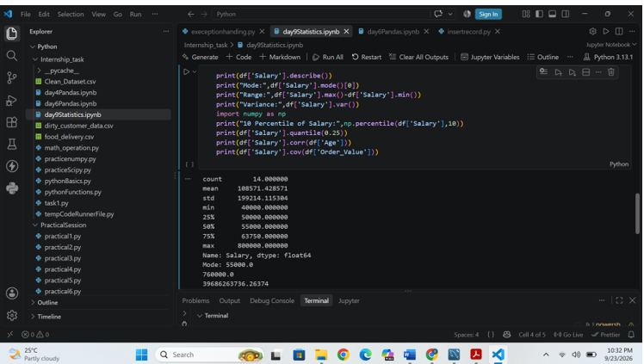

DAY 10 — Probability

Topics Covered

- Probability
- Conditional Probability
- Independence Events
- Dependent Events
- Bayes Theorem
- Normal Distribution
- Binomial Distribution

- Probability
Probability is a branch of mathematics that measures the chance or likelihood of an event happening.
In simple words, probability tells us how likely something is to happen.
Formula
$$\boxed{P\left(E\right)=\frac{\text{Number of favorable outcomes}}{\text{Total number of possible outcomes}}}$$
Where:
- P(E) = Probability of event E
- Favorable outcomes = Outcomes that we want
- Total possible outcomes = All possible outcomes

Example: Tossing a Coin
A coin has two possible outcomes:
{Head, Tail}
If we want to find the probability of getting Head:
$$P\left(\text{Head}\right)=\frac{1}{2}$$
So:
$$\boxed{P\left(\text{Head}\right)=0.5=50\%}$$
Example: Rolling a Dice
A dice has 6 possible outcomes:
{1, 2, 3, 4, 5, 6}
What is the probability of getting 4?
There is only 1 favorable outcome (4) and 6 total outcomes.
$$P\left(4\right)=\frac{1}{6}$$

- Conditional Probability
Conditional probability is the probability of an event happening when we already know that another event has happened.
In simple words:
It tells us the probability of Event A, given that Event B has already occurred.
Formula
$$P\left(A∣B\right)=\frac{P\left(A∩B\right)}{P\left(B\right)}$$

$$P\left(A∣B\right)=\frac{P\left(A∩B\right)}{P\left(B\right)}=\frac{\text{0.25}}{\text{0.50}}=\text{0.50}$$

$$P\left(B\right)$$
$$P\left(B\right)$$
$$P\left(A∩B\right)$$
$$P\left(A∩B\right)$$
P(B)=0.50P(A∩B)=0.25P(A|B) ≈ 0.50A∩B is the part of B where A also happens
Give feedback
$$\boxed{P\left(A∣B\right)=\frac{P\left(A∩B\right)}{P\left(B\right)}}$$
Where:
- P(A | B) = Probability of A given B
- P(A ∩ B) = Probability that both A and B happen
- P(B) = Probability of B happening
- | = "given that"

Easy Example
Suppose we roll a dice.
We know that the number is even. What is the probability that the number is 4?
Possible outcomes of a dice:
1, 2, 3, 4, 5, 6
Even numbers:
2, 4, 6
Since we already know the number is even, our possible outcomes are now only:
2, 4, 6
Only one of these is 4.
$$P\left(4∣\text{Even}\right)=\frac{1}{3} \\ \boxed{P\left(4∣\text{Even}\right)=33.33\%}$$
Normal Probability vs Conditional Probability

Probability | Conditional Probability
No additional information | We have additional information
P(A) | P(A|B)
Probability of A | Probability of A given B

- Independence Events
Independent events are two events where the occurrence of one event does not affect the probability of the other event.
In simple words:
If Event A happens, it does not change the chance of Event B happening.
Formula
For independent events:
$$\boxed{P\left(A∩B\right)=P\left(A\right)×P\left(B\right)}$$
Another way to check independence is:
$$\boxed{P\left(A∣B\right)=P\left(A\right)}$$
This means the probability of A remains the same even when we know that B has happened.

Example: Tossing a Coin
Suppose we toss a coin twice.
- Event A = getting Head on the first toss
- Event B = getting Head on the second toss
The result of the first toss does not affect the second toss.
$$P\left(A\right)=\frac{1}{2}$$
$$P\left(B\right)=\frac{1}{2}$$
Therefore:
$$P\left(A∩B\right)=\frac{1}{2}×\frac{1}{2}$$
$$\boxed{P\left(A∩B\right)=\frac{1}{4}}$$
So, the probability of getting Head on both tosses is 1/4 = 25%.

Another Example
Roll a dice twice.
- First roll = getting 6
- Second roll = getting 6
The first roll does not affect the second roll.
Therefore, these are independent events.

Independent vs Dependent Events
Independent Events | Dependent Events
One event does not affect another | One event affects another
Probability remains unchanged | Probability changes
Example: Two coin tosses | Example: Drawing cards without replacement
- Dependent Events
Dependent events are two events where the occurrence of one event affects the probability of the other event.
In simple words:
If Event A happens, it changes the chance of Event B happening.
Formula
For dependent events:
$$\boxed{P\left(A∩B\right)=P\left(A\right)×P\left(B∣A\right)}$$
Where:
- P(A) = Probability of Event A
- P(B|A) = Probability of B given that A has already happened
- P(A ∩ B) = Probability that both A and B happen
Example: Drawing Cards 🃏
Suppose we have a deck of 52 cards.
We draw two cards without replacement.
- Event A = First card is an Ace
- Event B = Second card is an Ace
Step 1: Probability of first Ace
There are 4 Aces out of 52 cards:
$$P\left(A\right)=\frac{4}{52}$$
Step 2: Probability of second Ace
After drawing one Ace, only 3 Aces and 51 cards remain:
$$P\left(B∣A\right)=\frac{3}{51}$$
Therefore:
$$P\left(A∩B\right)=\frac{4}{52}×\frac{3}{51} \\ \boxed{P\left(A∩B\right)=\frac{1}{221}}$$
The second probability changed because the first card was not replaced.
Independent vs Dependent
Independent Events | Dependent Events
One event does not affect the other | One event affects the other
Probability stays the same | Probability changes
Two coin tosses | Drawing cards without replacement
Example: Roll dice twice | Example: Selecting students without replacement

- Bayes Theorem
Bayes' Theorem is a probability rule used to update the probability of an event when we get new information or evidence.
In simple words:
Bayes' Theorem helps us find the probability of an event when we know that another related event has already occurred.
Formula
$$P\left(A∣B\right)=\frac{P\left(B∣A\right)P\left(A\right)}{P\left(B\right)}$$

$$P\left(A∣B\right)=\frac{0.85\left(0.20\right)}{0.25}=0.68$$

$$P\left(A\right)$$
$$P\left(A\right)$$
$$P\left(B∣A\right)$$
$$P\left(B∣A\right)$$
$$P\left(B∣¬A\right)$$
$$P\left(B∣¬A\right)$$
$P\left(B\right)$= 0.25
$P\left(B∩A\right)$= 0.17
$P\left(B∩¬A\right)$= 0.08
Give feedback
$$\boxed{P\left(A∣B\right)=\frac{P\left(B∣A\right)×P\left(A\right)}{P\left(B\right)}}$$
Where:
- P(A|B) = Probability of A given B
- P(B|A) = Probability of B given A
- P(A) = Probability of A
- P(B) = Probability of B
Easy Example
Suppose:
- A = A person has a disease
- B = The medical test is positive
Assume:
$$P\left(A\right)=0.01$$
Only 1% of people have the disease.
Suppose the test is positive for a person. Bayes' Theorem helps us answer:
What is the probability that the person actually has the disease given that the test is positive?
This is written as:
$$P\left(A∣B\right)$$
We use the known probabilities to calculate this value.

- Normal Distribution
Normal Distribution is a probability distribution that describes how values are spread around the mean. It is also called a Gaussian distribution.
Its graph has a characteristic bell shape 🔔.
Simple Meaning
In a normal distribution:
- Most values are close to the mean.
- Fewer values occur as we move farther from the mean.
- The distribution is symmetric around the mean.
For example, heights of people in a large population can approximately follow a normal distribution: most people have heights around the average, while very short and very tall people are less common.

Important Properties
For a perfectly normal distribution:
$$\boxed{\text{Mean}=\text{Median}=\text{Mode}}$$
The 68–95–99.7 rule is also important:
Range | Approx. percentage of values
Mean ± 1 Standard Deviation | 68%
Mean ± 2 Standard Deviations | 95%
Mean ± 3 Standard Deviations | 99.7%
For example, if:
- Mean = 50
- Standard deviation = 10
Then approximately:
- 40 to 60 → 68% of values
- 30 to 70 → 95% of values
- 20 to 80 → 99.7% of values
Formula
The probability density function of a normal distribution is:
$$\boxed{f\left(x\right)=\frac{1}{σ\sqrt{2π}}e^{-\frac{{\left(x-μ\right)}^{2}}{2σ^{2}}}}$$
Where:
- μ (mu) = Mean
- σ (sigma) = Standard deviation
- x = Data value
Standard Normal Distribution
A standard normal distribution has:
$$\boxed{μ=0, σ=1}$$
To convert a value into a standard score (Z-score):

- Binomial Distribution
Binomial Distribution is a probability distribution used to find the probability of getting a specific number of successes in a fixed number of independent trials, when each trial has only two possible outcomes.
In simple words:
Binomial distribution tells us the probability of getting a certain number of successes in repeated Yes/No experiments.
Example

Suppose we toss a coin 5 times.
Each toss has two outcomes:
- Success = Head
- Failure = Tail
We can ask:
What is the probability of getting exactly 3 Heads?
This is a binomial distribution problem.

Formula
$$\boxed{P\left(X=k\right)=\left({n \atop k}\right)p^{k}{\left(1-p\right)}^{n-k}}$$
Where:
- n = Total number of trials
- k = Number of successes we want
- p = Probability of success in one trial
- 1 − p = Probability of failure
- $\left({n \atop k}\right)$= Number of ways to choose k successes from n trials
Example: 3 Heads in 5 Tosses
Here:
$$n=5, k=3, p=\frac{1}{2}$$
So:
$$P\left(X=3\right)=\left({5 \atop 3}\right){\left(\frac{1}{2}\right)}^{3}{\left(\frac{1}{2}\right)}^{2} \\ =10×\frac{1}{8}×\frac{1}{4} \\ \boxed{P\left(X=3\right)=\frac{10}{32}=0.3125}$$

DAY 11 — Matplotlib

Topics covered
- Line Chart
- Bar Chart
- Histogram
- Scatter Plot
- Pie Chart
- Box Plot
- Area Chart

- Line Chart
A Line Chart is a type of graph used to show changes or trends in data over a sequence or It displays data points and connects them with lines.
In simple words:
A line chart helps us see how data increases, decreases, or changes over time.
Explanation
- import matplotlib.pyplot as plt → imports Matplotlib.
- x → values for the X-axis.
- y → values for the Y-axis.
- plt.plot(x, y) → creates the line chart.
- plt.show() → displays the chart.
Example of a line chart showing sales changing over six months

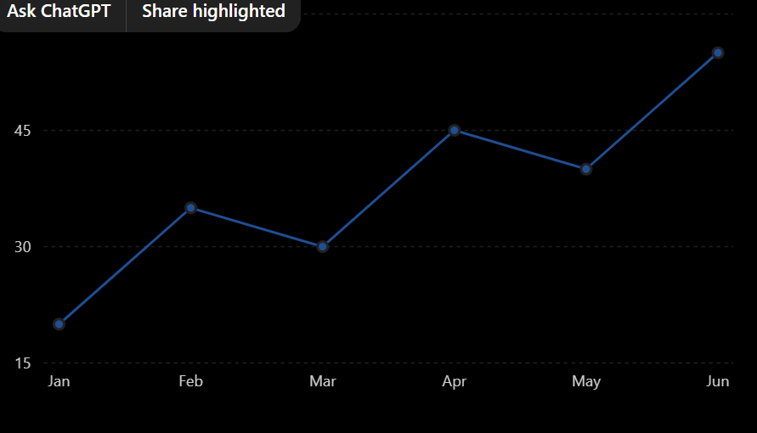
import matplotlib.pyplot as plt

months = ["Jan", "Feb", "Mar", "Apr", "May"]
sales = [100, 150, 120, 180, 200]

plt.plot(months, sales)

plt.title("Monthly Sales")
plt.xlabel("Months")
plt.ylabel("Sales")

plt.show()

- Bar chart
A Bar Chart is a type of data visualization used to compare values between different categories. It represents data using rectangular bars, where the length or height of each bar represents the value.

Example: Monthly Sales
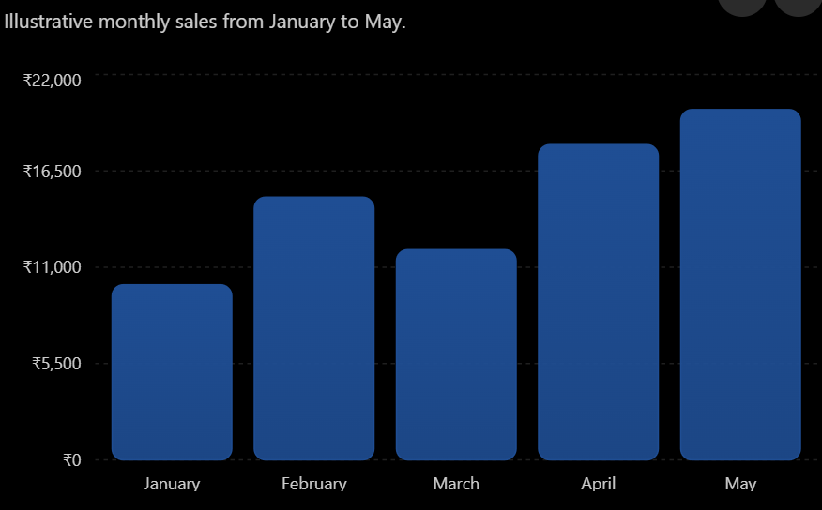

import matplotlib.pyplot as plt

months = ["January", "February", "March", "April", "May"]
sales = [10000, 15000, 12000, 18000, 20000]

plt.bar(months, sales)

plt.title("Monthly Sales")
plt.xlabel("Months")
plt.ylabel("Sales")

plt.show()

- Histogram
A Histogram is a type of graph used to show the distribution of numerical data. It groups data into intervals called bins and displays the frequency of values in each interval.

Example: Student Marks
Suppose the marks of students are:
35, 42, 45, 48, 52, 55, 58, 61, 65, 68, 72, 75, 78, 82, 85
A histogram can show how many students fall within different mark ranges.
Distribution of Student Marks
Illustrative frequency distribution of student marks grouped into intervals.
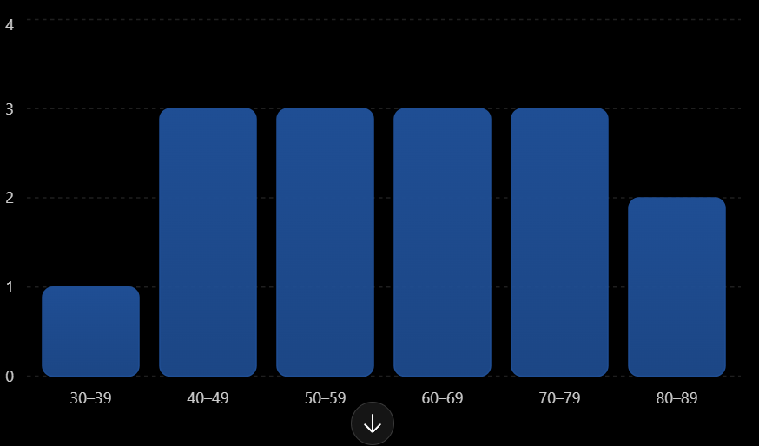
import matplotlib.pyplot as plt
marks = [35, 42, 45, 48, 52, 55, 58, 61, 65, 68, 72, 75, 78, 82, 85]
plt.hist(marks, bins=5)
plt.title("Distribution of Student Marks")
plt.xlabel("Marks")
plt.ylabel("Frequency")
plt.show()
- Scatter plot
A Scatter Plot is a type of graph used to show the relationship between two numerical variables. Each observation is represented by a point (dot) on the graph.

Example: Study Hours vs Marks
Suppose students study for different numbers of hours and get the following marks:
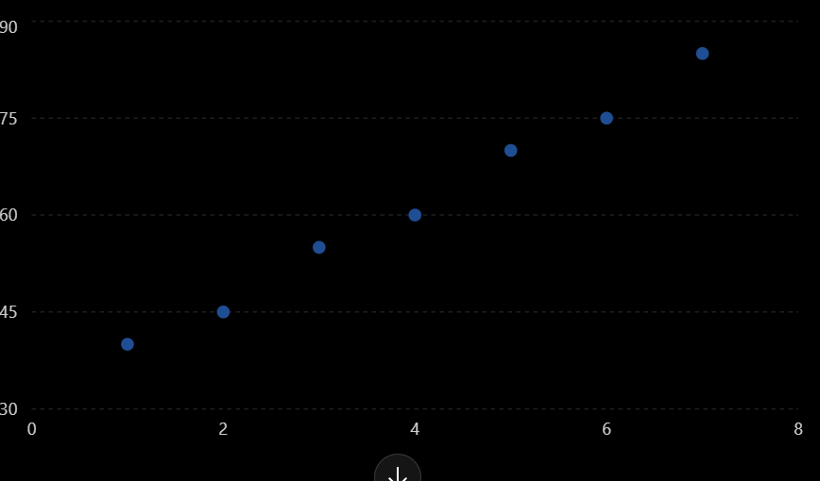
import matplotlib.pyplot as plt
hours = [1, 2, 3, 4, 5, 6, 7]
marks = [40, 45, 55, 60, 70, 75, 85]
plt.scatter(hours, marks)
plt.title("Study Hours vs Marks")
plt.xlabel("Study Hours")
plt.ylabel("Marks")
plt.show()

- Pie chart
A Pie Chart is a circular chart used to show how a whole is divided into different categories or parts. Each part is represented by a slice, and the size of the slice shows its proportion of the total.

Example: Monthly Expenses
Suppose a person spends money on different categories:
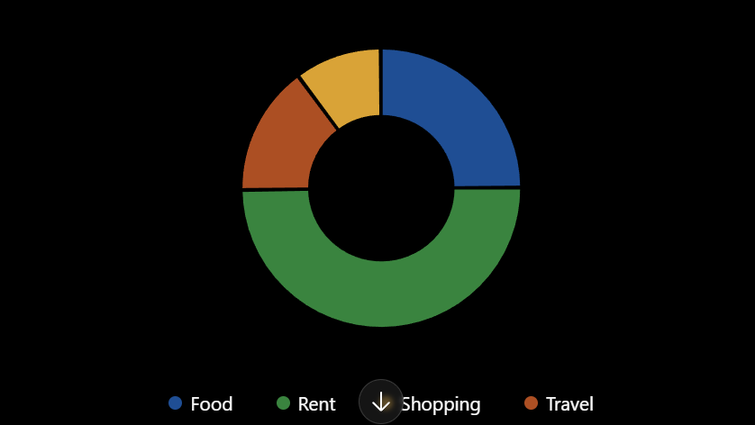
import matplotlib.pyplot as plt
categories = ["Food", "Rent", "Travel", "Shopping"]
amount = [5000, 10000, 3000, 2000]
plt.pie(amount, labels=categories, autopct="%1.1f%%")
plt.title("Monthly Expenses")
plt.show()

- Box plot
A Box Plot is a statistical chart used to show the distribution, spread, median, and outliers of numerical data.
It is also called a Box-and-Whisker Plot.

Example: Student Marks
Suppose the marks of students are:
45, 50, 52, 55, 58, 60, 62, 65, 70, 95
A box plot can help us understand how these marks are distributed and whether there are any outliers.
Student Marks Distribution
A simple categorical display of illustrative student marks used to introduce the data before creating a box plot.
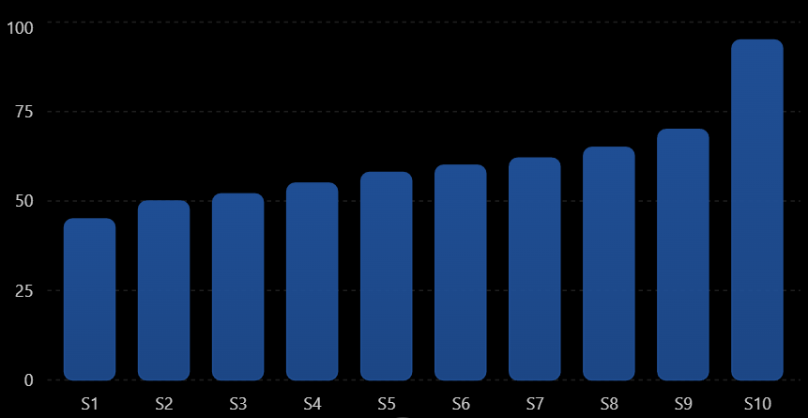
import matplotlib.pyplot as plt
marks = [45, 50, 52, 55, 58, 60, 62, 65, 70, 95]
plt.boxplot(marks)
plt.title("Student Marks")
plt.ylabel("Marks")
plt.show()

- Area chart
An Area Chart is a data visualization used to show changes or trends over time. It is similar to a line chart, but the area below the line is filled, which makes the magnitude of the values easier to see.

Example: Monthly Sales
Suppose a company has the following monthly sales:
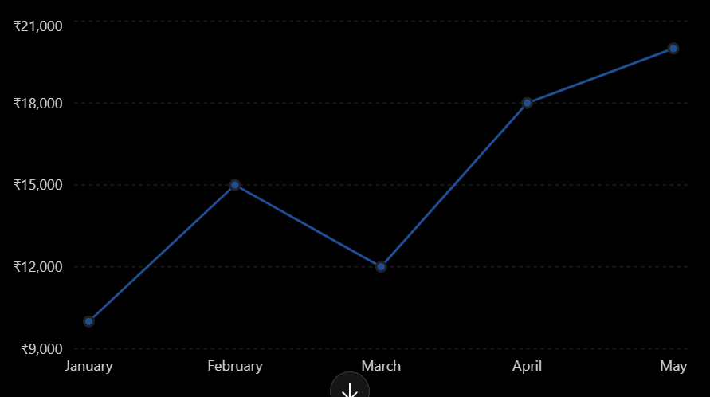
import matplotlib.pyplot as plt
months = ["January", "February", "March", "April", "May"]
sales = [10000, 15000, 12000, 18000, 20000]
plt.fill_between(months, sales)
plt.title("Monthly Sales")
plt.xlabel("Months")
plt.ylabel("Sales")
plt.show()

DAY 12 — Seaborn + Advanced EDA
Topics covered
- Count plot
- Boxplot
- Violin plot
- Heatmap
- Pair plot
- Distribution plots

- Count plot
A Count Plot is a Seaborn chart used to count the number of occurrences of each category in a dataset.

In simple words, it answers:
"How many times does each category appear?"

Example: Gender

Suppose we have this data:
Gender
Male
Female
Male
Male
Female
Female
Male
The count is:
- Male → 4
- Female → 3

Count of Students by Gender
Illustrative count of students in each gender category.

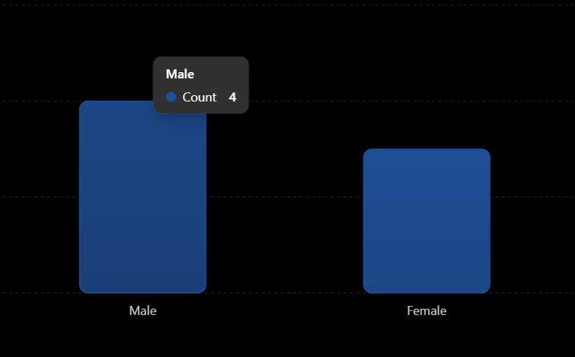
import seaborn as sns
import matplotlib.pyplot as plt

data = {
"Gender": ["Male", "Female", "Male", "Male",
"Female", "Female", "Male"]
}

sns.countplot(x="Gender", data=data)

plt.title("Count of Students by Gender")
plt.xlabel("Gender")
plt.ylabel("Count")

plt.show()

- Box plot
A Box Plot is a statistical graph used to show the distribution, spread, median, quartiles, and outliers of numerical data.
In simple words:
A Box Plot helps us understand how data is distributed and whether there are any unusual values (outliers).

Why do we use a Box Plot?
A box plot helps us identify:
- Minimum value
- Q1 (First Quartile)
- Median (Q2)
- Q3 (Third Quartile)
- Maximum value
- Outliers
- Spread/variation of data
Basic Structure

Minimum ────┬──── [ Q1 | Median | Q3 ] ────┬──── Maximum
│ │
Whisker Whisker

•
Outlier
The box represents the middle 50% of the data

import seaborn as sns
import matplotlib.pyplot as plt

marks = [45, 50, 52, 55, 58, 60, 62, 65, 70, 95]

sns.boxplot(y=marks)

plt.title("Student Marks")
plt.ylabel("Marks")

plt.show()

- Violin plot
A Violin Plot is a Seaborn visualization used to show the distribution and density of numerical data.
In simple words:

A Violin Plot shows how the data is distributed and where most of the values are concentrated.
It combines ideas from a Box Plot + Density Plot.

Why do we use a Violin Plot?
A violin plot helps us understand:

- Data distribution
- Data density
- Median
- Spread of data
- Different groups/categories
- Whether data has one or multiple peaks

import seaborn as sns
import matplotlib.pyplot as plt

marks = [45, 50, 52, 55, 58, 60, 62, 65, 70, 75, 78, 80]

sns.violinplot(y=marks)

plt.title("Distribution of Student Marks")
plt.ylabel("Marks")

plt.show()

- Heatmap
A Heatmap is a Seaborn visualization used to represent numerical values using different shades of color.

In simple words:

A Heatmap uses colors to make patterns, relationships, and high/low values easy to understand.
It is commonly used in correlation analysis during EDA.

Why do we use a Heatmap?
A heatmap helps us:

- Understand relationships between variables
- Find correlation
- Identify high and low values
- Find patterns in data
- Analyze large tables/matrices
- Perform Advanced EDA

import seaborn as sns
import matplotlib.pyplot as plt
import pandas as pd

data = pd.DataFrame({
"Math": [80, 70, 90, 60, 85],
"Science": [75, 65, 95, 55, 80],
"English": [70, 75, 85, 65, 90]
})

correlation = data.corr()

sns.heatmap(correlation, annot=True)

plt.title("Correlation Heatmap")

plt.show()

- Pair plot
A Pair Plot is a Seaborn visualization used to show the relationships between multiple numerical variables in a dataset.
In simple words:

A Pair Plot creates multiple scatter plots and distributions together so we can understand relationships between different variables.
It is very useful in EDA (Exploratory Data Analysis).

2. Why do we use Pair Plot?
Pair Plot helps us:

- Understand relationships between variables
- Identify positive/negative relationships
- Find patterns
- Detect possible outliers
- Understand distributions of individual variables
- Compare multiple numerical variables at once

import seaborn as sns
import matplotlib.pyplot as plt
import pandas as pd

data = pd.DataFrame({
"Age": [20, 21, 22, 23, 24],
"Study_Hours": [2, 3, 5, 6, 8],
"Marks": [45, 50, 65, 72, 85]
})

sns.pairplot(data)
plt.show()

- Distribution plot
A Distribution Plot is a visualization used to understand how numerical data is distributed.
In simple words:

A distribution plot shows where the data values are concentrated and how the data is spread.
It is very useful in EDA (Exploratory Data Analysis).

2. Why do we use a Distribution Plot?
A distribution plot helps us understand:

- Where most values are concentrated
- Spread of the data
- Shape of the distribution
- Whether data is symmetric or skewed
- Possible outliers
- Peaks in the data
- Whether the data looks approximately normally distributed

import seaborn as sns
import matplotlib.pyplot as plt

marks = [45, 50, 52, 55, 58, 60, 62, 65, 68, 70,
72, 75, 78, 80, 82, 85]

sns.histplot(marks, kde=True)

plt.title("Distribution of Student Marks")
plt.xlabel("Marks")
plt.ylabel("Frequency")

plt.show()

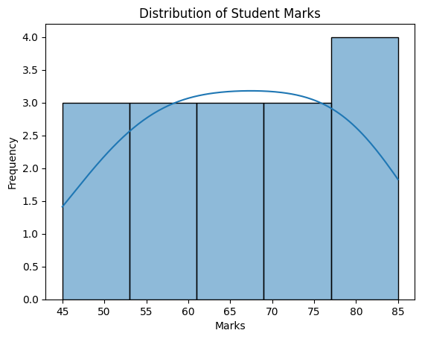

DAY 13 — Power BI

Topic covered
- Import data
- Power Query
- Transform Data
- Data Types
- Filters
- Slicers
- Charts
- Cards
- Tables
- Matrix

- Import Data
Import Data in Power BI means bringing data from an external source into Power BI Desktop so that we can clean, transform, analyze, and visualize it.

In simple words:
Import Data = Bring your data into Power BI for analysis.

2. Common Data Sources
Power BI can import data from many sources:

- Excel
- CSV
- SQL Server
- MySQL
- Text files
- Web
- JSON
- XML
- SharePoint
- Other databases

For a beginner, Excel and CSV are commonly used

Excel File
↓
Power BI
↓
Power Query
↓
Clean / Transform Data
↓
Data Model
↓
Visualizations.
- Power Query
Power Query is a data preparation and transformation tool in Power BI used to clean, transform, and prepare data before analysis.
In simple words:
Power Query = Clean and prepare your data before creating reports and dashboards.
Import Data
↓
Open Power Query
↓
Remove Duplicates
↓
Handle Missing Values
↓
Change Data Types
↓
Rename Columns
↓
Filter Data
↓
Transform Data
↓
Close & Apply

Transform Data
Transform Data in Power BI means changing, cleaning, and preparing raw data into a useful format for analysis.
In Power BI, Transform Data opens the Power Query Editor, where we can perform data cleaning and transformation.
Transform Data = Convert messy/raw data into clean and analysis-ready data
Raw Data
↓
Transform Data
↓
Power Query Editor
↓
Clean Data
↓
Transform Data
↓
Applied Steps
↓
Close & Apply
↓
Power BI Data Model
↓
Reports / Dashboard

- Data Types
Data Type tells Power BI what kind of data is stored in a column.
In simple words:

Data Type = The type or format of values stored in a column.

For example:
Name → Text
Age → Whole Number
Salary → Decimal Number
Joining Date → Date

Correct data types are important for calculations, filtering, sorting, and visualizations.

- Filters
A Filter in Power BI is used to display only the data that matches a specific condition.
In simple words:
Filter = Show only the data you want and hide the rest.
For example, if you have sales data for many cities and want to see only Pune sales, you can apply a filter on the City column.
A visual-level filter affects only one particular visual.
Example:
Suppose your report has:
Bar Chart → Sales by City
Pie Chart → Sales by Product
Table → Customer Details
If you apply a filter to the bar chart only, the other visuals are not necessarily affected by that visual-level filter.
- Slicer
A Slicer in Power BI is a visual filter that allows users to interactively select values and filter the data shown in a report.
Simple definition:
A Slicer is an interactive visual filter used to filter data in a Power BI report.
- Charts
Charts in Power BI are visualizations used to represent data in a graphical format. They help users understand, compare, and analyze data easily.
Simple definition:
A chart is a graphical representation of data used to identify patterns, trends, comparisons, and relationships.

Common Charts in Power BI
Chart | Main Use
Bar Chart | Compare categories
Column Chart | Compare values
Line Chart | Show trends over time
Pie Chart | Show proportions
Donut Chart | Show proportions
Area Chart | Show trends and magnitude
Scatter Chart | Show relationship between two numerical variables
Funnel Chart | Show stages in a process
Tree map | Show hierarchical part-to-whole data
Waterfall Chart | Show increases and decreases
Combo Chart | Compare two different measures
- Cardes
A Card in Power BI is a visualization used to display one important value or KPI in a simple and clear format.
Simple definition:
A Card is a Power BI visual used to display a single important number or value
- Tables.
A Table in Power BI is a visual used to display data in rows and columns, similar to an Excel table.
Simple definition:
A Table is a Power BI visual used to display detailed data in rows and columns.
How to Create a Table
- Open Power BI Desktop.
- Import your dataset.
- Go to Report View.
- Select the Table visual from the Visualizations pane.
- Drag fields into the table.
- Arrange the columns as required.
- Matrix
A Matrix in Power BI is a visual used to display summarized data in rows and columns, similar to a Pivot Table in Excel.
Simple definition:
A Matrix is a Power BI visual used to summarize and analyze data using rows, columns, and values.

Task
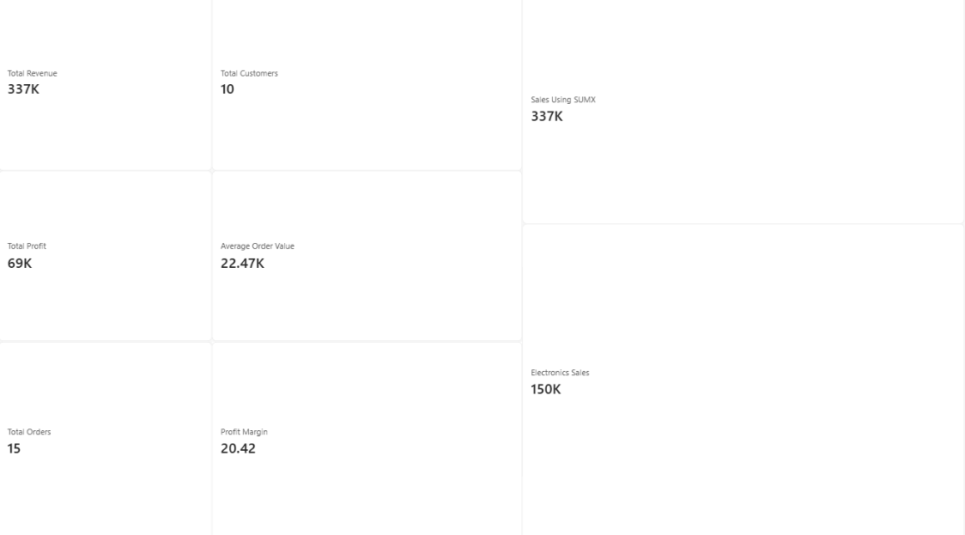

DAY 14 — DAX
s1. Task
Learn DAX (Data Analysis Expressions) and create these measures:
- Total Revenue
- Total Profit
- Total Orders
- Total Customers
- Average Order Value
- Profit Margin
Then learn these DAX functions:
- CALCULATE
- FILTER
- ALL
- SUMX
- COUNTROWS
- DISTINCTCOUNT
- 2. Why
DAX is required for dynamic calculations inside Power BI. A measure is recalculated every time the user clicks a slicer or filter, so the same formula gives the right answer for the whole company, one region, or one category — without writing separate formulas.
- 3. Deliverable
Power BI dashboard with at least 8 measures. This report defines 14 measures (6 required + 2 supporting + 6 function demonstrations), all shown on the dashboard image in section 7.
- 4. What is DAX? (Basics)
DAX is the formula language of Power BI. It is similar to Excel formulas but works on whole columns and tables instead of single cells.
- Measure — a calculation evaluated on the fly at report time, responds to slicers/filters (e.g. Total Revenue).
- Calculated column — a value computed for every row when data is loaded and stored in the model (e.g. Profit = Sales − Cost).
- Filter context — the set of filters currently active (slicers, chart axes, page filters) that a measure is calculated inside.
- Row context — the 'current row' when a formula iterates through a table, used by iterator functions such as SUMX.
Dataset used: sales_data.csv, imported as a table named Sales with columns OrderID, OrderDate, CustomerID, CustomerName, Region, Category, Product, Quantity, UnitPrice, Sales, Cost, Profit (400 rows, Jan–Jun 2026).
- 5. How to Create a Measure in Power BI Desktop
- Open the Day 13 dashboard (.pbix) or import sales_data.csv via Home → Get Data → Text/CSV → Load.
- In the Data pane on the right, right-click the Sales table and choose New measure (or Home → New measure).
- Type or paste the formula in the formula bar, for example: Total Revenue = SUM(Sales[Sales]), and press Enter.
- Select the measure, open the Measure tools tab and set the format (Currency, Whole number, Percentage).
- Drag the measure onto the report canvas as a Card, or into the Values well of a chart.
- Repeat for every measure. Click slicers to confirm the numbers change dynamically.
- 6. Measures — Formula, Result and Explanation
Values below were calculated from the dataset, so they can be used to check your Power BI cards.
A. The 6 Required Measures
Measure 1: Total Revenue
Total Revenue = SUM(Sales[Sales])
Result on this dataset: ₹1,30,94,730
What it does: Adds every value in the Sales column within the current filter context. It is the base measure that most other measures reuse.
How to use / check: Put on a Card visual. Click a Region slicer value: the number shrinks to that region only — this is what makes it 'dynamic'.
Measure 2: Total Profit
Total Profit = SUM(Sales[Profit])
Result on this dataset: ₹43,10,283
What it does: Adds the Profit column (Sales − Cost). Shows how much money is left after cost of goods.
How to use / check: Card visual. Compare with Total Revenue to see how much of each rupee of sales is kept.
Measure 3: Total Orders
Total Orders = DISTINCTCOUNT(Sales[OrderID])
Result on this dataset: 400
What it does: Counts unique OrderIDs. DISTINCTCOUNT is used so an order that appears on several rows is counted once.
How to use / check: Card visual. Should equal the number of orders in the CSV (400).
Measure 4: Total Customers
Total Customers = DISTINCTCOUNT(Sales[CustomerID])
Result on this dataset: 40
What it does: Counts unique customers who bought something in the current filter context.
How to use / check: Card visual. Select a Category slicer to see how many different customers bought that category.
Measure 5: Average Order Value
Average Order Value = DIVIDE([Total Revenue], [Total Orders], 0)
Result on this dataset: ₹32,737
What it does: Revenue ÷ orders = average money spent per order. DIVIDE returns 0 instead of an error if orders is 0.
How to use / check: Card visual. Format as Currency. Check by hand: 13,094,730 ÷ 400 = 32,736.83.
Measure 6: Profit Margin
Profit Margin = DIVIDE([Total Profit], [Total Revenue], 0)
Result on this dataset: 32.92%
What it does: Profit ÷ revenue expressed as a percentage — the share of each sale that is profit.
How to use / check: Card visual. Set Format → Percentage with 1 decimal place.
B. Supporting Measures
Measure 7: Total Cost
Total Cost = SUM(Sales[Cost])
Result: ₹87,84,447
Supporting measure: total cost of goods sold.
Measure 8: Total Quantity
Total Quantity = SUM(Sales[Quantity])
Result: 1,434
Supporting measure: total units sold.

7. Dashboard Screenshot
The dashboard below shows all six required measures as cards, with Revenue by Category, Profit by Region and a Monthly Revenue vs Profit trend. Every value is calculated from sales_data.csv.
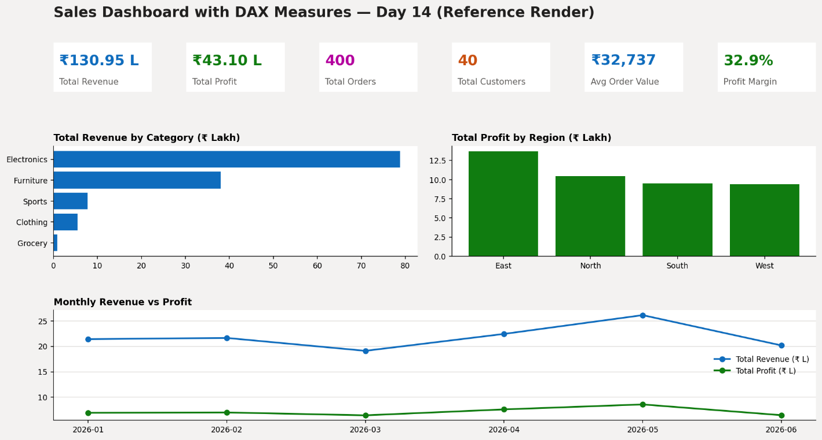
- 8. Key DAX Functions in Detail
CALCULATE
Evaluates an expression after changing the filters applied to it. Syntax: CALCULATE(<expression>, <filter1>, <filter2>, ...). It is the single most important DAX function because it lets a measure ignore or override the filters coming from slicers and visuals.
Example measure:
Electronics Revenue =
CALCULATE([Total Revenue], Sales[Category] = "Electronics")
Result: ₹78,81,743
Revenue of the Electronics category only, whatever the visual is showing.
FILTER
Returns a table containing only the rows that satisfy a condition, evaluated row by row. Syntax: FILTER(<table>, <condition>). Used inside CALCULATE when the condition is more complex than a simple column = value test.
Example measure:
High Value Revenue =
CALCULATE(
[Total Revenue],
FILTER(Sales, Sales[Sales] > 10000)
)
Result: ₹1,24,94,133
Revenue from only those orders whose Sales value is above ₹10,000.
ALL
Removes existing filters from a table or column. Syntax: ALL(<table or column>). It is used to get grand totals, so that percentage-of-total measures keep the full total as denominator even when slicers are used.
Example measure:
Electronics % of Total =
DIVIDE(
[Electronics Revenue],
CALCULATE([Total Revenue], ALL(Sales))
)
Result: 60.19%
Electronics revenue divided by the overall revenue of all rows, ignoring any slicer.
SUMX
An iterator: it goes through a table row by row, calculates an expression for each row, then adds up the results. Syntax: SUMX(<table>, <expression>). Needed when the value to sum is a calculation across columns, such as Quantity × UnitPrice.
Example measure:
Revenue via SUMX =
SUMX(Sales, Sales[Quantity] * Sales[UnitPrice])
Result: ₹1,30,94,730
Same answer as Total Revenue, which proves the calculation is consistent.
COUNTROWS
Counts the rows in a table (or in a table expression such as FILTER). Syntax: COUNTROWS(<table>). It counts every row, including duplicates.
Example measure:
Total Rows = COUNTROWS(Sales)
High Value Rows =
COUNTROWS(FILTER(Sales, Sales[Sales] > 10000))
Result: 400 rows in total
Number of rows in the Sales table; the second version counts only the high-value rows.
DISTINCTCOUNT
Counts unique values in a column. Syntax: DISTINCTCOUNT(<column>). Used for Total Orders and Total Customers because IDs can repeat across rows.
Example measure:
Unique Products = DISTINCTCOUNT(Sales[Product])
Result: 25 unique products
Counts each product name only once.
- 9. Summary of All Measures
# | Measure | Type | Value
1 | Total Revenue | Required | ₹1,30,94,730
2 | Total Profit | Required | ₹43,10,283
3 | Total Orders | Required | 400
4 | Total Customers | Required | 40
5 | Average Order Value | Required | ₹32,737
6 | Profit Margin | Required | 32.92%
7 | Total Cost | Supporting | ₹87,84,447
8 | Total Quantity | Supporting | 1,434
9 | Electronics Revenue (CALCULATE) | Function demo | ₹78,81,743
10 | High Value Revenue (FILTER) | Function demo | ₹1,24,94,133
11 | Electronics % of Total (ALL) | Function demo | 60.19%
12 | Revenue via SUMX | Function demo | ₹1,30,94,730
13 | Total Rows (COUNTROWS) | Function demo | 400
14 | Unique Products (DISTINCTCOUNT) | Function demo | 25

- 10. Conclusion
Using DAX, all the key business numbers — revenue, profit, orders, customers, average order value and profit margin — are calculated dynamically. CALCULATE and FILTER change what data a measure looks at, ALL removes filters for totals and percentages, SUMX iterates row by row, and COUNTROWS and DISTINCTCOUNT count rows and unique values. Together these form the foundation for every advanced Power BI report.

