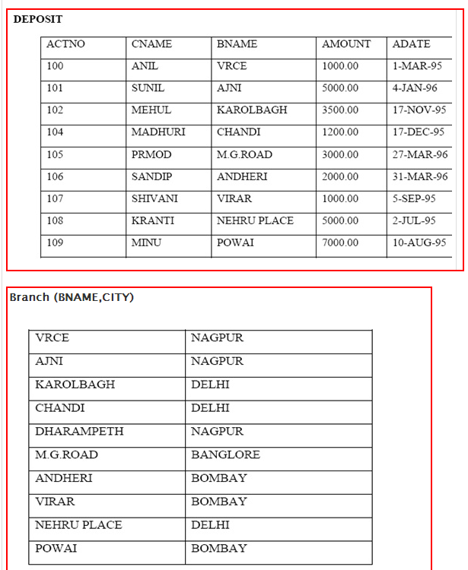-->**Create tables according to the following definition and insert the data as shown below:**

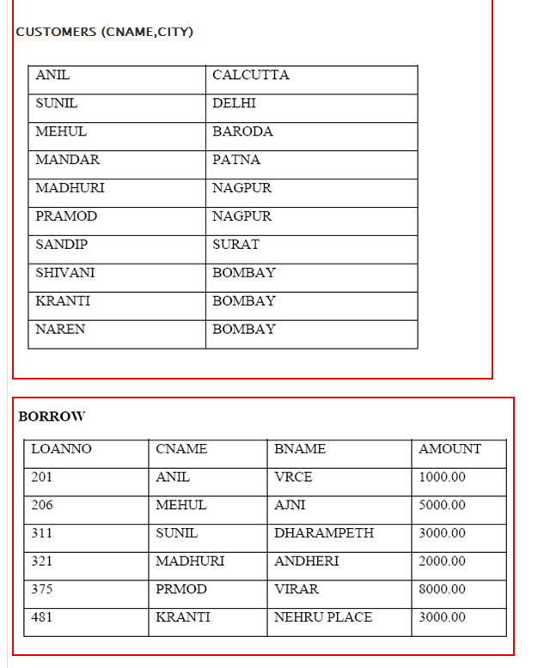

From the above given tables perform the following queries:

(1) Describe deposit.

(2) Describe borrow.

(3) List all data from table DEPOSIT.

(4) List all data from table BORROW.

(5) List all data from table CUSTOMERS.

(6) List all data from table BRANCH.

(7) Give account no and amount of depositors.

(8) Give name of depositors having amount greater than 4000.

(9) Give name of customers who opened account after date '1-12-96'.

(10) Find the number of branches from Delhi and Nagpur.

(11) Find the number of customers from Bombay.

(12) Find the total amount deposited by customers.

(13) Find the total amount borrowed by customers.

(14) Find the name of customers from Bombay and Nagpur.

(15) Find the name of branches from Delhi, Nagpur and Banglore.

(16) Find the average amount of depositor.

(17) Give the name of depositors who has maximum balance.

(18) Give the name of depositors who has minimum balance.

(19) To display the current date.

(20) Give name of depositors having amount greater than average amount.