29-01-2020

Experiment 1  
Basic Functions and Signals in MATLAB

Sahil Bondre (u18co021)

horizontal line

# Aim.

1. Plot basic functions: sin, cosine, exponent, tan in MATLAB.
2. Plot basic signals such as unit impulse, unit step and unit ramp.
3. Plot the periodic signals impulse train, square wave, sawtooth wave and triangular wave.

# Theory.

MATLAB is a programming language developed by MathWorks. It started out as a matrix programming language where linear algebra programming was simple. It can be run both under interactive sessions and as a batch job.

## Matlab Window

The desktop includes these panels:

* Current Folder — Access your files.
* Command Window — Enter commands at the command line, indicated by the prompt (>>).
* Workspace — Explore data that you create or import from files.

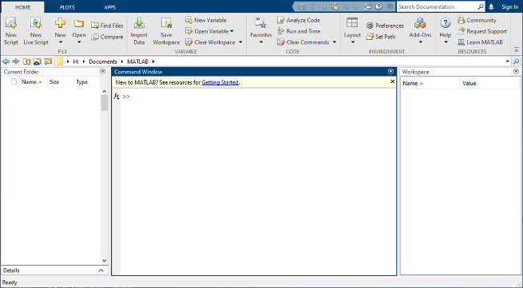

MATLAB Window

## Features of MATLAB

* It is a high-level language for numerical computation, visualization and application development.
* It also provides an interactive environment for iterative exploration, design and problem solving.
* It provides a vast library of mathematical functions for linear algebra, statistics, Fourier analysis, filtering, optimization, numerical integration and solving ordinary differential equations.
* It provides built-in graphics for visualizing data and tools for creating custom plots.
* MATLAB's programming interface gives development tools for improving code quality maintainability and maximizing performance.
* It provides tools for building applications with custom graphical interfaces.
* It provides functions for integrating MATLAB based algorithms with external applications and languages such as C, Java, .NET and Microsoft Excel.

## 

## Common Commands:

1. **clc**: Clears command window.
2. **clear:** Removes variables from memory.
3. **exist**: Checks for existence of file or variable.
4. **global**: Declares variables to be global.
5. **help**: Searches for a help topic.
6. **lookfor**: Searches help entries for a keyword.
7. **quit**: Stops MATLAB.
8. **who**: Lists current variables.
9. **whos**: Lists current variables (long display).
10. **cd**: Changes current directory.
11. **date**: Displays current date.
12. **delete:** Deletes a file.
13. **diary**: Switches on/off diary file recording.
14. **dir**: Lists all files in the current directory.
15. **load**: Loads workspace variables from a file.
16. **path**: Displays search path.
17. **pwd**: Displays current directory.
18. **save**: Saves workspace variables in a file.
19. **type**: Displays contents of a file.

## Input/Output Commands:

1. **disp**: Displays contents of an array or string.
2. **fscanf**: Read formatted data from a file.
3. **format**: Controls screen-display format.
4. **fprintf** : Performs formatted writes to screen or file.
5. **input**: Displays prompts and waits for input.

## 

## 

## Matrix Commands:

1. **cat**: Concatenates arrays.
2. **find**: Finds the indices of nonzero elements.
3. **length** : Computes number of elements.
4. **linspace:** Creates regularly spaced vector.
5. **max**: Returns the largest element.
6. **min**: Returns the smallest element.
7. **prod**: Product of each column.
8. **reshape**: Changes size.
9. **size**: Computes array size.
10. **sort**: Sorts each column.
11. **sum**: Sums each column.
12. **eye**: Creates an identity matrix.
13. **ones**: Creates an array of ones.
14. **zeros**: Creates an array of zeros.
15. **cross**: Computes matrix cross products.
16. **dot**: Computes matrix dot products.
17. **det**: Computes determinant of an array.
18. **inv**: Computes inverse of a matrix.
19. **rank**: Computes rank of a matrix.
20. **rref**: Computes reduced row echelon form.

## Plot Commands

1. **axis**: Sets axis limits.
2. **grid**: Displays gridlines.
3. **plot**: Generates xy plot.
4. **print**: Prints plot or saves plot to a file.
5. **Title**: Puts text at top of plot.
6. **xlabel**: Adds text label to x-axis.
7. **ylabel**: Adds text label to y-axis.
8. **axes**: Creates axes objects.
9. **close**: Closes the current plot.
10. **close all:** Closes all plots.
11. **figure**: Opens a new figure window.
12. **hold**: Freezes current plot.
13. **legend**: Legend placement by mouse.
14. **refresh**: Redraws current figure window.
15. **set**: Specifies properties of objects such as axes.
16. **subplot**: Creates plots in subwindows.
17. **text**: Places string in figure.
18. **bar**: Creates bar chart.

# Code.

## 1. Sin, Cosine, Tan and Exponential Functions

|  |
| --- |
| clc;  clear all; close all;  t = -10:0.01:10;  x = sin(t); y = cos(t); z = tan(t); w = exp(t);  *% figure;* subplot(2, 2, 1); plot(t, x); xlabel('time'); ylabel('amplitude'); title('sin wave');  *% figure;* subplot(2, 2, 2); plot(t, y); xlabel('time'); ylabel('amplitude'); title('cos wave');  subplot(2, 2, 3); plot(t, z); axis([-pi/2 pi/2 -50 50]); xlabel('time'); ylabel('amplitude'); title('tan wave');  subplot(2, 2, 4); plot(t, w); xlabel('time'); ylabel('amplitude'); title('exp curve'); |

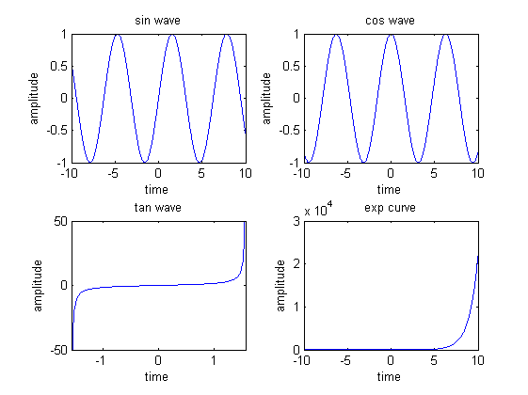

sin, cosine, tan and exponent curves plot

## 2. Unit Impulse, Unit Step and Unit Ramp Functions

|  |
| --- |
| clc; clear all; close all;  t = -10:0.01:10; d = zeros(1, length(t)); e = zeros(1, length(t)); f = zeros(1, length(t));  d(t == 0) = 1; e(t >= 0) = 1; f(t >= 0) = t(t >= 0);  subplot(3, 1, 1); plot(t, d); xlabel('time'); ylabel('amplitude'); title('impulse function');  subplot(3, 1, 2); plot(t, e); axis([-10 10 -1.5 1.5]); xlabel('time'); ylabel('amplitude'); title('unit step function');  subplot(3, 1, 3); plot(t, f); xlabel('time'); ylabel('amplitude'); title('ramp function'); |

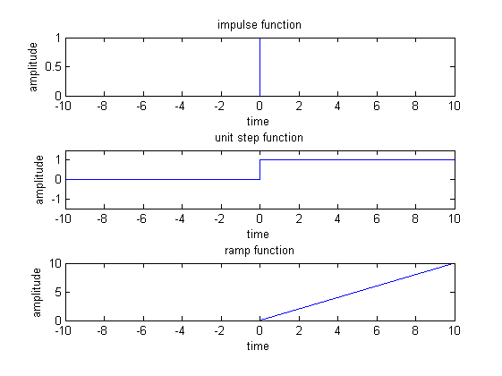

Impulse, unit step and ramp function

## 

## 3. Periodic Signals: Impulse Train, Square Wave, Sawtooth Wave and Triangular Wave

|  |
| --- |
| clc; clear all; close all;  t = -10:0.01:10; d = zeros(1, length(t)); period = 1;  d(mod(t, period) == 0) = 1; e = square(t * period); f = sawtooth(t * period); g = sawtooth(t * period, 0.5);  subplot(4, 1, 1); plot(t, d); axis([-10 10 -0.5 1.5]); xlabel('time'); ylabel('amplitude'); title('impulse train');  subplot(4, 1, 2); plot(t, e); axis([-10 10 -1.5 1.5]); xlabel('time'); ylabel('amplitude'); title('square wave');  subplot(4, 1, 3); plot(t, f); axis([-10 10 -1.5 1.5]); xlabel('time'); ylabel('amplitude'); title('saw tooth wave');  subplot(4, 1, 4); plot(t, g); axis([-10 10 -1.5 1.5]); xlabel('time'); ylabel('amplitude'); title('triangle wave'); |

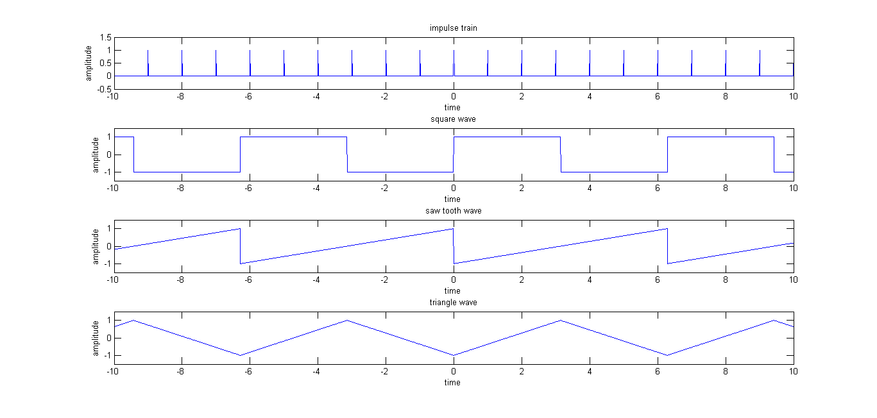

Impulse train, square wave, sawtooth and triangle wave

# Conclusion.

In this experiment we generated basic functions like sine, cosine, tangent and exponential, basic signals like unit impulse, unit step and unit ramp and periodic signals like impulse train, square wave, sawtooth wave and triangular wave using MATLAB.

# Remarks. Signature.