29-01-2000

Experiment 2  
Sampling and Reconstruction of Signals

Sahil Bondre (u18co021)

horizontal line

# Aim.

1. To Study Sampling and Reconstruction of signal.
2. Verify Nyquist criteria.

# Apparatus.

* Model ST 2151 W kit
* Connection wires
* CRO/DSO

# Theory.

In signal processing, sampling is the reduction of a continuous-time signal to a discrete-time signal. A common example is the conversion of a sound wave (a continuous signal) to a sequence of samples (a discrete-time signal).

A sample is a value or set of values at a point in time and/or space.

The original signal is retrievable from a sequence of samples, up to the Nyquist limit, by passing the sequence of samples through a type of low pass filter called a reconstruction filter.

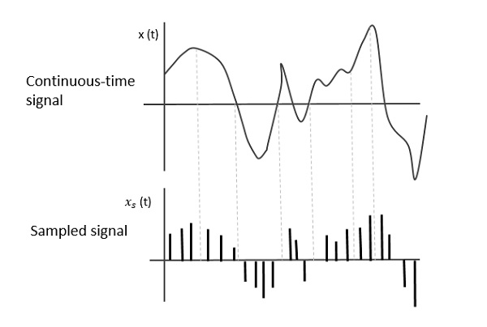

Signal Sampling Representation

To discretize the signals, the gap between the samples should be fixed. That gap can be termed as a sampling period Ts.

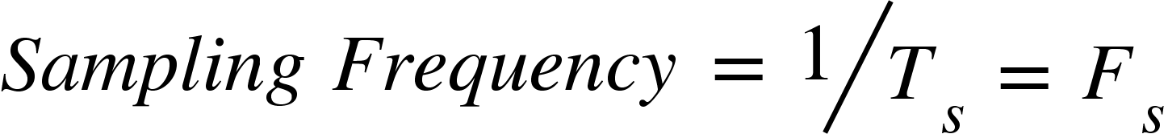

Where,

* Ts is the sampling time
* Fs is the sampling frequency or the sampling rate

Sampling frequency is the reciprocal of the sampling period. This sampling frequency can be simply called the Sampling rate. The sampling rate denotes the number of samples taken per second, or for a finite set of values.

For an analog signal to be reconstructed from the digitized signal, the sampling rate should be highly considered. The rate of sampling should be such that the data in the message signal should neither be lost nor it should get over-lapped. Hence, a rate was fixed for this, called the **Nyquist rate.**

Suppose that a signal is band-limited with no frequency components higher than W Hertz. That means, W is the highest frequency. For such a signal, for effective reproduction of the original signal, the sampling rate should be twice the highest frequency.

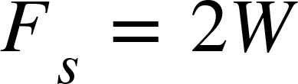

Where,

* Fs is the sampling rate
* W is the highest frequency

This rate of sampling is called the **Nyquist rate.**

# Procedure.

## A. Set up for Sampling and reconstruction of signal.

Initial set up of trainer:

Duty cycle selector switch position : Position 5

Sampling selector switch : Internal position

1. Connect the power cord to the trainer. Keep the power switch in ‘Off’ position.
2. Connect 1 KHz Sine wave to signal Input as shown in Fig 1.
3. Switch ‘On’ the trainer's power supply & Oscilloscope.
4. Connect BNC connector to the CRO and to the trainer’s output port.
5. You can observe the process of step-by-step generating sine wave signal from Square wave of 1 KHz at TP3, TP4, TP5 and TP6 respectively.

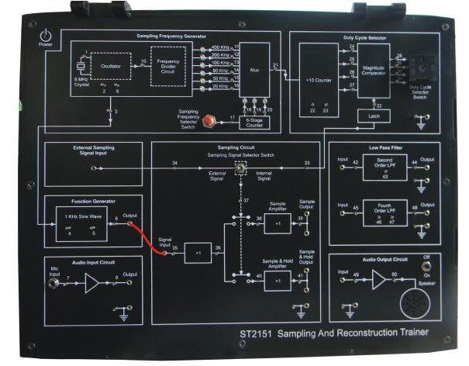

Fig 1. Connection diagram for sampling a signal

**B. Set up for effect of Sample Amplifier and Sample and Hold Amplifier on reconstructed signal.**

Set up for effect of II order and IV order Low Pass Filter on reconstructed signal.

Initial setup of trainer:

Duty cycle selector switch position : Position 5

Sampling selector switch: Internal position

1. Connect the power cord to the trainer. Keep the power switch in ‘Off’ position.

2. Connect 1 KHz Sine wave to signal Input.

3. Switch ‘On’ the trainer's power supply & Oscilloscope.

4. Connect BNC connector to the CRO and to the trainer’s output port.

5. Select sampling frequency of 5 KHz by Sampling Frequency Selector Switch pressed till 50 KHz signal LED glows.

6. Observe 1 KHz sine wave and Sample Output (TP39) on oscilloscope. The display shows

1 KHz sine wave being sampled at 5 KHz, so there are 5 samples for every cycle of the sine wave.

7. Connect Sample Output to Fourth Order low pass filter Input as shown in figure 1.2. Observe the filtered output (TP48) on the oscilloscope. The display shows the reconstructed 1 KHz sine wave.

8. Similarly observe the sampled 1 KHz sine wave at and Sample and Hold Output (TP41) on oscilloscope. The display shows 1 KHz sine wave being sampled and hold signal at 5 KHz. Connect Sample and Hold Output to Second Order low pass filter Input and observe the filtered output (TP44) on oscilloscope. The display shows the reconstructed1 KHz sine wave.

9. By pressing Sampling Frequency Selector Switch, change the sampling frequency from 2 KHz, 5 KHz, 10 KHz, 20 KHz up to 40 KHz (Sampling frequency is 1/10th of the frequency indicated by the illuminated LED). Observe how Sample output (TP39) and Sample and Hold Output (TP41) changes in each case.

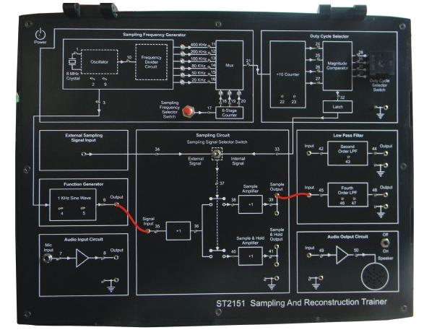

Fig 2. Connection diagram for reconstruction of a sampled signal

# Observation.

**5 Khz Sample Frequency**

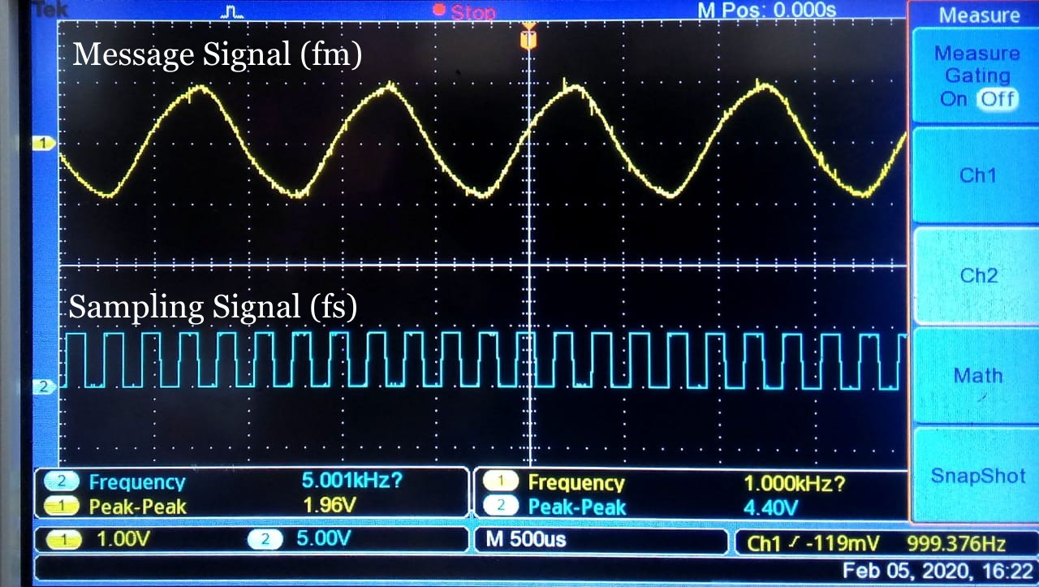

Message Sine Wave (fm) and Sample Signal (fs)

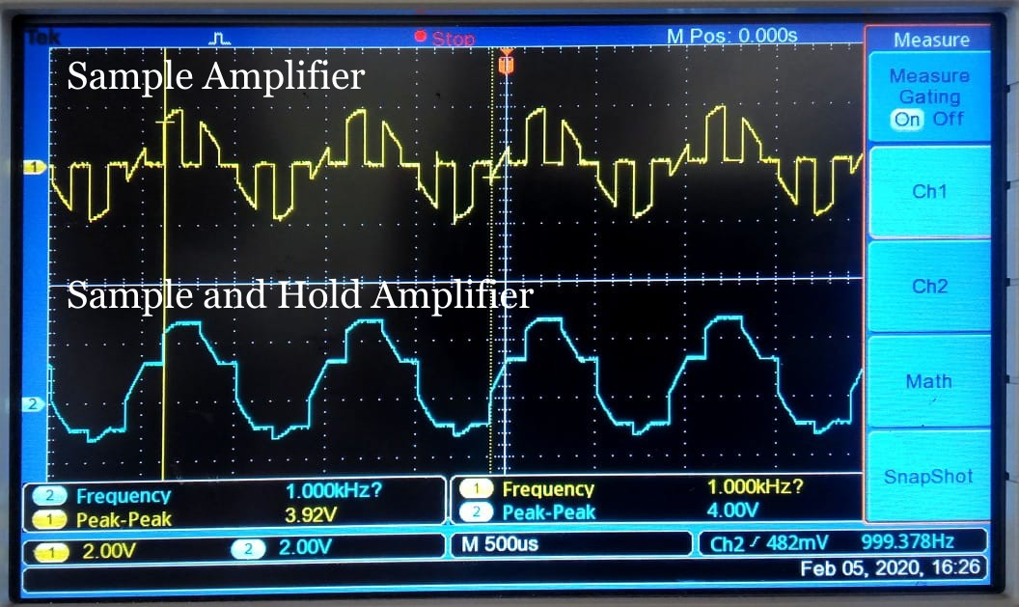

Sample Amplifier and Sample & Hold Amplifier Output

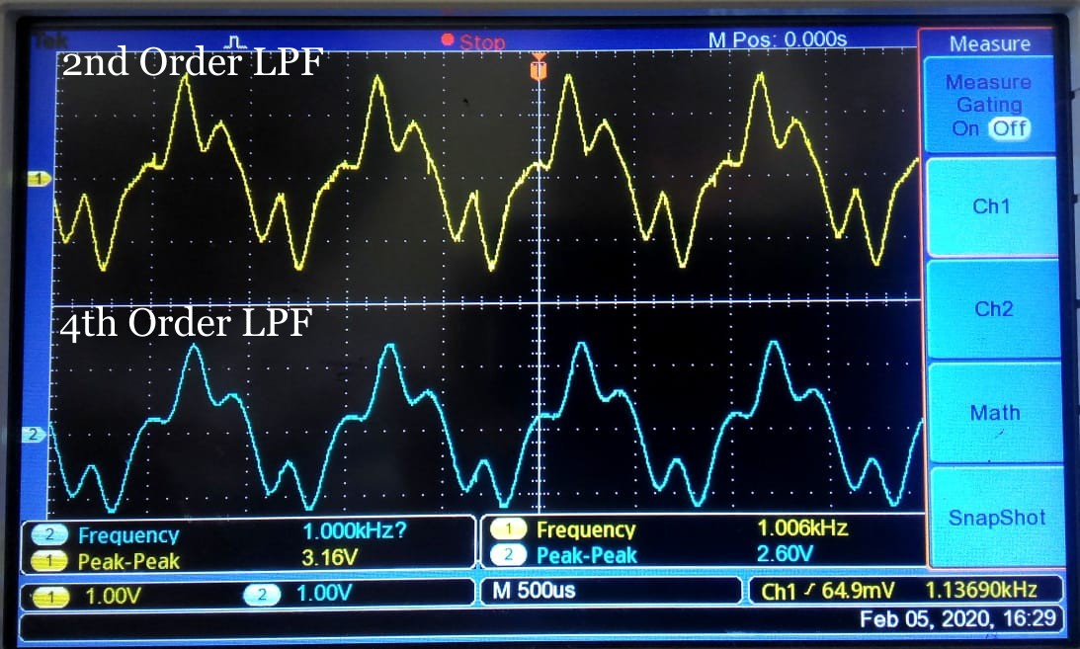

2nd and 4th Order Low Pass Filter Output for Sample Amplifier

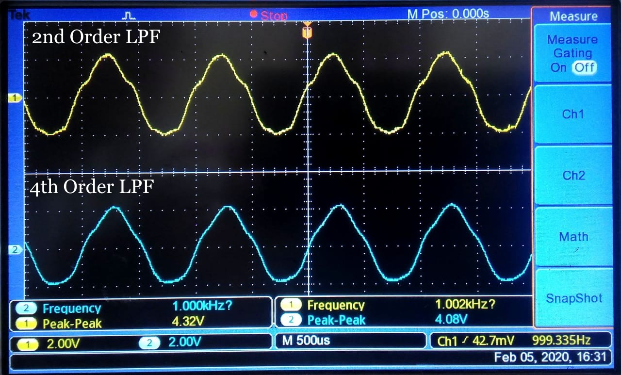

2nd and 4th Order Low Pass Filter Output for Sample & Hold Amplifier

**10 Khz Sample Frequency**

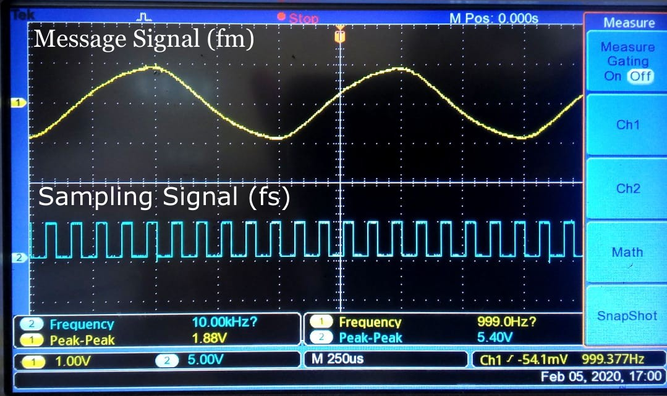

Message Sine Wave (fm) and Sample Signal (fs)

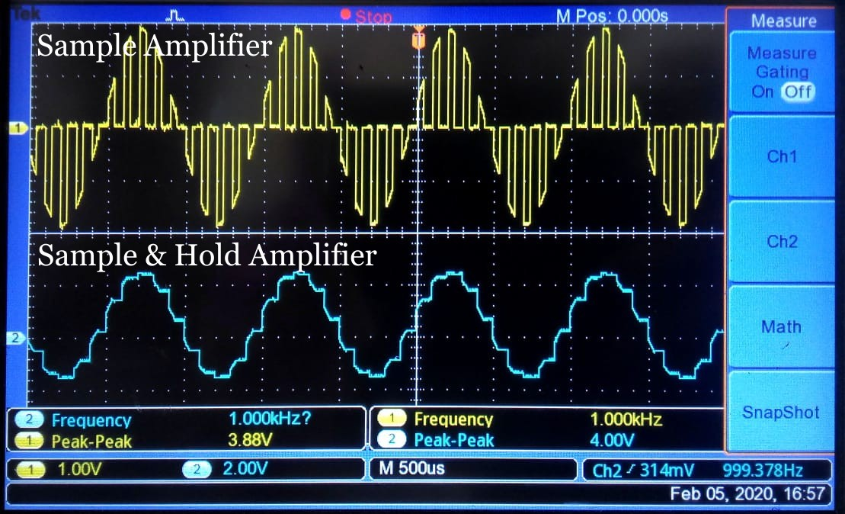

Sample Amplifier and Sample & Hold Amplifier Output

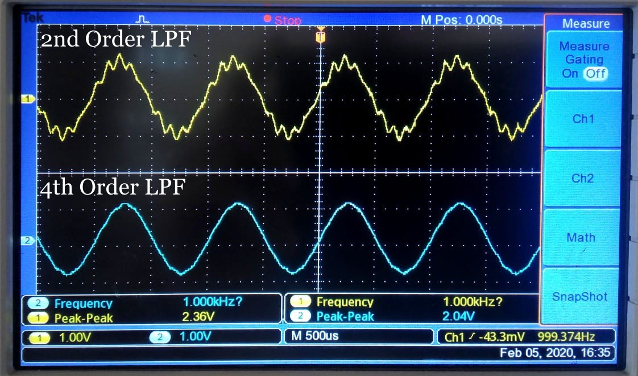

2nd and 4th Order Low Pass Filter Output for Sample Amplifier

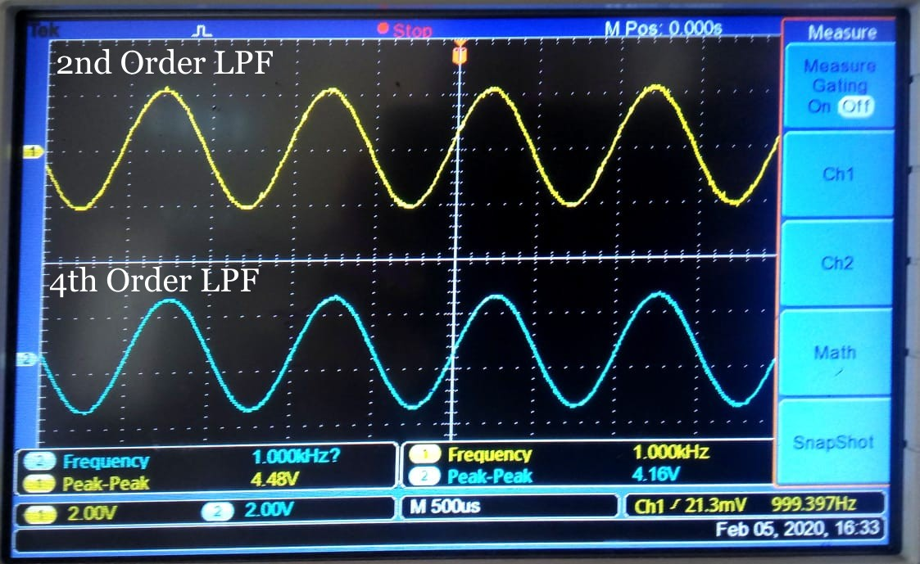

2nd and 4th Order Low Pass Filter Output for Sample & Hold Amplifier

# Conclusion.

In this experiment, we studied sampling and performed the reconstruction of 1 kHz sine signal using a sample frequency of 5 kHz and 10 kHz. We analysed the output of the sampled signal thru Sample Amplifier and Sample and Hold Amplifier. Finally, we reconstructed the original message signal by passing thru 2nd Order and 4th Order Low Pass Filters.

# 

# 

# 

# 

# Remarks. Signature.