1. Go to <https://github.com/Microsoft/Dynamics-365-Industry-Accelerators/tree/master/nfp/documentation>
2. Download and extract the “Nonprofit_Model_V1_­0_GA.zip” into a folder

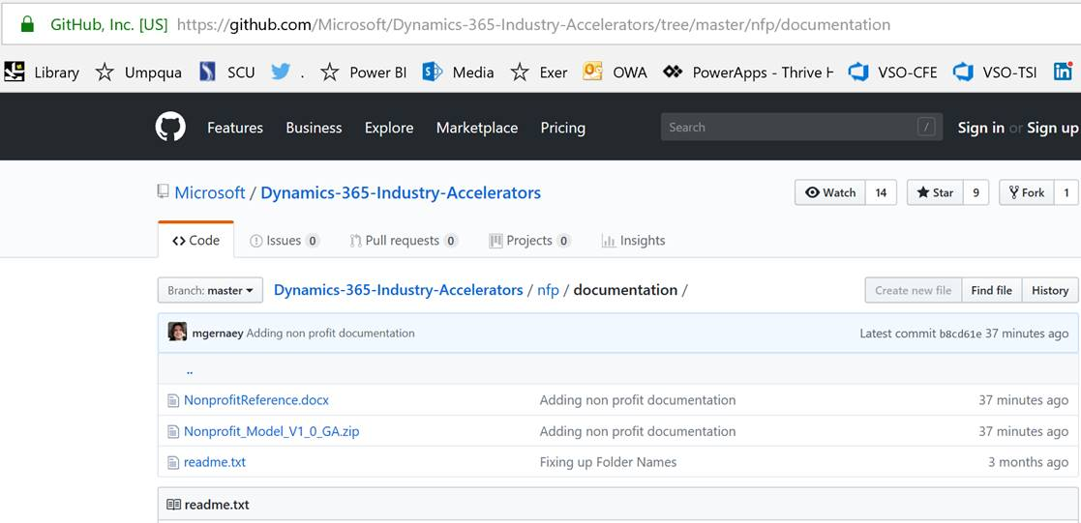

1. Go to <https://github.com/Microsoft/cdm> and click on the navigator

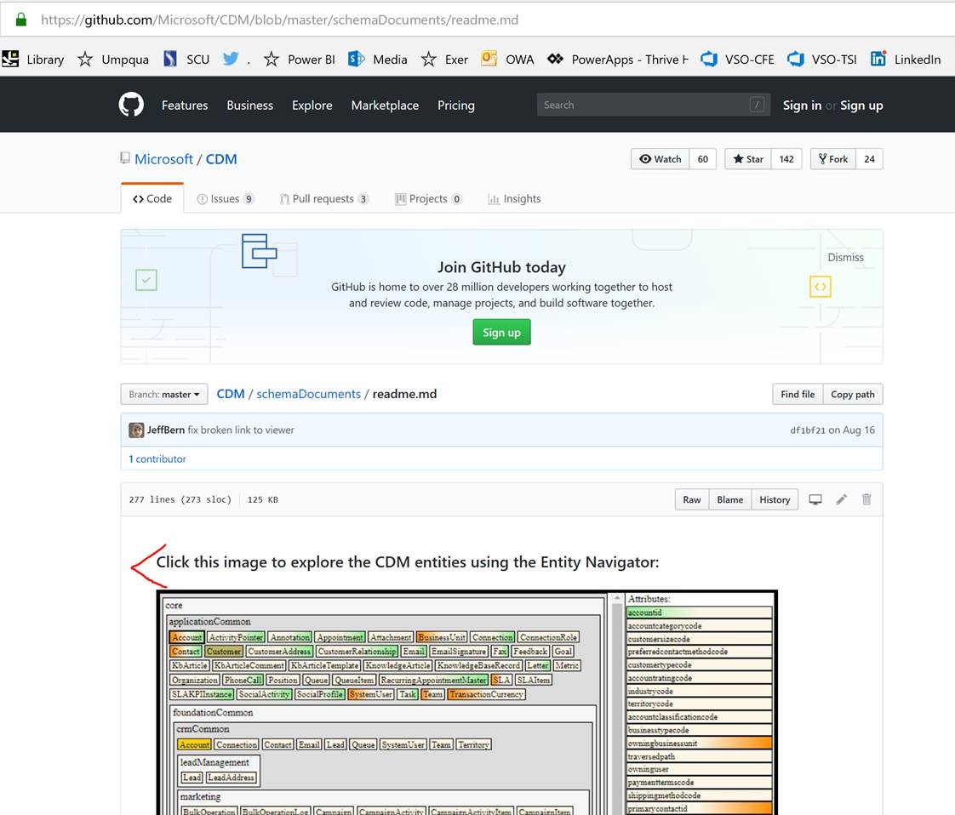

1. Click on “Load on Files” and browse to the folder that contains the files that you previously extracted (only select the root folder)

