Photo 1


The photograph features a Lamborghini Huracan which I spotted in a hotel parking lot. It’s a high-end luxury supercar with a whopping price of approximately 4 cr.

The car comes under Veblen Goods which is a type of good for which demand increases as the price increases, however there is a restriction to these types of goods as well. This will fail if the price of these goods increases manifold, for instance, Lamborghini Huracan’s prices suddenly rises to 15 cr, then the quantity demanded will decrease. However, if there is an increase of 10% or even 20% increase in the price of the car, it would have negligible impact on its sales. The target customers for these kinds of high-end cars are largely indifferent to price fluctuations.
Another micro-economics lesson which could be learnt from the above photo could be of Conspicuous Consumption. It means the use of consumer goods in such a way as to create a display for the purpose of impressing others rather than for the satisfaction of normal consumer demand. It is simply buying expensive things to display one’s wealth and social status to others rather than for practical use.

Prompt for Claud AI -> as an economics expert, tell me what economic concepts you see in this photo
Result - Veblen Good / Conspicuous Consumption
The Lamborghini in this photo is a classic example — it's a luxury item whose value and desirability increases as its price increases, purchased largely to signal wealth and social status rather than for practical transportation utility.
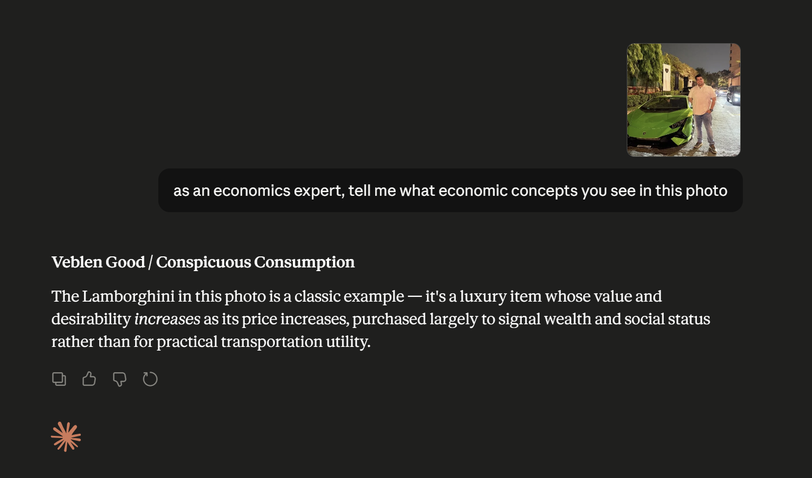

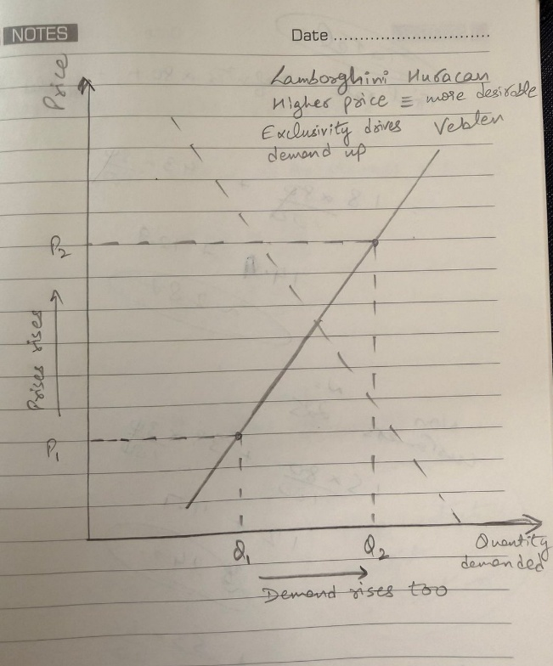
Photo 2

The photograph features Nitin Wire Group Factory which is located beside Great Lakes Institute of Management. The sign advertises Concertina Coil Fence and Lattice sheet. It was a physical factory building with an industrial roofing.
The main economics topic covered in this picture is of Factors of Production. The physical factory is visible which is presence of Capital, Land, Labour and Enterprise.
Being a factory at scale, reducing per unit of production as out put increases, this setup eliminates middlemen, giving them a cost advantage over smaller traders.
Capital in the form of Wire drawing machines and manufacturing equipment. Land in terms of the Factory premises. Labour as in the factory workers, sales staff and finally Enterprise in terms of Business ownership and management decisions.
Another topic which could is of Derived Demand which states that demand for a good which not arises from its direct consumption but from the demand for another good it helps produce. In this scenario, Nitin Wire group’s wire demand would be derived from demand for construction and real estate, demand for agriculture land protection, demand for industrial security fencing.

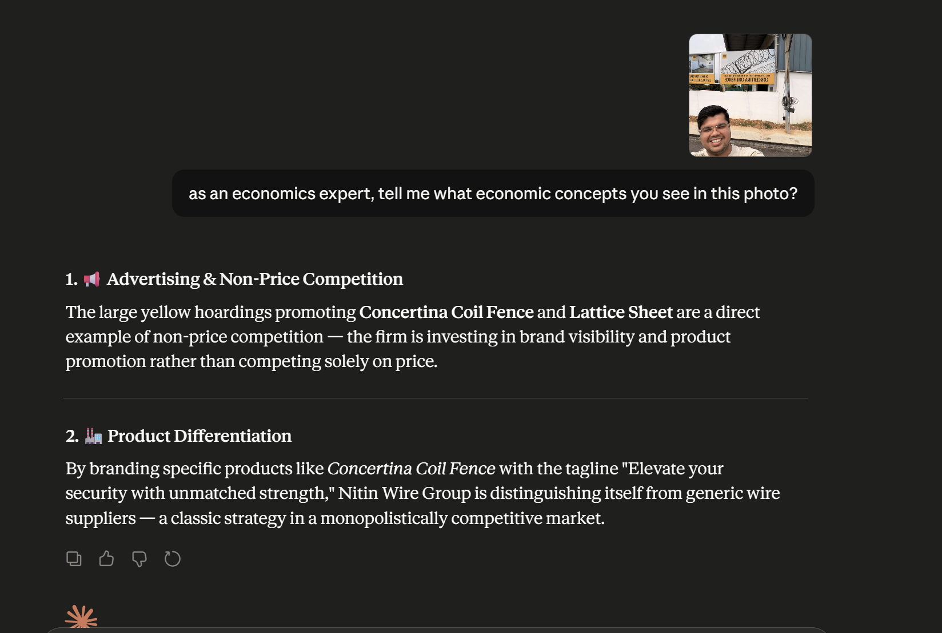

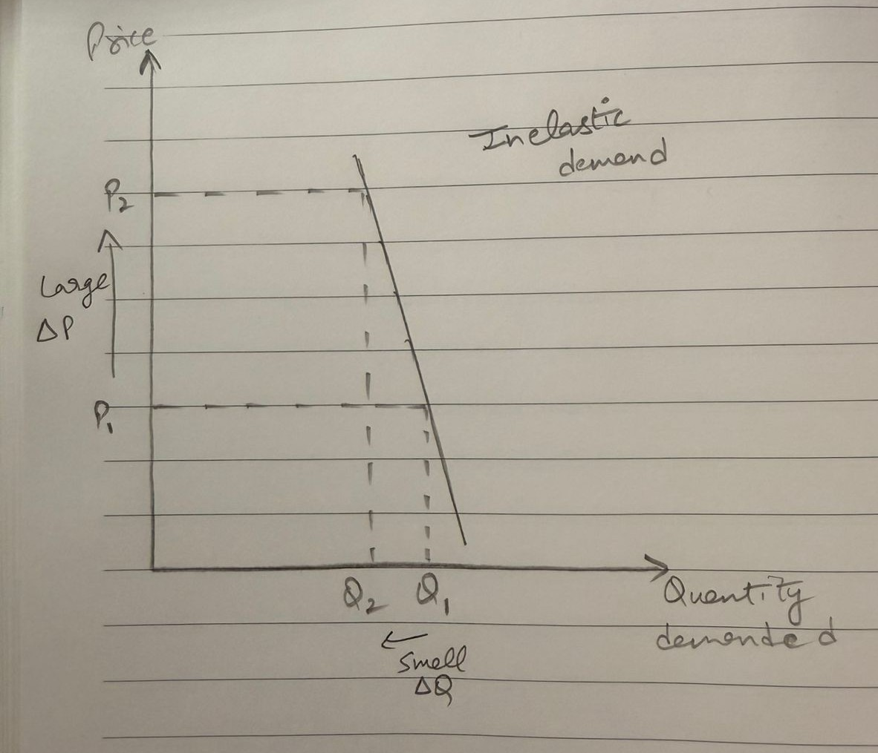

Photo 3

Today, 1 June 2026, I came across an article while reading The Hindu which stated that there was a fire at Hyundai Mobis factory in Sriperumbudur, an automobile components manufacturer. Though they were no casualty reported, the fire destroyed machinery worth crores.
The economic concept which could be applied here is Supply chain disruption because this is a major automotive manufacturing hub. A factory fire there could create a potential bottleneck across multiple downstream producers. We could also say that it’s a case of derived demand working in reverse, a supply shock through the chain.
Also, the fire destroyed machinery worth several crores, there is temporary disruption in the service which would impose costs beyond the factory itself, like, job losses, environmental damage, supply disruptions affecting other business. In other words, capacity to produce has been lost temporarily, reducing the economy’s ability to produce output until rebuilt which is a direct hit to factors of production. Also, the destroyed factory represents a sunk cost, capital which was invested in machinery, inventory and infrastructure is now permanently lost.

