Photo of Business
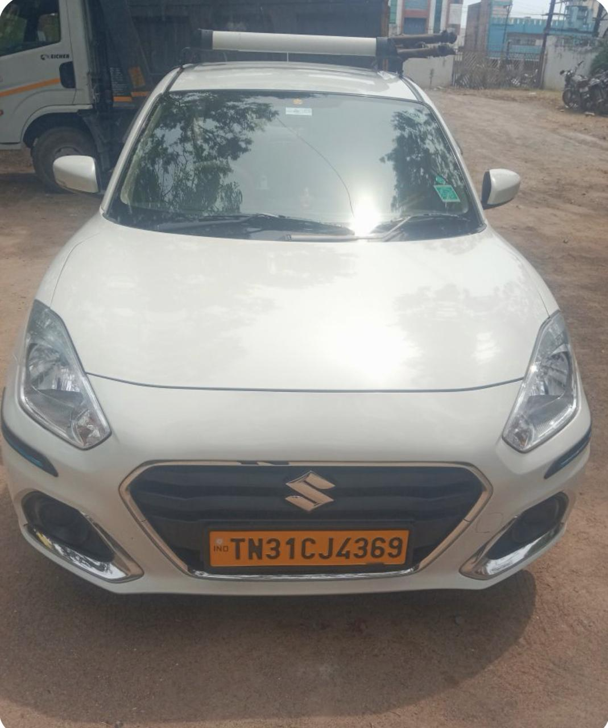
Step 3 —
Cost item | Monthly figure | Daily equivalent (÷30)
Fuel | ₹1.5–2 lakhs | ₹5,000–6,667
Driver salaries (8-9 vehicles × ~2.5 drivers × ₹21,500 avg) | ~₹4.3–4.8 lakhs | ~₹14,300–16,000
EMI | ₹25,000 | ~₹8,300-8,400
Maintenance, insurance

What are the major operational expenses?" lists driver salaries, vehicle maintenance, insurance, and fuel as the major expenses — but without classifying them by fixed vs. variable.
identifies employee salaries as the single largest expense, followed by maintenance — again, no fixed/variable

Output in an off-peak hour - 100 km is minimum per day in April – May
Output in a peak hour - 250 km is maximum per day

Field | Your entry
Business name & location | Cab Operation – Great Lakes, Chennai
Owner name & contact (consent: Y / N) | Suresh - 9840442076
Every cost listed (raw) | Vehicle Acquisition cost, EMI/Payment, Fuel Cost, Driver salary
Owner’s answer: which costs stay fixed / which grow? List | Vehicle Acquisition cost – Fixed  EMI/Payment – Fixed  Fuel Cost and Driver salary – Not Fixed
Output in an off-peak hour | 100 km is minimum per day in April - May
Output in a peak hour | 250 km is maximum per day
Owner’s answer: what they do when overwhelmed | Additional transportation requirements are handled as needed and the 24x7 Availability of substitute
Cost per trip
2–3 customer quotes | “It was a good experience with the cab. I chose this outlet as it was offering the cheapest ride in comparison to Uber. I booked 1 cab from Mahaballipuram to Great Lakes on my first day here.”

Fixed Cost – Fuel, Driver salary, EMI, maintenance, insurance, fastag
Variable –

Field | Number
Total Fixed Cost
Total Variable Cost
Total Cost
Average Fixed Cost
Average Variable Cost
Average Total Cost
Marginal Cost

- Plot AFC, AVC, ATC and MC against output.
- What happens to AFC as output rises, and why?
- Is your ATC U-shaped? Does your AVC / MC actually rise at high output, or stay flat?
- If it is U-shaped: what is the capacity bottleneck (the one oven, one blender, one chair) that makes MC rise? Tie it to the owner’s answer in Phase 1-C.
- If it is flat: explain why ATC still falls 0 what is really driving down unit cost here?
- Compute the unit cost (ATC) at the owner’s actual daily output, then recompute it if footfall doubled. Write one paragraph on what this tells the owner about pricing or expansion.

