STRATEGIC MARKETING AND CUSTOMER FOCUS

CASE STUDY - TRUEARTH HEALTHY FOODS

Aakash Kallepalli ( FT272045 )
Naman ( FT272022 )
Nikhil Aggarwal ( FT272013 )
Suhaila Abdulkareem ( FT272014 )
Sreshta ( FT272009 )
Pratikshya Suar ( FT272023 )

Analysis based on PESTEL Framework

P | As long as basic regulatory requirements are maintained there is no plausible political threat for TruEarth
E | Willingness to spend on better quality healthy food is on the rise , Still the product price for Pizza might be perceived on the higher side, in Double Income Household can have an offset
S | Awareness in rise in trends of healthy eating is a good opportunity to scale up on healthy yet convenient pizza options
T | Packaging built as Pizza would mean new production life with a perishable shelf life and Refrigerated Distribution network must be developed
E | Because of perishable shelf life , food wastage management might be a crucial issue to work upon, sustainable packaging must be taken into consideration.
L | Currently no scope for active threats as long as basic regulatory and recommendations of food safety department and government is followed. The Business Development Manager Rosie Carltons doubts needs to be addressed though

The looming concern is the competitor Rigazzi who entered the whole grain healthy pasta space have also been testing Pizza Recipe. First mover advantage needs to be tapped in by TruEarth before the space becomes saturated. Customer Loyalty must be earned before other competitors launch similar products.

Issues Vs Fixes
Price | The current pricing for pizza base in itself costs $8.00, additional cost for $3.50. each toppings which makes the meal cost about $12.38, which is above willingness to pay amount $10.09 (Exhibit 10). Around 45% of home-trial users said the pizza was expensive and 23% found that the takeout was cheaper (Exhibit 9) | Apart from our current Pizza Product , launching basic pizza bases like Margherita or Four Cheese at about $8 without any need to buy additional toppings which also makes it a figure closer to the price in willingness to pay
Crust Quality | The whole grain base is disliked by 16% who tried , 20% wanted change in taste | Improving the taste of pizza and taking customer feedback seriously.
Repeat Purchase |  | First conduct the in-home testing with existing TrueEarth Pasta and then build on it. Better taste will increase in Return Purchase as well.
  According to the BASES experiment the Repeat rates vary from 21% (mediocre product) to 49% (excellent product) (Exhibit 5). TruEarth also needs $12M wholesale volume to break even (Table B).
Competitive Pressure | Competition from other big players like Domino's Pizza, Nestlé, and Kraft Hein where refrigerated pizzas are cheaper | Create identity through making Pizza Healthy as well as indulgent one to build a loyal customer base

Phased Roll Out – TruEarth Pizza

TruEarth must launch the Pizza , but not a very large scale at the beginning. The Target Household and Market Opportunity is higher than Pasta (Table B), and also another key point to notice is that existing customers of TruEarth is more likely to brand Pizza. So the rollout must start with them and based on purchase patterns and feedback it needs to be scaled up

- Free Tester Kit : For Existing Customer Base to Incentivize their loyalty and possibly gives out the most raw and honest feedback
- Blind Mall Intercept Activities : Set up blindfolded pizza testing booths in malls and crowd attracting places where they will be asked to taste multiple takeout pizza, other competitors brand as well as TruEarth Pizza to break the bias around healthy pizza being less tasty
- Affordable Entry Cost Pizza :To keep pricing close to consumer average spending money , TruEarth must launch basic simpler variants like Margherita and Four Cheese on top of the proposed pricing
TruEarth must launch pizza but in phases and different pay scale to build the customer base.77% of Americans eating pizza monthly, and with a growing demand and buzz around healthier choices it is a promising market when penetrated carefully in phases.

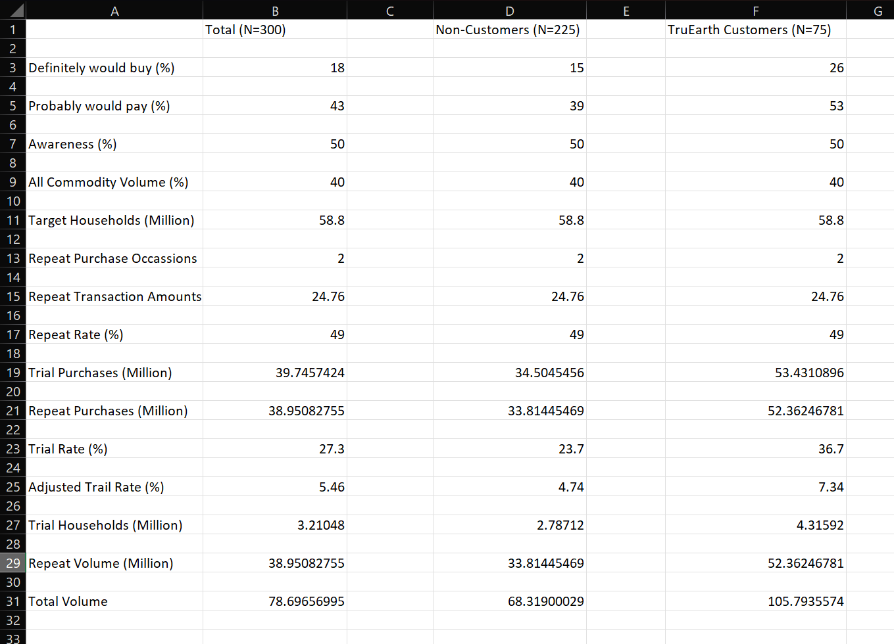
Source - TruEarth

