Connected Antigravity Exercise
Core Logic & Rules:
1. Parse the business scenario description.
2. Identify the parameter of interest (mean mu, proportion p, variance sigma^2).
3. Determine the claim or effect the manager wishes to prove (the alternative
hypothesis Ha).
4. Frame the Null Hypothesis H0 (the status quo or baseline to challenge).
5. Classify the test as:
- One-tailed (Upper-tailed: Ha: mu > mu0)
- One-tailed (Lower-tailed: Ha: mu < mu0)
- Two-tailed (Ha: mu != mu0)

ANSWERS -

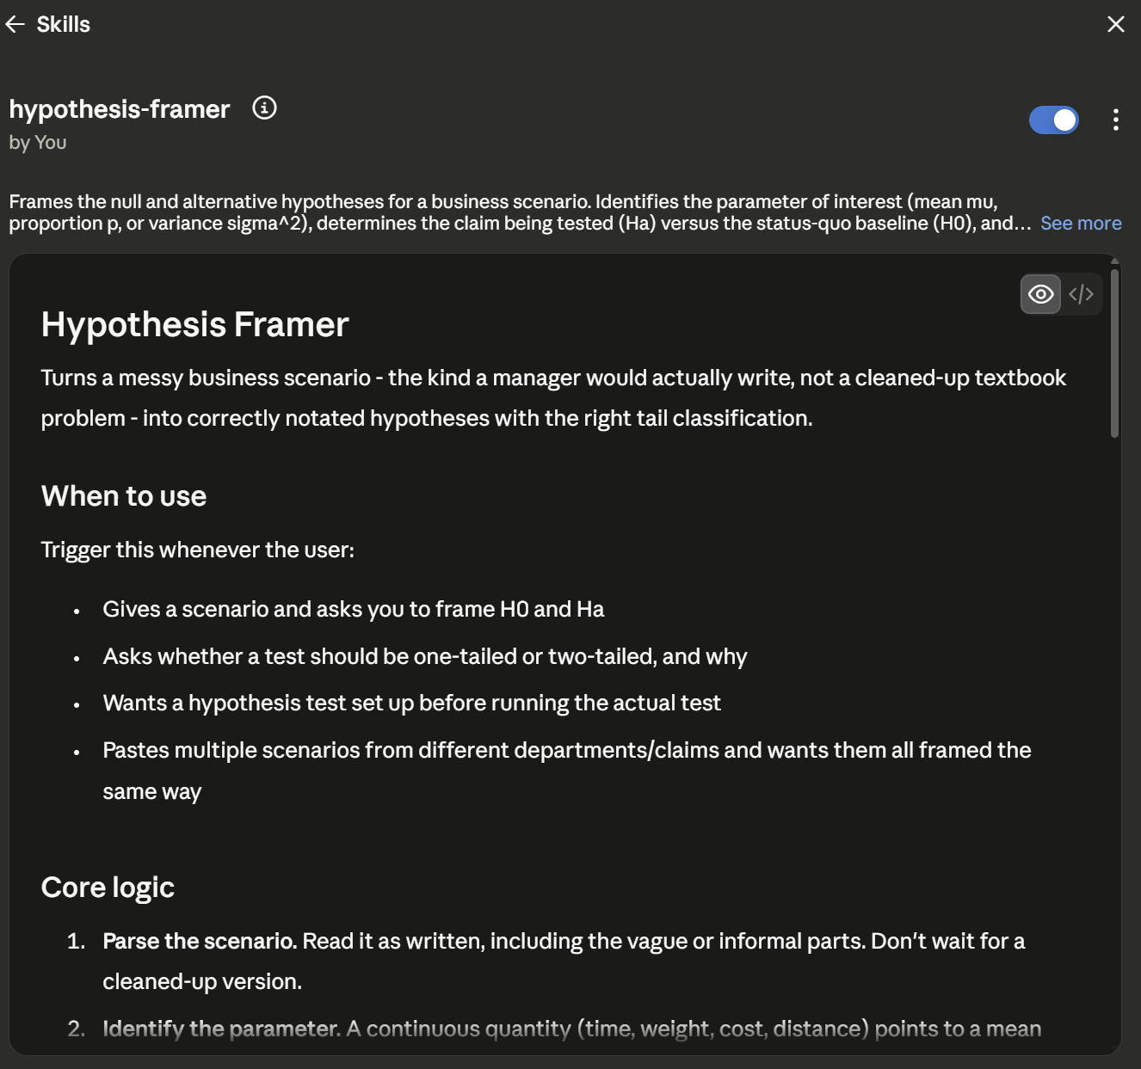

- The scenario -
A company switched to new delivery routing software and wants to know whether it changed the average order delivery time from the current baseline of 40 minutes.
- Identify the parameter of interest -
Delivery time is a continuous quantity (measured in minutes), not a percentage or a count of successes/failures. So, the parameter is a mean, μ — specifically, average order delivery time.
- Determine the claim the manager wishes to prove (Ha) -
The claim being tested is that the routing software changed delivery time from the baseline — the company wants to know if there's been a shift, without presupposing which direction.
- Frame the Null Hypothesis (H0) -
H0 is the status quo the claim is being tested against:
H0: μ = 40 (the routing software hasn't changed average delivery time)
Ha: μ ≠ 40 (the routing software has changed it, in either direction)
- Classify the test -
This is two-tailed:
Ha: μ ≠ 40
Reasoning through why it's not upper- or lower-tailed: an upper-tailed test (Ha: μ > 40) or lower-tailed test (Ha: μ < 40) would only be correct if the business genuinely didn't care about movement in the other direction. That's not true here. It's tempting to frame this as "we want it to be faster," which sounds like it should be one-tailed — but that's not actually what the business cares about. If the new software somehow made deliveries slower, that's just as important to catch as a genuine speed-up, since the company would act on either result: keep the software if it's faster, flag a problem if it's slower. Because a move in either direction changes the decision, two-tailed is the only correct classification, regardless of which direction the company was hoping for going in.

- What this looks like as a managerial decision

Once the test actually runs, the operations director isn't going to think in terms of μ and Ha - she wants to know one thing: did the new software change delivery time, and which way did it move? If the result is significant and times dropped, that supports keeping the software. If it's significant and times went up, that's a real problem worth acting on, even though it's not the outcome anyone was hoping for. Framing the test as two-tailed from the start is what makes the trial - in this case, a 30-order study - capable of catching either outcome, instead of being built only to notice the improvement everyone wanted to see.

