Stonehaven, Inc. — Case Analysis
Operations Management I • PGPM • Great Lakes Institute of Management
Group Number | 8
Batch Size (X = 5 × Group No.) | 40 pairs
Group Members | [Fill in names and roll numbers]
Submission Date | [Fill in date]

1. Problem Setup
The Gdansk factory runs one shift of 8 hours a day, five days a week. All calculations that follow use a working day of 480 minutes. Group 8's batch size is X = 5 × 8 = 40 pairs, so every batch that flows through the plant carries 40 identical pairs (same style, size, and colour). Consecutive batches change specifications, which is why die changes in the cutting department matter.
Two questions are answered below: the factory's daily output capacity, and the total time a batch of 40 pairs takes to move from raw leather to finished goods.

2. Question 1 — Daily Factory Capacity at X = 40
Factory capacity is set by the slowest department. We compute each department's daily throughput in the same unit (pairs per day) and take the minimum.

2.1 Cutting
The three stamping presses work at the same time on the same batch. Each press does four die changes and cuts four components per pair, so a 40-pair batch needs 4 × 40 = 160 stampings per press. The batch is done when the slowest press finishes.
Press | Setups (4 × die change) | Run (160 × time/piece) | Batch time (min)
M1 — Cut shoe leather | 4 × 5.25 = 21.0 | 160 × 0.05 = 8.0 | 29.0
M2 — Cut linings | 4 × 5.00 = 20.0 | 160 × 0.05 = 8.0 | 28.0
M3 — Cut insole | 4 × 4.00 = 16.0 | 160 × 0.04 = 6.4 | 22.4

Batch cycle time = 29 minutes (M1 governs).
Daily throughput = (480 ÷ 29) × 40 ≈ 662 pairs/day

2.2 Kitting
Ten minutes per batch, no other constraint. Daily throughput = (480 ÷ 10) × 40 = 1,920 pairs/day.

2.3 Stitching
Each worker takes one kit at a time, but workers in the same group work on different kits in parallel. Steady-state throughput per group therefore depends only on the number of workers and the per-pair rate. The supervisor's kit routing adds queueing time but does not lower long-run throughput as long as buffers stay full.
Work group | Workers | Time / pair | Daily throughput (pairs/day)
Prefit | 4 | 5.0 min | 4 × 480 ÷ 5.0 = 384
Join | 3 | 3.0 min | 3 × 480 ÷ 3.0 = 480
Ornament | 2 | 2.5 min | 2 × 480 ÷ 2.5 = 384

Stitching capacity = 384 pairs/day. Prefit and Ornament are tied as the internal bottleneck.

2.4 Steaming
The oven has significant excess capacity and holds multiple batches at once (six-hour dwell time, but not a queue constraint). Steaming is not the bottleneck.

2.5 Lasting
The lasting line is paced. It runs at the rate of the slowest station, which is Station 3 at 1.0 minute per pair. Only one batch is on the line at a time, so each batch pays a pipeline-fill penalty.
Station | Time / pair (min)
1 — Staple insole | 0.7
2 — Toe and heel seat lasts | 0.6
3 — Rough sole, pound | 1.0
4 — Cement sole, pull last | 0.9
5 — Inspect, pack | 0.3

Time for one 40-pair batch = 5 × 1.0 (pipeline fill) + 39 × 1.0 (remaining pairs) = 44 minutes.
Daily throughput = (480 ÷ 44) × 40 ≈ 436 pairs/day

2.6 Bottleneck Summary
Department | Daily capacity (pairs/day) | Role
Cutting | 662 | Slack
Kitting | 1,920 | Slack
Stitching | 384 | BOTTLENECK
Steaming | Excess capacity | Not constrained
Lasting | 436 | Near-bottleneck

Answer to Q1: Factory daily capacity = 384 pairs/day. The bottleneck is the Stitching department, specifically the Prefit and Ornament work groups.
Figure 1 below visualises the departmental capacities and the bottleneck.
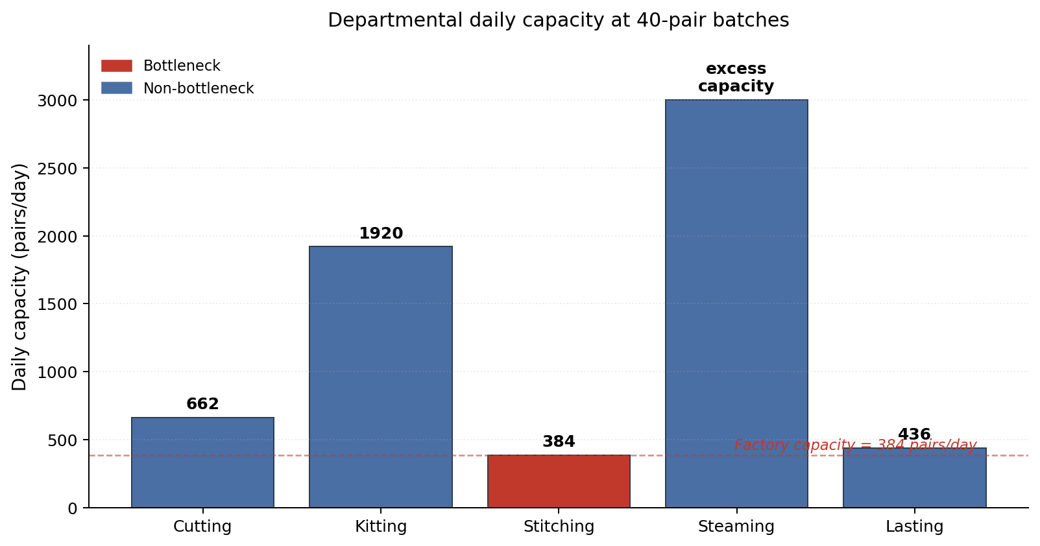
Figure 1. Daily capacity by department at X = 40 pairs.

2.7 Implication
Adding one worker to Prefit would raise its capacity to 5 × 480 ÷ 5 = 480 pairs/day, but Ornament would still cap the factory at 384. A capacity improvement therefore needs investment on both fronts, or a redesign that reduces the per-pair time in Ornament.

3. Question 2 — Manufacturing Lead Time for a 40-Pair Batch
We apply Little's Law: MLT = Average WIP ÷ Throughput. Throughput is the factory output rate from Question 1 (384 pairs/day). WIP is the total inventory sitting in the system, summed across every location listed in Table 2 of the case.
The footnote in Table 2 matters: the raw-material and pre-kitting triangles (20 and 2) are in units of 100-pair batches, because material has not yet been batched at those stages. Downstream buffers (before Stitching, Steaming, Lasting, and Finished Goods) are in units of the current batch size, which for Group 8 is 40 pairs.

3.1 WIP Inventory Conversion
Location | Batches (Table 2) | Pairs per batch | Pairs in WIP
Before Cutting (raw material) | 20 | 100 (footnote) | 2,000
Before Kitting | 2 | 100 (footnote) | 200
Before Stitching | 6 | 40 | 240
Before Steaming | 6 | 40 | 240
Before Lasting | 4 | 40 | 160
After Lasting (Finished Goods) | 8 | 40 | 320
Total WIP |  |  | 3,160

3.2 Applying Little's Law
MLT = 3,160 pairs ÷ 384 pairs/day ≈ 8.23 working days
In hours: 8.23 × 8 ≈ 66 working hours. In minutes: about 3,950 minutes of factory clock time from raw leather entering the plant to finished shoes leaving as inventory.
Answer to Q2: Manufacturing Lead Time ≈ 8.23 working days for a 40-pair batch.

4. Assumptions and Interpretation Notes
- Table 2 downstream buffers are read as fixed batch counts (6, 6, 4, 8) at the new batch size of 40. An alternate reading holds the physical pair inventory constant at the case's original 100-pair values (600, 600, 400, 800 pairs), giving total WIP = 4,600 and MLT ≈ 12 days. Our reading is consistent with the batch-size sensitivity theme of the question.
- Little's Law returns total flow time. This bundles queueing and processing. If processing time is required separately, the sum of departmental cycle times (29 + 10 + 420 + 360 + 44 = 863 minutes ≈ 1.8 days) can be split out from the WIP-based figure.
- Stitching capacity assumes buffers stay full so workers do not starve. The case notes that the supervisor-mediated kit routing can leave some workers idle, but this is a queueing issue affecting lead time, not steady-state throughput.
- Steaming's oven is treated as unlimited because the case states it has significant excess capacity. If the oven were sized to hold only two or three batches at once, its throughput would need to be modelled explicitly.
- All setup and run times used in Cutting come directly from Table 1. Die-change time dominates the cutting cycle at this batch size (21 of 29 minutes on M1), which is the arithmetic reason small batches are expensive on this step.

