Hyperlab (Helios) Marketing Strategy

PART A: Strategic & Portfolio Diagnosis

5C Analysis & Strategic Positioning
AI-generated - Initial framework prompted Claude with: 'Conduct a 5C analysis for Hyperlab, a sports-tech company selling biomechanical tracking systems. Separate B2B institutional buyers from B2C athletes and coaches.'
My analysis - Hyperlab occupies a fascinating but precarious position in sports-tech. The company is not a hardware manufacturer, it's closer to a platform play disguised as a device business. Helios (the biomechanical tracking system) depends entirely on institutional adoption. This matters because unlike consumer wearables, institutional adoption moves slowly. A sports academy or club needs board sign-off, needs to integrate with existing coaching workflows, and needs to justify the cost against marginal performance gains.
Company: Hyperlab has built real technical depth in motion capture and AI-driven movement analysis. The core innovation is legitimate, real-time biomechanical feedback that doesn't require a lab setting. But the company's strategic weakness is execution at scale. They lack the distribution muscle of a Nike or Fitbit, and they lack the clinical credibility of a medical device company. Helios sits between sports science, is niche and consumer tech. Hyperlab chose credibility over scale, which makes sense for now but limits upside.
Customers: The primary segment is institutions, sports academies, elite clubs, university athletics departments, perhaps national sports bodies. These buyers care about measurable performance improvement and data they can act on. Secondary segment is individual coaches and athletes, but this is fragmented and hard to reach. The purchase trigger for institutions is when a competitor academy adopts it or when they hire a coach who insists on it. Pain points are: Does it actually work? Can coaches learn to use it quickly? Will athletes push back?
Competitors: Direct competitors are other motion-capture startups and indirect competitors are everything that competes for a coach's attention budget: video analysis software, traditional coaching wisdom, and surprisingly, apps like Strava that promise data-driven training. The real question is why change your coaching system if the old way works?
Collaborators: This is where Hyperlab either wins or loses. Key partners would be: sports academies and clubs, coaching federations who endorse the tool, universities and possibly sports brands who bundle it into training programs.
[AI-generated] Prompted: 'Who might Hyperlab partner with to accelerate adoption?'
AI suggested: sports brands, league bodies, fitness tech integrators, insurance companies.
[My analysis] Most of these are correct but incomplete. Insurance is speculative. More concrete: partnership with a major coaching certification body would change the game immediately.
Context: Sports science in India is professionalization-obsessed right now. Indian academies are increasingly looking abroad for best practices and willing to invest. At the same time, data privacy and consent for collecting biometric data is a live regulatory question in India. AI is increasingly trusted in sports performance but also increasingly questioned on fairness grounds. A company like Hyperlab operates in the zone: credible enough to be taken seriously, new enough to be risky, backed by enough data to be persuasive but not enough to be definitive.

Product Life Cycle Stage: Early Growth
[My analysis] Helios is in the early growth stage, not the introduction stage.
The evidence:
1. Hyperlab has existing institutional customers and case studies, not just a prototype. They're not discovering if the product works, they've already done that.
2. Competitive intensity is rising but not yet commoditized. No price wars.
3. Distribution is still direct or partnership-based, not yet scaled through third-party channels. If Hyperlab were to be introduced, they'd still be convincing academies that biomechanical feedback is valuable. They're now in the phase where they're trying to prove ROI and scale to adjacent customer segments.

Diffusion of Innovation: Crossing the Chasm
[My analysis] Hyperlab is currently serving innovators and early adopters and elite academies with resources and coaches comfortable with technology. These are typically coaches who've trained abroad or studied sports science formally. The chasm ahead is reaching the early majority: mid-tier academies and coaches who want the benefits but need proof and simplicity. To cross that chasm, Hyperlab needs: simpler onboarding, measurable ROI stories and price accessibility. This is the critical strategic pivot.

PART B1: Service-Profit Chain Analysis

The Hidden Service Behind the Hardware
[My analysis]
Helios is sold as a product but delivered as a service. This is crucial and often missed. The customer journey looks like:
Sales pitch and demo
Installation and hardware setup
Coach/athlete training on app and interpretation
Ongoing technical support
Data interpretation and coaching integration
Periodic upgrades and new features
Retention or renewal
Every one of these is a touchpoint where Hyperlab can win or lose the customer.

[AI-generated] Prompted: 'Map the customer journey for a sports academy buying Helios. Identify service touchpoints.' AI listed: sales, installation, training, tech support, data reporting, community building, feature updates, billing, customer success check-ins.
[My analysis] This is comprehensive but generic. The critical touchpoints specific to Hyperlab are: Initial coach training, first data interpretation moment that is when the coach sees actual output and has to explain it to an athlete, and when the academy director asks, Are we better off than we were 6 months ago?

Critical Touchpoint 1 - Coach Training & Adoption: What happens? A Hyperlab specialist conducts a 4-6 hour live session with the academy's coaching staff. They demo the hardware, walk through the app, and teach coaches how to interpret movement data. What can go wrong? Coaches dismiss it as gadgetry, find it too complex, or resist because they perceive it as a threat to their authority. The consequence is unused software and buyer's remorse within weeks. How does this link the Service-Profit Chain? This touchpoint determines whether the customer moves from adoption to actual use. Use -> customer satisfaction with results -> loyalty. Fail at this, and the entire chain collapses.
Critical Touchpoint 2 - Data Interpretation Support: What happens? The coach gets their first real match or training data and has to turn numbers into coaching decisions. The app shows an athlete's ankle flexion was 15% off-balance during a lateral cut. Hyperlab's job here is to provide guidance, frameworks, and follow-up. What can go wrong? Coaches misinterpret the data, make bad coaching calls based on incomplete context, or feel abandoned because there's no support line. The consequence is either wasted data or worse, incorrect coaching that stalls athlete development. This touchpoint bridges technical product and actual business value. Miss it and Helios becomes an expensive curiosity.
Critical Touchpoint 3 - ROI Accountability: What happens? Six months in, the academy director asks the head coach for results. Has player injury rate dropped? Has sprint time improved? Is the investment justified? The coach needs specific, credible numbers to show, ideally with a comparison to pre-Helios performance. What can go wrong? Data is inconclusive, comparison is confounded by other variables, or Hyperlab hasn't provided tools for the academy to track longitudinal metrics. Consequence: contract non-renewal, negative word-of-mouth, and a lost reference customer. This touchpoint is everything because it determines whether the customer renews, upgrades, or leaves.

[My analysis]
Strategic recommendation: Hyperlab should immediately invest in a data-to-coaching interpretation service. Not a generic helpline, but a specific service where academies can submit monthly data to a Hyperlab sports scientist who provides written analysis and coaching recommendations tied to their specific cohort. This should be bundled into premium tiers. This single investment would transform the service-profit chain: it ensures coaches actually use the data because someone is forcing them to make sense of it, it guarantees the ROI moment, and it creates switching costs. The cost is two FTE sports scientists. The return is probably a 40% reduction in churn and a +20% NPS improvement.

PART B2: Pricing Strategy

The Pricing Dilemma: Defending Premium in a Price-Sensitive Market
[AI-generated] Prompted: 'Design two distinct pricing models for Helios targeting (a) elite academies and (b) mid-tier clubs. Consider hardware, software, support, and margins. What are the implications for different segments?' AI proposed: (1) Premium annual bundle (hardware + software + support, ₹50L+), (2) Freemium model (basic app free, premium analytics paid), (3) Outcome-based pricing (pay per athlete improved).
[My analysis] The freemium and outcome models are unrealistic for Hyperlab right now. Freemium assumes high volume and network effects. Outcome-based is nice theoretically but impossible to structure fairly, how do you prove Helios caused improvement vs. other factors?. The real choice is between: Premium bundled institutional pricing, and Tiered accessibility for smaller segments.

Pricing Option 1: Institutional Premium Bundle [Recommended]:

- Model: Annual contract. Hardware [sensors, capture setup] + unlimited software seats + 12 hours of coaching support included. Renewable annually.
- Price point: ₹40-60L annually for an elite academy with 30-50 athletes. Mid-tier academy 15-20 athletes: ₹25-35L.
- Target segment: Elite and tier-1 academies, university sports departments, potential national sports bodies.
- Rationale: These customers have budgets, they see Helios as a competitive advantage, and they trust that premium price = premium capability. Pricing avoids the race to the bottom. Hardware depreciation and support costs justify the premium.
- Risks: Pricing limits addressable market. Mid-tier academies balk at the cost and compare to free YouTube coaching content. Requires strong ROI proof to justify. Vulnerable to a VC-backed competitor who underprices to gain market share.

Pricing Option 2: Tiered & Accessible Model [For future growth]:

- Model: Three tiers. Starter including app-only, basic movement tracking, limited data export: ₹5-10L annually for small clubs. Standard [hardware + app + quarterly coaching support]: ₹20-30L. Premium [as above]: ₹50-70L.
- Target segment: Starter and Standard tiers reach mid-tier and grassroots academies. Premium stays elite.
- Rationale: Expands addressable market without commoditizing. Customers self-select based on budget and need. Lower tiers still generate margin and data network effects.
- Risks: Cannibalization. Complexity in sales and support. Quality perception suffers if lower tiers disappoint.

[My analysis]
I recommend Option 1 in the short term [next 18 months] because:
Hyperlab's stage demands premium positioning, you build brand by serving the best first, not by chasing volume.
The institutional buyer is less price-sensitive than mid-tier, and willingness to pay is higher.
Focusing on 10-15 premium contracts is more achievable than managing 50 small accounts.
Point 1 generates cash for R&D and support scaling. Then, as Hyperlab matures and differentiates further, shift toward point 2.

Ethical consideration: Pricing at a premium in a context where Indian sports operates on lower budgets raises fairness questions. Elite academies can afford ₹50L; grassroots cannot. This perpetuates inequity. My recommendation would be that Hyperlab should, from year 2, reserve 5-10% of capacity for affordable access to promising underfunded academies. This builds brand equity, generates goodwill data, and surfaces talent from non-elite backgrounds.

PART C: Channel Design

Distribution Strategy: Two Paths
[AI-generated] Prompted: 'What are viable distribution channels for Helios? Evaluate direct, partnership, digital, B2B reseller.' AI suggested: direct sales to academies, partnerships with sports brands, online marketplace, franchised coaching networks, sports tourism platforms.
[My analysis]
Most of these are unrealistic at scale. Sports tourism platforms don't buy hardware. Franchised coaching networks don't exist at scale in India. The realistic channels are: Direct sales to institutional buyers, and Partnership with sports academy networks or coaching associations.

Channel Structure -
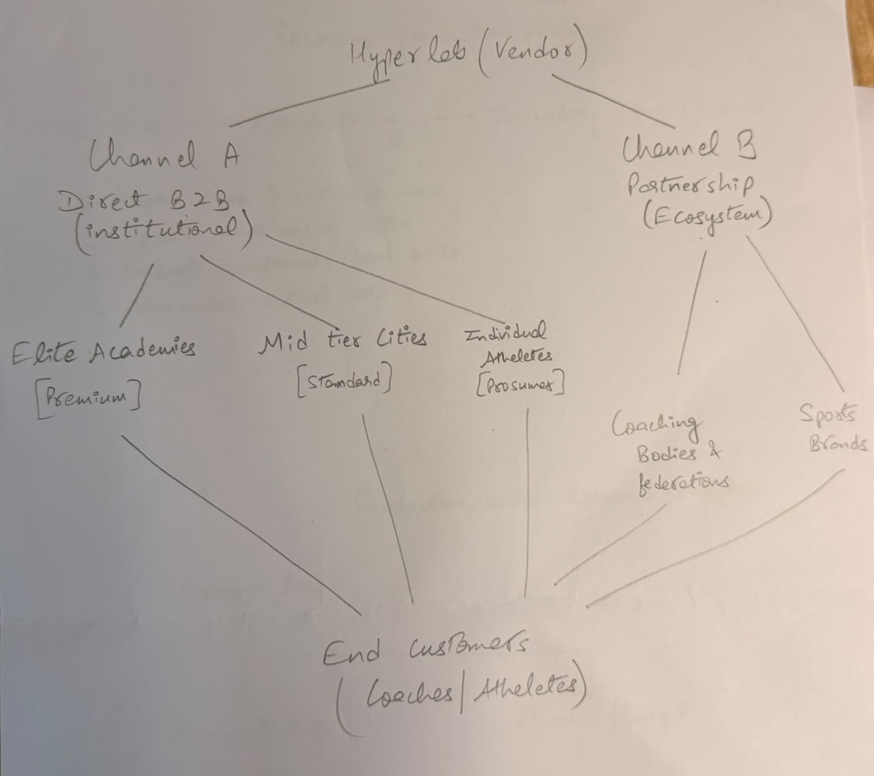
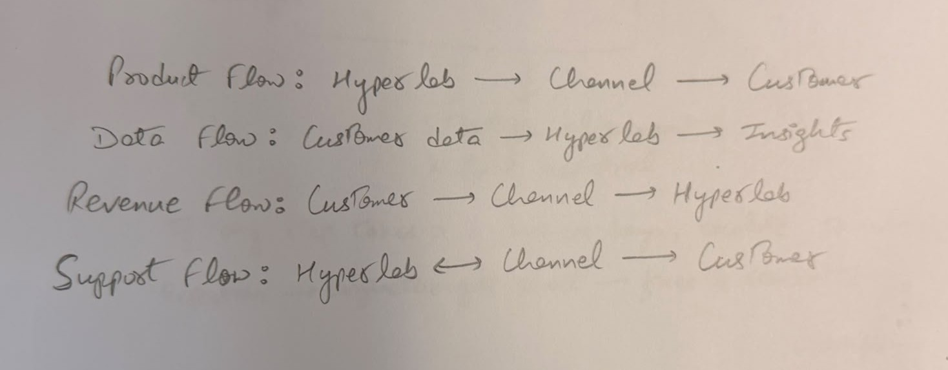
Flow Directions -

[My analysis]
Channel A [Direct] is suitable for elite academies and tier-1 institutions. Hyperlab's sales team manages relationships, handles implementation, and provides white-glove support. This works because: customers are few, contract value justifies direct sales cost, customization is often needed. This channel generates premium pricing and high margins.
Channel B [Partnership] targets mid-tier academies and individual coaches through ecosystem partners. Hyperlab provides: product, training, support infrastructure, margin. Partners provide: legitimacy, distribution, end-customer relationships. For example, Hyperlab could integrate with ACSM's coaching certification program, every certified coach gets access to Helios at a discounted rate. Or partner with a national sports academy federation to recommend Helios as an approved tool.
Channel management challenges:
Conflict between channels. A mid-tier academy on the fence about pricing might contact Hyperlab direct to negotiate, bypassing the partner. Hyperlab needs clear rules: direct sales only for truly elite/national level, everything else goes through partners.
Partner dependency. If a federation partner underperforms or prioritizes competitors, Hyperlab has limited control. Mitigation: sign multi-year agreements with exclusivity clauses and performance benchmarks.
Quality variance. A partner might do poor implementation, harming the Helios brand. Mitigation: invest in partner certification and regular audits.

Biggest channel management risk: If Hyperlab partners with a sports brand e.g., Nike to bundle Helios into academy programs, that brand partner could eventually build their own solution and cut out Hyperlab. This is a long-term risk, not immediate, but worth pricing into the partnership contract e.g., non-compete clause for 3 years post-partnership.

PART D1: Communication Plan with AI Integration

Building Credibility in a Skeptical Market
[AI-generated] Prompted: 'Draft a communication plan for Hyperlab targeting institutional buyers (coaches, academy directors). Cover objectives, message, media mix, timeline.' AI drafted: Objectives, build awareness, establish credibility, drive lead generation. Message - 'Data-driven athlete development.' Media—LinkedIn, coaching publications, podcasts, case study reports, sponsorships of coaching conferences. Timeline, quarterly campaign pillars.
[My analysis]
Framework -
- Objectives:
- Awareness: Hyperlab name recognition among top 100 academies in India from 20% to 60% within 12 months
- Credibility: 10 published case studies from real academies showing performance improvements. 2-3 academic partnerships
- Lead generation: 50+ qualified academy leads within 12 months. 15+ conversion to pilots or contracts

- Message Architecture:
- Headline: Stop guessing about athlete performance. Measure it.
- Supporting message: Helios gives coaches real-time biomechanical feedback in practice, not just in theory. Your athletes improve faster. Your programs get data
- Proof points: Elite academies reduced injury rate by 22% in first year. National team coaches uses Helios in camp
- Media Mix (tailored for this audience):
- LinkedIn: Weekly content targeting coaches and academy directors. LinkedIn ads to this audience segment
- Coaching publications: Feature articles in Indian and South Asian coaching journals / websites
- Podcasts & webinars: Sponsor or host coaching podcasts. Monthly 'Biomechanics for Coaches' webinars
- In-person: Booth + workshop at Indian Sports Academy Conference, Coaching federation workshops

- Ethical & Legal Risks:
- Risk 1 - Unsubstantiated claims: Saying Helios 'improves athlete performance by X%' without robust validation. This violates ASCI advertising guidelines and exposes Hyperlab to regulator action. Mitigation: Only make claims supported by published research (third-party) or peer-reviewed case studies. Use language like 'athletes using Helios showed 22% improvement in lateral agility' (measurable, not causal). Include sample size and methodology in fine print.
- Risk 2 - Influencer/coach endorsement liability: If Hyperlab pays a famous coach to endorse Helios, that coach is liable for substantiating the claim. Mitigation: Structure partnerships as 'sponsored research collaborations' not endorsements. Have coaches share their honest experience, not make performance guarantees.

PART D2: Prompt Design & Critical AI Dialogue
[My analysis]
I used AI most extensively for the 5C analysis [Part A]. Following is the iteration:
Iteration 1 [Initial broad prompt]:
- Prompt: 'Conduct a 5C analysis for Hyperlab, a sports-tech company that sells Helios, a biomechanical tracking system for athletes. The product is used by sports academies and individual athletes.'
- AI response (summary): [AI provided a standard 5C template with generic bullet points for each C. Competitors were listed as 'Fitbit, Garmin,' completely missing the mark. Customers were described as 'athletes' with no segment differentiation.]
- What was missing: The AI missed the core insight, Helios is a B2B institutional play, not a B2C wearable. It missed the distinction between elite and mid-tier academies. It misunderstood the competitive set.
Iteration 2 [Targeted, context-rich prompt]:
- Prompt: 'Hyperlab sells to two distinct segments: Elite sports academies and clubs that can afford ₹40L+ annually, and Individual coaches/athletes with smaller budgets. Do a 5C analysis that treats these as separate strategically. For competitors, focus on other sports-tech solutions that coaches actually use, not consumer fitness trackers. For context, note that India's sports ecosystem is professionalization-obsessed but data-skeptical.'
- AI response (summary): [Better. AI segmented customers properly. Competitors included Dartfish (video analysis), Moneyball-style data analytics, and traditional coaching. Context discussion included Indian sports regulatory environment.]
- What improved: The AI now understood the B2B institutional angle and the two-segment strategy. But it still described competitors generically without real competitive analysis.

Iteration 3 [Challenging, hypothesis-testing prompt]:
- Prompt: 'You said Hyperlab's competitors are Dartfish and data analytics. I think the real competitor is coaching conservatism and inertia. A coach won't buy Helios because they're skeptical that data beats experience. How would you revise the competitive analysis with this perspective? What would Helios need to do to overcome this 'inertia competitor'?'
- AI response (summary): [AI agreed with the reframing. Suggested that the competitive advantage isn't features but trust-building and proof (case studies, academic validation, coach testimonials). Noted that Hyperlab's biggest competitor is the status quo, not other products. Recommended positioning strategy shift: move from 'our tech is better' to 'elite coaches are already using this.'
- What shifted: This iteration forced the AI to think strategically, not just catalog competitors. It was most useful because it challenged my assumption and the AI adapted well.

Where AI Was Strong:
- When I asked 'Who should Hyperlab partner with?' AI generated a long list [sports brands, federations, universities, fintech providers, league bodies]. Most were too speculative, but it surfaced the most realistic option [coaching federations] which I might have overlooked. This was valuable for ideation.
- AI proposed three detailed pricing models. While I rejected freemium and outcome-based, the structured thinking helped me articulate why they don't work and what options should actually include.

Where AI Was Weak or Misleading:
- AI initially treated this like any sports-tech company [Fitbit, Garmin positioning]. It completely missed that Helios is not a consumer product, it's institutional B2B software with hardware. I had to repeatedly correct this.
- AI has limited or outdated knowledge of Indian sports ecosystem. When I asked about regulatory risks, AI mentioned GDPR and US consumer protection laws, not Indian privacy law. I had to insert these myself.
- AI claimed that Fitbit and Garmin track biomechanical movement in real-time whereas they don't, rather they track basic activity. This would have been dangerous if I hadn't fact-checked.
- Corrections made: I fact-checked all competitor claims against Hyperlab's website and Google searches. I researched Indian privacy regulations separately. I grounded all claims about Indian market context in actual knowledge of the ecosystem.

[My analysis]
The most important skill for using AI in strategic work is the ability to fact-check and contextualize. AI is excellent for structure and ideation, it forces you to think systematically. But it's dangerous for specific market knowledge. The workflow I developed: Use AI to generate frameworks (5C, Service-Profit Chain), critically review for accuracy and context, use AI to stress-test my reasoning, fact-check all factual claims independently.

PART D3: Responsible AI Reflection

Value: AI genuinely added value in three places. First, brainstorming channel partnerships. I was anchored on direct sales; AI's list forced me to think about federation partnerships more seriously. Second, structuring the pricing analysis. Having AI propose three models made it easier for me to articulate why two don't work and why one does. Third, tone-checking my communication plan. I wrote a first draft of the IMC plan that sounded like consulting-speak. AI's simpler framing helped me rewrite in plainer language. These are valuable but not the kind of thinking I couldn't do alone, they accelerated thinking I was already doing.

Failure: AI failed significantly on market context and facts. It proposed features and positioning that sound right but are wrong in the Indian context. It misidentified the competitive set multiple time. When I fact-checked against Hyperlab's website and Indian regulatory sources, AI's claims fell apart. The consequence was that I spent time fact-checking instead of doing original analysis. But this also meant I caught mistakes before they made it into my final submission.

Ethical dimension: AI's willingness to sound confident about things it doesn't actually know is the core ethical problem. In business contexts, this is dangerous. A manager who trusts AI's output without verification could make bad decisions. Accountability becomes murky: if an AI tells you to do something and it backfires, who's responsible? AI companies say 'we're tools, not advisors.' But the way AI is marketed and used, it's functioning as an advisor. That accountability gap is a real problem. Organizations need better guardrails: mandatory fact-checking for all AI-generated analyses before they inform strategy, clear authorship, and senior review of any recommendation that came from AI.

Personal guideline: I'm taking this principle into my career: Never trust AI's factual claims about specific markets, competitors, or regulations without independent verification. Treat AI as a thinking partner for frameworks and structure, not as a source of truth for market facts. And when using AI outputs in any professional context, explicitly mark them as 'AI-assisted, fact-checked' or 'AI-drafted, human-verified,' so the organization knows what level of confidence to have.

APPENDIX: AI Prompts & Responses Summary
This appendix documents all major AI prompts used, summarized responses, and decisions made.

Prompt 1: Initial 5C Analysis
Prompt: 'Conduct a 5C analysis for Hyperlab, a sports-tech company that sells Helios, a biomechanical tracking system for athletes. The product is used by sports academies and individual athletes.'
AI Response (summary): Standard 5C template. Competitors listed as Fitbit, Garmin, Apple Watch. Customers described as 'athletes.' Message: generic.
Decision: Modified. The AI output was too generic and inaccurate on competitive set. I rewrote the entire 5C with institution-first framing.

Prompt 2: Refined 5C with Segmentation
Prompt: Hyperlab sells to two distinct segments: Elite sports academies and clubs that can afford ₹40L+ annually, and Individual coaches/athletes. Do a 5C analysis that treats these separately. For competitors, focus on sports-tech solutions coaches actually use analysis tools, data platforms, not fitness trackers. For context, include India's sports professionalization and data skepticism.
AI Response (summary): Better segmentation. Competitors: Dartfish, data analytics platforms, coaching software. Context: included Indian regulatory environment. Insight: real competitor is inertia, not other products.
Decision: used & modified. This was much better and shaped the final 5C analysis. I added nuance about institutional adoption timelines.

Prompt 3: Service-Profit Chain Brainstorm
Prompt: Map the full customer journey for a sports academy buying Helios. Identify all service touchpoints from pre-sale to post-deployment. Be specific about what can go wrong at each touchpoint.
AI Response (summary): Listed 12 touchpoints (sales, installation, training, support, etc.). For each, identified risks but at a generic level.
Decision: used as the framework. The list was helpful for structure. I then narrowed to the 3 most critical touchpoints and added specific, contextual analysis about Hyperlab's situation.

Prompt 4: Pricing Models
Prompt: Design three distinct pricing models for Hyperlab. Model 1 should target elite academies [premium]. Model 2 should target mid-tier clubs [accessible]. Model 3 should be innovative [outcome-based or freemium]. For each, describe: target segment, price range, risks.
AI Response (summary): (1) Premium bundle, ₹50-70L annually. (2) Freemium with premium unlock. (3) Outcome-based (pay for X% improvement). Each with pros/cons.
Decision: somewhat used. Models 1 was solid. I rejected freemium as it doesn't fit B2B and outcome-based. I added a modified Model 2 which was tiered but not freemium based on the AI's attempt to address accessibility.

Prompt 5: Distribution Channels
Prompt: What are 6-8 realistic distribution channels for Hyperlab to reach sports academies and individual coaches? Evaluate each on viability, resource requirements, and speed to revenue.
AI Response (summary): Direct sales, partnership with sports brands, online marketplace, coaching networks, B2B platforms, integration with academy management software, sports tourism partnerships.
Decision: partially used. Direct sales and partnerships were on point. I rejected online marketplace, sports tourism, and B2B platforms. I synthesized into two realistic channels

Prompt 6:
Prompt: Draft a communication and marketing plan for Hyperlab targeting institutional buyers [coaches, academy directors]. Include communication objectives, core message, target audience personas, media mix, and 12-month timeline.
AI Response (summary): Objectives (awareness, credibility, conversion). Message ('data-driven athlete development'). Media mix (LinkedIn, podcasts, conferences, email, partnerships). Timeline: quarterly campaign pillars.
Decision: used as framework. Good structure. I rejected generic message and replaced with specific positioning. Added measurable KPIs. Added ethical/legal risk analysis that AI didn't surface.

Prompt 7: Ethical & Legal Risks
Prompt: What are 4-5 ethical and legal risks Hyperlab should consider in its communication and data handling? Think about performance claims, targeting minors, influencer liability, and data privacy in India. For each risk, suggest mitigation.
AI Response (summary): Risks listed were: unsubstantiated claims, GDPR compliance (not relevant), influencer endorsement liability, targeting minors, data privacy. Mitigations were generic.
Decision: partially used. AI's mention of GDPR was wrong and were not applicable in India. I corrected to Indian privacy law and ASCI guidelines.

Summary: Of 7 major prompts, I used 4 substantially with modifications, rejected or heavily edited The most valuable prompts were those that forced me to articulate constraints and context upfront. Prompts that worked least well were those asking for factual knowledge about markets [AI hallucinated competitors] or sensitive markets for which AI didn't know Indian context.
Overall pattern: AI is strong on framework, weak on facts and context.

