Strategic Management
Meta Platforms in the Technology Industry: Industry Structure, Competitive Position and Business Strength

Group Number: 4
Name of group member | FT Number
Naman Jain | FT272022
Tanya | FT272073
Harshraj | FT272017
Pushkar | FT272056
Ojasvi | FT261010R
Tanmay | FT272069
Section 2
Assess the structure of the industry
"Technology" is too wide a label to analyse as one industry, so we started the way we did with the US retail case in Session 1: size the whole, break it into segments, and then ask which segment the company actually competes in. Gartner puts worldwide IT spending at about $6.37 trillion for 2026, up 14.2%, but Meta sells almost none of it. It does not sell servers, software or IT services. It sells the attention of about 3.6 billion people to advertisers, so its revenue comes out of the global advertising budget: about $1.3 trillion in 2026 according to WPP Media, with digital close to $1 trillion of that according to eMarketer.

Segment | 2026 size | 2026 growth | Leading players | Life-cycle stage (our view)
Data centre systems and cloud infrastructure (IaaS) | $822 bn + $287 bn | 62.5% / 29.3% | Nvidia, AWS, Microsoft, Google | Stage 2: growth, driven by AI
Software | $1,468 bn | 15.5% | Microsoft, Oracle, SAP, Salesforce | Stage 2 to 3
IT services and telecom services | $1,570 bn + $1,354 bn | 5.3% / 4.4% | Accenture, TCS, telecom operators | Stage 3 to 4: mature
Devices | $868 bn | 9.8% | Apple, Samsung, Xiaomi | Stage 3 to 4
Ad-funded consumer platforms (Meta's segment) | About $1.3 tn total ads; digital close to $1 tn | 8.9% (all ads) | Alphabet, Meta, Amazon (57.6% of the market outside China), ByteDance | Social: late stage 3. AI assistants: stage 1 to 2
Sources: Gartner (27 Jul 2026)

Inside advertising we found the same split the professor drew for US retail, where about 70% of the market was commoditised and 30% was brand-driven and premium. Here the commoditised part is open-web display bought through programmatic auctions. The inventory looks alike, prices are fully transparent and the intermediaries keep thin margins. The premium part is the logged-in, closed platforms (Facebook, Instagram, Google Search, YouTube, TikTok, Amazon) where the owner knows who the user is and what they did after seeing the ad. Advertisers pay for measured results there, and the owners earn operating margins of 30% to 40%. Meta sits almost entirely in this second group.
On the life cycle, the user side of social media looks like late stage 3. Meta's daily active people grew only 3% in the year to June 2026, which is expected when about 3.6 billion people already use its apps. Our notes from the Thyrocare session warn against reading slower growth as a change of stage, and the test suggested in class points the same way. In Q2 2026 Meta's ad impressions grew 14% and average price per ad 12%, and revenue per user outside North America is still a small fraction of the US level. User growth is maturing; monetisation is still growing. The newest segment, AI assistants and AI search, is at stage 1 to 2, with few players, very high R&D and capex, and WPP expecting generative search advertising to grow from $5.1 billion in 2026 to over $100 billion by 2030.
We then applied Porter's 5 forces to Meta's segment, adding regulation from the institutional view of Session 6.
Force | Strength | Why
Threat of new entrants | Low for a copy; moderate for a new format | A social graph of billions of users cannot be bought; it builds up over years through network effects. Capex needs are huge. TikTok got in only by changing the product: an interest-based video feed instead of a friend graph.
Bargaining power of buyers (advertisers) | Moderate | Millions of advertisers, none big enough to set terms, and prices come from auctions. But advertisers spread budgets across Meta, Google, Amazon and TikTok and move money to the best return on ad spend.
Bargaining power of suppliers | High and rising | Apple and Google own the mobile operating systems; Apple's 2021 tracking change cut Meta's ad signals. GPUs, data-centre power and top AI researchers are all scarce.
Threat of substitutes | Moderate to high | Users can spend the same hours on streaming, gaming and AI chatbots; WPP names time spent, age limits and chatbots as the headwinds for social. Advertisers can shift to retail media and connected TV.
Rivalry among competitors | High, but not on price | 4 or 5 giants compete on features and AI ranking, not on price. Copying is quick: Stories came from Snapchat, Reels from TikTok.
Read through the SCP lens, this structure rewards scale. The segment is very attractive for the 3 or 4 firms that already own large logged-in audiences and data, and unattractive for everyone else. The margins show it: in 2025 Meta earned a 41% operating margin and Alphabet 32%, while Snap, with 474 million daily users, still made an operating loss, a margin of minus 9%.
Finally, we ran the "is the industry attractive?" checklist from our class notes. Meta's core segment comes out attractive for incumbents at scale; the AI segment comes out attractive but uncertain.

Checklist question | Social and video ads (Meta's core) | AI assistants (new segment)
Is competition high? | Yes, among a few giants | Yes, and the field is still forming
Is demand dropping? | No: total ad spend grows about 9% in 2026 | No: early, fast growth
Are there price pressures? | No: Meta's price per ad rose 12% in Q2 2026 | Yes: most consumer assistants are free
Can firms command a price premium? | Yes, for measured results | Unclear
Is it easy to imitate? | Features yes; the user network no | Models yes

How strongly is Meta positioned within that industry setting?
Very strongly in the core, and less so at the edges. In 2025 Meta's revenue grew 22% to $201.0 billion and operating income was $83.3 billion, a 41% margin. Advertising brought in $196.2 billion, about 98% of the total. eMarketer expects Meta to pass Google in 2026 as the world's largest seller of digital ads by net revenue, which would be a first. Growth has held up in 2026, with Q2 revenue up 28% to $60.8 billion.
Value chain and generic strategy
Meta's position is easiest to see on Porter's value chain. The raw material (posts, photos, videos) is supplied by users and creators for free, so inbound cost is close to 0. Operations is the ranking and recommendation AI that decides what each person sees, running in Meta's own data centres; capital spending was $72.2 billion in 2025. Outbound is the feed itself across Facebook, Instagram, WhatsApp, Messenger and Threads. Marketing and sales are a self-serve auction that lets a small bakery in Pune buy the same targeting as a global brand without talking to a salesperson. Among support activities, technology development matters most: the research lab FAIR, now inside Meta Superintelligence Labs, and Meta's own MTIA chips. The activities feed each other. More users give more data, better ranking keeps people on the apps longer, more time creates more ad slots, and better targeting raises the price per ad. It reminded us of the activity system at Thyrocare, where each choice lowered the cost of the next one, except that Meta is pointed at attention rather than test volumes. In generic-strategy terms Meta sits in the middle like the Lexus example from class: its scale spreads fixed costs over more users than anyone except Google, and its targeting is what advertisers pay a premium for.
VRIO
Resource or capability | V | R | I | O | Result
Social graph and 3.58 bn daily users across four apps | Yes | Yes | Yes (network effects, path dependence) | Yes | Sustained advantage
Self-serve ad system used by millions of advertisers | Yes | Yes | Yes (installed base, integrations) | Yes | Sustained advantage
Engagement data and ranking/ad AI | Yes | Yes | Partly (TikTok matched feed ranking) | Yes | Temporary to sustained
Data-centre and compute scale | Yes | No (Google, Microsoft, Amazon match it) | No | Yes | Parity
Frontier AI models (Llama, Muse Spark) | Yes | No | No | Partly | Parity at best
Smart glasses and VR (Reality Labs) | Not yet | Yes | Not yet | No (loses about $19 bn a year) | Temporary at most
In class the professor circled the I in VRIO as the most important letter. On that test only the first 2 resources clearly pass. Compute can be bought by any rich rival, and AI models are matched or overtaken within months. Meta's defensible position rests on its users and its advertisers, not on technology alone.
Portfolio view (BCG) and corporate strategy
Meta does not report revenue by app, so the following placement is our own. Facebook is the cash cow. Instagram, with Reels, is the star. WhatsApp and Threads are question marks that Meta is slowly monetising through business messaging and, since 2025, ads in WhatsApp's Updates tab. Meta AI is a question mark in a very fast-growing market. Reality Labs, with $2.2 billion of revenue against a $19.2 billion operating loss in 2025, sits between question mark and dog. The cash cow funds everything else, the same pattern we drew in class for Google Search paying for Alphabet's moonshots. One ad system, one data layer and one ranking stack are shared across all the apps, which gives economies of scope and lets Meta sell placements on every app to the same advertiser. That is the opposite of the Reliance picture, where the businesses had no clear common core.
Meta solves a real problem for small businesses: reaching the right customer without a media agency or a large budget. Advertisers value it because results can be measured in sales and sign-ups rather than impressions. What Meta became good at is ranking, deciding in milliseconds which post or ad each person should see. That skill is what it is now trying to carry into its next markets, AI assistants and smart glasses, and whether it carries over is the open question for the next two sections.
Our overall view is that Meta's position in social advertising is close to dominant and protected by network effects. It is weaker where the industry is heading next: its AI models are not yet at the frontier and its hardware bet has not paid off.
How would we rate Meta in terms of "Business Strength"?
In the GE-McKinsey matrix, business strength is the horizontal axis. It combines market position, capabilities and financial strength, and it is kept separate from how attractive the industry is. We compared Meta with 2 peer groups. The first is the other large ad-funded platforms: Alphabet - Google Search and YouTube and, for context, Amazon's ad business. The second is the social and short-video players: ByteDance - TikTok and Douyin and Snap.

FY2025 | Revenue | Growth | Operating margin | Users | Capex
Meta | $201.0 bn | 22% | 41% | 3.58 bn daily (Dec 2025) | $72.2 bn
Alphabet | $402.8 bn (ads $320.0 bn; Cloud $68.5 bn) | 15% | 32% | Not comparable | $91.4 bn
Amazon (ads only) | Over $68 bn | n/a | Not disclosed | n/a | n/a
ByteDance (private) | About $186 bn (company target) | About 20% | Not public | Not public | Not public
Snap | $5.93 bn | 11% | -9% | 474 m daily (Q4 2025) | Small
To turn these facts into a rating we used the weighted method from our class, picked the capabilities that decide success in this segment, give them weights that add up to 1.0, and rate each firm from 1 to 5.
Capability | Weight | Meta  Score (weight) | Alphabet  Score (weight) | ByteDance  Score (weight) | Snap  Score (weight)
Reach and engagement | 0.20 | 5 (1.00) | 5 (1.00) | 4 (0.80) | 2 (0.40)
Ad targeting and measurement | 0.20 | 5 (1.00) | 5 (1.00) | 4 (0.80) | 2 (0.40)
Profitability and cash generation | 0.15 | 4 (0.60) | 5 (0.75) | 4 (0.60) | 1 (0.15)
Frontier AI models and compute | 0.15 | 3 (0.45) | 5 (0.75) | 4 (0.60) | 1 (0.15)
Revenue diversification | 0.10 | 1 (0.10) | 4 (0.40) | 3 (0.30) | 1 (0.10)
Regulatory and governance resilience | 0.10 | 2 (0.20) | 2 (0.20) | 1 (0.10) | 3 (0.30)
New-business pipeline | 0.10 | 3 (0.30) | 4 (0.40) | 4 (0.40) | 2 (0.20)
Weighted score | 1.00 | 3.65 | 4.50 | 3.60 | 1.70
Meta scores 3.65, far ahead of Snap, level with ByteDance and behind Alphabet. It matches the best on the 2 factors with the most weight, reach and ad performance, and loses on AI models, diversification and governance. Alphabet's lead comes from having a second engine. Google Cloud grew 48% to $68.5 billion in 2025 and made an operating profit, and Gemini gives Alphabet a frontier model of its own. Meta has nothing like that; nearly all its revenue is still ads. ByteDance is the closest like-for-like rival. Its revenue is about Meta's size, its recommendation engine is at least as good, and Douyin adds e-commerce. Its weak point is the US: TikTok's US business now sits in a joint venture led by outside investors, which limits ByteDance in Meta's most valuable market. Snap shows what business strength looks like without scale. It has 474 million daily users and invented Stories, a format Meta later copied, but ad prices depend on data and measurement, and those depend on scale, so it still lost money at the operating level in 2025.
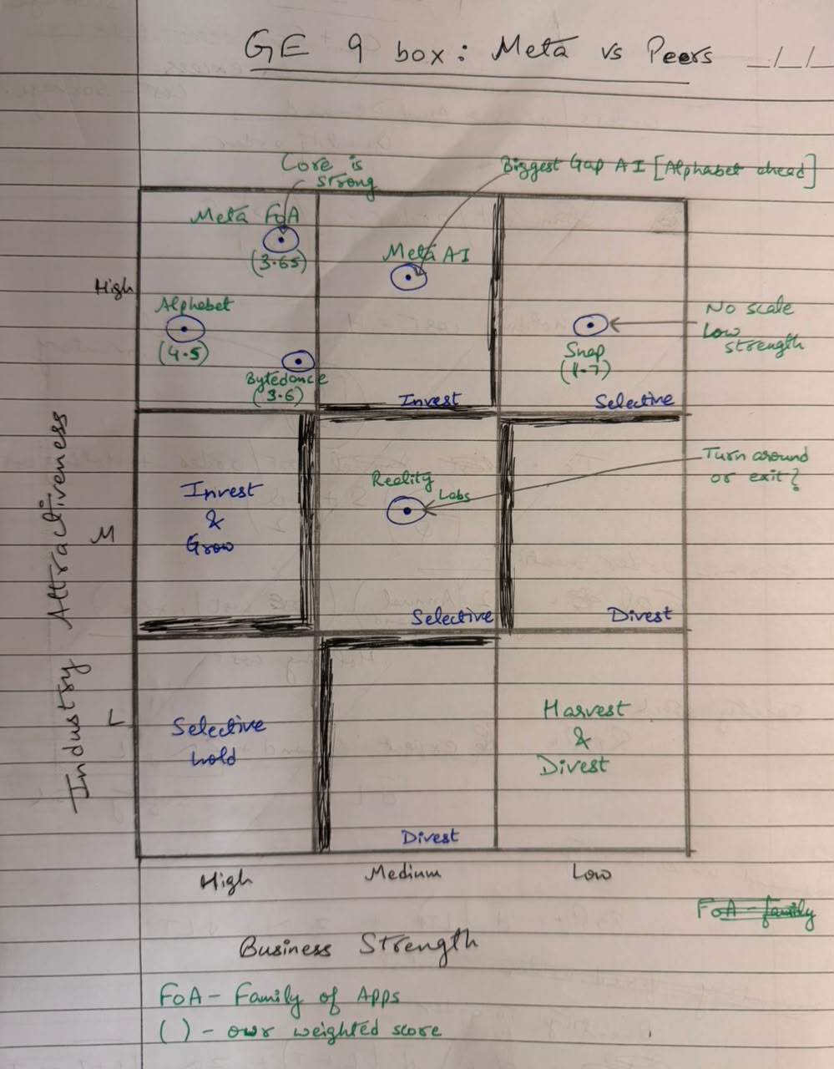
On the 9-box, Meta's Family of Apps sits in the invest-and-grow cell with Alphabet and ByteDance. Meta's AI effort is in a highly attractive segment with only medium strength, which calls for selective investment. Reality Labs sits in the middle cell, the same zone where turnaround plan was worth its cost compared with exiting. Overall, we rate Meta's business strength as high in its core and medium once the new businesses are included.
What are the gaps? What are our interpretations?
Capability gap | Weight | Meta | Best peer | Gap | Weighted gap
Frontier AI models and compute | 0.15 | 3 | 5 (Alphabet) | 2 | 0.30
Revenue diversification | 0.10 | 1 | 4 (Alphabet) | 3 | 0.30
Profitability and cash generation | 0.15 | 4 | 5 (Alphabet) | 1 | 0.15
New-business pipeline | 0.10 | 3 | 4 (Alphabet, ByteDance) | 1 | 0.10

The two largest gaps, AI and diversification, are linked. Llama 4 disappointed in 2025, which led to the $14.3 billion investment in Scale AI and the creation of Meta Superintelligence Labs, whose first model, Muse Spark, came out only in April 2026. Meanwhile capex is rising to $130-145 billion for 2026, and in Q2 2026 free cash flow fell to $0.8 billion. Meta is spending like a cloud company without a cloud business that sells compute to others, so the AI bet has to pay back through ads alone. In IBM's language, Meta has sensed the shift and is seizing it, and the 8,000 job cuts in May 2026 show it is reconfiguring. Whether that becomes a dynamic capability or just a bigger cost base is still open.
The Aghion-Howitt curve helps explain why Meta innovates in bursts. When a rival is neck and neck, i.e., Snapchat in 2016, TikTok in 2020, OpenAI and Google in 2025, Meta moves fast to escape the competition: Stories, Reels, the AI reorganisation. When it is comfortably ahead, the replacement effect sets in, because anything that pulls time away from the feed eats into its own ad inventory. A chatbot that answers a question instead of showing a feed is that kind of threat.
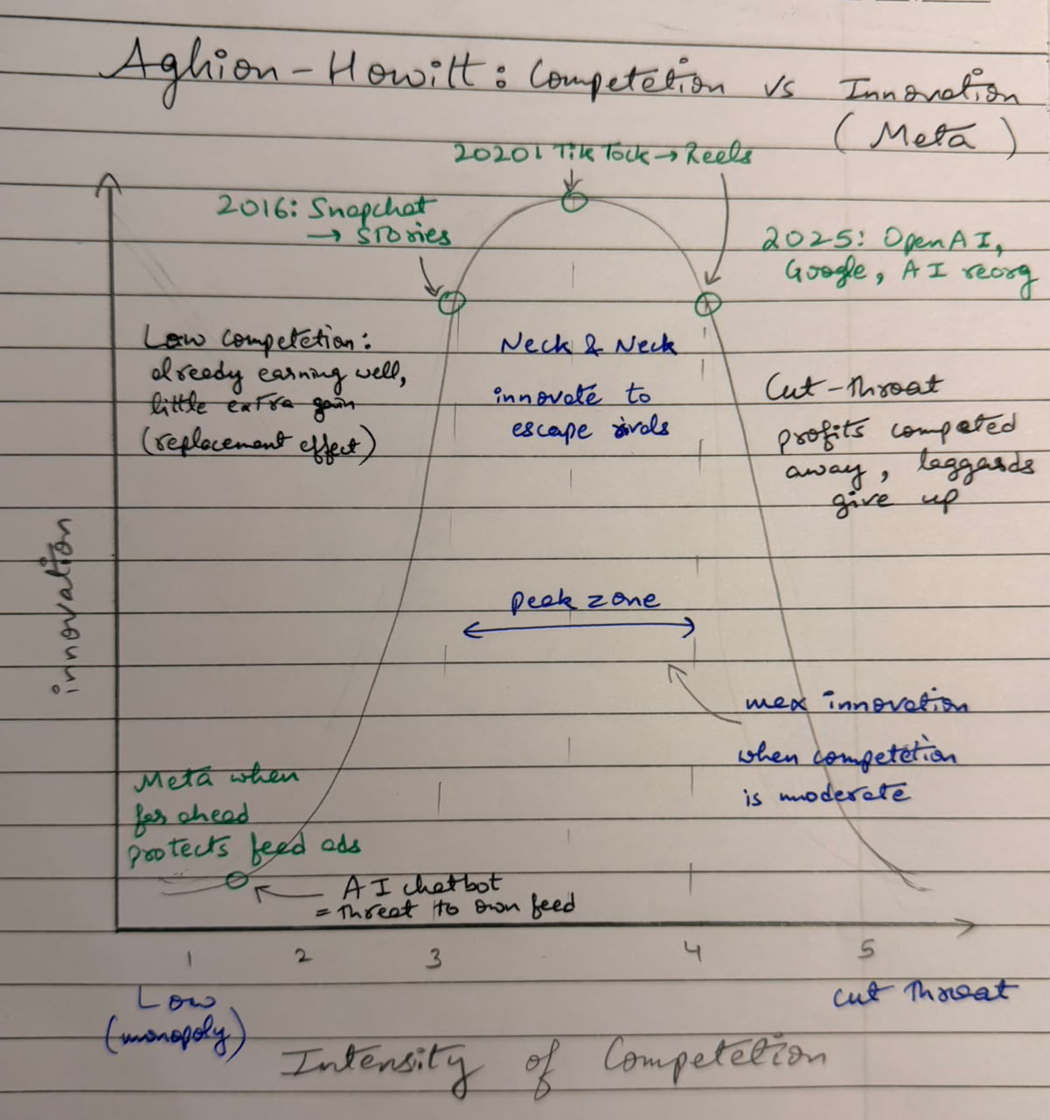
The governance gap is structural. Mark Zuckerberg holds about 61% of the votes with about 14% of the economic interest. In agency terms, this removes the usual conflict between owners and managers but weakens the board as a check. Class A shareholders have given majority support to proposals such as ending the dual-class structure, and none of them passed. Meta is nowhere near Satyam, but the Satyam case showed what happens when checks exist only on paper, and Meta's biggest bets, the metaverse, and now superintelligence rest on one person's judgement.
Our interpretation is that Meta's gap is not in running today's business but in building the next one. Using Prof. Srinivasan's execution model, it needs ambidextrous leadership: keep exploiting the ad engine while running AI and Reality Labs against their own KPIs and milestones instead of open-ended budgets. The first test is whether the 2026 capex shows up as higher ad prices and engagement before cash flow and investor patience run out.

