Read & Publish social media toolkit

Please also consult the [general Journals social media toolkit for librarians](http://fdslive.oup.com/www.oup.com/academic/content/librarian/Journals_socialmedia_tools.docx) for additional images and copy for promoting usage of Oxford University Press Journals.

Please insert the specific link to your institution’s agreement (which you can find via [this page](https://academic.oup.com/pages/open-research/read-and-publish-agreements/participating-journals-and-institutions)) where prompted in the sample copy below.

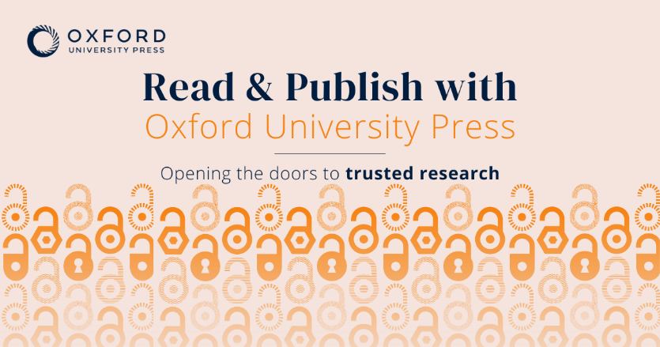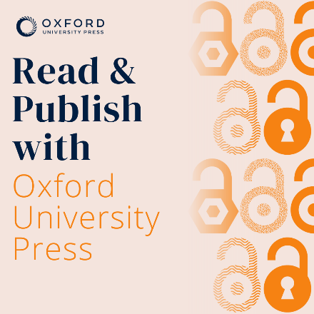

High quality versions of these images, suitable for use on each platform, can be downloaded [here](http://fdslive.oup.com/www.oup.com/academic/zip/online/R&P-Social-Media-Banners.zip).

Tweet templates

1. Publishing open access maximizes the visibility and impact of your research – and with your institution’s Read & Publish agreement with Oxford University Press, you can do it without paying a fee. Explore your funding options now: [link to your institution’s deal from [this link](https://academic.oup.com/journals/pages/authors/production_and_publication/publication-charges/read-and-publish-agreements/participating-journals-and-institutions)]
2. [Institution]’s Read & Publish agreement with Oxford University Press means unlimited access to world-class scholarship plus funding for open access publishing. Take advantage now: [link to your institution’s deal from [this link](https://academic.oup.com/journals/pages/authors/production_and_publication/publication-charges/read-and-publish-agreements/participating-journals-and-institutions)]

Facebook template

[Institution]’s Read & Publish agreement with Oxford University Press (OUP) means that you can:

* **Read** trusted, high-quality, peer-reviewed research from OUP’s prestigious journals collection
* **Publish** open access articles with no fee to pay

Explore your funding options now: [link to your institution’s deal from [this link](https://academic.oup.com/journals/pages/authors/production_and_publication/publication-charges/read-and-publish-agreements/participating-journals-and-institutions)]

Instagram template

Authors, with [Institution]’s Read & Publish agreement with Oxford University Press you can:

* **Read** trusted, high-quality, peer-reviewed research from the Press’s prestigious journals collection
* **Publish** open access articles with no fee to pay

By publishing open access, you maximize the discoverability, visibility, and impact of your work, allowing scholars from around the world to read, share, cite, reuse, and build on your findings.

Explore your funding options now: [link to your institution’s deal from [this link](https://academic.oup.com/journals/pages/authors/production_and_publication/publication-charges/read-and-publish-agreements/participating-journals-and-institutions)]