**NAME: ANESU JERRY RIMAU**

**STUDENT NUMBER: R187847R**

**Program and code: Animal Science (HAGAS)**

**LECTURER: PROFESSOR T HALIMANI**

**ASSIGNMENT: AS4O5 Assignment 2** Design a breeding programme for goats to improve smallholder farmer chevon production.

Community based breeding program (Flat Structure Breeding Program) for Matebele Goat to improve Smallholder farmer’s chevon production Matebeleland in Zimbabwe.

**1. Production System Description:**

Goat production in Zimbabwe forms an integral and important component of the smallholder farming system (Kusina, Chinuwo, Hamudikuwanda, Ndlovu and Muzanenhamo, 2001). Over 97 % of the 4.7 million goats in Zimbabwe are found in the smallholder farming sector (Chikura, 1999). Most of the smallholder farmers live in agro- ecological regions IV and V, which are characterised by poor rainfall, which only permits low cropping activities. Livestock rearing, especially goat production, predominate in such arid and semi- arid regions (Chikura, 1999; Masunda, 2001).

Most livestock is found in the drier regions, natural region IV (parts of Manicaland, Mashonaland Central and East, Masvingo and Matabeleland North and South) and V (parts of Manicaland, Masvingo and Matabeleland North and South). In these drought-prone areas, goats are considered to be highly valuable assets for income generation and source of investment. Almost all goats are found in communal areas, thus the goat sector has the potential to ensure food security (Ndlovu C *et al*, 2020).

The dominant goat breeds kept by smallholder farmers are the indigenous Mashona and Matebele goats. The Matebele goat is found predominantly on Matebeleland North and South Provinces of Zimbabwe and the breed is adapted to local conditions. It is a dual purpose (meat and milk production) large framed breed. According to Chikwanda A.T, (2004) the Matebele goat has a dressing percentage of 43.7 at live-weight of 30.9kg in castrated males at about 24 months and 43.5% at live weight of 31.4kg in castrated males at about 23 months. Female Matebele goat has a gestation period of 145 to 154 days, can be mated first time at 18months and has a weaning rate of 82%.

The herding and confinement management system will be used by smallholder farmers. The livestock production systems mentioned insures adequate feeding and monitoring of animals to meet the production goal meat (chevon). The choice of breed will be based on local genetics of the Matebele goat and adaptive fitness characterized by reproductive related traits; (kidding rate, body weight at slaughter, carcass quality and body condition score). Upgrading any breed must always be accompanied by three measures: improved feeding management, good disease and parasite control, and measures to prevent inbreeding. Otherwise, genetically upgraded animals will not be able to perform better than local animals they may even perform worse, as they may be less adapted to the local conditions.

**2. Breeding Goal:** improving goat fertility, feed intake capacity, growth rate, milk production and carcass (meat) quality.

**Breeding Objective:** Breeding program to improve chevon quality of Matebele goat.

**Smallholder farmers breeding criteria to select the best performing buck and does (Table 1)**

|  |  |  |
| --- | --- | --- |
| **Breed Type** | **Major Selection criteria/traits of interest** | **Production System** |
| Matebele Goat | Doe: litter size, growth rate, age at first kidding, appearance | Mixed farming |
| Matebele Goat | Buck: size, pedigree, growth rate, body conformation, testicular characteristics, prolificacy | Mixed farming |

Breeding program to improve local Matebele goat meat using linebreeding based on performance Table 2:

|  |  |  |
| --- | --- | --- |
| **Trait** | **Base** | **20th Generation** |
| Fertility | 62% | 70% |
| Post-weaning growth rate | 82% | 88% |
| Dressing percentage | 43.7 | 50.4 |

10years Breeding program. 365/150days = 2. 2nd Gen per year x 10yrs = 20th gen

**Breeding bucks ownership and mating system:**

Breeding program with flat structure involves intense selection in bucks – a limited number of males are needed to produce the next generation. Breeding does are owned by individuals- (smallholder farmers). Does can be issued stamps based on: their own qualities (growth rate and disease tolerance) or progeny performance (meat quality). Bucks are strictly evaluated to become studbook approved males. Health checks On-station performance testing for growth parameters to be conducted.

**Culling as flock Management Tool and Reasons of culling from the flock:**

Culling in goat flocks is an important tool for the development of a good flock. Culling should be stringent and used as a means of improving the genetic quality and productivity of a flock. Flock size can be maintained by replacing culled goats in the flock (ESGPIP, 2008). Reasons of culling could be based on reproductive problem, old age, sickness, unwanted physical characteristics and physical defect. Productivity problems, disease, persistent poor body condition and synergetic effects of all these factors.

**3. Performance recording:**

Performance recording should be based on a good animal identification system. Each animal should have a unique identification number. Record of parent-offspring relationships helps to trace the process of transmission of heritable traits. Phenotypic measurements are turned into *Estimated Breeding value’s (EBV’s)*

**Goats Performance records that should be kept by smallholder farmers:**

|  |  |
| --- | --- |
| Pedigree of the animal | Pre-weaning growth rate |
| Animal identity | Post-weaning growth rate |
| Sire identity | Dressing percentage |
| Doe identity | Carcass Quality |
| Farm number (herd) | Body weight at slaughter |
| Date of birth of each animal | Reason for death |
| Date of mating | Date of culling |
| Date of weaning | Reason for culling |
| Birth weight (kg) | Herd events (disease incidence, vaccinations) |
| Breeding soundness evaluation records (scrotal circumference and check libido) | |

**4. Determining Selection Criteria** Involves estimating breeding values of the animals through Statistical modelling including pedigree information. Use performance records from performance recording system. Genetic evaluation of goats using breeding values. The *estimated breeding value (EBV)* is the value of the animal with respect to the breeding goal.

Low *EBVs* have a negative effect on the breeding goal traits and high *EBVs* improve breeding goal traits

**5. Selection and mating**

The decision about which animals should be selected as parents for the next generation is mainly based on assessment of breeding value of individual animals. Genetic evaluation is central to animal improvement schemes. Selecting animals based on *estimated breeding value* maximizes the response to selection that can be achieved. However, there is one other criterion that is relevant when deciding which animals should have offspring. This criteria is common ancestry of all selected parents. The coancestry of selected parents should stay below certain limits, since it is directly related to the build-up of inbreeding. Coancestry among selected parents is determined by the average relationship among the selected parents as well as the number of parents selected.

Selection and mating involve predicting selection response and evaluation of mating. Line breeding is the mating of more distantly related animals but of less close relationship. Repeated backcrossing to one outstanding ancestor, so that its contribution to the progeny is more. The advantages of this process is a pure line of a particular breed is maintained. Does and bucks will be selected usingvisual selection, raw data and *estimated breeding values*.

**6. Dissemination of improved genotypes**

The dissemination aspect: how do we manage that those superior animals disseminate their genes quickly though the whole population of production animals. Depends of the structure of the breeding programs and can be done using artificial insemination or embryo transfer.

**7. Evaluation of genetic improvement; genetic diversity**

Breeding program should be evaluated regularly. Molecular genetics techniques preferably marker assisted selection can be used to evaluate genetic improvement. The idea behind marker assisted selection is that there may be genes with significant effects that may be targeted specifically in selection. Most traits of economic importance are quantitative traits that most likely are controlled by a fairly large number of genes. However, some of these genes might have a larger effect. Such genes can be called major genes located at QTL. After the review, the breeding circle starts.

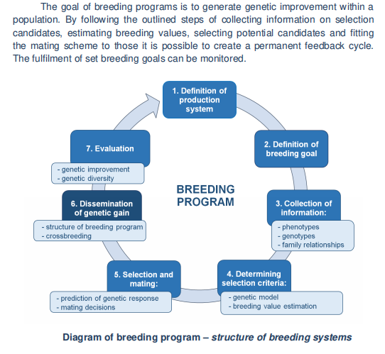

Source: ANIMAL BREEDING AND HUSBANDRY Text Book

**Policy issues and recommendations:**

Availability of reliable data on goat breeds population at different areas and trends over time is one of the chief criterion for formulating appropriate breeding policies and strategies. Hence there is need for availability of good quality authenticated data on indigenous goats of Zimbabwe.

Animal identification and field performance recording of indigenous goat breeds needs to be started. This will assist in identifying superior germplasms for further use in breeding programme.

Participation of livestock keepers (smallholder farmers) in the genetic improvement programme should be encouraged.

Genetic improvement is permanent and is inherited from parental generation to the progenies automatically so long the selected superior animals are used for breeding and their progenies are used for further breeding. But genetic and environmental improvement act synergistically. Hence making the genetic improvement programmes broader by addressing disease health, nutrition and management will bring more success.

The period of a genetic improvement programme should be minimum 10years and require strong institutional support.

Encouraging semen freezing and artificial insemination can effectively overcome the problem of good quality breeding bucks and the smallholder farmer’s difficulty and economic non-feasibility of maintaining a buck.

**References**

ANIMAL BREEDING AND HUSBANDRY Text Book AGROPRINT - TIMISOARA, 2020

Chikwanda A.T. CHARACTERISATION OF GOAT PRODUCTION SYSTEMS AND PRODUCTIVITY IN RUSHINGA COMMUNAL AREA, ZIMBABWE (2014)

Karnuah, A.B and Dunga G Community based breeding program for improve goat production in Liberia *MOJ Curr Res & Rev.* 2018;1 (5):216‒221.

ESGPIP Genetic improvement of sheep and goat. Ethiopia Sheep and Goat Productivity Improvement Program. *Sheep and goat production handbook for Ethiopia*. Addis Ababa, Ethiopia pp. 99-101. (2008)

Mhlanga F.N Khombe C.T Makuza SM *Indigenous Livestock Genotypes Of Zimbabwe* Department of Animal Science University of Zimbabwe (1999)

Mohammed A.S Breeding Practices and Strategies for Genetic Improvement of Indigenous Goats in Ethiopia (2017)

Ndlovu C. Wutete O. Mayimele R.R. and Ndudzo A. Breeding of goats: An indigenous approach to enhancing opportunities for smallholder farmers in Inyathi, Zimbabwe *International Journal of Livestock Production* DOI: 10.5897/IJLP2019.0586 (2020)

Werf J Chapter1 Overview of animal breeding programs

Zimbabwe Agricultural Growth Programme Breed Standards for the Mashona Goat Type

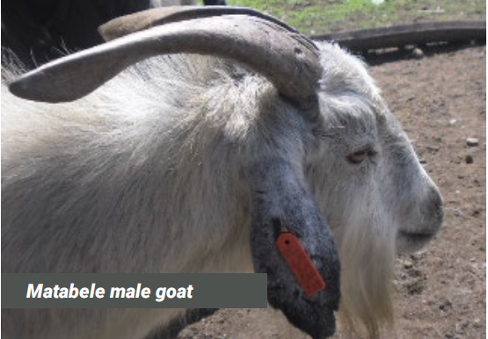 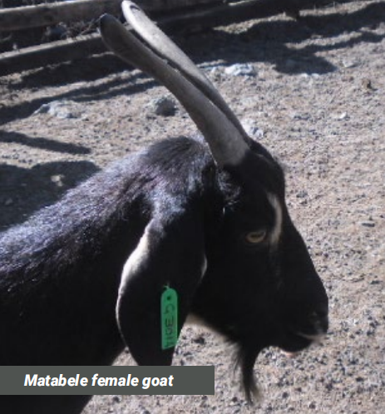

Picture Source: Zimbabwe Agricultural Growth Programme Breed Standards for indigenous goats.