**Credisafe Lease Management System Documentation**

1. **Introduction**
2. **Background**
3. **Aim**
4. **Motivation**
5. **Requirements**

* Functional Requirements
* Non-Functional Requirements

1. **System Overview**

* Key Features
* Technology Stack

1. **Architecture**

* High-Level Architecture
* Data Model
* Use Case Diagram
* Class Diagram

1. **Installation and Setup**

* Prerequisites
* Installation Steps
* Configuration

1. **Authentication and Authorization**

* User Roles
* Authentication Workflow
* Authorization Workflow

1. **Modules and Functionality**

* Lease Management

1. **User Documentation**

**1. Introduction**

The Credisafe Lease Management System is a web-based application designed to streamline the management of leases and tenants for real estate businesses, homes, and offices. This system provides a centralized platform for managing lease agreements, tenant information, and various reporting functionalities.

2. **Background**

The real estate industry has seen a growing need for efficient and centralized lease management solutions. Traditional methods of managing leases and tenant information often involve manual processes, scattered data, and limited reporting capabilities. The Credisafe Lease Management System aims to address these challenges by providing a comprehensive solution that streamlines the lease management process.

3. **Aim**

The primary aim of the Credisafe Lease Management System is to provide a robust and user-friendly platform for real estate businesses and landlords to manage their lease agreements, tenant information, and related operations. The system aims to improve efficiency, enhance data organization, and task automation, and enable informed decision-making through comprehensive reporting and analytics.

4. **Motivation**

The motivation behind the development of the Credisafe Lease Management System stems from the increasing complexity of managing leases and tenant information in the real estate industry. The system aims to address the pain points experienced by real estate professionals, such as:

* Inefficient manual processes for lease management
* Difficulty in tracking and monitoring lease details
* Manual tenant invoicing
* Scattered tenant information across multiple systems
* Limited reporting and data analysis capabilities
* Lack of a centralized platform for managing lease-related operations

By addressing these challenges, the Credisafe Lease Management System aims to empower real estate businesses to streamline their lease management processes, improve operational efficiency, and make more informed decisions.

5. **Requirements**

Functional Requirements

**Lease Management:**

* Create, update, and view lease agreements
* Associate tenants with leases
* Track key lease details (start/end dates, rent amount, payment history)
* Tenant Management:
* Create, update, and view tenant information
* Automatic invoice generation
* Generate tenant-specific reports

**Reporting:**

* Generate reports on lease status, rent collection, and other relevant metrics
* Export reports in various formats (e.g., PDF, CSV)
* Overal active credit accounts for tenants

**Authentication and Authorization:**

* Secure user access with roles-based permissions
* Manage user accounts and roles

**Integration and Extensibility:**

* Provide a RESTful API for integration with third-party systems
* Allow for future expansion and integration of new features

Non-Functional Requirements

**Usability:**

* Intuitive and user-friendly interface
* Responsive design for optimal experience on various devices
* Performance:
* Efficient data processing and retrieval
* Scalable to handle increasing number of users and data

**Security:**

* Secure storage and handling of sensitive data (e.g., tenant information, financial data)
* Adherence to industry-standard security practices

**Reliability:**

* Robust error handling and logging mechanisms
* Reliable backup and disaster recovery strategy

**Maintainability:**

* Easy to upgrade and update the system
* Clear documentation for future development and support

**Deployment:**

* Cloud-based deployment for scalability and accessibility
* Automated deployment and configuration processes

6. **System Overview**

* *Key Features:*

**Lease management:** Create, update, and track lease agreements.

Tenant management: Manage tenant information, including contact details and lease details.

**Reporting:** Generate reports on lease status, tenant information, and other relevant metrics.

**Authentication and authorization:** Secure user access with roles-based permissions.

**Technology Stack**

* Backend: Django (Python)
* Frontend: React, Inertia.js
* Version control: Github
* Continuos integration & Deployment: Github Actions
* Database: PostgreSQL
* Cloud Platform: AWS EC2

**7. Architecture**

* High-Level Architecture

The Credisafe Lease Management System follows a client-server architecture, where the frontend (React) communicates with the backend (Django) using Inertia.js, a library that enables server-driven single-page applications.

The backend Django application handles the business logic, API endpoints, and database interactions. The frontend React application provides the user interface and interacts with the backend through the API.

**Data Model**

* The system's data model consists of the following main entities:

**Company**: Represents the company associated with the system.

**Individuals**: Represents the individuals, such as tenants, users, etc. associated with the system.

**Lease**: Represents the lease agreements, including details like start/end date, rent amount, and associated tenant.

**LeasePayments**: Tracks the payments made for each lease.

**Invoicing**: Handles the invoicing related to the leases.

**OpeningBalance**: Tracks the opening balances on lease creation.

**Subscription**: Manages any subscription-based services or features.

**OTP**: Handles one-time passwords for authentication or verification.

**Inquiries**: Records any inquiries made through the system.

**Users**: Represents the different user roles (e.g., admin, agent, tenant) with access to the system.

**Use Case Diagrams**

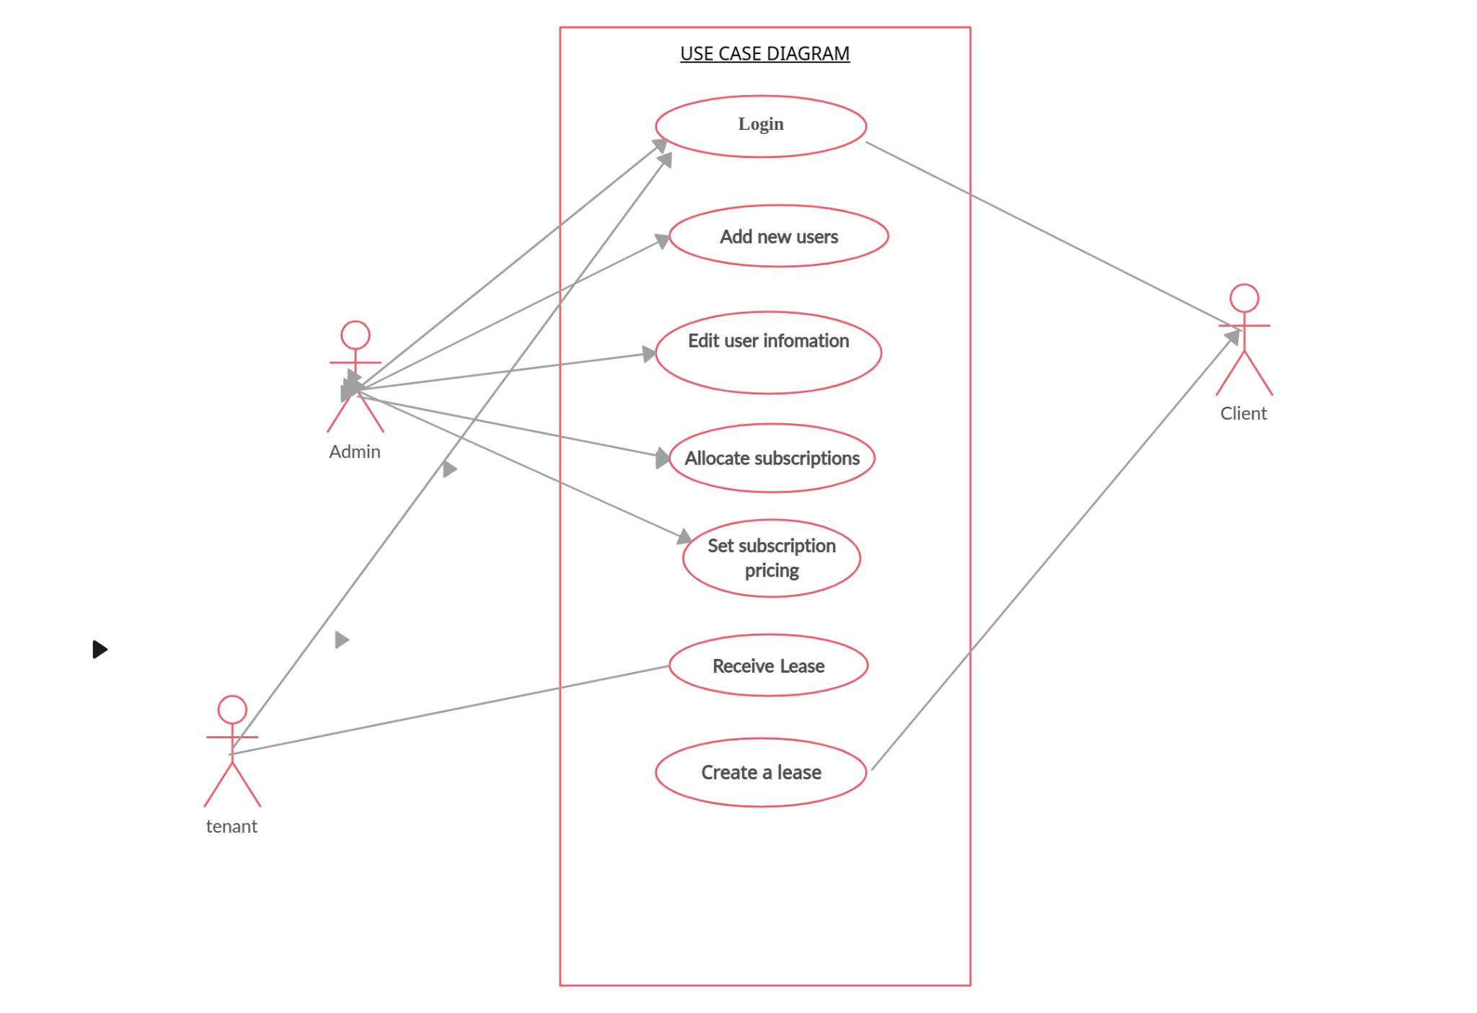

**8. Installation and Setup**

**Prerequisites**

* Python 3.x
* Node.js v19 +
* PostgreSQL
* AWS account (for deployment)

**Installation Steps**

* Clone the repository:
* git clone https://github.com/godfrey-tankan/credisafe-lease-management.git
* Create a virtual environment: python -m venv env
* Activate the virtual environment: - Windows: env\Scripts\activate - macOS/Linux: source env/bin/activate
* Install the Python dependencies: pip install -r requirements.txt
* Install the frontend dependencies: cd frontend && npm install

**Configuration:**

* Create a PostgreSQL database and update the database connection details in the Django project settings.
* Generate a secret key for the Django project and update the SECRET_KEY setting.
* Configure any other necessary settings, such as email settings, AWS credentials, etc.
* Run the Django database migrations: python manage.py migrate
* Start the Django development server: python manage.py runserver
* Start the React development server: cd frontend && npm run vite-dev

**9. Authentication and Authorization**

* User Roles

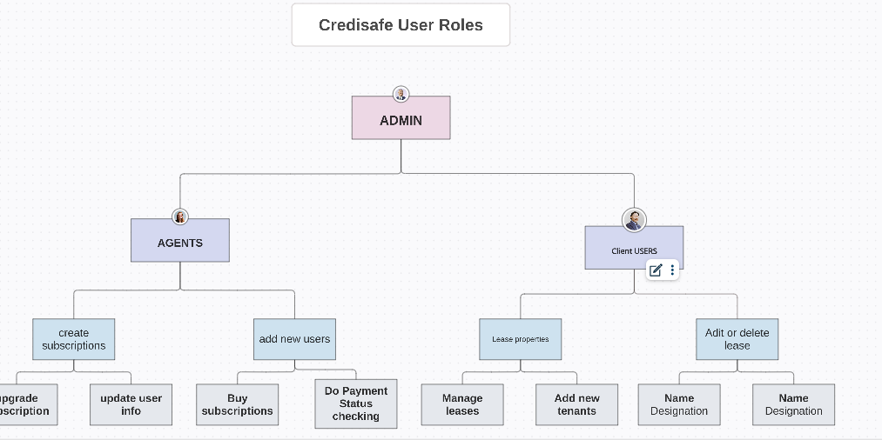

The Credisafe Lease Management System supports the following user roles:

Admin: Responsible for system administration, user management, and overall system configuration.

Client: Can create leases, manage leases, delete,edit, and create their own users.

agent: Manages leases, users,creates subscriptions, add new companies/individuals..

tenant: Can view and manage their own lease information.

**10. Authentication Workflow**

* Admin or Client Creates a new user and their login details are sent through email or sms.
* Users can log in using their email and password.
* The system generates and manages session tokens for authenticated users.
* Authorization Workflow
* The system checks the user's role when they attempt to access a specific resource or functionality.
* Permissions are granted or denied based on the user's role and the defined access rules.
* Users can only perform actions and access data that are allowed for their respective roles

**11. User Documentation.**

Login to Credisafe:

Fig 1.1

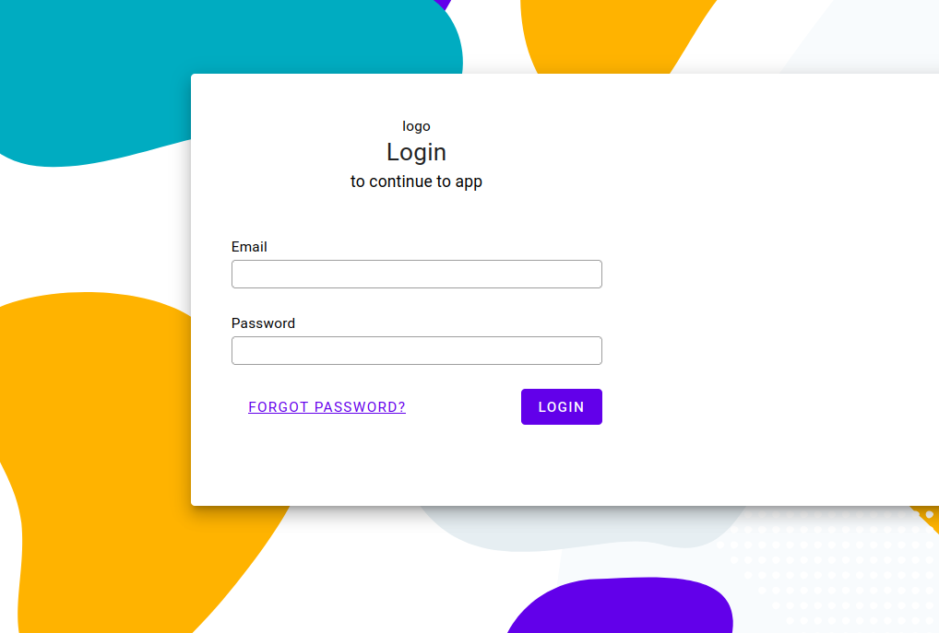

* *Use the email used when the account was created and your password in case of a forgotten password, Just put in your email and click forgot password, and new login credentials will be sent to your email.*

**Once logged in, this is the client dashboard you must see**

Fig 1.2

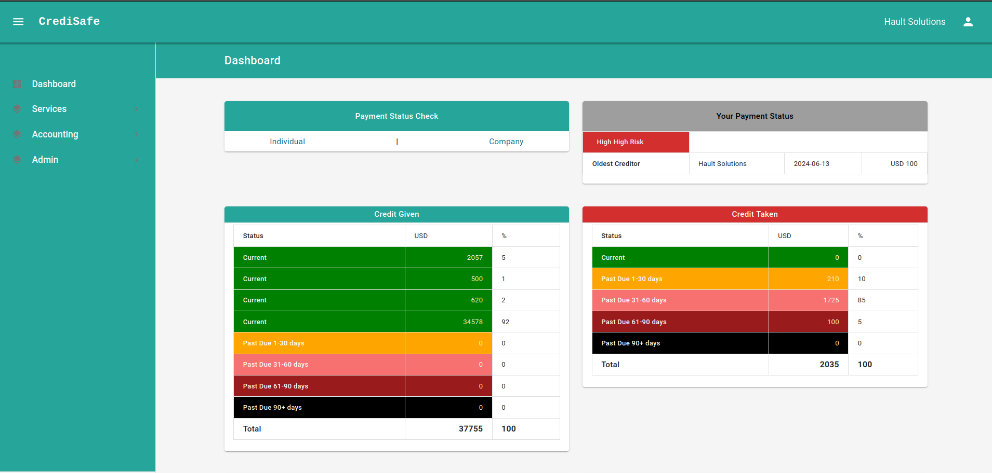

*-This is the dashboard that shows a summary of all the leases you gave to tenants or you took and your payment status.*

Tenant Credit Check: Before creating a lease, the landlord must perform a credit check on the prospective tenant (company or individual) to assess their payment history and creditworthiness.

Fig 1.3

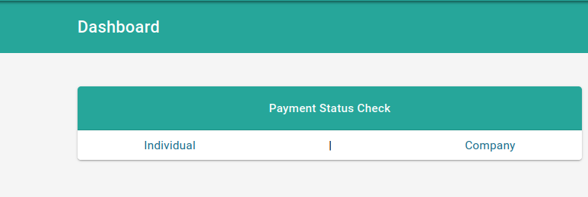

If the tenant is found in the system, the following records show up:

Fig 1.4

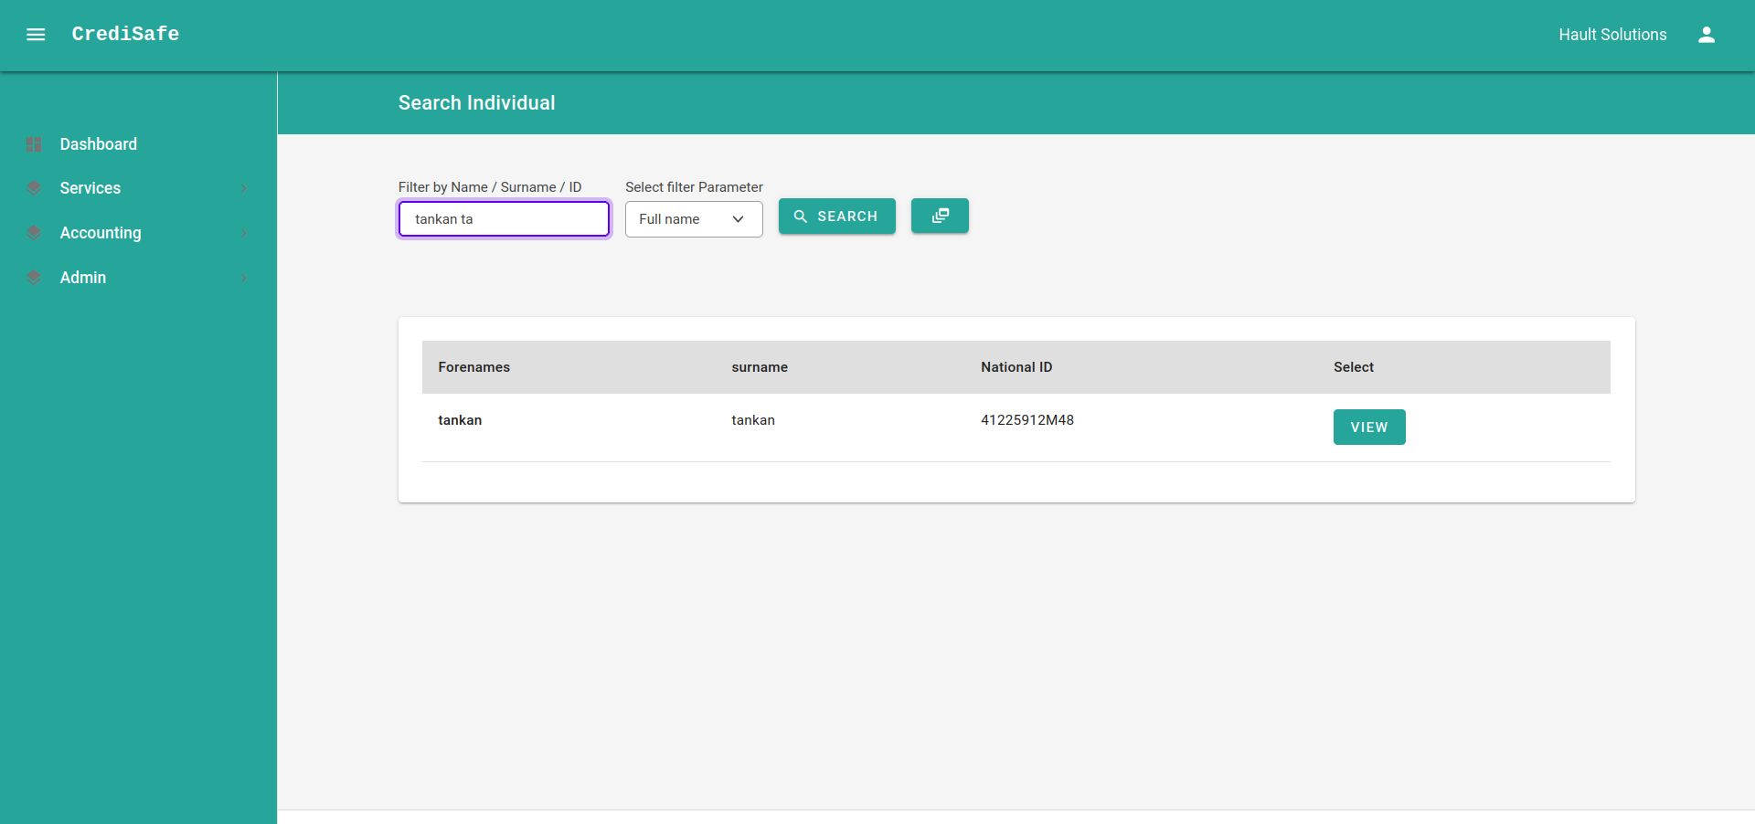

To generate a credit report, clicking ‘view’ will generate a report like this :

Fig 1.5 (t**enant report**)

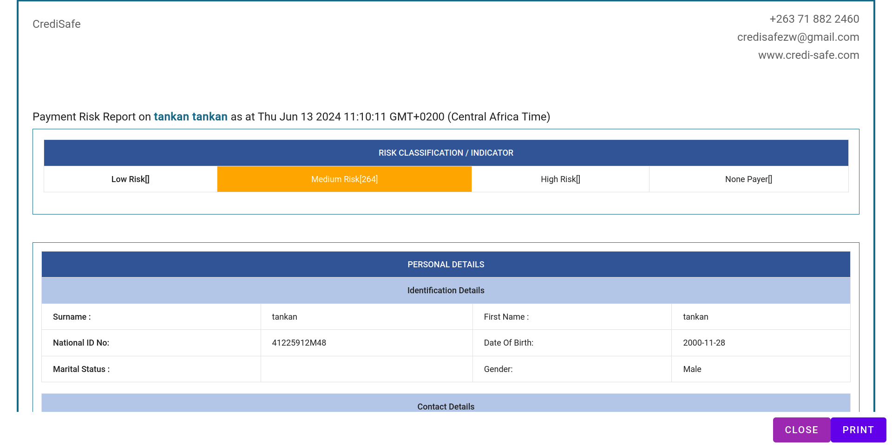

* All the tenant's records will be in that report, if they have previous credit accounts, adverse records, or court claims, they’ll all be shown in this report.

In the case that you are satisfied with the tenant's payment status and you choose to go ahead and give a lease to them, the side navigation has options for rent safe under services, which is a section of lease management.

Fig 1.6

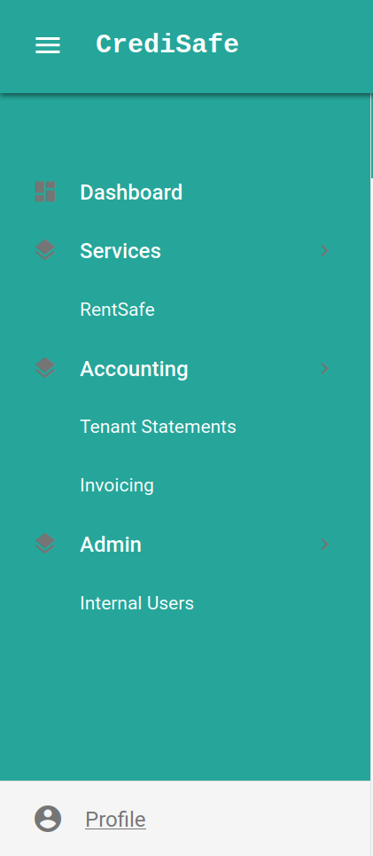

Clicking rentsafe will navigate to this section:

Fig 1.7

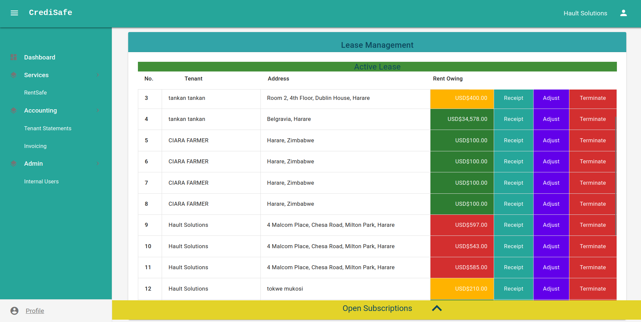

* If you don’t have any lease with any tenant, this will be blank and they will show after creation.before creating a lease, you need to buy a subscription, the following shows subscription plans that one can choose from:

Fig 1.8

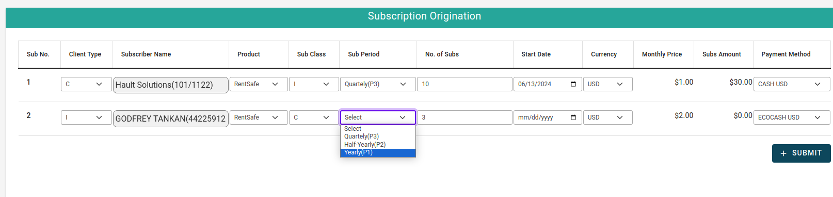

Once you got a subscription, you’ll see it under ‘open subscription and you can start activating new leases.

Fig 1.9

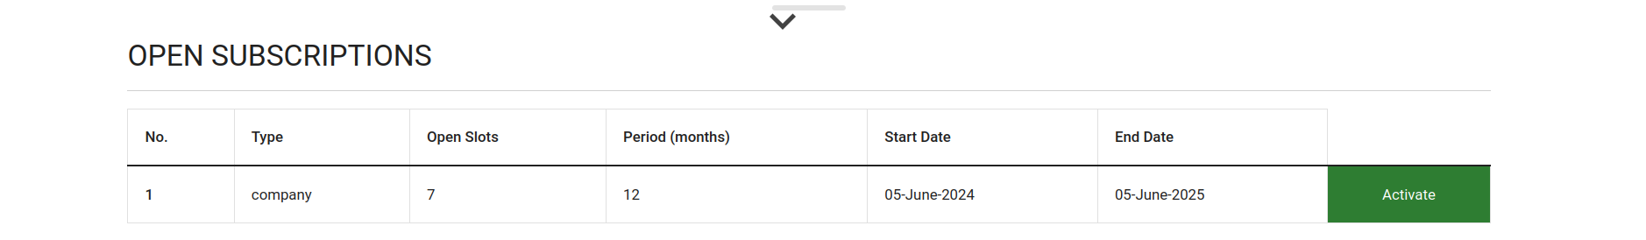

You need to have the right subscription for the right lease type, for example you’ll need a subscription of type company to create company leases and a subscription of type individual to create individual leases.Once the subscription shows,go ahead click ‘activate’ to start the leasing process.

Fig 2.0 shows the lease creation panel, in this form, you can choose to upload bulk company leases or continue with one company, to give a certai company a lease, you just seach that company by it’s registration name or registration number in the ‘company name’ text field.

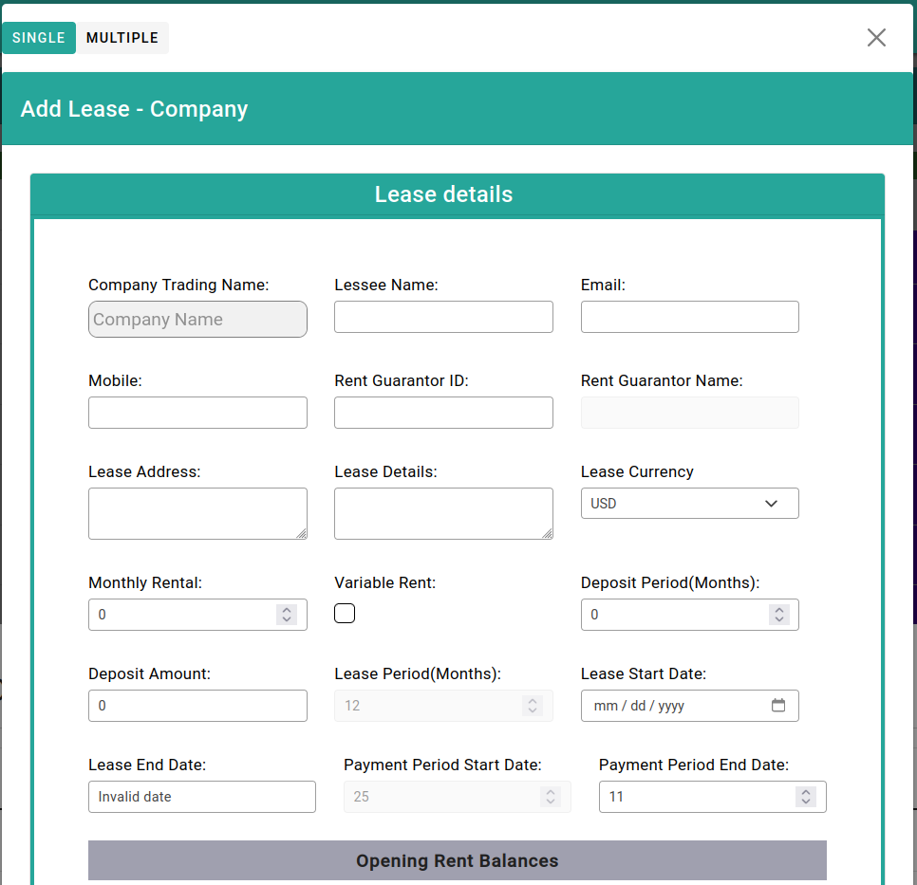

**Tenant Information:**

The landlord will input the tenant's details, such as company registration number or individual's national ID/passport number, to populate the lease receiver information.

**Lease Creation:**

1. **Tenant Details:**

Company Registration Number/Name or Individual National ID/Passport Number: Identifies the tenant and populates their contact information.

Leasee Name, Mobile Number, Email Address: Contact information for the tenant.

1. **Rent Guarantor:**

Rent Guarantor ID, Rent Guarantor Name: Identifies the individual who will be responsible for the rent payments if the company tenant fails to pay.

1. **Lease Address:** The physical address of the leased property.
2. **Lease Details:**
3. **Currency:** The currency in which the rent and deposit are paid.
4. **Deposit Amount**: The amount of the security deposit required from the tenant.
5. **Monthly Rental**: The monthly rent amount.
6. **Rent Variables:** Indicates whether the lease has variable rent components (e.g., utilities, maintenance, etc.).
7. **Deposit Period (in months):** The duration of the security deposit.
8. **Lease Start Date and End Date:** The start and end dates of the lease, based on the landlord's subscription plan.
9. **Payment Period Start and End**: The period during which the tenant must make rent payments.
10. **Opening Balances**: Any outstanding balances from previous months that the tenant owes.

**Lease Management**

Once a lease has been created, the Credisafe system provides various tools and functionalities for managing the lease effectively.

**Lease Dashboard (fig 1.7):**

The lease dashboard gives the landlord an overview of all the active leases, including key details such as the tenant, lease address, monthly rental, and the lease owing amount.

The dashboard also displays any outstanding balances.

**Rent Collection and Invoicing:**

The system automatically generates monthly rent invoices for non variable leases.

Landlords can easily track and manage rent payments.

Fig 2.1

For non variable rent leases, the invoice will automatically kick in on the day of payment period start, highlighting which month was invoiced.

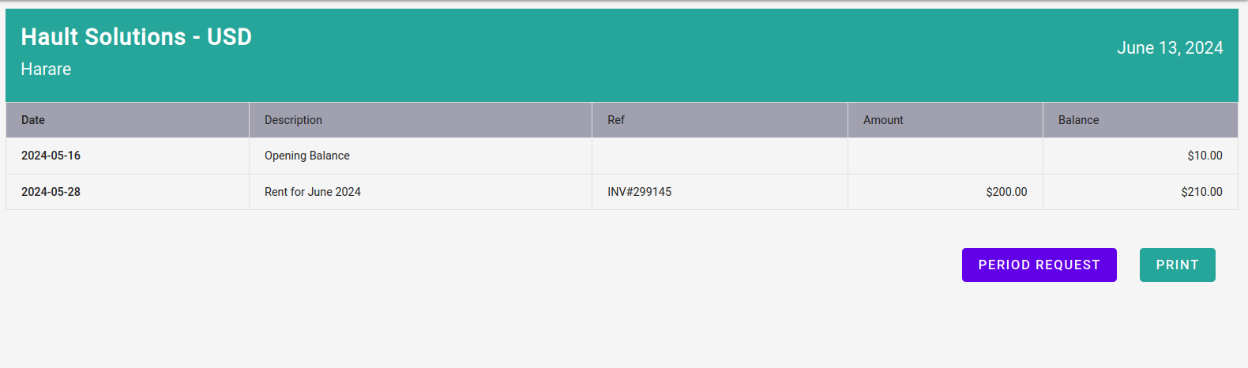

For rent variable leases, the landlord must select ‘invoicing’ and set up invoices including operational costs to be charged for tenants.

-The system provides detailed reports on rent collection, outstanding balances, and payment history.

Lease Payment end date:

As the lease end date approaches, the system will notify the tenants about the new payment status change if they did not pay rent within the payment period.

Lease Termination:

When a lease is terminated, the landlord can close the lease and it will nolonger be managed by the system.

**Automated Notifications and Reminders:**

The Credisafe system sends automatic notifications and reminders to tenant regarding important lease events, such as upcoming due dates, late payments.

This helps ensure timely communication and effective lease management.

Fig 2.3 (email sent to tenant-company)

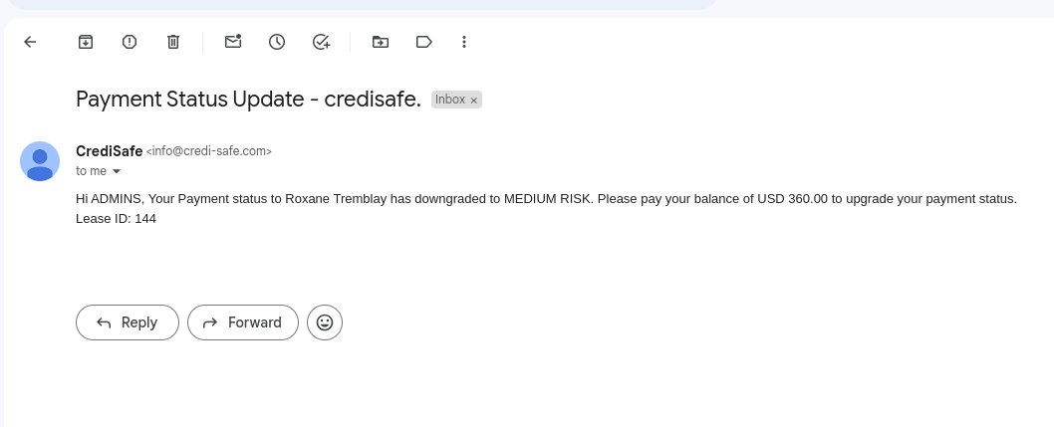

**Summary and Analytics:**

The system provides comprehensive summary and analytics on the landlord's entire lease portfolio, including financial performance, tenant behavior, and overall lease management efficiency.

These summary helps the landlord make informed decisions and optimize their property management strategies.

Fig 2.4

