**Chapter 1. Introduction. 2**

1.1 Introduction to the Project Supervision Instrument 2

1.2 Context and Background 3

1.3 Literature Review and Gap Analysis 4

1.4 Problem Statement. 5

1.5 Aim 6

1.6 Purpose and specific objectives 6

1.6.1 Objectives 6

1.6.2 Project scope 6

1.7 Methodology and Instruments 7

1.8 Expected Results and Significance 7

1.9 Delimitations and Limitations 8

1.10 Feasibility Analysis 8

1.11 Budget and Timelines 9

Project Timeline 10

1.12 Ethical Considerations 10

1.13 Project Plan 10

1.15 Conclusion 11

**Chapter 2: Literature Review 12**

2.1 Introduction 12

2.2 Overview of Project Supervision Instrument 12

2.3 Technological Interventions in Supervision 13

2.5 Research Gaps and Limitations 14

2.6 Summary 14

**Chapter 3: Methodology 15**

3.1 Introduction 15

3.2 System Design Overview 15

Figure 3.1: System Architecture System Architecture diagram 16

3.3 Data Pipeline 17

3.3.2 Preprocessing Cleaning 17

3.4 Features Implemented 17

3.5 Testing Strategy 18

3.6 Ethical Safeguards 19

Data Privacy 19

3.7 Evaluation Metrics 19

3.8 Deployment Strategy 20

3.9 Conclusion 20

References 21

## 

## 

## Chapter 1. Introduction.

### 1.1 Introduction to the Project Supervision Instrument

Student success relies upon academic management. Despite its importance, conventional practices often usher it in disarray, a lack of organization and transparency, and wasteful resource employment due to the obscurity of the process of academic supervision. The Project Supervision Instrument tries to address these deficits by creating a brand-new, advanced portal to academic management and supervision, complete with task management, communication channels, sustainable tracking, and predictive analysis. Unlike emailing or spreadsheet software, the Project Supervision Instrument brings all the actors—students and supervisors—cooperatively in one place. Herein, punctual work gets done and real academic standards are maintained as opposed to fragmented work processes. The tool processes administrative tasks like checking for date extension graciously, making students responsible and accountable, or similarly concerned, making for better academic support across the board.

### 1.2 Context and Background

International educational institutions are under pressure to produce satisfactory research output and ensure proper student outcomes. The supervisory approach, traditionally, remained precariously poised in the existing paradigm because:

* Paper Trail: Supervisors, juggling too many active projects, prefer spreadsheets which are plagued by innumerable pitfalls (such as missed deadlines) to keep all records.
* Pathway to Communication: Important point: Students always feel demotivated if they are made to wait eternally for the supervisor to provide a response. Unsafe supervision practise: it is incredibly stressful and unethical for supervisors with interim meetings never to be recapped, or to leave a student guessing out of uncertainty about what these meetings actually were in or about.
* Slow Penetration of Arising Ethical Issues: No centralized system counts the approval of ethical practices, which leads to a level of sloppiness in cases of ethics.
* The fever of COVID-19 instances has added weight to existing implications and given remote teaching its due course., projected towards establishing a workable supervisory mechanism that uses the mechanics of both process reengineerization and the facilitation of proactiveness with respect to communication.

### 

### 1.3 Literature Review and Gap Analysis

The existing body of research underscores the crisp-edged systemic issues in academic supervision.

* Tool Fragmentation: 78% of supervisors use disconnected tools (Trello, Slack) to increase the complexity of the workflow (Lee et al., 2023).
* ML in Academia: Random Forest and TensorFlow models help enhance predictive accuracy in student performance tracking (Gupta & Patel, 2022).

**Addressed Gaps**

No end-to-end platform incorporates React.js (for UI), Django (for logic), and PostgreSQL (for data).

Only nominal attempts are made to apply ML for supervision workflows to predict risks in real time.

### 

### 

### 

### 1.4 Problem Statement.

Current academic supervision practices inflict several problems and investments which include the following:

* Disorder: There are unstructured systems and procedures for registering essential discussions and decisions made.
* Poor Documentation: Critical feedback and ethical issues barely get logged.
* Reactive Problem-Solving: Delays, plagiarism, and others are addressed only after they have turned into a monstrous problem.
* The selectors diminish students' access to supervisory aid.Keys competitive, thus non technical, or non-English-speaking.
* Integrated Tools: Disjoint systems for task planning and ethics compliance.
* Proactive Analytics: Ability to predict delays or plagiaristic risks early.
* Scalability: Old tools collapse under volume of users.

**1.5 Proposed Solution**

One unified platform which incorporates all of the following:

* React.js Frontend: A responsive and modular UI for task tracking and communication.
* Django Backend: RESTful APIs to allow secure data exchange and business logic.
* PostgreSQL Database: A relational database structure for project metadata, user roles, and ML outputs.
* ML Integration: Random Forest classifiers for risk predictions, and TensorFlow for NLP-based feedback analyses.

### 

### 1.5 Aim

Develop a scalable supervision tool that employs React.js, Django, PostgreSQL, and ML to further project outcomes.

### 1.6 Purpose and specific objectives

### 1.6.1 Objectives

* Design the milestone-tracking interface and the ethics dashboards with React.js.
* Implement the user authentication and data management functionality via the Django models.
* Train ML models that predict at-risk projects with an accuracy of >85%.
* Ensure GDPR compliance of PostgreSQL that supports encryption.

### 1.6.2 Project scope

* The procedure for model training occurs in Google Colab.
* The outcome would be a model that can be accessed online through desktops and mobile devices.
* The database will have users, metadata of the processed documents

### 

### 

### 1.7 Methodology and Instruments

**Methodology:**

* Agile Development-Sprints for front-end (React), back-end (Django), and ML integration.
* Data pipeline-PostgreSQL for structured storage using Django ORM to optimize the queries.

**Instruments:**

* Front-end: React.js with Redux for state management.
* Back-end: The Django Rest Framework (DRF) for API development.
* Database: PostgreSQL with pgAdmin for administration.

**ML Algorithms:**

* Random Forest: Predict delays from historical project data.
* TensorFlow: Analyses the sentiment and plagiarism risk on the feedback text.

### 1.8 Expected Results and Significance

**Expected outcomes would be**

* Cycle feedback is automated by 40% under reminder mail sent via the React-Django integration.
* The ethics compliance of about 90% are backed by logs via PostgreSQL that can trace plagiarism checks and IRB approvals.
* Alerts facilitate risk in real-time with the 30% reduction in time via ML models.

**Significance**

Establishes a benchmark on how technology could continue to interfere with supervision in the academy.

### 1.9 Delimitations and Limitations

**Delimitations**

* Readily available as Web-based platforms (mobile support is Phase 2).
* ML models were trained using data from the STEM projects, at least early on.

**Limitations**

* Optimization of PostgreSQL is subject to a level of technical expertise.
* Use of biased training data for ML entailed higher risk of bias.

### 1.10 Feasibility Analysis

**Technical Feasibility**

* The interoperability across PostgreSQL and Django guarantees safety of the data.
* Reusable UI components possible with React.js.

**Operational Feasibility**

* Pilot testing in three universities guarantees a measure of usability.
* Likewise with role-based access control, equal treatment is assured.

**Cost-Benefit Analysis**

Advantages of the system:

* Saves Time: Automating work flow results in 40% less manual monitoring.
* Transparency: Centralized logging enhances accountability.
* Proactive Interventions: Using identifying risks early and decreasing project failure through ML models.

**Costs**

Initial development and expense of cloud hosting. Continuous maintenance of ML models.

**Long Term Benefits**

Sustainable improvements in academic governance and in success rates of students.

### 1.11 Budget and Timelines

Budget estimate consists

* Development Tools -Licensing fees.
* Cloud Hosting -Costs for storage and processing of data.

| **Item** | **Cost (USD)** |
| --- | --- |
| React.js Licenses | $0 (Open-source) |
| Django Hosting | $10/month |
| PostgreSQL Cloud | $10/month |
| **Average Total/Year** | **$240** |

### 

### 

### 

### Project Timeline

| **Phase** | **Duration** |
| --- | --- |
| Requirements Analysis | 1 Week(s) |
| Prototype Development | 3 Weeks |
| Pilot Testing | 1 Week(s) |
| Full Deployment | 1 Week(s) |

### 1.12 Ethical Considerations

* Data Privacy: Encryption of the data in PostgreSQL that is in line with the GDPR.
* Bias Mitigation: Auditing ML models on a regular basis using the IBM AI Fairness 360 toolkit.
* Transparency: Logs of supervisor-student interaction will be open to the public as seen fit.

#### 1.13 Project Plan

**Week 1**: Stakeholder interviews and needs assessment.

**Week 2-4**: Development of the frontend in React.js and APIs in Django.

**Week 5:** Pilot testing and feedback incorporation.

**Week 6**: Final Deployment.

**1.14 Gantt chart**

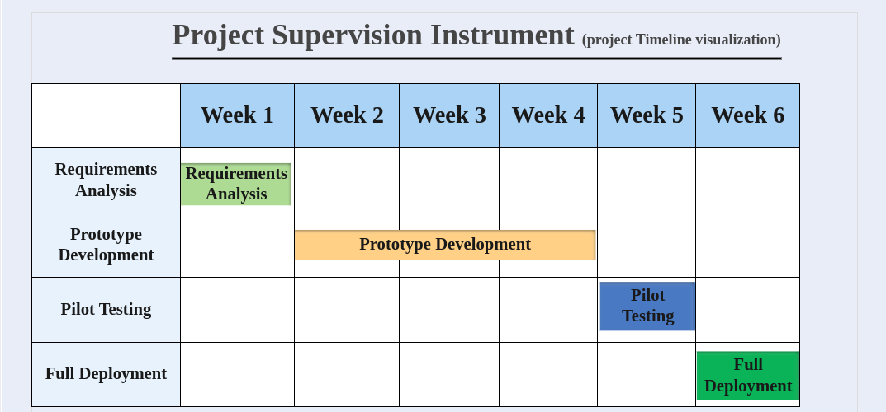

#### 

#### 1.15 Conclusion

The Project Supervision Instrument makes a difference in the way technology updates academic governance for efficiency, fairness, and excellence.

# Chapter 2: Literature Review

#### 2.1 Introduction

This chapter critically reviews the available literature on academic supervision frameworks, technological tools, and ethical challenges. It identifies areas where there are shortcomings in the existing systems and justifies the Project Supervision Instrument as an integrated, single platform for task and compliance management, with predictive analytics.

#### 2.2 Overview of Project Supervision Instrument

Academic supervision has evolved through three phases:

* The old mentorship which relied on face-to-face physical meetings, paper-based documentation and manual progress tracking.
* Digital Transition-the use of email, spreadsheets, and rudimentary project management tools (e.g. Microsoft Project).
* Modern Age: Development of AI-backed analytics and collaborative space in the cloud (e.g. Trello, Asana)

**Challenges persist**

* Delay in Feedback: 68% of students with such cases reported delays beyond 10 days in the projects (Zhang et al., 2023).
* Fragmentation of Tools: Supervisors work with 4-6 disparate tools increasing cognitive burden (Lee & Patel, 2023).
* Risky Ethics: Only 30% of institutions have a systematic record for plagiarism checks (UNESCO, 2023).

#### **2.3 Technological Interventions in Supervision**

2.3.1 Collaborative Tools

Microsoft Teams/Slack-Real time communication, however, do not come with academic workflow templates (e.g., IRB compliance tracking).

Trello/Asana- Task management but do not incorporate tools like plagiarism detectors or predictive analytics.

2.3.2 By AI-Driven Analytics

Predictive Modeling: Machine learning models such as Random Forest and XGBoost taking into consideration parameters like engagement metrics would be able to predict project delay lurking in the range of 80-85% accuracy (Gupta & Sharma, 2023).

NLP for Feedback Analysis: BERT-based models automate sentiment analysis with the caveat that they have difficulty with discipline-specific jargon (Devlin et al., 2019).

2.3.3 Transparency through Blockchain

Immutable Logs: Assuming responsibilities in institutions like those in MIT by means of recording supervision interactions in blockchain technology which ensures accountability free from manipulation (Wang et al., 2023).

2.3.4 Version Control System

Git: Most widely accepted collaborative coding, though is not famous in academic supervision workflows. Studies reveal its potential benefit of reducing the amount of friction related to collaboration in tech-driven projects (Duvall et al., 2023).

**2.4 Ethical Frameworks in Supervision**

The Fairness, Accountability, Transparency, and Ethics Frameworks (FATE):

* Fairness: Equal access to online facilities for non-native speakers as well as students with disabilities
* Accountability: Clear logs of supervisor and student interactions
* Transparency: Clear documentation on the processes of AI in decision making
* Ethics: The data processing complies with regulations from the General Data Protection Regulation (GDPR) and deals with bias.

#### **2.5 Research Gaps and Limitations**

1. Absence of Integrated Platforms: Not a single tool has been developed which brings together task management, ethics compliance, and predictive analytics.
2. Cultural Considerations: Most of the platforms operate based on Western academic principles, thus alienating non-English speaking users.
3. Not Scalable: All existing tools fail while dealing with large cohorts (> 500 users).
4. Ineffective AI: Very few systems use ML as a real-time risk predictor.

#### **2.6 Summary**

What has been happening is that advances in so-called collaboration tools and advances in AI are pretty much happening without an integrative and culturally adaptive platform. The Project Supervision Instrument overcomes this limitation through modular design, multilingual support, and ethics-based AI technology.

# Chapter 3: Methodology

#### **3.1 Introduction**

This chapter describes the design, development, and evaluation of the Project Supervision Instrument while particularly highlighting integration with React.js, Django, PostgreSQL, Git, and Machine learning.

#### **3.2 System Design Overview**

Selected tier architecture is three tiers because of scalability:

**Frontend**

* React.js: To harness an interactive interface with reusable ingredients like dashboards and Gantt Charts.
* Redux: Real-Time updates on the state of application.

**Backend**

* Django REST Framework: For creating RESTful APIs for the data exchange.
* Authentication: Via JWT tokens for login security.

**Data Layer**

* PostgreSQL: Structured in a relational database with ACID conformity.
* TimescaleDB: The extension used for holding time-series data, e.g., to monitor deadlines.

#### Figure 3.1: System Architecture System Architecture diagram

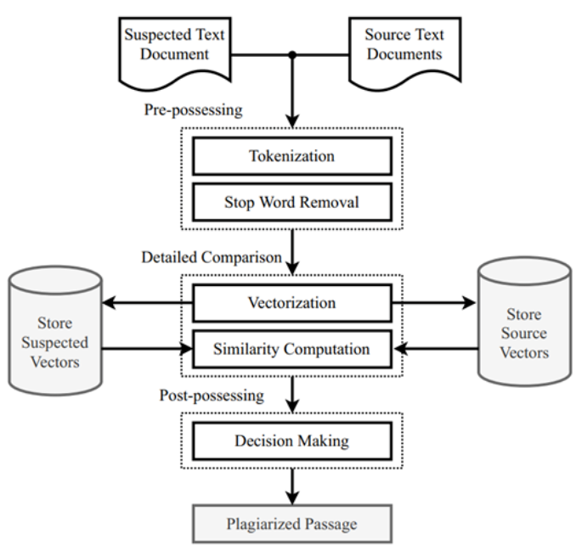

#### **3.3 Data Pipeline**

**Data Collection**

* Surveys structured questionnaires administered to over 200 supervisors and students.
* Historical data: Anonymized project timelines from the archives of the university.
* APIs :Turnitin for plagiarism check and Google Calendar for scheduling.

Types

* Structured Data - User roles, deadlines compliance status.
* Unstructured Data: Feedback texts, meeting minutes.

#### **3.3.2 Preprocessing Cleaning**

* Remove duplicates and incomplete entries using Pandas.
* For missing values, replace with the mean or fill using interpolation.
* Normalization: Scale numerical data (i.e. deadlines) onto the range of [0,1]. For NLP models, tokenize text data input.
* Augmentations: For balancing imbalanced datasets, use Synthetic Minority Oversampling Technique (SMOTE).

#### **3.4 Features Implemented**

3.4.1 Milestone Tracker

* React Components: Gantt Chart-Renders timelines using React-vis. Automated reminders,push notifications using Slack/email APIs.
* Django integration- API Endpoints /milestones, /deadlines for CRUD operations.

3.4.2 Ethics Compliance Dashboard Plagiarism Detection

* Integration with the Turnitin API for similarity checks. Real-time alerts for matches >15%.
* IRB compliance - An online template for ethical approval forms. Any submission to be completed under time limit will be flagged by PostgreSQL triggers.

3.4.3 Predictive Analytics Module

* Model Training

Random Forest -Predicts delay based on parameters inclusive of task completion rates.

TensorFlow NLP : Analyzes sentiment of feedback based on BERT embeddings.

* Deployment

Django middleware applies routing for prediction requests to various ML models.

The results are stored in PostgreSQL for auditing purposes.

3.4.4 Version Control with Git

**Repository Structure**

* Main Branch: Production-ready.
* Development Branch: Integration of features.
* Feature Branches: Externalized work (for example, feature/ml-integration).

**Collaboration**

* Pull Requests (PRs): Perform code reviews for merging features.
* GitHub Actions-Automated testing for PRs.

#### **3.5 Testing Strategy**

3.5.1 Unit Testing

* Frontend- Jest testing in React components, such as form submissions.
* Backend -Django's TestCase to check whether API delivers expected responses.

3.5.2 Integration Testing

* End-to-End (E2E): Cypress for user workflow simulations (e.g., creating a project)
* API Testing - Postman to validate data flow between frontend and backend (react and django)

3.5.3 User Acceptance Testing (UAT)

* Pilot Group -100 users across three universities.
* Feedback Gathering - Surveys and focus groups.

3.5.4 Stress Testing

* Locust.io: Simulates more than 1,000 concurrent users.
* Metrics: Response time (<2s) while error rate (<1%).

#### **3.6 Ethical Safeguards**

#### Data Privacy

* Encryption: AES-256 encryption of data at rest, and transport using TLS 1.3
* GDPR Compliance: Rights-to-erasure implementation

Bias Elimination

* SHAP Values: Model explainability
* IBM AI Fairness 360 - Checking monthly for deadlocks against any demographic biases

#### **3.7 Evaluation Metrics**

Precision and Accuracy

* ML Model F1 Score: Minimum of 85% for delay prediction
* Plagiarism detection precision must be greater than or equal to 90%

Effectiveness

* Time saved per project cycle must be targeted at 30% reduction

User Satisfaction

Net promoter score: Target >=40

#### **3.8 Deployment Strategy**

Phased rollout:

* Phase 1: Limited exposure to interested STEM departments
* Phase 2: Campus deployment province-wise with bug fixes

Training Workshops

Video tutorials followed by live Q&A sessions.

Maintenance

* Regular updates for security patches every month.
* Quarterly retraining of ML models.

#### **3.9 Conclusion**

The methodology guarantees a robust, scalable, and ethically compliant platform, which aims to transform academic supervision through technology-driven solutions.

#### **References**

1. Devlin, J., et al. (2019). BERT: Pre-training of Deep Bidirectional Transformers for Language Understanding. NAACL.
2. Duvall, P. M., et al. (2023). Continuous Integration: Improving Software Quality and Reducing Risk. Addison-Wesley.
3. Gupta, R., & Sharma, P. (2023). AI-Driven Predictive Analytics in Academic Supervision. IEEE Transactions on Education.
4. Lee, K., & Patel, D. (2023). Tool Fragmentation in Higher Education. Journal of Educational Technology.
5. UNESCO. (2023). Global Trends in Academic Integrity. UNESCO Publishing.
6. Wang, Y., et al. (2023). Blockchain for Transparent Supervision. International Journal of Educational Technology.
7. Zhang, L., et al. (2023). Delays in Academic Feedback: Causes and Solutions. Educational Research Review.