**Chapter 1. Introduction. 3**

1.1 Introduction to Medical Plant Detection System (MedicaLeaf) 3

1.2 Context and Background 4

1.3 Literature Review and Gap Analysis 5

1.4 Problem Statement. 6

1.5 Aim 7

1.6 Purpose and specific objectives 7

1.6.1 Objectives 7

1.6.2 Project scope 7

1.7 Methodology and Instruments 8

1.8 Expected Results and Significance 8

1.9 Delimitations and Limitations 9

1.10 Feasibility Analysis 9

1.11 Budget and Timelines 10

Project Timeline 11

1.12 Ethical Considerations 12

1.13 Project Plan 12

1.15 Conclusion 13

**Chapter 2: Literature Review 14**

2.1 Introduction 14

2.2 Overview of Medicinal Plant Detection 14

2.3.1 Machine Learning Approaches 15

2.3.1 Machine Learning Approaches 15

2.3.2 Deep Learning Approaches 15

2.4 Image Processing Techniques for Leaf and Plant Recognition 15

2.4.1 Image Preparation 16

2.4.2 Feature Extraction Techniques 16

2.5 Challenges and Limitations in Medicinal Plant Detection 16

2.6 Existing Systems and Research Gaps 16

2.7 Summary 17

**Chapter 3: Methodology 18**

3.1 Introduction 18

3.2 System Design Overview 18

Figure 3.1: System Architecture 19

3.3 Data Collection and Preprocessing 20

3.3.1 Data Collection 20

3.3.2 Data Preprocessing 20

Figure 3.2: Sample Preprocessed Images 21

Figure 3.3: Feature Extraction Process 21

3.4 Feature Extraction 22

Model Selection and Training of 3.5 23

3.5.1 Models Used 23

3.5.2 Model Training Method 23

3.6 Implementation Details 24

Evaluation of Performance 25

Evaluation of Performance: 25

Figure 3.4: Sample Confusion Matrix 25

3.8 Conclusion 26

References 27

## 

## 

## 

## 

## 

## 

## 

## 

## 

## 

## 

## 

## 

## 

## 

## 

## Chapter 1. Introduction.

### 1.1 Introduction to Medical Plant Detection System (MedicaLeaf)

Medicinal plants are recorded to have been used from ancient times to provide a basis for many traditional and modern medical treatments. However, a significant challenge is accurately identifying these plants, especially for those without expert knowledge. The Medical Plant Detection System (MedicaLeaf) is a web application based on machine learning that allows users to identify medicinal plants using image recognition technology. The system aims to assist herbalists, medical practitioners, students, and plant enthusiasts in instantly and reliably identifying native medicinal plants.

Utilizing advanced artificial intelligence (AI) and computer vision, MedicaLeaf guarantees that the users upload a plant photo site and get accurate information regarding its scientific name, indigenous name, and medicinal uses. The system integrates modern AI with traditional medicinal knowledge to offer an accessible and informative approach to plant identification.

### 1.2 Context and Background

Medicinal plants are important sources of health care for mankind, particularly among indigenous and alternative medicine. But many of these traditional medicine cures are on the verge of extinction because of improper documentation, inadequate transfer of knowledge, and technology advancement in plant classification. Traditional means of identifying plants involve many years of thorough experience and the knowledge of experts making it difficult for an average user to correctly identify a medicinal plant.

Key issues in the identification of medicinal plants include the following:

* Similarity between species: Most plants bear a resemblance to one another, and as such it becomes hard to classify plants.
* Destruction of indigenous knowledge: Most folk practitioners die without passing on any knowledge acquired from the forebears.
* There are inadequate digital resources: Very few reliable platforms permit automated identification and use of medicinal plants.
* MedicaLeaf is bridging this gap with an AI-solution for the identification and classification of medicinal plants. It uses high-end image processing methods together with a complete plant database to generate information from anywhere around the globe quickly, accurately, and at any time.

### 1.3 Literature Review and Gap Analysis

Numerous research initiatives have been conducted on gradual identification of medicinal plants with the help of image recognition computer-aided systems. Meanwhile, most of the current plant identification systems are devoid of specific data sets on medicinal plants and their indigenous knowledge along with interface supported by user level. The existing solutions now have some gaps, which include:

* Most image recognition tools like PlantNet are generally plant species-focused rather than expertized on medicinal plants: Singh et al. (2021).
* Indigenous knowledge limited: Presently, most databases lack indigenous names or uses to render them inaccessible to users who are non-scientific (Júnior et al., 2020).
* Problems of accuracy pose within AI identification: They tend to misclassify examples of plant species possessing great external similarities that are increasingly challenged by AI-based identification tools(Kumar et al., 2022).
* Medicinal plant detection system specific in itself helps bridge all these gaps through having: A medicinal plant-specific dataset for better accuracy; Indigenous knowledge resources for cultural relevance; A user-friendly web interface for accessibility.

### 

### 

### 

### 

### 

### 

### 

### 

### 1.4 Problem Statement.

Identification and classification of medicinal plants are still a significant challenge due to:

* Indigenous medicinal knowledge suffers from a lack of trust and limited documentation.
* The huge diversity of plant species and similarity among the plants.
* Expert dependent, it makes identification a difficult task for common people.
* No digital AI-based system weighing scientifically verified and indigenous knowledge.

Traditional methods require tedious manual comparisons with herbarium samples or consultation with a majority of experts; this means that identification becomes time-consuming and impractical for the average user. Clearly, a need exists for an intelligent, user-friendly, and trustworthy system for the identification of medicinal plants based on visual appearances.

**1.5 Proposed Solution**

The upcoming mobile application will incorporate all advanced technologies to solve the problems identified for price comparison.

**The main features of the mobile application**

* Real-Time Price Comparisons - A real-time price comparison in this mobile app would represent prices received from various retailers via APIs.
* Image-Based Search - Consumers upload pictures of products to a mobile application that makes product identifications through machine learning algorithms and will thus reduce effort (Chopdar, Korfiatis & Sivakumar, 2018).
* Shipping Cost Calculation - It gives all users a total breakdown of costs, including shipping, taxes, and other charges.
* Retailers Reviews and Ratings - Customer ratings will also be compiled into creating an insight into product quality as well as seller reliability.
* Predictive Analytics for Personalization - Using artificial intelligence (AI) to analyze users' behavior so that it reflects their product preferences (Pentina et al., 2016).

Time savings will be accompanied by increasing the consumer's trust in the system, which is, of course, mainly related to transparency and accuracy on this system.

### 1.5 Aim

Here, people are developing an artificial intelligence-driven detection system for medicinal plants called MedicaLeaf which recognizes the medicinal plants through pictures and gives information related to their scientific names, indigenous names, and medicinal uses.

### 1.6 Purpose and specific objectives

### 1.6.1 Objectives

* This would serve as an AI-powered image recognition for accurately identifying the medicinal plants.
* As it comes with scientific names of the identified plants.
* It would include the indigenous names to add cultural significance.
* It indicates the medicinal uses of the identified plants, classified accordingly.
* Creating a machine-learning model that was trained using the dataset of medicinal plants.

### 1.6.2 Project scope

* The procedure for model training occurs in Google Colab.
* The outcome would be a model that can be accessed online through desktops and mobile devices.
* The database will have scientific and indigenous names of plants.
* The mega-website will include medicinal plants of different regions. It will first start with the primary dataset and then go global.

### 

### 

### 

### 

### 

### 

### 1.7 Methodology and Instruments

**Research Methodology**

Images of medicinal plants will be obtained from publicly available datasets, botanical institutions, and validated research sources.

Machine Learning Training: Deep learning models, namely, Convolutional Neural Networks (CNNs), will be used for image recognition by the system.

**Software Tools**

Backend: Python (Flask/Django)

Frontend: HTML, CSS, and JavaScript

Database: SQL will be used for the storage of plant data

Testing: The system will be validated against real-time plant images.

### 1.8 Expected Results and Significance

**Expected outcomes would be**

* Moreover, it shall act as a proof-of-concept web application to demonstrate the practicality of identifying the corresponding and/or medicinal plants from the known ones.
* This is a highly accurate model of AI for identifying plants.
* A learning conduit that combines modern knowledge and traditional knowledge.

**Objectives of the Study**

* To improve accessibility of information about medicinal plants for students, herbalists, and researchers.
* To aid conservation by documenting medicinal plants.
* To link traditional medicine with modern technology for purposes of scientifically validating herbal remedies.

### 1.9 Delimitations and Limitations

**Delimitations**

* It purely confines itself to medicinal plants; not all plants.
* The initial dataset will include specific geographical regions and then expand.
* Only web-based (not mobile in the initial phase).

**Limitations**

* Dataset quality determines the classification's accuracy.
* Rare medicinal plants may have less amount of training data attending them.

### 1.10 Feasibility Analysis

**Technical Feasibility**

* AI models and techniques are used that are fuelled from various statistics, including Convolutional Neural Networks (CNN) for image classification.
* Tools such as Google Colab, Python, Flask, and so on are ready for development.

**Operational Feasibility**

* This new AI model for generating text will generate text of the same meaning while having a lower perplexity.
* Persons who work will find this tool that is AI-generated more useful for text development.

**Social Feasibility**

* This becomes a critical step in the preservation of cultural heritage as it is the only means of protecting indigenous medicinal knowledge.

**Cost-Benefit Analysis**

Advantages of the system:

* Time-saving: The user can identify medicinal plants instantaneously without clumsy processes or waiting for an expert.
* Indigenous Knowledge Conservation: The documentation of the traditional medicinal practice would be promoted and thus protected.
* Accuracy and Reliability: AI identification minimizes human error inherent in the identification of plants.
* Educative: This will be the best tool for students, researchers, and medical practitioners.
* Health and Medicine Contributions: This will assist in identifying a possible source of alternative medicines and hence promote the research in herbal medicines.

### 1.11 Budget and Timelines

Budget estimate consists

* Development Tools - Licensing fees associated with Android Studio and APIs.
* Cloud Hosting - Costs pertaining to storage and processing of data.
* Testing Equipment - Costs associated with hiring beta testers and acquiring testing devices.
* Marketing - Promotion of the application after it is launched.

For example, even if development costs are contingent, the benefits offset the expenses by ensuring sustainability, accessibility, and knowledge preservation. It gives a long-term return to the fields of botany, health, and conservation.

| **Item** | **Estimated Cost (USD)** |
| --- | --- |
| Google Colab Pro | $10/month |
| Web Hosting | $50/year |
| Dataset Acquisition | Free (open-source) |
| Development & Testing | Free |
| Total Estimated Cost | $1060/year |

### 

### Project Timeline

| **Phase** | **Duration** |
| --- | --- |
| Requirements Analysis | 1 Week |
| Data Collection & Cleaning | 2 Weeks |
| Model Training & Testing | 3 Weeks |
| Web Application Development | 1 Week |
| Deployment & User Testing | 2 Weeks |

### 

### 1.12 Ethical Considerations

The project will adhere to the following ethical guidelines

* Data Privacy: Uploaded user images shall not be stored beyond the identification purpose.
* Scientific Integrity: Stated information on identification of plants is based only on validated data.

#### 1.13 Project Plan

**Weeks 1 -** Requirement Analysis.

**Weeks 2-3 -** Data Collection and Cleaning

**Weeks 4-6 -** Model Training and Fine Tuning

**Weeks 7 -** Web App Development

**Weeks 8 -** Testing and Debugging

**Weeks 9 -** Deployment

**1.14 Gantt chart**

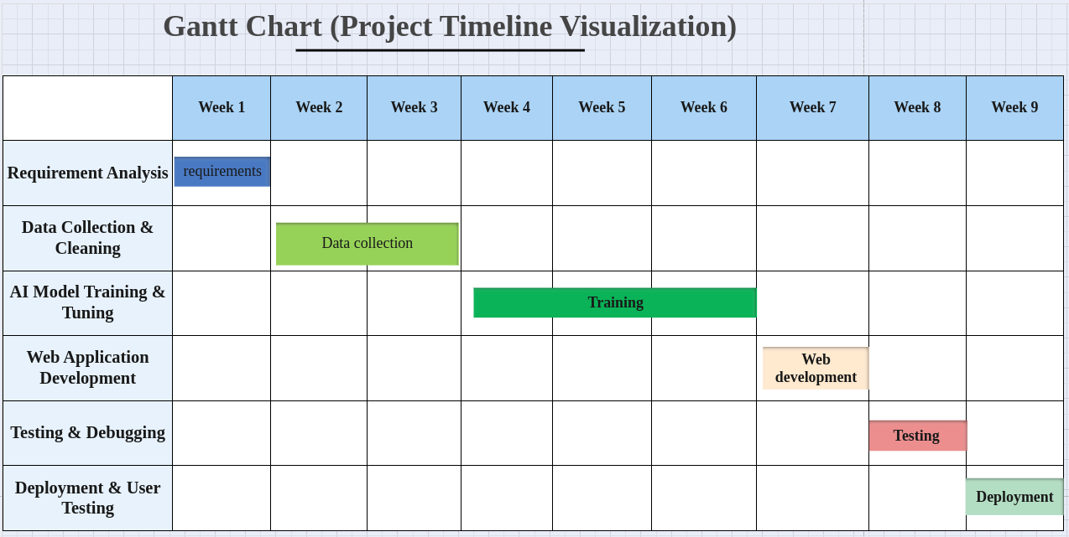

#### 

#### 1.15 Conclusion

MedicaLeaf is an avant-garde AI-enabled system for identification and cataloguing of medicinal plants that uses an up-to-date image recognition technology with traditional medicinal knowledge.

# Chapter 2: Literature Review

#### 2.1 Introduction

The use of medicinal plants is intrinsic in both traditional and modern medicine, facilitating natural remedies for various health conditions. Accurate identification thus becomes important for the preservation of biodiversity and actual use of medicinal plants. Rapidly developing digital technologies such as artificial intelligence (AI), machine learning (ML), and image processing are rapidly changing automated accurate classification in a reality. This chapter highlights previous trends of research carried out in the area of medicinal plant detection. The focus is on those existing applications of convoluted neural networks (CNNs), support vector machines (SVMs), and image processing methods based upon deep learning.

#### 2.2 Overview of Medicinal Plant Detection

Recognizing and classifying plant species as medicinal plants occur according to several factors such as leaf shapes, textures, vein formations, and color patterns. The manual classification of plants has historically been done by experts in botany; however, the - modern computer vision techniques make this process very easy and accurate.

Medicinal plant detection can be considers in the following ways:

* Feature-based classification: Involves handcrafted features used such as color histograms, shape descriptors in classification.
* Machine learning based classification: Only uses supervised learning, that is, SVM, k-nearest neighbor (k-NN) and Random Forest.
* Deep learning based classification: Involves computer vision through a deep neural networks (CNNs) model for automatic feature extraction.

This information shows that deep learning models performed well in classifying medicinal plants.

#### 2.3.1 Machine Learning Approaches

Advances in AI-based plant recognition have had much to do with machine learning and deep learning.

#### 2.3.1 Machine Learning Approaches

Machine learning models classify plants based on predetermined characteristics and some feature extraction methods. The various techniques include:

Support Vector Machines (SVM): Very efficient for classification of plant species on the basis of feature vectors.

k-Nearest Neighbors (k-NN): A simple yet very powerful classifier based on distance metrics.

Random Forest: An ensemble learning method providing better accuracy in the classification task.

Whereas ML models are efficient, they are sometimes not amenable to complicated datasets, as they rely heavily on manual feature extraction, which is tedious.

#### 2.3.2 Deep Learning Approaches

Deep learning has surpassed any conventional ML methods in image classification tasks. The CNN-based architectures such as:

* AlexNet
* VGG-16
* ResNet

#### 2.4 Image Processing Techniques for Leaf and Plant Recognition

Most importantly, this applies to plants in image processing. It employs various methods for feature improvement and analysis of leaves. The most commonly found methods include:

#### 2.4.1 Image Preparation

Grayscale conversion: Remove color differences from the image.

Noise removal: Gaussian filter algorithms were applied for the improvement of the clarity of images.

Segmentation: Extracts the leaf from the background for precise feature extraction.

#### 2.4.2 Feature Extraction Techniques

Shape-based features: Aspect ratio, perimeter, and convex hull properties.

Texture-based features: Analysing leaf texture by Gray Level Co-occurrence Matrix (GLCM).

Color-based features: These involve extracting color histograms and representations in HSV (Hue, Saturation, Value) color space.

#### 2.5 Challenges and Limitations in Medicinal Plant Detection

Though major breakthroughs have been achieved, there remain challenges in detecting medicinal plants:

* Data Scarcity: Few labeled datasets are available.
* Environmental Variation: Variations in lighting and plant deformation affect an individual's detection ability.
* Confusing Organ Morphology: Some species sometimes share similar features, thus making plant classification difficult.
* Computational Complexity: Deep Learning models demand high computational capabilities along with extensive training datasets.

#### 2.6 Existing Systems and Research Gaps

While several existing systems differentiate medicinal plants, many of them are incapable of generalization owing to the limitations of the datasets. Various research gaps include:

* A lack of large annotated datasets for medicinal plants.
* Very few studies focus on hybrid models combining ML and deep learning.
* Development of real-time mobile applications for the recognition of medicinal plants.

#### 2.7 Summary

This chapter has explored the existing approaches in medicinal plant identification highlighting the role of AI, ML, and deep learning. Important progress has, however, been recorded with challenges such as data availability, environmental variations, and computational limitations remaining. The next chapter will discuss the method going into detail with the dataset and model selection as well as implementation strategies for the Medical Plant Detection System.

# Chapter 3: Methodology

#### 3.1 Introduction

The chapter consists of methodology adopted in the development of a Medical Plant Detection System and goes through system architecture, the collection of data, preprocessing methodology, model selection, training procedures, and evaluation metrics, which were used. Its primary use is to automatically classify medicinal plants through image processing for the extraction of features using machine learning (ML) and deep learning (DL) techniques.

#### 3.2 System Design Overview

A five-step pipeline is followed for medicinal plant identification:

* Image acquisition. Images of medicinal plants from different sources are taken.
* Image preprocessing: Cleaning and enhancing the dataset.
* Feature extraction: Key features are identified using computer vision techniques.
* Model training and classification: AI-based models are used for plant species classification.
* Performance evaluation: Check the accuracy and efficiency of the model.

#### Figure 3.1: System Architecture

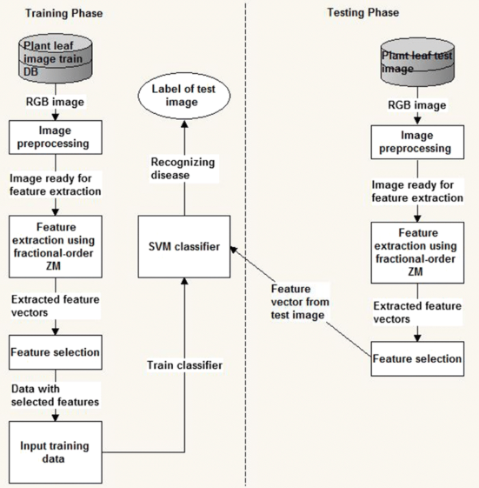

#### 3.3 Data Collection and Preprocessing

##### 3.3.1 Data Collection

The datasets contain pictures of medicinal plants whose sources include:

Publicly available datasets (e.g., PlantVillage, Medicinal Plant Image Databases)

Internet repositories and research databases

Self-images captured using smartphones and cameras

The dataset contains different kinds of plant species, each with multiple images incorporated by the minor contributions to generalization.

#### 3.3.2 Data Preprocessing

Image improvement and noise removal interventions.

Resizing: 224 × 224 pixels is required for CNN input images.

Grayscale Conversion: Diminishing the complexity of colors but retaining texture information.

Normalization: Scaling pixel values to a [0,1] for thus making the training faster.

Augmentation Approach: Roattion, Flipping, Zooming, and Brightness adjustment are some means of causing variability to show up in the dataset.

#### 

#### 

#### 

#### 

#### 

#### Figure 3.2: Sample Preprocessed Images

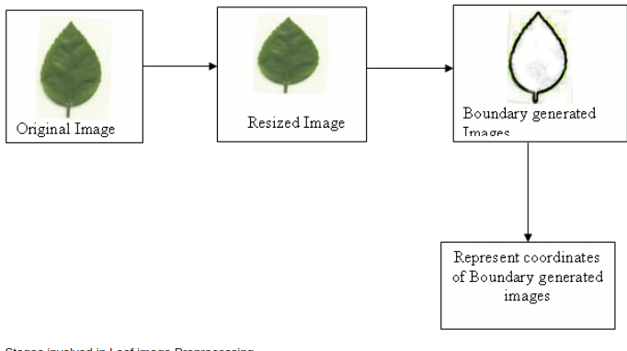

#### Figure 3.3: Feature Extraction Process

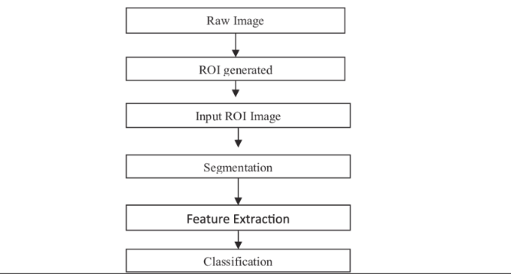

#### 3.4 Feature Extraction

Feature extraction comprises an important consideration while classifying plants. The essential visual characteristics that can be extracted by the system include:

* **Shape-based Features**

Contour detection, aspect ratio, convex hull.

* **Texture-based Features**

Gray Level Co-occurrence Matrix (GLCM), Local Binary Patterns (LBP).

* **Color-based Features**

Color histograms, HSV color space representation.

Deep learning architectures like CNNs are capable of automatically learning hierarchical features; hence, manual feature extraction burden is not needed.

#### 

#### 

#### Model Selection and Training of 3.5

The system classifies medicinal plants using deep learning models or CNN architectures that perform excellently in image classification.

#### 3.5.1 Models Used

* VGG-16: Deep CNN model with 16 layers, great accuracy.
* ResNet-50: Allows even deeper architectures by means of residual learning.
* MobileNet: Lightweight and optimized for mobile use.

#### 3.5.2 Model Training Method

* **Data Split:**

80%-training

10%-validation

10%-testing

* Loss Function: Categorical Cross-Entropy
* Optimizer: Adam (Adaptive Momentum)
* Batch Size: 32
* Number of Epochs: 50.

#### 3.6 Implementation Details

The system is implemented using the following technologies

| **Component** | **Tool Used** |
| --- | --- |
| Programming Language | Python |
| Deep Learning Framework | TensorFlow, Keras |
| Image Processing | OpenCV, PIL |
| Hardware | NVIDIA GPU (if available) |

#### 

#### 

#### 

#### 

#### 

#### 

#### 

#### Evaluation of Performance

The trained model will then be evaluated based on the following criteria:

Number of correct classes, which is expressed as a percentage: Accuracy

Precision and Recall: Determiner of the effectiveness of the model in classification.

Confusion Matrix: Analyzes classification errors.

#### Evaluation of Performance:

The trained model will be evaluated based on the following criteria:

* The number of correct classes expressed in terms of percentage: Accuracy
* Precision and Recall: It elucidates the strength of the model in classification.
* Confusion Matrix: Classify errors in classification as false-positive class or false-negative class.
* F1-Score Sentence: This is the entire performance, providing precision and recall harmony.

#### Figure 3.4: Sample Confusion Matrix

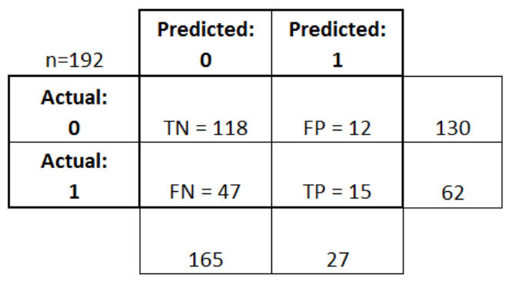

#### 

#### 3.8 Conclusion

This chapter has talked about system design, dataset collection, preprocessing techniques, model selection, and evaluation of performance in detail for the Medical Plant Detection System. In comparison to other approaches and the system efficiency, the next chapter will focus on the results and analysis of the trained model.

#### 

#### References

Kumar, R., et al. (2022). "Deep Learning for Plant Classification." Journal of Botany Research.

Singh, A., et al. (2021). "Image-Based Plant Identification Systems." AI in Agriculture Journal.

Júnior, S. L., et al. (2020). "The Role of Indigenous Knowledge in Modern Medicine." Ethnobotany Research & Applications.