*do the following in view : - 1) update 2) alter 3) delete*

Without ‘Group by’ (**ALTER FUNCTION**)-- Add or Drop dono main error aarha hai

**---ADD**

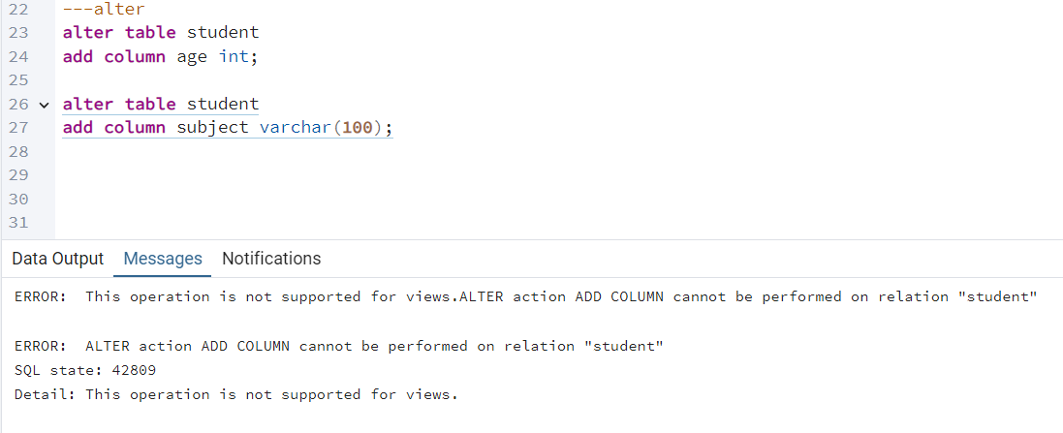

**---DROP**

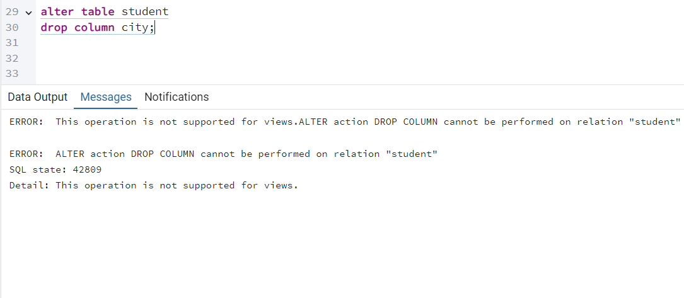

With Group by

-----**update query**

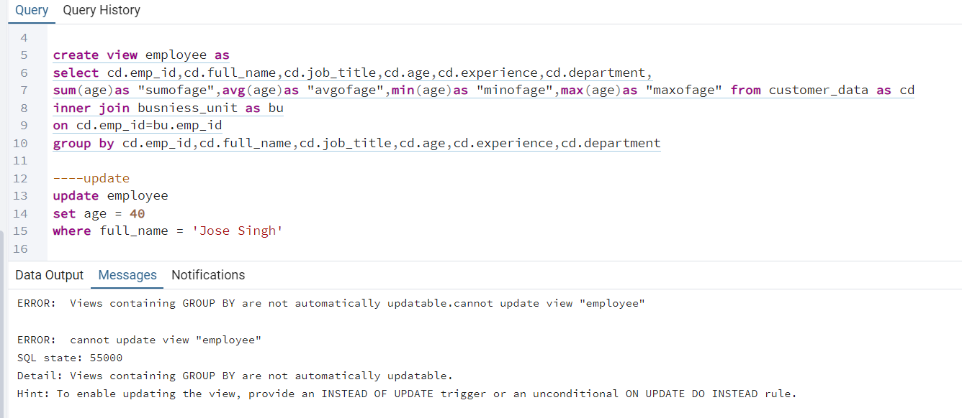

**----alter (add column)**

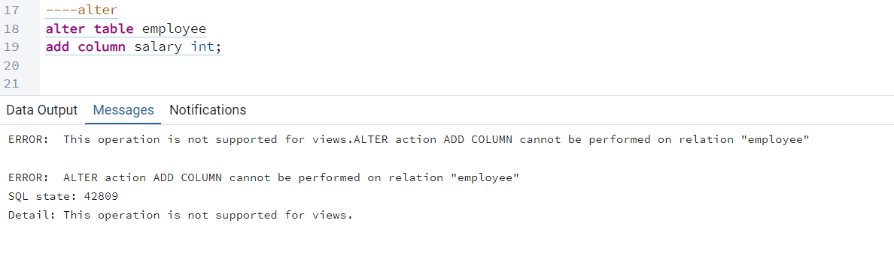

**---alter (drop column)**

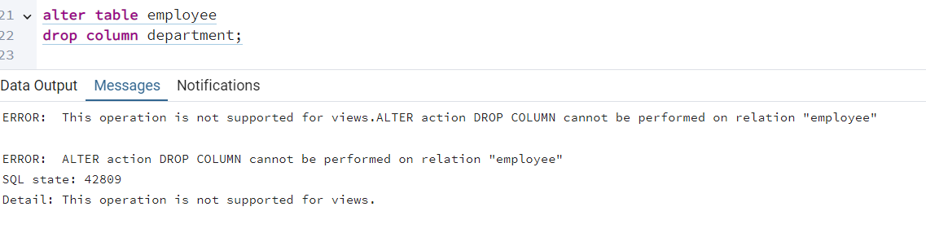

**---delete**

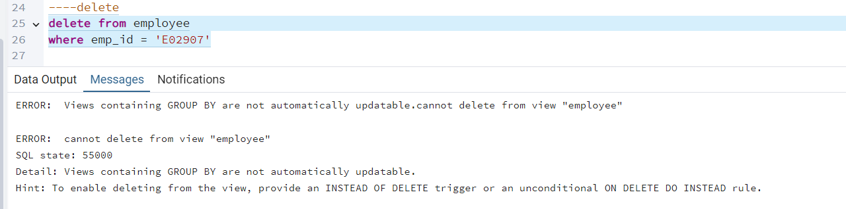

**View table main hum kuch bhi changes karte hai to hamari original table (database) main kuch changes nhi hote hai…..**