HL60 and NK Graphs

Maria Godinez

February 3, 2022

## HL60 E:T 20:1

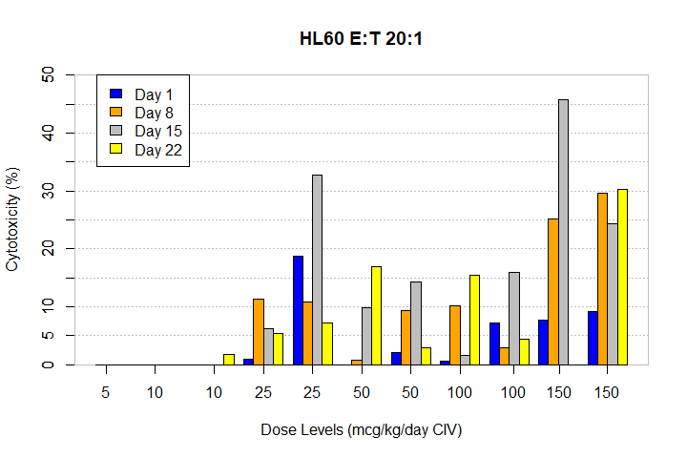

## HL60 E:T 6.6:1

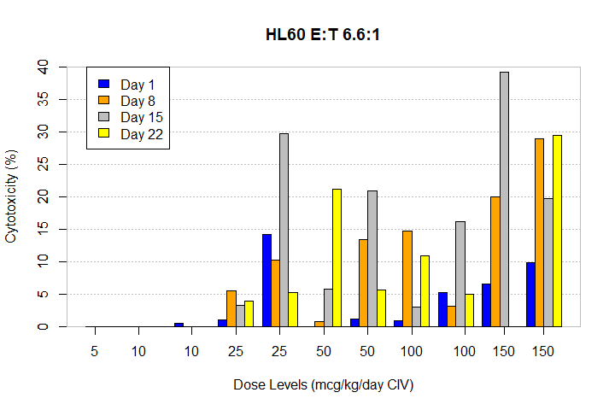

## HL60 E:T 2.2:1

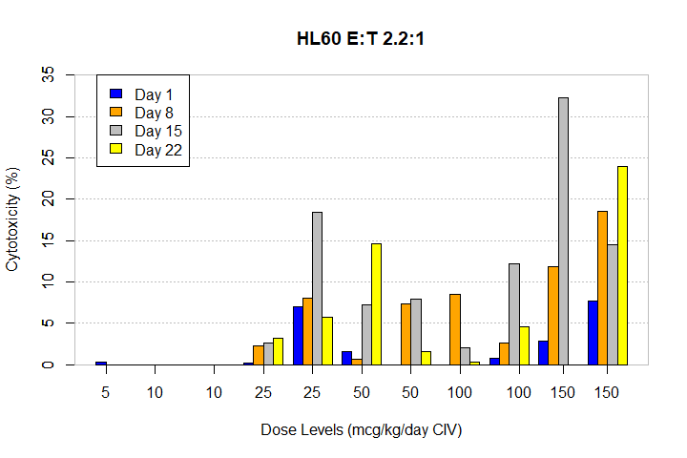

## HL60+TriKE E:T 20:1

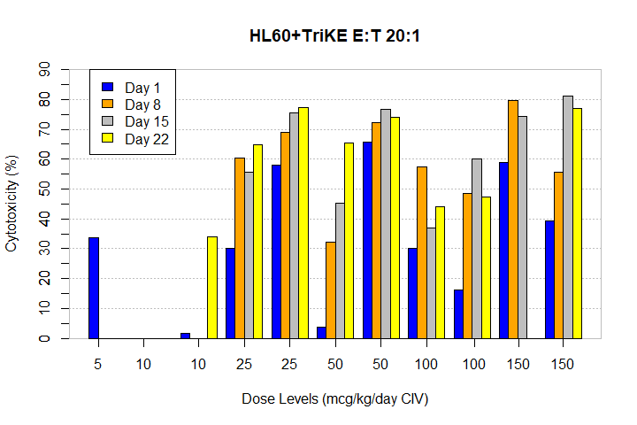

## HL60+TriKE E:T 6.6:1

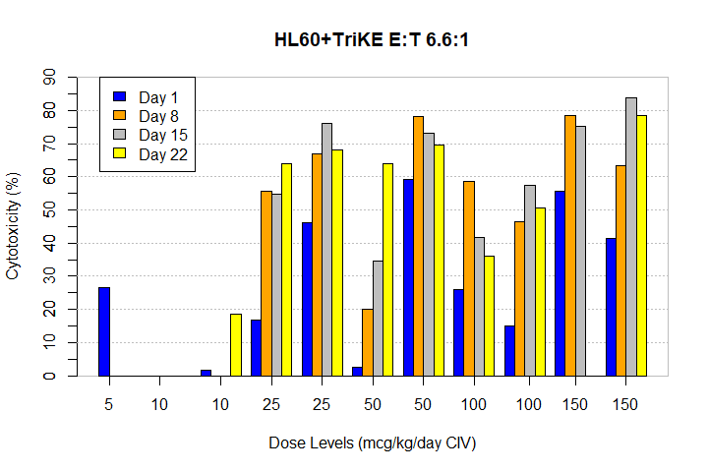

## HL60+TriKE E:T 2.2:1

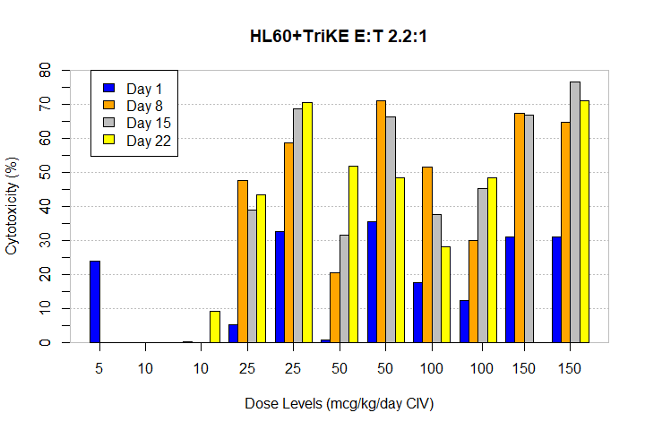

# NK graphs: 12 patients aggregated

When you plot the mean of 12 patients there is a strong outlier (patient in Dose 100).

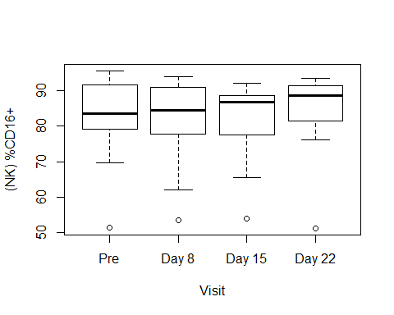

**Patients plotted individually: Color coded by dose**

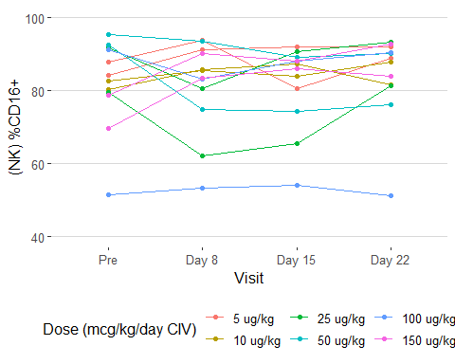

# Data pooled together by dose

|  |  |  |  |  |  |  |
| --- | --- | --- | --- | --- | --- | --- |
| Visit | Dose | N | (NK) %CD16+ | sd | se | ci |
| Pre | 5 ug/kg | 2 | 85.98 | 2.52 | 1.78 | 22.62 |
| Pre | 10 ug/kg | 2 | 81.47 | 1.65 | 1.16 | 14.80 |
| Pre | 25 ug/kg | 2 | 85.75 | 8.68 | 6.14 | 78.02 |
| Pre | 50 ug/kg | 2 | 93.97 | 2.18 | 1.54 | 19.63 |
| Pre | 100 ug/kg | 2 | 71.29 | 28.06 | 19.84 | 252.09 |
| Pre | 150 ug/kg | 2 | 74.21 | 6.49 | 4.59 | 58.32 |
| Day 8 | 5 ug/kg | 2 | 92.58 | 1.75 | 1.24 | 15.76 |
| Day 8 | 10 ug/kg | 2 | 85.56 | 0.21 | 0.15 | 1.84 |
| Day 8 | 25 ug/kg | 2 | 71.43 | 13.12 | 9.28 | 117.91 |
| Day 8 | 50 ug/kg | 2 | 84.23 | 13.24 | 9.36 | 118.97 |
| Day 8 | 100 ug/kg | 2 | 68.31 | 21.07 | 14.90 | 189.32 |
| Day 8 | 150 ug/kg | 2 | 86.85 | 4.74 | 3.35 | 42.57 |
| Day 15 | 5 ug/kg | 2 | 86.25 | 8.15 | 5.76 | 73.25 |
| Day 15 | 10 ug/kg | 2 | 85.60 | 2.47 | 1.75 | 22.24 |
| Day 15 | 25 ug/kg | 2 | 78.17 | 17.83 | 12.61 | 160.16 |
| Day 15 | 50 ug/kg | 2 | 81.81 | 10.51 | 7.44 | 94.47 |
| Day 15 | 100 ug/kg | 2 | 71.06 | 24.09 | 17.03 | 216.45 |
| Day 15 | 150 ug/kg | 2 | 87.05 | 1.48 | 1.05 | 13.34 |
| Day 22 | 5 ug/kg | 2 | 90.53 | 2.17 | 1.54 | 19.50 |
| Day 22 | 10 ug/kg | 2 | 84.73 | 4.53 | 3.20 | 40.66 |
| Day 22 | 25 ug/kg | 2 | 87.38 | 8.38 | 5.93 | 75.28 |
| Day 22 | 50 ug/kg | 2 | 83.21 | 9.86 | 6.98 | 88.63 |
| Day 22 | 100 ug/kg | 2 | 70.89 | 27.82 | 19.67 | 249.99 |
| Day 22 | 150 ug/kg | 2 | 88.45 | 6.15 | 4.35 | 55.27 |

Means (Medians) plotted for all 6 doses based on table above. SE was omitted from this graph due to some high SE values (please reference table).

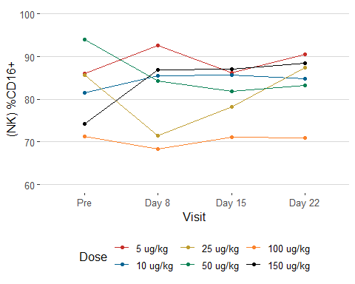

**Patients plotted individual: Color coded by Dose**

# 

# TOP THREE DOSES:

TOP THREE DOSES POOLED BY DOSE

|  |  |  |  |  |  |  |
| --- | --- | --- | --- | --- | --- | --- |
| Visit | Dose | N | (NK) %CD16+ | sd | se | ci |
| Pre | 50 ug/kg | 2 | 93.97 | 2.18 | 1.54 | 19.63 |
| Pre | 100 ug/kg | 2 | 71.29 | 28.06 | 19.84 | 252.09 |
| Pre | 150 ug/kg | 2 | 74.21 | 6.49 | 4.59 | 58.32 |
| Day 8 | 50 ug/kg | 2 | 84.23 | 13.24 | 9.36 | 118.97 |
| Day 8 | 100 ug/kg | 2 | 68.31 | 21.07 | 14.90 | 189.32 |
| Day 8 | 150 ug/kg | 2 | 86.85 | 4.74 | 3.35 | 42.57 |
| Day 15 | 50 ug/kg | 2 | 81.81 | 10.51 | 7.44 | 94.47 |
| Day 15 | 100 ug/kg | 2 | 71.06 | 24.09 | 17.03 | 216.45 |
| Day 15 | 150 ug/kg | 2 | 87.05 | 1.48 | 1.05 | 13.34 |
| Day 22 | 50 ug/kg | 2 | 83.21 | 9.86 | 6.98 | 88.63 |
| Day 22 | 100 ug/kg | 2 | 70.89 | 27.82 | 19.67 | 249.99 |
| Day 22 | 150 ug/kg | 2 | 88.45 | 6.15 | 4.35 | 55.27 |

## Mean(Median) With SE

As mentioned in previous graph SE is large and make graphs look messy but still would like to show an example.

